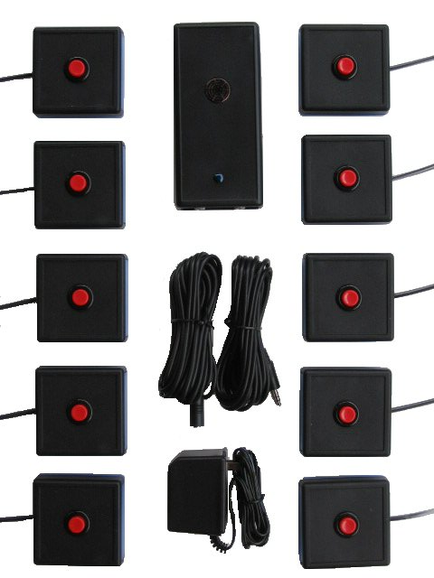

<http://www.svbz.com/n_complete_10.jpg>

Computer Science HL Dossier

Academic Challenge Organizer

Name: Ryan Benjamin McCashin Amos

School: The Awty International School

IB Number: IB-D-000436-005

Pages: 360

Words: 37,622

Table of Contents

**Analysis of the Problem2**

**Criteria For Success8**

**Prototype Solution12**

**Data Structures39**

**Algorithms49**

**Modular Organization60**

**Handling Errors67**

**Code Listing75**

**Annotated Hard Copy232**

**Evaluation of Solutions334**

**Documentation of Mastery Aspects336**

Analysis of the problem

Academic challenge meets twice a week with around 10 students. In the club, we answer questions as quickly as possible, hopefully before the other team responds. These meetings are training for tournaments. When there is a tournament, the club sponsor, Mr. Williamson, must select 4 students who he believes will perform best. While Mr. Williamson does the best he can, I have wondered if there may be a more scientific way to select a team, using computational mathematics instead of picking who seems to perform best in practice. Thus, I have proposed to Mr. Williamson that I create a program that will use statistical data from practices to determine what might be the optimal team for a tournament. The program will be able to use mathematics instead of perceptions to solve the problems. Frequently, teams will be polar towards math, science, history, or literature, which means the other team can answer the questions in other areas faster. As well, the best candidates for a team will be split among all teams attending the tournament, meaning that no team is optimal.

Creating an academic challenge team can be difficult. Many factors are needed to decide how each player performs. Creating a well balanced team is a must, as teams must have all subjects covered. If a team is weak in a specific area where the opponent is not, this can easily lead to an extra 20% more points for the opposing team. Thus, it becomes evident that statistical analysis of the players’ performance is necessary to create the optimal team. When it comes to statistics, computers are excellent. Computers store data and never lose it; they perform calculations quickly. Thus, a computer could be used to store and retrieve the data. However, this data would still have to be analyzed by a human, which can be quite painstaking. Thus, the burden of analysis should be given to a machine that will follow precise formulas for producing the optimal team or aiding in the production of the optimal team.

 After searching for some software on the internet that can be used in place of what I’m proposing, the only similar software I could find was the Texas Quiz Bowl database, found at <http://www.texasquizbowl.org>. The software is set up as a database on the website which provides detailed information about scores. They have several different ways to look at the scores. These are displayed in a bar at the top of the website. This is shown below.

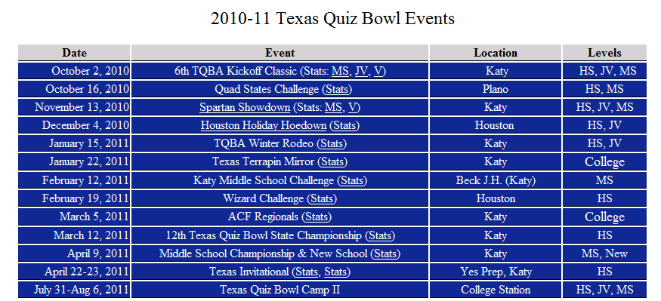The main page of the website lists all the different games that have been played and provides links for them that allow you to look at the scores for that event. You cannot view scores over time or for different events.

The software lists several different things. I found the following to be the most notable:

Team overall score

Individual score against each team

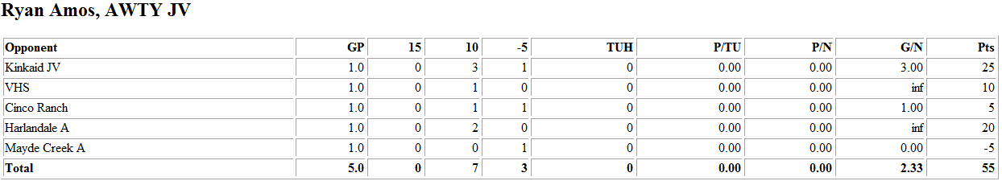

Team score against each team and individual total score

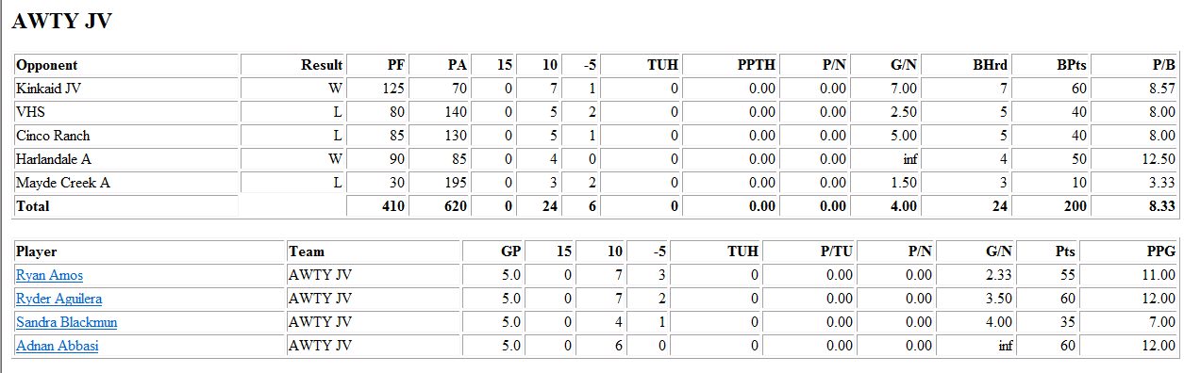

The problem can be divided into two parts. The first part is the database portion. In this part, I will need to find a way to store all of the data efficiently without losing any data. I will need to keep track of who scored how many points and at which matches on which questions. The user will be able to input data into the database by entering data in through the application. The application will handle database modification and reading.

The next part is the analysis portion. This part will be significantly difficult and will set my program apart from Texas Quiz Bowl’s program. This program will involve developing a graphical system for data; calculating the individual scores of those in the database; sorting the scores, preferably without loading them into memory; sorting individuals by strength; and organizing all the above data in a format such all of the parts link together instead of being rewritten, saving disk space. The data will used to determine the optimal team.

Given that TexasQuizBowl does not charge for their database, I will not charge for my program, making a budget of $0.00 to make it competitive. The time frame to develop the program will be around 15 weeks from now. I plan to improve upon TexasQuizBowl by providing analysis as well as database access. Individual questions will be available as well, unlike TexasQuizBowl.

The client asked for the following features:

1. Regarding participant performance:
   1. Percent correct
      1. Pros: This is simple to calculate because it’s simply two counts divided by each other.
      2. Cons: This does not account for any unanswered questions. You could be silent for 59 questions and answer one question correctly and have 100% accuracy.
   2. Top participant per subject
      1. Pros: This criteria is very important in team design because it prevents polarization of teams.
      2. Cons: requires that questions be labeled by category. This takes extra harddrive space and may take a long time with large data sets.
   3. Top participant
      1. Pros: The top participant should usually be included in a team. As well, an award at the end of the year could be given to the top participant.
      2. Cons: None, although it is not terribly useful.
   4. Team organizer by strength
      1. Pros: saves much time for the user, and is the primary focus of this project
      2. Cons: will probably involve complex algorithms and will take a lot of debugging time
   5. Graph of performance over time
      1. Pros: This will allow examination of how students perform, examining how certain events affect performance, such as studying for the tournament or the impact of large workloads.
      2. Cons: May take up extra memory or CPU time if multiple graphs are rendered. Requires storing large amounts of data in memory.
2. Counting system:
   1. By points earned (as opposed to questions correct per question) per question
      1. Pros: more accurate
      2. Cons: favors different systems. Academic challenge has two counting systems: 10/0 and 15/10/0/-5. Total points may vary depending on the counting system. Crossing the systems may have odd effects on scores.
3. Ranking systems:
   1. Percent correct per subject
      1. Pros: allows for cross comparison of students by subject
      2. Cons: requires extra data
   2. Percent correct per match
      1. Pros: shows activity. Prevents high indexes for being safe
      2. Will be essentially the same as system *c*, percent correct per question heard.
   3. Percent correct per question heard
      1. Pros: shows activity. Someone who answers one question may have a high score index but will never score any points
      2. Cons: this index will not account for any other skilled members on the team taking questions from the participant.
4. Information to be stored about participants:
   1. Name
   2. Age
   3. Email
5. Only the club sponsor will be using the program.
   1. Pros: fewer features need to be added, as only what the client wants will be necessary to add.
   2. Cons: less feedback and less frequent feedback.

I did not discuss security with the client. The application will not require any authorization methods because the application stores no sensitive data. The client requested name, age, and email to be stored in the database, none of which reveal much about the participants. If the client were to request the address or GPA be stored, I would encrypt the database and require authorization. However, the client has asked for only name, age, and email, so encryption and authorization are unnecessary.

A graphical user interface will be used to aid the user in interacting with the system. If I were to use a console based system, it would be impossible to show graphs for view large databases, so a graphical interface becomes necessary.

The application will run on any Java SE enabled platform with Java 6 or more recent. No compilers will be needed, nor any other software than Java and a platform on which to run Java, such as Linux, Windows, Solaris, and Macintosh. The current session will be saved on the hard disk, but not backed up. The archive data will be backed up and automatically loaded in case of data corruption. The client should not require updates when finished. However, if I believe that the client may require updates after it has been written, I will add that functionality before the first release. Updates will be delivered via internet if I add updating.

All input will be text input, done through text fields and radio buttons. No external files will be required for full functionality. All output will be in either sorted lists or graphs.

Criteria for Success

# Summary:

My application will aid in the collection of data from an academic challenge match and aid in the analysis of such data. The application will use the data to provide individual stats of team members as well as combine that data to select the optimal team. This will ideally improve the ability of the selected team. The application will also provide statistics on individual members and individual analyses, tracking progress over time.

# Application setup

My application will have 2 modes. The first mode is the user input. The second mode of the application is the analysis or output. Both modes are critically bound and each is useless without the other. Both will be launched from the same executable and will be available as different tabs in the same window.

# Input

Upon entering input mode, the application will first ask the user to add team members. After team members have been added, the computer will store the identification numbers of these users in memory for later storage. For input is assumed that the application is initialized or reset at the beginning of each match and not closed. If the application is closed, the team members will have to be selected again.

Team members will be added by inputting their name. Age and email will be optional and can be added later. This will allow for an adequate method of sorting team members, while still being able to collect data when not all information on a team member is available.

There will be two methods of inputting questions: before and on-the-go. Both methods will automatically log the time when the question was answered

# Entering questions before

If the user chooses to enter the questions beforehand, the program will cycle through the questions for faster input. This will allow the reader to enter data quickly in time pressed situations. This option is provided for those who have prior access to questions so that they can enter more details and still be able to handle the fast pace of a match. This option will allow readers and scorekeepers to quickly record data without losing focus on the task at hand.

# Entering questions on-the-go

If the user chooses to enter the question on-the-go, the user will be offered the option to only provide the subject or provide the question and subject. Response entry will then be offered after the question is entered. This option is provided for those who do not have access to the questions before the match. This is ideal for anyone without prior access to the question list, such as a spectator.

Ideally, the program will minimize mouse use and maximize keyboard use so that question and response data can be entered in real time. Autocomplete will be offered for team member entry. Hotkeys will be available for submitting questions, teammates, and responses, as well as indicating a lack of response. Without this, the program will not operate fast enough to be viable.

# Output

The application will aid the user in designing the perfect academic challenge team. After accumulating adequate data, the user will be able to run analyses on the data to determine what the optimal team is, based on the percentage of questions a team member answers correctly. Ideally, this team should be the best possible team to send to a tournament. The teams will be well balanced to maximize wins. The percentage of each type of question will be optionally provided by the user, otherwise taken from past data.

The application will be able to perform calculations right from the first moment; however, the accuracy of these analyses will improve as the data increases in size. The reason for this is that the error margin is relatively large for small data; however, over large data sets the error margin approaches zero. The application will provide users with the option to see statistics and some analyses of each individual, such as percentage correct by subject, questions answered, and questions heard.

## Result viewing

The output will be displayed as both statistics tables as well as graphs. All data will first be analyzed, and then stored for later loading. Lists will be sortable according to each of their criteria. Results will be computed on the spot and stored in temporary files. Graphs will be kept in non-temporary image files for later viewing. Although this will be slower, it will minimize memory usage and allow for larger data sets to be used.

## Database viewing

The user will be able to view all the entered databases, including

* Team member listing, sorted by name or age
* Question listing, sorted chronologically or alphabetically
* Response listing, sorted chronologically (and thus grouped by question) or by name of responder

The user will be able to select a question and view the responses and lack of responses. The user will also be able to select a team member and view that team member’s responses. The user will be able to select a response and see the relevant question. This will allow the users

# Analyses

The application will have several methods for analyzing individuals. These are:

* Percent correct per subject
* Percent correct per match
* Percent correct per question heard

Percent correct will be based on point value of the question. For example, if a student receives 15 for responding early, they will have a $\frac{15}{10}$ for that question. A student who responds early and loses 5 will receive a $-\frac{5}{10}$ for that question. Using the accumulation of responses, a decimal value $\frac{points earned}{potential points}$ will be determined, ranging from $-0.5$ to $1.5$. For those questions worth 10 points, correct responders will receive a $1.0$. If there is a 60 second group response round, this information will not be recorded.

Graphs will be available representing

* Line graph of time vs question answered correctly
* Line graph of time vs percent correct

Statistics will be available representing

* Ranking
* Rankings by subject
* Total questions heard
* Total questions answered
* Total questions missed
* Total questions correct

Time can be specified to see how team members have done since a certain point in time, so that old performance doesn’t hurt or help individuals, and only their current performance helps. I see no value in including a time restraint to see how team members used to do, as the newest performance is generally the best way of deciding future performance, not old performance.

# Team optimization

The following is the mathematical description for determining the viability of a team:

Assume *T* is the set of all team members. *Tn* refers to team member *n*. Assume a set of functions *S* extract the percent incorrect of a given member in a subject area. *S1(T1)* would provide the correct percentage of team member 1 in subject 1. A team will have a score in a subject *x* of

$$\prod_{i=1}^{n}{\left({1- S}_{x}\left(T_{i}\right)\right)}$$

The overall score of a team would be

$$\sum_{x=1}^{z}{\prod_{i=1}^{n}{\left(1-S_{x}\left(T_{i}\right)\right)}}$$

Where *z* is the number of subjects and *n* is the number of teammates, $n≤4$.

The optimal team would be the team with the highest score.

The number of possible teams will be

Because the possible number of teams is $\frac{x!}{\left(x-4\right)!}$, where *x* is the number of team members in the database, it is vital that all teams are unique. Combinations, not permutations, will be used.

Prototype Solution

Why did you decide to supply a prototype to the client?

Which types of prototypes did you consider? What are the pros and cons for your final selection?

Describe the steps in making the prototype. The program you used, the panels you included or did not include. What things you might have left out (like images).

Include the end-user feedback at each stage and supply all images in the appendix.

# Introduction

## Why a prototype?

I have created a prototype for my application for two reasons. The first reason is so that I can visualize the prototype, acting as an outline for how my program will look. This will allow me to focus on the program itself while writing instead of worrying about design. The second reason is that I can now show my prototype to the client and see how the client feels about my prototype. If my client feels that certain buttons are redundant or that he needs certain functionality, then the client will be able to communicate this better. The prototype will also help clear up any confusion between the client and I about how the program will look and what functionality it will have.

## What kinds of prototypes?

I am using two prototypes. The first prototype is simply an illustration made in Adobe Illustrator. This prototype will allow me to understand spacing and placement of parts before working about actual layout in the application. However, this illustration is not interactive and shows less of the program. As such, all interactivity must be communicated to the client when discussing the prototype made in illustrator. The second prototype is made in JBuilder with the GUI editor. This prototype will provide a semi-interactive prototype that will allow the user to see how the program flows before any database work is done. The user will be able to understand which buttons bring the user to which panels and where certain pop-ups come from. Dummy data will be used in this prototype to test spacing. This prototype will be more complicated, but will also give me a jumping point from which I can leap into my programming, already having the GUI created.

# Illustrator prototype

## Problems encountered

#### V1

In my first version of my prototype, the program was very similar to a wizard. Each step would be completed and would flow into the next step. However, after these wizards would become quite long and end up in loops. These loops could potentially be a source of memory leaks, and can greatly confuse the user. The original prototype was poorly organized and similarly functioning items were not placed together. The database was tab based, and as has become clear from tabbed browsing, tabs are a great source of confusion and can cause the client to become lost in a sea of tabs, all of which are chewing up memory, making the system less efficient. Input was designed such that editing was impossible—once something was entered, there was no way to delete or modify it. The wizard setup was difficult to follow because it could be up to 40 steps long and provided no way to go “back.”

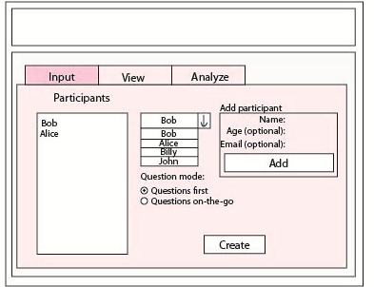

This panel will be the panel to which the program will open. The user will be able to initialize a new session, which would be stored in memory.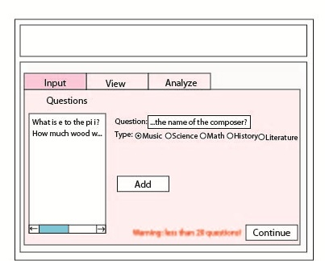

This panel requests from the user 20 questions that will be asked that day. This panel only shows when “Questions first” is selected. If fewer than 20 questions are entered, a warning appears. Once a question is entered, there is no way to delete this question.

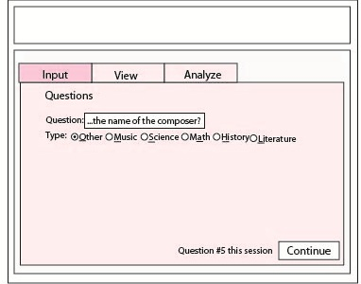

This panel will allow users to enter questions. The various options are hotkeyed for fastest movement through the program. This panel will not appear if “Questions first” is selected. Responses are final once entered – there is no mechanism for undoing.

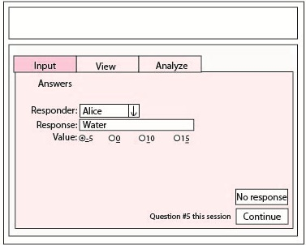

This panel allows user to input responses and will be cycled with the question entry panel provided “Questions first” was not selected. If “Questions first” was selected, the program would automatically update the selected question from the list entered in the questions first entry panel.

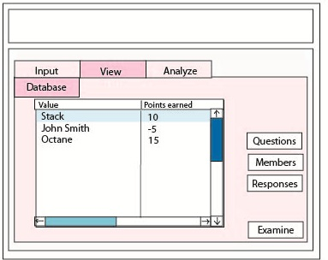

This panel allows the user to examine the question, member, and response databases. Edits are not possible through the program, but the user will be able to manually see what has been answered and possibly draw conclusions that are not offered through the analysis panel. Selecting “Examine” will open a new tab providing more information. Selecting “Questions”, “Members”, and “Responses” will switch the database list to the respective list.

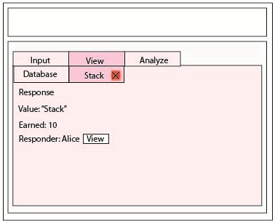

This panel is an example of a tab that would appear after “Examine” is selected in the database panel. It would be possible to move between tabs. For example, the response tab would allow one to view the responder, as shown above as a “View” button.

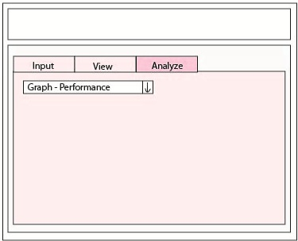

This is a brief model of how the analysis would look. The panel would be plain except for a single combo box. Once that box is selected, a graph or chart will be rendered in the space below showing the selected item.

#### V2

Solving these problems became my next challenge. I decided to recreate my prototype, so that I could simply start from scratch instead of spending hours fixing countless problems. I created the opening page as a parallel lists between which the user can move participants. This will give the user a selection process which is reversible. After this, the user will be moved to the appropriate selection screen where they can either add questions or add responses to a list of responses. The user will be able to use a more intuitive setup to manipulate data. This more intuitive setup uses lists instead of wizards to navigate through the meet. If the user chooses to enter questions first, they will be able to enter them and then select them and match them to a participant though two lists and then type out the response. If the user chooses to answer questions at the same time as responses, they will be able to select a participant from a list and match that up with a typed answer and question. In both cases, the user will see a list of previous responses and be able to edit these responses.

The utility of a response list has been under some debate, although it has been decided that although it costs screen space, it allows the user to modify the previous response. The modification for responses when the user chooses to enter questions first is not very intuitive and may require some modification.

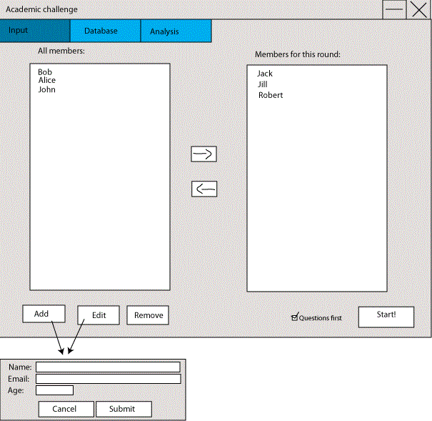

When I recreated the input panel, which is also the panel to which the program opens, I decided that members should be editable, unlike version one. Two parallel lists are used and members can be moved between the members in use and the ones not in use. “Questions first” is a check box instead of a radio button. Adding and editing are done through the same pop-up panel. If the panel is for editing, the “name”, “age”, and “email” fields will be filled in, and selecting “Submit” will edit rather than add a member.

Similar to version one, there is a “Start” button. Pressing this button will bring the user into the data entry mode.

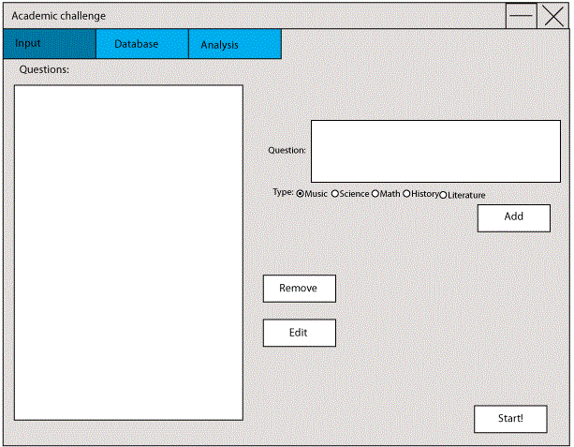

This new “Questions first” question entry panel allows users more space to type the question. Although there is no practical character limit in either version one or version two, this version will allow the user to better see any errors in their typing.

Should a user make a mistake in typing, the user will be able to edit the question by clicking the edit button or the remove button. Questions do not have to be in chronological order. All of these are improvements of version 1.

Type selecting is no longer hotkeyed, although this could be added later if necessary.

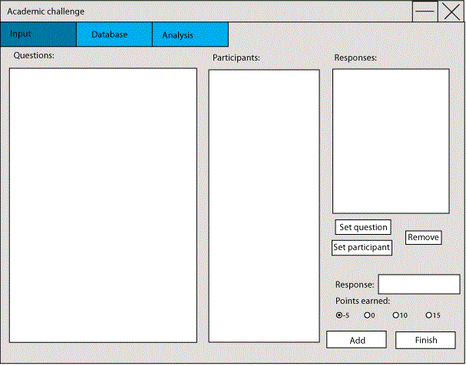

This panel if for adding responses if you have added the questions first. It allows for response editing through removing and retyping the response. Changing the participant and question are also possible by selecting the response and the question or participant, then selecting the appropriate button. This would modify the response listed in the response list, rather than the response being entered.

The response being entered will be created by using the question selected from the “Questions” list and the member selected from the “Participants” list, as well as the response entered in the text field and the point value listed below it. Pressing add will take these 4 items and combine them into a response, which will immediately be stored in a database or cache and shown in the responses list.

The user will be able to finish at any time, which is an improvement over version 1.

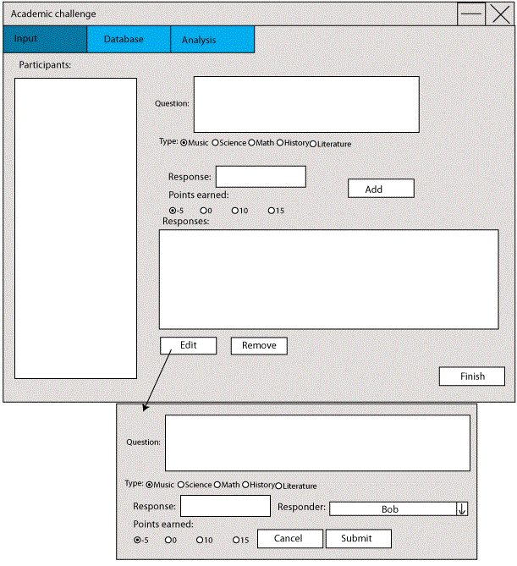

This panel is a great improvement over the version one equivalent. The version one equivalent was two panels in a wizard cycling between each other, with no way to edit mistakes. In this version, the user will be able to edit responses and will be able to enter the question and response in the same panel.

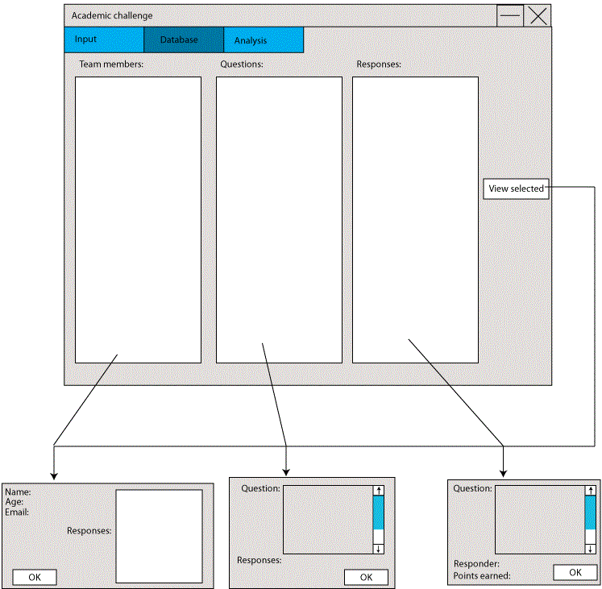

This database panel prevents the user from creating a tab mess, although it allows for a popup mess. I will likely need to implement some method to prevent the user from opening too many popups. The panel consists of three parallel lists which the user can select one item from. If an item in a list is selected, all selected items in other lists are deselected. When the user presses the “View selected” button, a popup will appear which allows the user to view more information about the selected item. As with the previous version, some information pieces will be linked to more information. For example, double clicking a response on the “members” popup will open information about that response. Clicking a response listed on the “Questions” popup will open information about that response. The response popup will ink to both the member who responded and the question to which it refers.

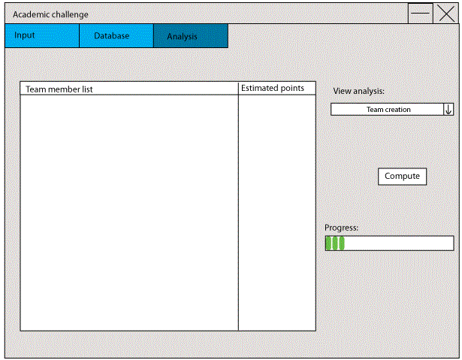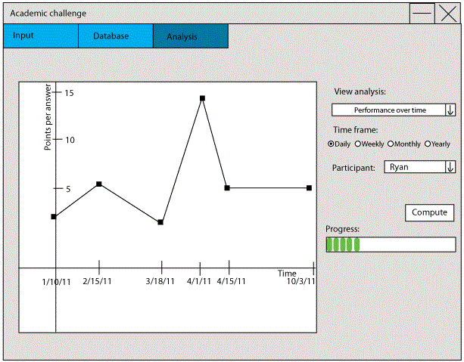

This is a sample analysis page. The user will be able to select from a drop-down box the type of analysis they want. A progress bar may or may not appear, depending on how long the calculation takes. I will likely remove the progress bar if the calculations do not take a lot of time. A panel will appear when parameters are needed. The panel doesn’t appear immediately because different functions will require different parameters.

This sample analysis panel shows how when parameters are needed, a panel requesting these parameters will appear.

#### V3: JBuilder prototype

I have found that the input panel will require many different panels to function. However, the JTabbedPane needs to have only one, so a container panel is necessary.

There is no option for a button with an arrow on it, so a workaround is necessary. I had three options: ASCII arrows, overriding the paint method and drawing areas in-line, and creating an entirely new button subclass.

On the questions first answer entry panel, I decided to remove the response edit options and keep only remove. I decided that if you are most likely to have incorrectly typed the question, which wasn’t originally available for editing, so there’s no reason to have any of the other options if the most likely isn’t an option.

I became increasingly worried about having matching sizes. Because my panels were designed to not be resizable, the scale on which they are made is important.

I realized that my response dialog lacked a listing of the actual response, so I added that in, as I believe it would be helpful to know the response.

I determined a progress bar is likely to be unnecessary. However, if the calculations begin to take more than 10 seconds, I will reimplement it.

This was not created as a working model. This GUI is simply meant as a guide and a stepping stone.

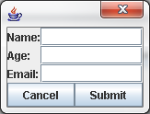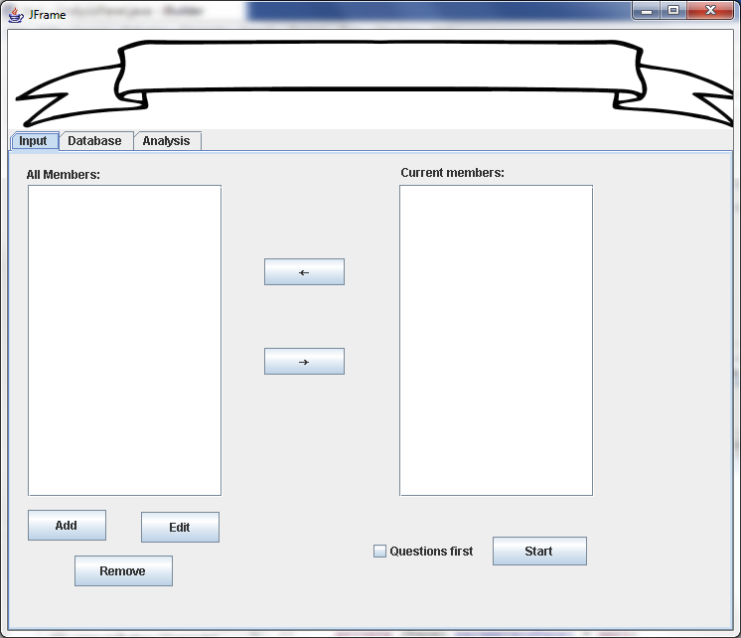

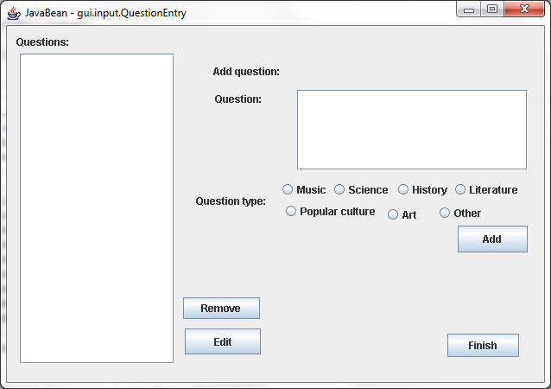

As will the two previous versions, the application will open to the input tab, which is this tab. This panel is more or less how it was shown in version 2.

The popup window will appear when Add or Edit is pressed, as was discussed in version 2.

The difference between this panel and the panel shown in version two is that I have added more options for the question types. The new question types cover nearly all of the questions and I have added an “Other” catch-all. However, after completing this panel and re-evaluating, I believe that it may be best to offer the option to simply type in the question’s subject.

I have not yet created an edit panel, but the client has stated that they would like the setup to be similar to the member modification panel in the sense that the add question and edit question will look the same, but the edit question will have the information filled it.

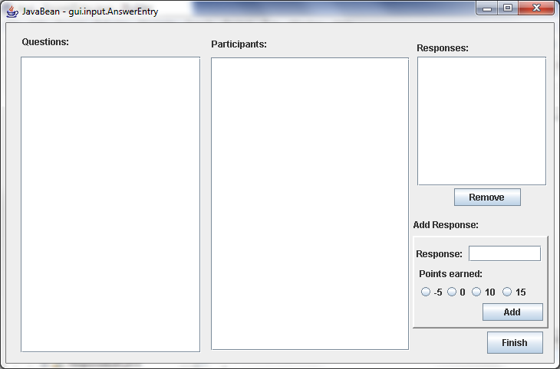

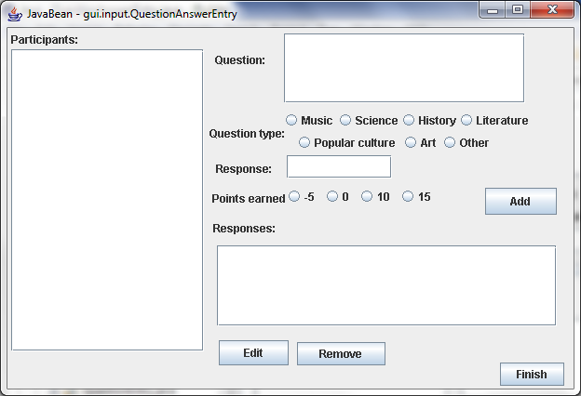

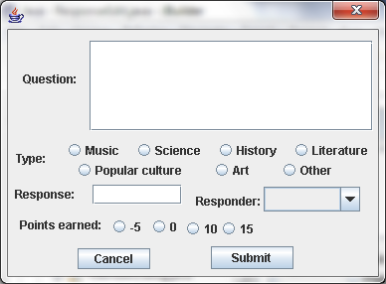

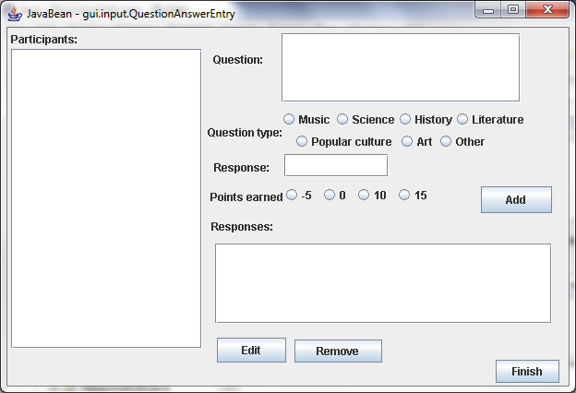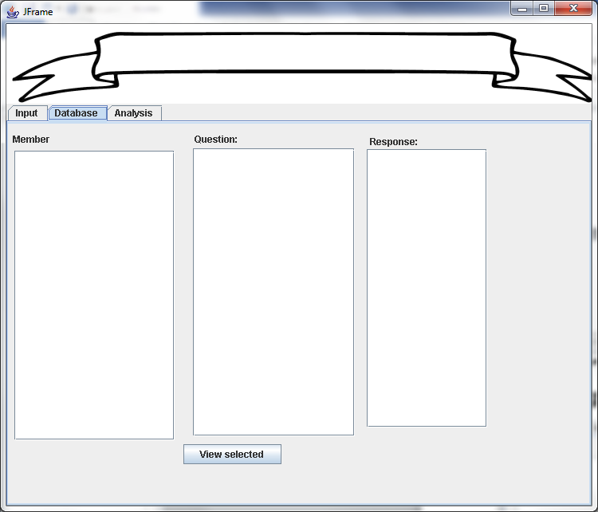

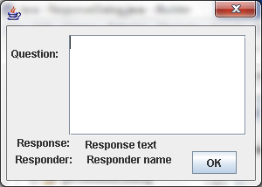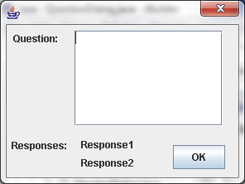

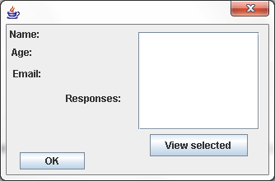

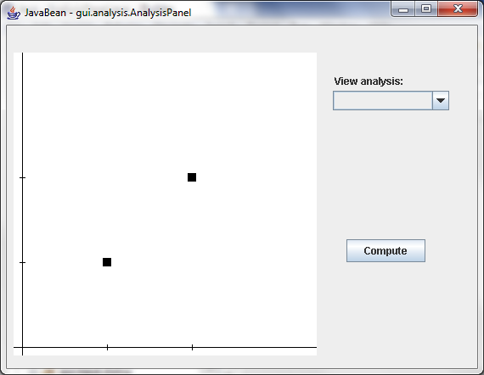

Data Structures

Preparing an outline for data organization is important. Because data organization must be optimized for the project, sequential files shouldn’t be used when insertion and deletion is required. As well, data will fit together best when well planned. Thus, I will outline for the reader how I will organize my data.

# External Data

For storage, I have many options. I will discuss the options below

## Encryption

### Encrypted

An encrypted file will be far more secure than an unencrypted file, which is vital for secure information such as grade point averages, social security numbers, and credit card number.

### Unencrypted

An unencrypted file will have all of its information available for viewing, even without the use of my application.

### Decision

I will use an unencrypted file. Encrypted files are not terribly secure if Java is being use because Java is very vulnerable to decompiling. Even if the application is obfuscated, it is trivial to recover the encryption algorithm. Thus, encryption is immediately possible, unless a password is required for users and used as the seed for the algorithm. However, asking for a password is an addition step for the user and having to re-input a password each use can be quite irritating for many users. As well, simply keylogging the user’s computer or modifying the application would recover a password. In any case, using encryption is just not necessary, because the application is not storing sensitive data Thus, because it is nearly impossible to secure a file accessed by a Java program and because the application is not storing very sensitive data, I will not use encryption for my files.

## Storage method

### Sequential

Sequential file access stores data in the order that it is added. Data can only be appended. When editing (inserting or deleting) a sequential file, the only way to do so is by rewriting the entire file, with an efficiency of O(*n*) where *n* is the number of lines in the file. Sequential files have no buffer space and thus are compact and easy to use. However, they are very inefficient and require a lot of read/write time.

### Random Access

Random file access allows access to any point in the file, making insertion and deletion simple. In order to insert data, the data is inserted without rewriting the initial part of the file, for an average efficiency of O($\frac{n}{2}$), best case O(1), worst case O(*n*) where *n* is the number of lines in the file. Adding data can be done in a similar manner to sequential files, by appending. Unit deletion can be done by marking the units block with a deletion character, with an efficiency of O(1). Insertion into a deleted unit will also have an efficiency of O(1), greatly improving the efficiency of this method.

The drawback to random access file handling is that files tend to become bloated. Block size has to be a constant size in order to have maximum utility from random access file handling. As well, random access is slightly more difficult to use, though not much.

### Binary

Binary file handling has very high efficiency. Values are stored in bytes instead of characters. For example, the number 10 can be stored in 1 byte instead of 2 characters, totaling 8 bytes. This reduces read/write time, and because disk writing is slow, binary file handling is vital for large files and very fast applications such as scientific applications. As well, binary files tend to be much smaller than their sequential and random access counterparts, thus making them the most compact of all 3 types.

The drawback to binary files is that they are very difficult to handle. Small mistakes will corrupt files, which can be stressful in debugging. As well block sizes must be constant to have the same advantages as random access, which can take up much room.

### Decision

I will choose random access file handling. Given the disk size and speed of modern machines, disk efficiency is trivial, except in cases where gigabytes or terabytes are being handled. Most text files take up spaces on the order of kilobytes, which are tiny compared to gigabytes. Random access file handling will maximize processor and memory efficiency, when compared to sequential file handling, so I will use random access file handling.

## Indexing

Indexes are lookup files which provide a map of item to location. These are incredibly useful for sequential files, as they point to the location of an item without having to search through the entire file for that item.

If I find that deletions and insertions become frequent (which I do not expect), I will index the locations of all deleted units. This would be done with a file that serves as a last-in-first-out (LIFO) stack. Items pushed onto the stack would be appended and items popped off the stack would be taken off the end. This will eliminate the need to shift all items when editing. The size of the file would be stored at the beginning to allow the program to jump to the end.

Stack

Push

In

Pop

Out

Last-in-first-out (LIFO) stack

I intend to use random access file handling with ID numbers. The ID number will correspond to the location within the file by the equation $bn$ where *b* is the block size and *n* is the ID number. IDs will start counting from 0.

0

1

2 (Deleted)

3

Deleted blocks will remain in the file but will not be read by the reader. The first item will be marked with a deletion marker, listed in the Standards section. This will remove the need for indexing because all IDs will be in sequential order and retrieval for a certain ID will be O(*n*).

# Standards

A standard protocol will be used for reading different items within the database.

## End of value

The grave accent (ASCII 96) character, `, will be used at the end of each item. For example, a grave accent character will follow an age value.

## End of block

The newline (ASCII 10) character, \n, will be used at the end of each block. A newline character will follow a list of values. For example, a newline will follow the storage of a member object.

## Value filler

The tab (ASCII 9) character, \t, will be used as filler for any unused slots. For example, if a value of 12 is placed in a 3 character slot, the stored value will be “12” followed by one tab where one tab is used per character unused in the slot. This will allow for specific block sizes

## Deletion marker

The hash (ASCII 35) character, #, will be used to denote units marked for deletion. The first slot of each block will be marked with the hash character, where the first slot of the ID would normally go. Because the slot is non-numeric and has the # character, the application will know that the block is not corrupt but deleted.

# Read/write (I/O) Methods

## Write

#### Append

Given a RandomAccessFile f, and a Block b, it is trivial to append data. Assuming that b.toString() yields a String with the correct block size and all empty slots are filled, appending is as simple as:

f.seek(f.length());

f.writeChars(b.toString());

#### Insert

Given a RandomAccessFile f, a Block b, and an ID int id, which would signify what the ID of the block will be, inserting information is done by:

f.seek(BLOCK_SIZE * id * CHAR_SIZE);

f.writeChars(b.toString);

Insertion would overwrite a block marked as deleted.

#### Delete

Given a RandomAccessFile f and an ID int id, deleting information is done by

f.seek(BLOCK_SIZE * id * CHAR_SIZE);

f.writeChar(DELETION_MARKER);

## Read

Given a RandomAccessFile f and an ID int id, one would retrieve a block by:

f.seek(BLOCK_SIZE * id * CHAR_SIZE);

char[] blockValue = new char[BLOCK_SIZE);

for(int off = 0; off < BLOCK_SIZE; off++){

blockValue[off] = f.readChar();

}

return blockValue;

# Organization

Members, Questions, and Response will be stored in the same manner, but with different fields. IDs will be based on location in the file and thus not stored in the file

Members will have 3 fields: name, age, email.

Questions will have 3 fields: date, value, type.

Responses will have 4 fields: date, responder ID, value, question ID, and points earned.

An example Members.txt might look like:

Ryan Amos `17` `

Philip Etuk `17` `

Where the first item is the name, 21 characters large, the second item is an age, 2 characters large, and an email, 20 characters large, for a total of 46 characters per block, including 3 markers. The ID of the first block would be 0, the second would be 1. Accessing the block with ID 1 would be done by skipping to $1∙46=46$ characters off from the start.

# Internal Storage

For internal storage, I will have to be more careful with space and speed balance. I have devised several classes for which I have listed the fields.

## Organization

### Member

**package** data.type;

**import** data.container.LinkedList;

**public** **class** Member {

/**

* The member's name

*/

**public** String name;

/**

* The age of the member. A byte because I don't expect anyone will be older than 127 years

*/

**public** **byte** age;

/**

* The member's email

*/

**public** String email;

/**

* The id of the member. Correlates to the location in the question

* file.

*/

**public** **int** id;

}

The member class will have 4 fields, name, age, and email, and id. All of these items are loaded at the same time as they are located sequentially in the file. The questions related to this member will be lazy loaded externally, improving memory efficiency but significantly reducing speed efficiency. However, I feel that the questions will not have to be loaded very often, meaning that it would be best not to cache them in the Member object.

### Question

**package** data.type;

**public** **class** Question {

//BEGIN: private fields

/**

* The actual question. This is what is asked by the reader.

*/

**private** String value;

/**

* The id of the question. Correlates to the location in the question file

*/

**private** **int** id;

/**

* The question type

*/

**private** Type t;

/**

* The date when the question was asked

*/

**private** **long** date;

/**

* The first response to this question. May be {@code null}.

*/

**private** Response answer1;

/**

* The second response to this question. May be {@code null}.

*/

**private** Response answer2;

//BEGIN: nested classes

**public** **static** **enum** Type{

*MATH*, *SCIENCE*, *HISTORY*, *POPULAR_CULTURE*, *MUSIC*, *LITERATURE*, *ART*, *OTHER*;

}

}

Similar to the Member object, the Question object will cache all items stored in its block in questions.txt. The Question object will cache references to related answers, which may or may not be null, depending on if they exist (not all questions are answered, but some are answered twice). A nested class, an enum (enumerated type, subclass of java.lang.Enum) will be used to denote the type of the question. Because a Type object cannot be stored in a file, I will have two options when storing a Question:

1. Use Type.toString() and Type.valueOf() to determine which Type is being referred to.
2. Create a map of int to Type which can be read to decide which type is being referred to.

### Response

**package** data.type;

**public** **class** Response {

/**

* The question to which the response is a response to

*/

**private** Question question;

/**

* The person who made this response

*/

**private** Member responder;

/**

* The response: what was spoken

*/

**private** String value;

/**

* The ID of the response. Correlates to the position in responses.txt

*/

**private** **int** id;

/**

* The date when this response was given. Should correlate to {@code question.date}

*/

**private** **long** date;

/**

* The points earned (or lost) by the response. Possible values: -5, 0,

* 10, 15

* This is not an enum for efficiency.

*/

**private** **byte** pointsEarned;

}

The Response object will store references to the Member who responded to it, responder, and the Question, question, it answered. The date is also stored for archiving purposes. The ID is stored so that the file handler will know where to read and write the object.

# Containers

## Linked List

**package** data.container;

**public** **class** LinkedList<T> **implements** Iterable<T>{

**private** Node head;

**private** Node tail;

**public** LinkedList(){

}

**public** **void** add(T element){

}

**public** **void** remove(T element){

}

**public** **void** remove(**int** index){

}

**public** **void** add(T element, **int** index){

}

**public** **void** get(**int** index){

}

**private** **class** Node{

**private** Node next;

**private** Node prev;

**private** T value;

}

}

This class will be my main list class. I have elected to use a linked list because linked lists are optimal for adding and removing data. The list will store a reference to the tail for faster appending and will be linked forward and backward for maximum performance.

### Searching

A linked list works by linking a series of objects, each one pointing to another object in a sequential fashion, such that all objects in the list are iterated through once. These objects are called “Nodes”. The first node is called the “Head.” The last node is called the “Tail.” This organization is illustrated below. For example, to find node 2, one would start at the head node, which is referenced in LinkedList, and move from the head node to Node.next to reach the second node, successfully finding the second node. This process can be repeated for any number of nodes.

Head

Node 2

Node 3

Node 4

Tail

### Insertion

To insert in a linked list, multiple steps must be taken to ensure all references at kept.

Given the following linked list:

1

15

32

18

2

And the following node, which we want to be in the 3rd slot:

4

First we would get a reference to the first node, 1, and search for the node in the 2nd slot, 1 before the 3rd slot. The node in the 2nd slot will be referenced as A and the node. We will set A to what we found in the search as the 2nd node. B will be the node we want to insert, which, as of yet, has no value for B.next.

4

B

A

1

15

32

18

2

Now, we need to insert B, so we will set B.next to A.next.

A

1

15

32

18

2

B

4

Next, we need to change A to reference B, because A is before B.

A

1

15

32

18

2

B

4

We are now free to drop A and B and the linked list will be as follows:

1

15

32

18

2

4

### Deletion

Now suppose we want to delete the node we just added. This is done by first referencing the node before the one we want to delete, which is 15. As with the previous example, this will be value A and will be obtained by a search.

A

1

15

32

18

2

4

Now, we need to modify A.next and set it to A.next.next, 32, so that A.next, 4, is no longer in the list.

1

15

32

18

2

4

In Java, we do not need to worry about the deleted item; the Java garbage cleaner will see that it is no longer in use and will delete it. We also need not worry about dereferencing 32 from 4.

Algorithms

Planning algorithms ahead of time is crucial to a successful program. Once the algorithms have been developed, creating the program is simply linking the different parts together. Before I write my application, I have decided to design many of my algorithms and possibly find and eliminate any problems that may arise.

# IO

## Constants, variables, and methods

### IO constants:

**public** **static** **final** **char** *DELETION_MARKER* = '#'

Holds the value for the deletion marker. This could be private, and I will decide later if I have any external use for this character or if it should be private.

**public** **static** **final** **int** *CHAR_SIZE* = 2

Holds the bytes in a character written by an instance of java.io.RandomAccessFile.

### IO variables:

**protected** RandomAccessFile raf

Holds an instance of java.io.RandomAccessFile for use by the AbstractFileHandler.

### IO Methods

**public** String getContents()

Returns a java.lang.String representation of the block. This is, **char** for **char**, what will be written in the file.

**public** **int** getBlockSize()

Returns the size of the block, in characters. This should be the equivalent to getContents().length(). This method exists separately because getBlockSize() should be returning a constant while getContents() should be generating the message dynamically.

**public** **int** getID()

Returns the ID of the block. This is required to find the location of the block

## Add/Edit block

/**

* Writes a block to the file.

* **@param** block The block to write to the file. If the block ID is

* -1, an ID is assigned. This is used for adding blocks. If

* the ID is not -1, then the writer writes at the relevant

* position.

*/

**public** **void** writeBlock(Block block){

**int** id;

**long** pos;

//check if "add" or "edit" is requested.

**if**(block.getID() == -1){

//assign an ID

block.setID(findNextAvailableLocation(block.getBlockSize()));

}

//get the ID so the writer knows where to write

id = block.getID();

//find the position to write to

pos = (**long**)id * block.getBlockSize() * CHAR_SIZE;

//call the write() function to initialize writing

write(block.getContents(), pos);

}

This is the write block method. It takes a Block, which is either to be added or edited. This function will accept either blocks to be edited or added. If a Block is to be added, it will assign an ID, then proceed to edit the location corresponding to the ID. The position to write to is not at block.getID(), however it is related via id * block.getBlockSize() * CHAR_SIZE. block.getContents() will provide the message to write in the file.

/**

* Finds the next possible location for insertion.

* **@param** blockSize The number of characters in the block.

* **@return** The ID of thenext deleted block or the end of

* the file if there are none.

*/

**public** **long** findNextAvailableLocation(**int** blockSize){

**long** pos;

//Account for character size in block size

blockSize *= CHAR_SIZE;

//iterate through all the blocks

**for**(pos = 0; pos < raf.length(); pos += blockSize){

//move to the given position

raf.seek(pos);

//read a character

**if**(raf.readChar() == DELETION_MARKER){

//if the character is the deletion marker, the block is

free.

**return** pos / blockSize / CHAR_SIZE;

}

}

//no deleted blocks, so return the end block

**return** pos / blockSize / CHAR_SIZE;

}

This is an algorithm to find the next available location. It searches for a deleted block by checking the first character of the block. When searching, this algorithm uses the current position to search, but converts to ID when returning. This will make code easier to understand. This function has an efficiency of O(n), which is not the maximum efficiency it could be. An efficiency of O(1) could be achieved with a stack-based index file, as discussed in Data Structures. However, I have decided that it is worth sacrificing some efficiency in return for increasing available disc space and simplifying the application.

/**

* Writes a string to the given position

* **@param** block The string to be written, intended to be

* {@code block.getContents()}

* **@param** pos The position to write to

*/

**public** **void** write(String block, **long** pos){

//Move the pointer to the desired location

raf.seek(pos);

//iterate through the string

**for**(**char** c : block.toCharArray()){

raf.writeChar(c); //write each character

}

}

This is the write function. I have chosen not to use the RandomAccessFile.writeUTF() function because I want to have more control over my data input and output. By using a built-in function, I would not be able to write my data how I want it written, which could lead to conflictions with delimiters and block sizes. As such, I chose to use my own write function. In any case, is simple to write a string writing function. This write algorithm is O(n) for writing. For arriving at the write location, the algorithm is O(1). Thus, the write algorithm is highly efficient and attractive, processor wise.

## Delete Block

/**

* Deletes a given block.

* **@param** block The block to be deleted

*/

**public** **void** delete(Block block){

**long** pos;

//Calculate the start position of the block

pos = block.getID() * block.getBlockSize() * CHAR_SIZE;

//Seek to the block

raf.seek(pos);

//Mark the block for deletion by writing a

//deletion marker to the first slot

raf.writeChar(DELETION_MARKER);

}

Deleting a block is done by seeking to the position of the block and overwriting the first character, marking the block for deletion. The advantage of this method is that the deletion marker only needs to be illegal for the first slot. As with the previous seek calls, the position is dependent on the block ID, the block size, and the bytes for a character. This algorithm is highly efficient with an efficiency of O(1). Thus, it is both efficient for processing and memory, as well as being simple, making it very desirable.

## Find Block

/**

* Finds the unique block corresponding to the unique ID given.

* **@param** id The ID of the block

* **@param** blockSize The size of each block in the file. Should be a

* constant.

* **@return** The block with the unique ID given.

*/

**public** Block find(**int** id, **int** blockSize){

**long** pos;

String value;

//Calculate the position of the desired block

pos = (**long**)id * blockSize * CHAR_SIZE;

//Read the value of the block at the location

value = read(pos, blockSize);

//Convert the String to a Block and return it

**return** stringToBlock(id, value);

}

This algorithm will find a block at a given location. The block will be converted by an abstract method, stringToBlock(), which will have to be overwritten by any subclasses. The find algorithm is held in read().

/**

* Reads from the file for a given length. Usually, the provided length

* is the length of the block to be read.

*

* **@param** pos The offset from the start of the file

* **@param** length The length to read in

* **@return** The String of the desired length at the desired offset.

* Usually a block.

*/

**private** String read(**int** pos, **int** length){

StringBuffer buf;

buf = **new** StringBuffer();

//Seek to the desired position.

raf.seek(pos);

//Read in the block. Stop when the block is of the desired length

**while**(buf.append(raf.readChar()).length() < length);

//Return the block's String value.

**return** buf.toString();

}

This is the find algorithm for the program. It is not a search algorithm, so it achieves efficiency of O(1) for locating the block, and efficiency of O(n) for reading. This is as efficient as it is because it does not have to search for the block with an ID, but can simply skip to it because position is a function of ID.

## Find Questions for Members

/**

* Finds the questions for a given member based ID for the member.

* **@param** m A {@code Member} ojbect which contains the ID to search for

* **@return** All the {@code Question}s linked to this {@code Member}

*/

**private** LinkedList<Question> findQuestions(Member m){

**int** roff = RESPONDER_OFF;

**int** desID; //Desired ID

**int** blockSize = QUESTION_BLOCK_SIZE;

LinkedList<Question> questions; //To be returned

//Get the ID to search for

desID = m.getID;

//Instantiate the LinkedList

question = **new** LinkedList<Question>();

//Iterate through all the positions of IDs

**for**(**long** pos = (**long**)roff; pos < raf.length(); pos += blockSize){

//Move to the position

raf.seek(pos);

//Iterate through both IDs

**for**(**byte** b = 0; b < 2; b++){

//get the ID

**int** id = raf.readInt();

//check if it is the desired ID

**if**(id == desID){

//Find the ID of the current question

**int** questionID = (**int**)((pos - roff) / blockSize);

//Read in the current question

questions.add(find(questionID, blockSize));

}

}

}

//Return the question list

**return** questions;

}

This method will lie within the QuestionFileHandler subclass of AbstractFileHandler. It will find all of the questions for a given Member m. It will use the ID from m to find all the questions m has answered.

# Analyses

## Rate Team

/**

* Rates the team based on a null hypothesis of zero, or every question

* incorrect.

* **@param** team The array of {@code Member}s which are in the team. This

* cannot be more than 4.

* **@return**

* **@throws** IllegalArgumentExcpetion If {@code team.length} is greater than 4.

*/

**public** **static** **double** rateTeam(Member[] team){

//rating of the team. Initially zero

**double** rating = 0;

//team scores based on getMemberValue()

**double**[][] teamValues = **new** **double**[team.length][];

//check that the team is legal

**if**(team.length > 4){

**throw** **new** IllegalArgumentException("Team too large");

}

//create the teamValues[][] matrix

**for** (**int** i = 0; i < teamValues.length; i++) {

teamValues[i] = getMemberValue(team[i]);

}

//analyze the matrix

//iterate through each subject

**for** (**int** j = 0; j < teamValues[0].length; j++) {

//A team starts with the chance of being wrong as 0

**double** probWrong = 1;

//Iterate through each team member

**for** (**int** i = 0; i < teamValues.length; i++) {

//compute the probability AND of being wrong

probWrong *= (1 - teamValues[i][j]);

}

//the probability of being right is the inverse probability

//of being wrong

**double** probRight = 1 - probWrong;

//rating will be the average, so compute this subject's

//contribution to the average

rating += probRight / teamValues[0].length;

}

**return** rating;

}

This method applies de Morgan’s law to analyze OR probabilities. Because it is vital to examine how the team works togeather, I have taken the viewpoint that if member A is 95% correct and member B is 80% correct, their combined correctness of 99% because member B will know 20% of the ones A does not and A will know 95% of the ones B does not. Thus, the score of a team in a subject is based on the OR of each team member’s success in that subject. This is different from what I put in my Criteria for Success, which was the NOR. After reanalyzing my mathematics, I have realized that the OR is needed, so I have corrected this. I have used the formula !(!A AND !B) = A OR B for my mathematical analysis above.

The total team score is the sum of all the subjects, divided by the number of subjects. For simplicity, I have distributed the division over each subject instead of summing everything at once.

/**

* Gets the accuracy of the member in each subject

* **@param** m The member to examine

* **@return** An array of accuracies indexed by suject

*/

**public** **static** **double**[] getMemberValue(Member m){

//1 average per question type

**double**[] averages = **new** **double**[Question.Type.values().length];

//1 counter per question type

**int**[] counts = **new** **int**[Response.Type.values().length];

//iterate through all the responses

**for**(Response r : m.listResponses){

//get the type as an index so that it can be used to locate

//information in an array

**int** type = r.getQuestion().getType().asInt();

//increment the count of the given type

counts[type]++;

//compute the new average, which is:

//old average * terms in old average + new term (which is

//r.getPoints() / MAX_POINTS)

//ALL over the number of terms in the new average

averages[type] = (

averages[type] * (counts[type] - 1)

+ r.getPoints() / MAX_POINTS

) / counts[type];

}

**return** averages;

}

This method calculates the percent of questions correct. It factors in -5s and +15s, although I’m not sure if going over 1.0 or going below 0.0 will prevent calculations from working correctly in rateTeam(). The averages are sorted by question type, such that each average corresponds to a given question type. The method I chose for calculating the average is

$$A_{t}=\frac{A_{t-1}∙\left(t-1\right)+x}{t}$$

Where *At* is the average of the first *t* terms and *x* is the *t*thterm. The other option for calculating the average is taking the sum of all the scores, then dividing it by the number of scores inputted. This would be a counter and sum per subject. In either case, subject is relevant, so counts and averages are sorted into types.

# Linked List

## Append

/**

* Appends an item to the end of the {@code LinkedList}

* **@param** item The item to append

*/

**public** **void** append(T item){

//create the node to add

Node<T> newNode = **new** Node<T>(item);

//give the current end/tail node a "next" value

tailNode.next = newNode;

//update the tail node to point to the new tail node

tailNode = newNode;

}

This method will append an item onto a LinkedList at the end. tailNode is a variable held within a LinkedList that refers to the end of the linked list. There were three possible methods for appending:

1. What’s shown above: appending to the end of a linked list with a tailNode stored in memory. This requires extra information to be stored in memory, but has an efficiency of O(1). When reading, the list will be arranged such that the first node to be added will be the first node read.
2. Appending to the end of a linked list by searching for the end of the list. This has efficiency O(n), but saves some memory. The list will be arranged as listed above. I chose not to use this route because of the low efficiency compared to option a).
3. Appending to the front of a linked list through the head node. Like a), this has efficiency O(1). However, it is read with the first node added being the last node read. I decided that this might throw off the client in some lists, so I chose not to use this method.

Although keeping a tailNode requires extra memory, I decided that the processor tradeoff was of much higher value than the memory tradeoff.

## Get Iterator

/**

* Creates an iterator to iterate through the list with efficiency O(n)

* instead of O(n^2)

* **@return** An object of type {@code java.util.Iterator}

*/

**public** Iterator<T> iterator() {

**return** **new** Iterator<T>(){

//set the first node in the list to the head node

Node<T> n = headNode;

**public** **boolean** hasNext() {

//only has a next if n can be read

**return** n != **null**;

}

**public** T next() {

//retrieve the value for return later

T value = n.value;

//travel along the LinkedList

n = n.next;

**return** value;

}

**public** **void** remove() {

**throw** **new** UnsupportedOperationException();

}

};

}

This function, iterator() is a useful function to have. Instead of simply using a get() function based on index, I decided that having my own custom iterator would be far more efficient. Using a get() function to iterate would have O(n^2) while simply traversing the list has an efficiency of O(n)

## Remove

/**

* Removes an element in a list using its {@code Object.equals()} method

* **@param** element The element to search foor

* **@return** True if and only if an element was removed

*/

**public** **boolean** remove(T element){

//check if the head node need to be remove

//and handle seperately

**if**(removeFirst(element))

**return true**;

//set n to the headNode. n will traverse the nodes

Node n = headNode;

//iterate through each node

//stop when n is null

//assign n to n.next each time

**while**((n = n.next) != **null**){

//check if this node is the desired node

**if**(n.value.equals(element)){

**if**(n.next == **null**){ //tail node

//Special case: tail node

n.prev.next = **null**;

//reassign tail node when done

tailNode = n.prev;

**return true**;

}

//Remove node by changing pointers in adjacent nodes

//to point to each other

n.prev.next = n.next;

n.next.prev = n.prev;

**return true**;

}

}

//node didn't exist

**return false**;

}

This function will remove an element from the linked list. There are three separate cases: the element is in the head node, the element is in the middle of the list, or the element is the tail node. This method has a search efficiency of O(n), with a best case of O(1). This is not as efficient as the efficiency of a HashTable, but appending to a HashTable is far less efficient, so I have chosen not to use a HashTable. First, the method checks for a collision in headNode, then it starts searching from the second node forward. Once it finds the correct node, it identifies the case, tail node or middle of the list. It then appropriately removes the node.

/**

* Removes the first node if it matches the desired element

* **@param** element The element to check for

* **@return** {@code true} if the elements in the node and provided matched

* and thus the node was removed. {@code false} if otherwise.

*/

**private** **boolean** removeFirst(T element){

**if**(headNode.value.equals(element)){

headNode = headNode.next;

headNode.prev = **null**;

**return** **true**;

} **else** {

**return** **false**;

}

}

This is a very simple algorithm to remove the first node. If the node contains the provided element, then it will remove the node. Otherwise, it will not remove the head node and it will return false, which means that no action was taken.

## Find

/**

* Finds the element with the given id. Elements must have

* a getID() function with no parameters. getID() must return

* type {@code int}

* **@param** id The ID to search for

* **@return** The element if it exists, {@code null} otherwise.

*/

**public** T findByID(**int** id){

Node<T> n = headNode;

**while**(n != **null**){

**try** {

**int** nodeID = (**int**)(Integer)n.value.getClass()

.getMethod("getID", **new** Class[0])

.invoke(n.value, **new** Object[0]);

**if**(nodeID == id){

**return** n.value;

}

} **catch** (Exception e){

e.printStackTrace();

}

n = n.next;

}

**return** **null**;

}

This method searches for the element with a given ID, passed in as a parameter. It starts at the head node and continues to search for the correct node. It uses reflection to examine the getID() method of the class to get the ID of the element. This will make it usable for any generic class which has a getID() method, without necessarily having a common interface. The algorithm has a search efficiency of O(n).

Modular Organization

Organizing a program before writing it with class diagrams and sequence diagrams is vital to having a successful application. By organizing a program, one can decide how to optimize locations, sequences, and storage to minimize processor use and ease up on the memory footprint of the application.

# Class Diagrams

Class diagrams are diagrams which demonstrate connections between different classes. They show how different classes connect and relate to other classes.

## Benefits:

Creating a class diagram helps to organize your classes and know where different instances of classes should be stored for most intuitive retrieval. This will make the source code much easier to understand and update.

Class diagrams also help identify missing links and classes. If a gap appears, then one knows that one must add more classes to fill these gaps.

## My Diagram:

My class diagram follows on the next page. It is divided into 2 regions, GUI and Data. The classes in-between these regions serve as a buffer layer helping the two regions to interact without directly touching.

In creating my diagram, I first created the GUI region. The GUI is the main part of the program. As I was drawing the diagram, I realized that I should have a DataHandler class that will serve to connect the GUI to the Data classes. This way, the GUI does not have to deal with hard storage, caches, and sessions. This will make bugs easier to track down because the design will be more intuitive and isolated. It will also be possible to create test classes of individual aspects and methods of the application without running the entire application.

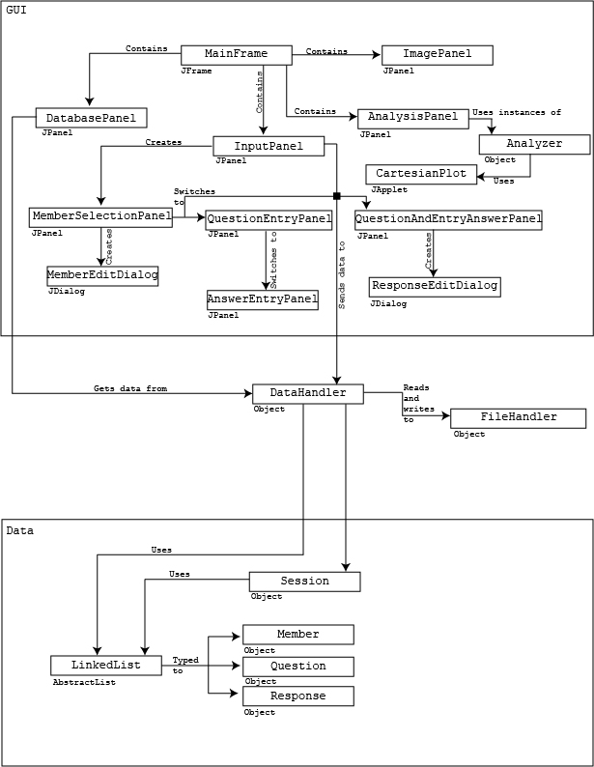

# Sequence diagrams

Sequence diagrams are diagrams which lay out the execution of various methods in a diagram. They show, more or less in chronological order, how the various classes will interact and through what methods.

### Benefits

Sequence diagrams help to lay out timing so that update calls do not occur too soon, especially if they are threaded. They help to prevent simultaneous editing, which can be disastrous. They also help to organize who is involved, but on a smaller level than the class diagrams. Another advantage is that these diagrams lay out the methods and functions required, giving deeper insight to which classes should have access to which other classes.

## Modify Member

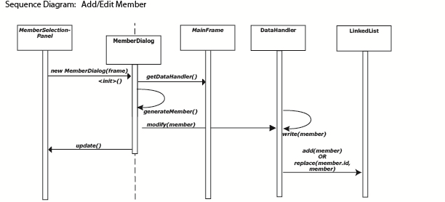

This sequence diagram shows the add member function that creates a new member and saves it to the hard drive. Most of the handling will be done through the MemberDialog class. I decided that shuffling data between the MemberSelectionPanel and the MemberDialog would be unnecessary and a waste of processor time and, as such, the MemberDialog handles the data interaction. Because MainFrame will be a singleton, there should be little trouble connecting to MainFrame. The member will be generated by MemberDialog with an id of -1 if an add is occurring. An edit would entail setting the id to the current id of the member.

### Deleting:

Deleting a member is trivial compared to this. It would be activated by a button press. Then, using the selected value on the members JList, a delete request would be sent to the DataHandler. That would then send out a removal request to the members LinkedList and a request to mark member.id for deletion.

## Modify Block

Much like with Add/Edit Member, Add/Edit Block doubles as both Add and Edit functions. The difference between Add and Edit functions is that the object passed into the function will have a positive id if edit is requested, and negative if add is requested. When calling writeBlock(), an edit request will call writeBlock(object.id, block) while an edit request will call writeBlock(getFreeID(), block). This will be determined either by using reflection to examine the id field of the object or by making both objects subclasses of an IDable interface. I have chosen this method to simplify my application. Because the add and edit functions would be essentially the same, I decided that I will simply combine them into one function and use an if/else statement to determine the type of call.

### Deleting:

To delete a block it will be nearly the same. Instead of writing a block with data, a block with only deletion markers will be used and passed in as the parameter to writeBlock(). This block will be statically accessed. I will later assess whether deletion should be marked by a flag or if a totally separate function should exist for it.

## Add Response

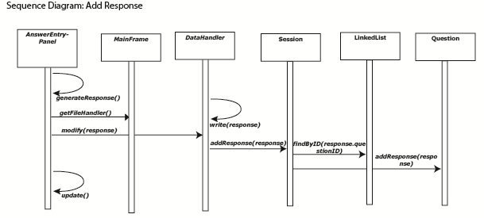

Adding a response is similar to modifying a member, except that it will be done through the panel itself, not through a popup. Editing a response will be done through a popup, making it essentially the same as modifying a member. This will make updating much easier. The algorithm for this is the same for the QuestionAndAnswerEntryPanel, even though only AnswerEntryPanel is listed. As with members, deletion will be done through a button. One interesting thing to note about responses is that the responses are not actually stored in a list. They are stored within the Questions, which means that the question list must be searched for the appropriate question first.

## Add Question

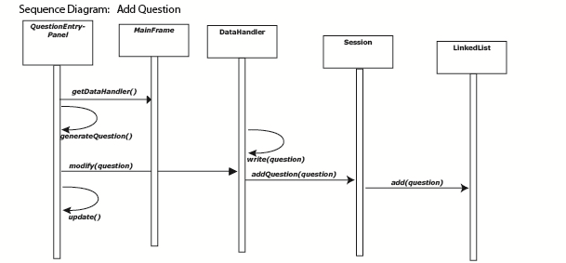

To add a question, the application collects the appropriate data and sends it to the DataHandler, much like Add Response. The algorithm for Add Question is the same in QuestionAndAnswerEntryPanel as it is in QuestionEntryPanel, with the only difference being how generateQuestion() is performed. Deleting or modifying a question would have essentially the same algorithm as adding a question, except that the modification may be handled from a popup, as in Add/Edit Member.

## Run Analysis

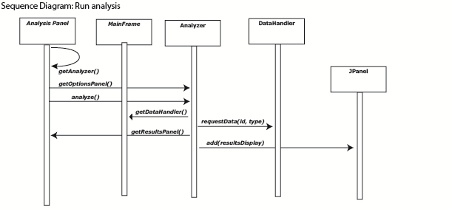

The Run Analysis function is designed to work for any generic analysis. It depends on an Analyzer interface. All analyses will have an Analyzer associated with it. These Analyzers will be held as static final variables in the AnalysisPanel. When the user selects their analysis method from the AnalysisPanel, each option in the ComboBox will correspond to one of these Analyzers. The analyzer will provide a JPanel that provides the desired settings for the analysis. For example, a performance analyzer may want to know which member is being analyzed. Once a submit button is pressed, the analyze() method will be called and the analyzer will use its copy of the options inputs to determine how to run the analysis. The analyzer will then access the needed data, run the analysis. Finally, it will request the results panel from the AnalysisPanel so that it can display the results.

Handling errors

# Handling Errors

Handling errors is very important. An error is usually severe and full information providing the solution to the error must be provided to the user, through the console, log files, or otherwise. My application overrides System.*err* to handle uncaught or unexpected errors in three ways:

1. *Print* the error information to the console
2. *Write* the error information to a log file
3. *Display* the error information in a pop-up, with a notice telling the user to send the information to the developer.

Here’s how I do it:

//reassign error stream

System.setErr(**new** PrintStream(f)

{

PrintStream oldErr = System.err;

JFrame frame;

JTextArea err = **new** JTextArea();

**public** **void** init()

{

**...**

}

@Override

**public** **void** println(Object x)

{

**this**.println(String.*valueOf*(x));

}

@Override

**public** **void** println(String x)

{

//write to file

**super**.println(x);

//write to console

**this**.oldErr.println(x);

//verify frame

**if** (**this**.frame == **null**)

**this**.init();

//print to frame

String txt = **this**.err.getText();

**if** (txt.length() != 0)

txt += "\n";

**this**.err.setText(txt + x);

**if** (!**this**.frame.isVisible())

{

**this**.frame.setVisible(**true**);

//display warning notification and instructions

**new** Thread(**new** Runnable()

{

**public** **void** run()

{

JOptionPane.*showMessageDialog*(

MainFrame.*getInstance*(),

"The application has encountered a serious error. Please copy and paste this stack trace and send to the developer.",

"ERROR!", JOptionPane.*ERROR_MESSAGE*);

}

}).start();

}

}

});

This will display any unexpected errors and provide multiple options for the user to report them back to me.

All checked exceptions are surrounded with try/catch blocks or thrown so that they can be handled higher up the stack trace.

For some very severe errors, the application will automatically exit to prevent any hanging threads, for example, in MainFrame.java:

**try**

{

**this**.dataHandler = **new** DataHandler();

}

**catch** (IOException e)

{

e.printStackTrace();

System.*exit*(2);

}

# Handling Potential Problems

Handling potential problems is achieved by first identifying where these problems may exist, then providing a solution. For example, in my MemberDialog, which allows the user to edit and add members, I ensure that the age of a Member is legal. I do this in two ways: handling any potential errors when modifying the member and ensuring that the age is not negative or greater than 127 (maximum byte value)

I prevent the user from entering a value to big or not using numbers by verifying input first: (MemberDialog.java)

**this**.ageField.addKeyListener(**new** KeyListener()

{

**public** **void** keyTyped(KeyEvent e)

{

**switch** (e.getKeyChar())

{

**case** '0': **case** '1': **case** '2': **case** '3': **case** '4':

**case** '5': **case** '6': **case** '7': **case** '8': **case** '9':

**break**;

**default**:

e.consume();

**return**;

}

**if** (Short.*valueOf*(MemberDialog.**this**.ageField.getText()

+ e.getKeyChar()) > Byte.*MAX_VALUE*)

e.consume();

}

}

I also handle errors when modifying the member with a try/catch statement. This defaults the age to zero if the user manages to enter something strange: (MemberDialog.java)

**try**{

MemberDialog.**this**.member.age = Byte

.*valueOf*(MemberDialog.**this**.ageField.getText());

} **catch** (Exception ex){

MemberDialog.**this**.member.age = 0;

}

Button groups are used frequently to ensure that users only select one radio button. For example, in QuestionEditDialog.java:

// Create button group

ButtonGroup group = **new** ButtonGroup();

group.add(**this**.artButton);

group.add(**this**.historyButton);

group.add(**this**.literatureButton);

group.add(**this**.musicButton);

group.add(**this**.otherButton);

group.add(**this**.popularCultureButton);

group.add(**this**.scienceButton);

Whenever I use a switch statement that covers all possible values, I always add in a default clause in case something happens. These will be caught by my unexpected error handling, and will prevent more severe errors, such as corrupt data in a file. For example, in PerformanceGraph.java:

**default**:

**throw** **new** UnknownError(

"Somehow passed point that should not be passed");

QuestionEditDialog.java:

**default**:

**throw** **new** RuntimeException("Question type " + q.t

+ " outside of known types");

ResponseEditDialog.java:

**default**:

**throw** **new** RuntimeException("Points " + **this**.r.pointsEarned

+ " for response " + **this**.r + " is invalid");

When deleting blocks, I remove all references to that block, both in memory and in storage. For example, in DataHanler.java, for deleting a question:

**if** (q.responder1 == block)

{

**if** (q.responder2 == **null**)

{

**this**.delete(q);

**continue**;

}

q.responder1 = **null**;

q.answer1 = **null**;

**this**.delete(q.answer1);

}

**if** (q.responder2 == block)

{

q.responder2 = **null**;

q.answer2 = **null**;

**this**.delete(q.answer2);

}

**this**.write(q);

This prevents null references.

In DataHandler.java, when initializing the member cache, I create an empty cache if there is an IOException:

// load member cache

**try**

{

**this**.memberCache = **this**.mfh.loadAllMembers();

}

**catch** (Exception ex)

{

ex.printStackTrace();

//error, initialize memberCache as empty list to avoid NPE

**this**.memberCache = **new** LinkedList<Member>();

}

To prevent FileNotFoundException, I verify that a file exists. If it doesn’t, I make it. In AbstractFileHandler.java:

**if** (!file.exists())

{

file.getParentFile().mkdirs();

file.createNewFile();

}

To prevent raf from being initialized twice in AbstractFileHandler, I verify that it hasn’t been initialized:

**if** (**this**.raf != **null**)

**throw** **new** UnsupportedOperationException(

"raf has already been initialized");

When reading in from the file, the AbstractFileHandler fills the remaining slots to ensure no runtime errors:

**try**

{

**while** (buf.append(**this**.raf.readChar()).length() < length)

;

}

**catch** (EOFException ex)

{

//Reached end of file. Make sure we have enough space

buf.ensureCapacity(length);

}

To prevent the AbstractFileHandler from reading a deleted field, a check is done to verify if the field is use before returning it:

// Read the value of the block at the location

value = **this**.read(pos, blockSize / 2);

//verify that the block exists and is not deleted

**if** (value.length() == 0 || value.charAt(0) == *DELETION_MARKER*)

**return** **null**;

// Convert the String to a Block and return it

**return** **this**.stringToBlock(id, value);

To ensure that users select enough members in TeamAnalyzer.java, I verify that they have selected at least 3 members:

**if** (TeamAnalyzer.**this**.members.getSelectedValues().length < 3)

{

JOptionPane.*showMessageDialog*(

TeamAnalyzer.**this**.this$0,

"You should select at least "

+ (3 - TeamAnalyzer.**this**.members

.getSelectedValues().length)

+ " more members.", "Not Enough Members!",

JOptionPane.*WARNING_MESSAGE*);

**return**;

}

To prevent multiple instances of the classes MainFrame and Session, I set them up as singleton classes. This means that their constructors are private and an instance is obtained via getInstance(). For example, in Session.java:

**public** **static** Session getInstance()

{

**if** (*session* == **null**)

*read*();

**if** (*session* == **null**)

**return** **new** Session();

**return** *session*;

}

The only constructor for Session, in Session.java, has private access:

**private** Session()

{

...

}

To verify that no other instances exist, the first thing done in the constructor is to verify that the instance being constructed is the only known instance:

// verify that no other instances exist

**if** (*session* != **null**)

**throw** **new** UnsupportedOperationException();

Immediately followed by registering **this** as the only known instance:

// ensure that no other copies can exist

*session* = **this**;

The only way to create a second instance of Session would be to use reflection to set *session* to **null** via reflection.

To prevent a corrupt Session file, the file is automatically deleted if there is an error, in Session.java:

**catch** (Exception e)

{

f.delete();

e.printStackTrace();

}

If several lines of code depend on each other, but one line is error prone, the lines will be kept in the same try block to prevent blank blocks from being written or dialogs from closing, even if there’s an error. For example, in QuestionEditDialog.java, I ensure that the lists have been updated before closing the dialog:

**try**

{

...

QuestionEditDialog.**this**.owner

.getClass()

.getMethod("updateLists", **new** Class[0])

.invoke(QuestionEditDialog.**this**.owner,

**new** Object[0]);

QuestionEditDialog.**this**.dispose();

}

To prevent blocks of an inappropriate size from being saved, I devised a method (used in Member.java, Question.java, and Response.java) which lengthens a character array to the appropriate length, filling it with spaces, or copies only a portion of the array, truncating the remainder:

**private** **static** **void** arraycopy(**char**[] src, **int** srcPos, **char**[] dest,

**int** destPos, **int** length)

{

**if** (src.length < length)

{

**char**[] newSrc = **new** **char**[length];

System.*arraycopy*(src, 0, newSrc, 0, src.length);

**for** (**int** i = src.length; i < length; i++)

newSrc[i] = ' ';

src = newSrc;

}

System.*arraycopy*(src, srcPos, dest, destPos, length);

}

To prevent small changes in constants like block sizes and file directories from not changing in other places, I stored all constants in the same place, Constants.java, and these constants are used as much as possible:

**public** **interface** Constants

{

...

}

Their use is certainly abundant. For example, in Member#getBlockSize():

**public** **int** getBlockSize()

{

**return** *MEMBER_BLOCK_SIZE* * *CHAR_SIZE*;

}

Question#getContents() references constants about 20 times in 24 lines.

To prevent a FileNotFoundException, a file is always created before initializing the RandomAccessFile, in RandomAcessFileHandler.java:

**protected** **final** **void** init() **throws** IOException

{

...

File file = **this**.getFile();

**if** (!file.exists())

{

file.getParentFile().mkdirs();

file.createNewFile();

}

**this**.raf = **new** RandomAccessFile(file, "rw");

}

Frequently found in CartesianPlot.java is concurrent modification prevention, in order to prevent values from changing during painting. If another class attempts to modify the plot’s data, it will run the following code:

**if** (**this**.isGraphPainting)

**throw** **new** ConcurrentModificationException("Graph is painting.");

The paint method gets a lock whenever it is run, and the instructions above verify that the lock is open. Here is how and when the lock is obtained, in CartesianPlot#paint(Graphics):

**public** **void** paint(Graphics g)

{

// get lock

**this**.isGraphPainting = **true**;

... // paint graph

// close lock

**this**.isGraphPainting = **false**;

}

Code listing

## AbstractFileHandler.java

package data.io;

import java.io.EOFException;

import java.io.File;

import java.io.FileNotFoundException;

import java.io.IOException;

import java.io.RandomAccessFile;

import data.Constants;

import data.DataHandler;

import data.container.Session;

import data.type.Block;

/**

* Superclass of all file handlers in this application, aside from

* {@link Session}, which is handled differently.

*

* This superclass handles writing, deleting, reading, finding, and ID

* assigning. The method {@link #init()} <b>must</b> be called. Failure to do so

* will result in a NullPointerException.

*

* @author Ryan Amos

*

* @see DataHandler

* @see Session

*/

public abstract class AbstractFileHandler implements Constants

{

protected RandomAccessFile raf;

public static final char DELETION_MARKER = '#';

protected abstract File getFile();

protected abstract Block stringToBlock(int id, String s);

/**

* Initializes the AbstractFileHandler. Subclasses should throw

* FileNotFoundException in initialization. If the AbstractFileHandler

* doesn't initialize, the subclass is toast and should not be allowed to

* initialize.

*

* @throws FileNotFoundException

*/

protected final void init() throws IOException

{

if (this.raf != null)

throw new UnsupportedOperationException(

"raf has already been initialized");

File file = this.getFile();

if (!file.exists())

{

file.getParentFile().mkdirs();

file.createNewFile();

}

this.raf = new RandomAccessFile(file, "rw");

}

/**

* Writes a block to the file.

*

* @param block

* The block to write to the file. If the block ID is -1, an ID

* is assigned. This is used for adding blocks. If the ID is not

* -1, then the writer writes at the relevant position.

* @throws IOException

* When the write failed. See the exception for details.

*/

public void writeBlock(Block block) throws IOException

{

int id;

long pos;

// check if "add" or "edit" is requested.

if (block.getID() == -1)

// assign an ID

block.setID(this.findNextAvailableID(block.getBlockSize()));

// get the ID so the writer knows where to write

id = block.getID();

// find the position to write to

pos = (long) id * block.getBlockSize();

// call the write() function to initialize writing

this.writeString(block.getContents(), pos);

}

/**

* Writes a string to the given position

*

* @param str

* The string to be written, intended to be

* {@code block.getContents()}

* @param pos

* The position to write to

* @throws IOException

* When raf encouters a problem

*/

protected void writeString(String str, long pos) throws IOException

{

// Move the pointer to the desired location

this.raf.seek(pos);

// iterate through the string

for (char c : str.toCharArray())

this.raf.writeChar(c); // write each character

}

/**

* Finds the next possible location for insertion.

*

* @param blockSize

* () The number of characters in the block.

* @return The ID of thenext deleted block or the end of the file if there

* are none.

* @throws IOException

* When raf has a problem.

*/

private int findNextAvailableID(int blockSize) throws IOException

{

long pos;

// Account for character size in block size

// iterate through all the blocks

for (pos = 0; pos < this.raf.length(); pos += blockSize)

{

// move to the given position

this.raf.seek(pos);

// read a character

if (this.raf.readChar() == DELETION_MARKER)

// if the character is the deletion marker, the block is free

return (int) (pos / blockSize);

}

// no deleted blocks, so return the end block

return (int) (pos / blockSize);

}

/**

* Deletes a given block.

*

* @param block

* The block to be deleted

* @throws IOException

* When the file handler encounters a problem. See the exception

* for details.

*/

public void delete(Block block) throws IOException

{

long pos;

// Calculate the start position of the block

pos = block.getID() * block.getBlockSize();

// Seek to the block

this.raf.seek(pos);

// Mark the block for deletion by writing a

// deletion marker to the first slot

this.raf.writeChar(DELETION_MARKER);

}

/**

* Finds the unique block corresponding to the unique ID given.

*

* @param id

* The ID of the block

* @param blockSize

* The size of each block in the file. Should be a constant.

* @return The block with the unique ID given.

* @throws IOException

* When file reading fails. See exception for details.

*/

public Block find(int id, int blockSize) throws IOException

{

long pos;

String value;

// Calculate the position of the desired block

pos = (long) id * blockSize;

if (pos > this.raf.length())

return null;

// Read the value of the block at the location

value = this.read(pos, blockSize / 2);

// verify that the block exists and is not deleted

if (value.length() == 0 || value.charAt(0) == DELETION_MARKER)

return null;

// Convert the String to a Block and return it

return this.stringToBlock(id, value);

}

/**

* Reads from the file for a given length. Usually, the provided length is

* the length of the block to be read.

*

* @param pos

* The offset from the start of the file

* @param length

* The length to read in

* @return The String of the desired length at the desired offset. Usually a

* block.

* @throws IOException

* When raf has a problem

*/

protected String read(long pos, int length) throws IOException

{

StringBuffer buf;

buf = new StringBuffer();

// Seek to the desired position.

this.raf.seek(pos);

// Read in the block. Stop when the block is of the desired length

try

{

while (buf.append(this.raf.readChar()).length() < length)

;

}

catch (EOFException ex)

{

// Reached end of file. Make sure we have enough space

buf.ensureCapacity(length);

}

// Return the block's String value.

return buf.toString();

}

public final void close()

{

try

{

this.raf.close();

}

catch (IOException e)

{

e.printStackTrace();

}

}

}

## Analysis Panel

package gui.analysis;

import java.awt.BorderLayout;

import java.awt.Dimension;

import java.awt.FlowLayout;

import java.awt.Rectangle;

import java.awt.event.ItemEvent;

import java.awt.event.ItemListener;

import javax.swing.JComboBox;

import javax.swing.JComponent;

import javax.swing.JLabel;

import javax.swing.JPanel;

import javax.swing.border.EtchedBorder;

import analyzer.Type;

import analyzer.util.Analyzer;

import analyzer.util.ResultFoundListener;

public class AnalysisPanel extends JPanel

{

private static final long serialVersionUID = 1L;

private JComboBox analysisTypeComboBox = null;

private JLabel viewAnalysisLabel = null;

private JPanel parametersPanel = null;

private JPanel analysisPanel = null;

private static AnalysisPanel instance;

public static Dimension getDim()

{

return instance.getSize();

}

/**

* Default instance of ResultFoundListener

*/

private final ResultFoundListener rfl = new ResultFoundListener()

{

public void resultFound(JComponent result)

{

AnalysisPanel.this.analysisPanel.removeAll();

AnalysisPanel.this.analysisPanel.add(result);

AnalysisPanel.this.analysisPanel.validate();

AnalysisPanel.this.analysisPanel.repaint();

AnalysisPanel.this.parametersPanel.validate();

AnalysisPanel.this.parametersPanel.repaint();

}

};

/**

* This is the default constructor

*/

public AnalysisPanel()

{

super();

instance = this;

this.initialize();

}

/**

* This method initializes this

*

*/

private void initialize()

{

this.viewAnalysisLabel = new JLabel();

this.viewAnalysisLabel.setBounds(new Rectangle(386, 30, 92, 16));

this.viewAnalysisLabel.setText("View analysis:");

this.setSize(554, 404);

this.setLayout(null);

this.add(this.getAnalysisTypeComboBox(), null);

this.add(this.viewAnalysisLabel, null);

this.add(this.getParametersPanel(), null);

this.add(this.getAnalysisPanel(), null);

}

/**

* This method initializes analysisTypeComboBox

*

* @return javax.swing.JComboBox

*/

private JComboBox getAnalysisTypeComboBox()

{

if (this.analysisTypeComboBox == null)

{

this.analysisTypeComboBox = new JComboBox(Type.values());

this.analysisTypeComboBox

.setBounds(new Rectangle(384, 50, 160, 23));

this.analysisTypeComboBox.addItemListener(new ItemListener()

{

public void itemStateChanged(ItemEvent e)

{

AnalysisPanel.this.parametersPanel.removeAll();

Analyzer analyzer = ((Type) AnalysisPanel.this.analysisTypeComboBox

.getSelectedItem()).getAnalyzer();

AnalysisPanel.this.parametersPanel.add(analyzer

.getOptionsPanel(AnalysisPanel.this.rfl));

AnalysisPanel.this.parametersPanel.validate();

}

});

}

return this.analysisTypeComboBox;

}

/**

* This method initializes parametersPanel

*

* @return javax.swing.JPanel

*/

private JPanel getParametersPanel()

{

if (this.parametersPanel == null)

{

this.parametersPanel = ((Type) this.getAnalysisTypeComboBox()

.getSelectedItem()).getAnalyzer().getOptionsPanel(this.rfl);

this.parametersPanel.setLayout(new FlowLayout());

this.parametersPanel.setBounds(new Rectangle(382, 82, 300, 285));

this.parametersPanel.setBorder(new EtchedBorder());

}

return this.parametersPanel;

}

/**

* This method initializes analysisPanel

*

* @return javax.swing.JPanel

*/

private JPanel getAnalysisPanel()

{

if (this.analysisPanel == null)

{

this.analysisPanel = new JPanel();

this.analysisPanel.setLayout(new BorderLayout());

this.analysisPanel.setBounds(new Rectangle(8, 32, 357, 357));

this.analysisPanel.add(new JPanel());

this.analysisPanel.setBorder(new EtchedBorder());

}

return this.analysisPanel;

}

} // @jve:decl-index=0:visual-constraint="10,10"

## Analyzer.java

package analyzer.util;

import gui.analysis.AnalysisPanel;

import javax.swing.JPanel;

import analyzer.Type;

/**

* Used to analyze data. Data is found after options are selected. This class

* handles the options.

* {@link ResultFoundListener#resultFound(javax.swing.JComponent)} is then

* called.

*

* @see AnalysisPanel

* @see Type

* @author Ryan Amos

*/

public interface Analyzer

{

/**

* Please note:

* {@link ResultFoundListener#resultFound(javax.swing.JComponent)} may be

* called before this method returns.

*

* @param rfl

* The {@link ResultFoundListener} to act when the result is

* found.

* @return The panel for the option

*/

public JPanel getOptionsPanel(ResultFoundListener rfl);

}

## AnswerEntryPanel.java

package gui.input;

import gui.input.dialog.ResponseEditDialog;

import gui.util.FinishListener;

import java.awt.Rectangle;

import java.awt.event.ActionEvent;

import java.awt.event.ActionListener;

import java.util.Stack;

import javax.swing.BorderFactory;

import javax.swing.ButtonGroup;

import javax.swing.JButton;

import javax.swing.JLabel;

import javax.swing.JList;

import javax.swing.JOptionPane;

import javax.swing.JPanel;

import javax.swing.JRadioButton;

import javax.swing.JScrollPane;

import javax.swing.JTextField;

import javax.swing.border.BevelBorder;

import data.Constants;

import data.container.Session;

import data.type.Member;

import data.type.Question;

import data.type.Response;

public class AnswerEntryPanel extends JPanel

{

private static final long serialVersionUID = 1L;

private JLabel questionsLabel = null;

private JScrollPane questionsScrollPane = null;

private JList questionList = null;

private JScrollPane participantsScrollPane = null;

private JList participantList = null;

private JLabel participantsLabel = null;

private JLabel responsesLabel = null;

private JScrollPane responseScrollPane = null;

private JList responseList = null;

private JButton removeButton = null;

private JLabel responseLabel = null;

private JTextField responseTextField = null;

private JLabel pointsEarnedLabel = null;

private JRadioButton negFiveButton = null;

private JRadioButton zeroButton = null;

private JRadioButton tenButton = null;

private JRadioButton fifteenButton = null;

private JPanel addResponsePanel = null;

private JButton addButton = null;

private JButton finishButton = null;

private JLabel addResponseLabel = null;

private Stack<FinishListener> listeners;

private AnswerEntryPanel this$0;

private ButtonGroup points = new ButtonGroup();

private JButton editButton;

/**

* This is the default constructor

*/

public AnswerEntryPanel()

{

super();

this.this$0 = this;

this.initialize();

this.updateLists();

this.points.add(this.negFiveButton);

this.points.add(this.zeroButton);

this.points.add(this.tenButton);

this.points.add(this.fifteenButton);

}

/**

* This method initializes this

*/

private void initialize()

{

this.pointsEarnedLabel = new JLabel();

this.pointsEarnedLabel.setText("Points earned:");

this.pointsEarnedLabel.setBounds(new Rectangle(9, 41, 88, 16));

this.responseLabel = new JLabel();

this.responseLabel.setText("Response:");

this.responseLabel.setBounds(new Rectangle(5, 15, 60, 16));

this.responsesLabel = new JLabel();

this.responsesLabel.setBounds(new Rectangle(536, 24, 76, 16));

this.responsesLabel.setText("Responses:");

this.participantsLabel = new JLabel();

this.participantsLabel.setBounds(new Rectangle(268, 19, 80, 16));

this.participantsLabel.setText("Participants:");

this.questionsLabel = new JLabel();

this.questionsLabel.setText("Questions:");

this.questionsLabel.setBounds(new Rectangle(21, 16, 70, 16));

this.setSize(714, 444);

this.setLayout(null);

this.add(this.questionsLabel, null);

this.add(this.getQuestionsScrollPane(), null);

this.add(this.getParticipantsScrollPane(), null);

this.add(this.participantsLabel, null);

this.add(this.responsesLabel, null);

this.add(this.getResponseScrollPane(), null);

this.add(this.getRemoveButton(), null);

this.add(this.getAddResponsePanel(), null);

this.add(this.getFinishButton(), null);

this.add(this.addResponseLabel, null);

this.add(this.getEditButton(), null);

}

/**

* This method initializes questionsScrollPane

*

* @return javax.swing.JScrollPane

*/

private JScrollPane getQuestionsScrollPane()

{

if (this.questionsScrollPane == null)

{

this.questionsScrollPane = new JScrollPane();

this.questionsScrollPane.setBounds(new Rectangle(19, 44, 235, 387));

this.questionsScrollPane.setViewportView(this.getQuestionList());

}

return this.questionsScrollPane;

}

/**

* This method initializes questionList

*

* @return javax.swing.JList

*/

private JList getQuestionList()

{

if (this.questionList == null)

this.questionList = new JList(Session.getInstance().getQuestions()

.toArray(new Question[0]));

return this.questionList;

}

/**

* This method initializes participantsScrollPane

*

* @return javax.swing.JScrollPane

*/

private JScrollPane getParticipantsScrollPane()

{

if (this.participantsScrollPane == null)

{

this.participantsScrollPane = new JScrollPane();

this.participantsScrollPane.setBounds(new Rectangle(267, 45, 259,

383));

this.participantsScrollPane.setViewportView(this

.getParticipantList());

}

return this.participantsScrollPane;

}

/**

* This method initializes participantList

*

* @return javax.swing.JList

*/

private JList getParticipantList()

{

if (this.participantList == null)

this.participantList = new JList(Session.getInstance()

.getParticipants().toArray(new Member[0]));

return this.participantList;

}

/**

* This method initializes responseScrollPane

*

* @return javax.swing.JScrollPane

*/

private JScrollPane getResponseScrollPane()

{

if (this.responseScrollPane == null)

{

this.responseScrollPane = new JScrollPane();

this.responseScrollPane.setBounds(new Rectangle(536, 44, 169, 169));

this.responseScrollPane.setViewportView(this.getResponseList());

}

return this.responseScrollPane;

}

/**

* This method initializes responseList

*

* @return javax.swing.JList

*/

private JList getResponseList()

{

if (this.responseList == null)

this.responseList = new JList(Session.getInstance().getResponses()

.toArray(new Response[0]));

return this.responseList;

}

/**

* This method initializes removeButton

*

* @return javax.swing.JButton

*/

private JButton getRemoveButton()

{

if (this.removeButton == null)

{

this.removeButton = new JButton();

this.removeButton.setBounds(new Rectangle(540, 218, 87, 23));

this.removeButton.setText("Remove");

this.removeButton.addActionListener(new ActionListener()

{

public void actionPerformed(ActionEvent e)

{

if (AnswerEntryPanel.this.responseList.getSelectedValue() == null)

{

JOptionPane.showMessageDialog(

AnswerEntryPanel.this.this$0,

"You must select a member to remove.",

"Select a member", JOptionPane.WARNING_MESSAGE);

return;

}

Session.getInstance()

.getResponses()

.remove((Response) AnswerEntryPanel.this.responseList

.getSelectedValue());

AnswerEntryPanel.this.updateLists();

Session.backup();

}

});

}

return this.removeButton;

}

private JButton getEditButton()

{

if (this.editButton == null)

{

this.editButton = new JButton();

this.editButton.setBounds(new Rectangle(650, 218, 60, 23));

this.editButton.setText("Edit");

this.editButton.addActionListener(new ActionListener()

{

public void actionPerformed(ActionEvent e)

{

if (AnswerEntryPanel.this.responseList.getSelectedValue() == null)

{

JOptionPane.showMessageDialog(

AnswerEntryPanel.this.this$0,

"You must select a member to edit.",

"Select a member", JOptionPane.WARNING_MESSAGE);

return;

}

new ResponseEditDialog(AnswerEntryPanel.this.this$0,

(Response) AnswerEntryPanel.this.responseList

.getSelectedValue());

Session.backup();

}

});

}

return this.editButton;

}

/**

* This method initializes responseTextField

*

* @return javax.swing.JTextField

*/

private JTextField getResponseTextField()

{

if (this.responseTextField == null)

{

this.responseTextField = new JTextField(

Constants.RESPONSE_BLOCK_VALUE_SIZE);

this.responseTextField.setBounds(new Rectangle(73, 13, 95, 21));

}

return this.responseTextField;

}

/**

* This method initializes negFiveButton

*

* @return javax.swing.JRadioButton

*/

private JRadioButton getNegFiveButton()

{

if (this.negFiveButton == null)

{

this.negFiveButton = new JRadioButton();

this.negFiveButton.setText("-5");

this.negFiveButton.setBounds(new Rectangle(7, 63, 37, 21));

}

return this.negFiveButton;

}

/**

* This method initializes zeroButton

*

* @return javax.swing.JRadioButton

*/

private JRadioButton getZeroButton()

{

if (this.zeroButton == null)

{

this.zeroButton = new JRadioButton();

this.zeroButton.setText("0");

this.zeroButton.setBounds(new Rectangle(41, 61, 32, 24));

}

return this.zeroButton;

}

/**

* This method initializes tenButton

*

* @return javax.swing.JRadioButton

*/

private JRadioButton getTenButton()

{

if (this.tenButton == null)

{

this.tenButton = new JRadioButton();

this.tenButton.setText("10");

this.tenButton.setBounds(new Rectangle(73, 63, 41, 21));

}

return this.tenButton;

}

/**

* This method initializes fifteenButton

*

* @return javax.swing.JRadioButton

*/

private JRadioButton getFifteenButton()

{

if (this.fifteenButton == null)

{

this.fifteenButton = new JRadioButton();

this.fifteenButton.setText("15");

this.fifteenButton.setBounds(new Rectangle(113, 61, 39, 24));

}

return this.fifteenButton;

}

/**

* This method initializes addResponsePanel

*

* @return javax.swing.JPanel

*/

private JPanel getAddResponsePanel()

{

if (this.addResponsePanel == null)

{

this.addResponseLabel = new JLabel();

this.addResponseLabel.setText("Add Response:");

this.addResponseLabel.setBounds(new Rectangle(531, 255, 102, 16));

this.addResponsePanel = new JPanel();

this.addResponsePanel.setLayout(null);

this.addResponsePanel.setBounds(new Rectangle(530, 278, 177, 121));

this.addResponsePanel.setBorder(BorderFactory

.createBevelBorder(BevelBorder.RAISED));

this.addResponsePanel.add(this.responseLabel, null);

this.addResponsePanel.add(this.getResponseTextField(), null);

this.addResponsePanel.add(this.pointsEarnedLabel, null);

this.addResponsePanel.add(this.getNegFiveButton(), null);

this.addResponsePanel.add(this.getZeroButton(), null);

this.addResponsePanel.add(this.getTenButton(), null);

this.addResponsePanel.add(this.getFifteenButton(), null);

this.addResponsePanel.add(this.getAddButton(), null);

}

return this.addResponsePanel;

}

/**

* This method initializes addButton

*

* @return javax.swing.JButton

*/

private JButton getAddButton()

{

if (this.addButton == null)

{

this.addButton = new JButton();

this.addButton.setBounds(new Rectangle(91, 88, 79, 23));

this.addButton.setText("Add");

this.addButton.addActionListener(new ActionListener()

{

public void actionPerformed(ActionEvent e)

{

Response r = new Response();

Member m = (Member) AnswerEntryPanel.this.participantList

.getSelectedValue();

Question q = (Question) AnswerEntryPanel.this.questionList

.getSelectedValue();

r.question = q;

r.date = System.currentTimeMillis();

if (q.answer1 == null)

{

q.answer1 = r;

q.responder1 = m;

}

else if (q.answer2 == null)

{

q.answer2 = r;

q.responder2 = m;

}

else

JOptionPane

.showMessageDialog(

AnswerEntryPanel.this,

"Warning: this question already has two responses.",

"Too Many Responses",

JOptionPane.WARNING_MESSAGE);

r.value = AnswerEntryPanel.this.responseTextField.getText();

if (AnswerEntryPanel.this.negFiveButton.isSelected())

r.pointsEarned = -5;

else if (AnswerEntryPanel.this.zeroButton.isSelected())

r.pointsEarned = 0;

else if (AnswerEntryPanel.this.tenButton.isSelected())

r.pointsEarned = 10;

else if (AnswerEntryPanel.this.fifteenButton.isSelected())

r.pointsEarned = 15;

Session.getInstance().addResponse(r);

AnswerEntryPanel.this.updateLists();

Session.backup();

}

});

}

return this.addButton;

}

/**

* This method initializes finishButton

*

* @return javax.swing.JButton

*/

private JButton getFinishButton()

{

if (this.finishButton == null)

{

this.finishButton = new JButton();

this.finishButton.setBounds(new Rectangle(627, 403, 73, 29));

this.finishButton.setText("Finish");

this.finishButton.addActionListener(new ActionListener()

{

public void actionPerformed(ActionEvent e)

{

if (AnswerEntryPanel.this.listeners != null)

{

while (AnswerEntryPanel.this.listeners.size() > 0)

AnswerEntryPanel.this.listeners.pop().finished(

AnswerEntryPanel.this.this$0);

AnswerEntryPanel.this.listeners = null;

}

}

});

}

return this.finishButton;

}

public void addFinishListener(FinishListener l)

{

if (this.listeners == null)

this.listeners = new Stack<FinishListener>();

this.listeners.push(l);

}

public void updateLists()

{

this.questionList.setListData(Session.getInstance().getQuestions()

.toArray(new Question[0]));

this.responseList.setListData(Session.getInstance().getResponses()

.toArray(new Response[0]));

this.participantList.setListData(Session.getInstance()

.getParticipants().toArray(new Member[0]));

}

} // @jve:decl-index=0:visual-constraint="10,10"

## Block.java

package data.type;

import data.Constants;

import data.io.AbstractFileHandler;

/**

* Represents a block that can be stored by an {@link AbstractFileHandler}

* subclass

*

* @author Ryan Amos

*/

public interface Block extends Constants

{

public int getBlockSize();

public int getID();

public void setID(int id);

public String getContents();

}

## CartesianPlot.java

package analyzer.util;

import java.awt.Color;

import java.awt.FontMetrics;

import java.awt.Graphics;

import java.awt.Point;

import java.awt.image.BufferedImage;

import java.util.ConcurrentModificationException;

import javax.swing.JComponent;

/**

* Creates a Cartesian (x,y) plot. Auto-scales to fit the range of the data.

* Note: setters will throw {@link ConcurrentModificationException} if accessed

* while painting.

*

* @author Ryan Amos

*/

public class CartesianPlot extends JComponent

{

private double[] x;

private double[] y;

private double xMin, xMax, yMin, yMax;

private double xRange, yRange;

private int xDensity, yDensity;

private TickGenerator tg;

// cached values

private boolean isGraphPainting = false;

private double xScale;

private double yScale;

private Point origin; // prescaled

private int w;

private int h;

private int xBuffer = 40, xTBuffer = 2 * this.xBuffer;

private int yBuffer = 40, yTBuffer = 2 * this.yBuffer;

/**

* Initializes a {@code CartesianPlot}

*

* @param x

* The x coordinates of the points. Must be the same length as

* the y coordinates list and must be longer than 0.

* @param y

* The y coordinates of the points. Must be the same length as

* the x coordinates list and must be longer than 0.

* @param xDensity

* The density of ticks along the X axis

* @param yDensity

* The density of ticks along the Y axis

* @param generator

* The {@code TickGenerator} to name ticks.

* @see TickGenerator

*/

public CartesianPlot(double[] x, double[] y, int xDensity, int yDensity,

TickGenerator generator)

{

if (x.length != y.length || x.length == 0)

throw new IllegalArgumentException();

// save values

this.x = x.clone();

this.y = y.clone();

this.xDensity = xDensity;

this.yDensity = yDensity;

this.tg = generator;

this.precomputeData();

}

/**

* Initialize the values for: xMin, xMax, yMin, yMax, xRange, yRange. These

* values are to be used later and are pre-computed for easier access.

*/

private void precomputeData()

{

// cache min/max values for x,y

this.xMin = this.x[0];

this.xMax = this.x[0];

this.yMin = this.y[0];

this.yMax = this.y[0];

for (int i = 1; i < this.y.length; i++)

{

this.xMax = Math.max(this.xMax, this.x[i]);

this.xMin = Math.min(this.xMin, this.x[i]);

this.yMax = Math.max(this.yMax, this.y[i]);

this.yMin = Math.min(this.yMin, this.y[i]);

}

// cache range

this.xRange = this.xMax - this.xMin;

this.yRange = this.yMax - this.yMin;

if (this.xRange == 0)

throw new UnsupportedOperationException("Range of x values is 0");

if (this.yRange == 0)

throw new UnsupportedOperationException("Range of y values is 0");

}

/**

* Paints the graph

*/

@Override

public void paint(Graphics g)

{

// get lock

this.isGraphPainting = true;

// create a double buffer

BufferedImage db = new BufferedImage(this.getWidth(), this.getHeight(),

BufferedImage.TYPE_INT_ARGB);

Graphics g2 = db.getGraphics();

g2.setColor(Color.BLACK);

// caches

this.initGraph();

// axes

this.drawAxes(g2);

// points

this.drawPoints(g2);

// render the buffer

g.clearRect(0, 0, this.getWidth(), this.getHeight());

g.drawImage(db, 0, 0, null);

g2.dispose();

// close lock

this.isGraphPainting = false;

}

/**

* Draws graph points

*/

private void drawPoints(Graphics g)

{

Point last = null;

for (int i = 0; i < this.x.length; i++)

{

Point p = this.graphToComponent(this.x[i], this.y[i]);

// draw connector, if any

if (last != null)

g.drawLine(last.x, last.y, p.x, p.y);

last = p;

// draw point

g.fillRect(p.x - 2, p.y - 2, 5, 5);

}

}

/**

* Initializes graph constants

*/

private void initGraph()

{

this.w = this.getWidth() - this.xTBuffer;

this.h = this.getHeight() - this.yTBuffer;

this.xScale = this.w / this.xRange;

this.yScale = this.h / this.yRange;

this.origin = new Point((int) (-this.xMin * this.xScale),

-(int) (this.yMin * this.yScale));

}

/**

* Draws the axes

*

* @param g

* The Graphics object to draw with

*/

private void drawAxes(Graphics g)

{

FontMetrics fm = g.getFontMetrics();

// XAxis

g.drawLine(0, this.yBuffer + this.h - (this.origin.y), this.getWidth(),

this.yBuffer + this.h - (this.origin.y));

// YAxis

g.drawLine(this.xBuffer + this.origin.x, 0, this.xBuffer

+ this.origin.x, this.getHeight());

double xJump = this.xRange / this.w * this.xDensity;

// X ticks

for (double i = this.xMin; i <= this.xMax + xJump; i += xJump)

{

Point p = this.graphToComponent(i, 0);

p.y = Math.max(p.y, 0);

p.y = Math.min(p.y, this.getHeight());

g.drawLine(p.x, p.y - 5, p.x, p.y + 5);

String s = this.tg.xToString(i);

if (p.y != this.getHeight())

g.drawString(s, p.x - fm.stringWidth(s) / 2,

p.y + 5 + fm.getHeight());

else

g.drawString(s, p.x - fm.stringWidth(s) / 2, p.y - 6);

}

double yJump = this.yRange / this.h * this.yDensity;

// Y ticks

for (double i = this.yMin; i <= this.yMax + yJump; i += yJump)

{

Point p = this.graphToComponent(0, i);

p.x = Math.max(p.x, 0);

p.x = Math.min(p.x, this.getWidth());

g.drawLine(p.x - 5, p.y, p.x + 5, p.y);

String s = this.tg.yToString(i);

if (p.x != 0)

g.drawString(s, p.x - fm.stringWidth(s) - 5,

p.y + fm.getHeight() / 4);

else

g.drawString(s, p.x + 5, p.y + fm.getHeight() / 4);

}

}

/**

* Converts a point on the graph to the point on the screen, including the

* buffer

*

* @param x

* The x coordinate on the graph

* @param y

* The y coordinate on the graph

* @return The Cartesian (x, y) point on the component, after including the

* buffer.

*/

private Point graphToComponent(double x, double y)

{

int compX = this.xBuffer + (int) (x * this.xScale) + this.origin.x;

int compY = this.yBuffer + (int) (this.h - y * this.yScale)

- this.origin.y;

return new Point(compX, compY);

}

public double[] getXValues()

{

return this.x.clone();

}

public void setXValues(double[] x)

{

if (this.isGraphPainting)

throw new ConcurrentModificationException("Graph is painting.");

this.x = x.clone();

this.precomputeData();

}

public double[] getYValues()

{

return this.y.clone();

}

public void setYValues(double[] y)

{

if (this.isGraphPainting)

throw new ConcurrentModificationException("Graph is painting.");

this.y = y.clone();

this.precomputeData();

}

public int getxDensity()

{

return this.xDensity;

}

public void setxDensity(int xDensity)

{

if (this.isGraphPainting)

throw new ConcurrentModificationException("Graph is painting.");

this.xDensity = xDensity;

}

public int getyDensity()

{

return this.yDensity;

}

public void setyDensity(int yDensity)

{

if (this.isGraphPainting)

throw new ConcurrentModificationException("Graph is painting.");

this.yDensity = yDensity;

}

public TickGenerator getTickGenerator()

{

return this.tg;

}

public void setTickGenerator(TickGenerator tg)

{

if (this.isGraphPainting)

throw new ConcurrentModificationException("Graph is painting.");

this.tg = tg;

}

public boolean isLocked()

{

return this.isGraphPainting;

}

/**

* Helps the plot generate ticks.

*

* @author Ryan Amos

*/

public static interface TickGenerator

{

public String xToString(double x);

public String yToString(double y);

}

}

## Combinations.java

package analyzer.util;

/**

* Located at:

* http://stackoverflow.com/questions/127704/algorithm-to-return-all-

* combinations-of-k-elements-from-n

*

* @author Sourabh Bhat (heySourabh@gmail.com)

*/

public class Combinations

{

public static int[][] getCombinations(int num, int outOf)

{

int possibilities = get_nCr(outOf, num);

int[][] combinations = new int[possibilities][num];

int arrayPointer = 0;

int[] counter = new int[num];

for (int i = 0; i < num; i++)

counter[i] = i;

breakLoop: while (true)

{

// Initializing part

for (int i = 1; i < num; i++)

if (counter[i] >= outOf - (num - 1 - i))

counter[i] = counter[i - 1] + 1;

// Testing part

for (int i = 0; i < num; i++)

if (counter[i] < outOf)

continue;

else

break breakLoop;

// Innermost part

combinations[arrayPointer] = counter.clone();

arrayPointer++;

// Incrementing part

counter[num - 1]++;

for (int i = num - 1; i >= 1; i--)

if (counter[i] >= outOf - (num - 1 - i))

counter[i - 1]++;

}

return combinations;

}

private static int get_nCr(int n, int r)

{

if (r > n)

throw new ArithmeticException("r is greater then n");

long numerator = 1;

long denominator = 1;

for (int i = n; i >= r + 1; i--)

numerator *= i;

for (int i = 2; i <= n - r; i++)

denominator *= i;

return (int) (numerator / denominator);

}

}

## Constants.java

package data;

import java.io.File;

/**

* Constant field values. Interface for easy access by implementing this

* interface.

*

* @author Ryan Amos

*/

public interface Constants

{

public int CHAR_SIZE = 2;

public int INT_SIZE = 4;

public char[] NEG_ONE =

{ '-', '1' };

/* QUESTION */

public int QUESTION_BLOCK_DATE_OFF = 0;

public int QUESTION_BLOCK_DATE_SIZE = 14;

public int QUESTION_BLOCK_VALUE_OFF = QUESTION_BLOCK_DATE_OFF

+ QUESTION_BLOCK_DATE_SIZE;

public int QUESTION_BLOCK_VALUE_SIZE = 100;

public int QUESTION_BLOCK_ANSWER1_OFF = QUESTION_BLOCK_VALUE_OFF

+ QUESTION_BLOCK_VALUE_SIZE;

public int QUESTION_BLOCK_ANSWER_SIZE = 4;

public int QUESTION_BLOCK_ANSWER2_OFF = QUESTION_BLOCK_ANSWER1_OFF

+ QUESTION_BLOCK_ANSWER_SIZE;

public int QUESTION_BLOCK_RESPONDER1_OFF = QUESTION_BLOCK_ANSWER2_OFF

+ QUESTION_BLOCK_ANSWER_SIZE;

public int QUESTION_BLOCK_RESPONDER_SIZE = 4;

public int QUESTION_BLOCK_RESPONDER2_OFF = QUESTION_BLOCK_RESPONDER1_OFF

+ QUESTION_BLOCK_RESPONDER_SIZE;

public int QUESTION_BLOCK_TYPE_OFF = QUESTION_BLOCK_RESPONDER2_OFF

+ QUESTION_BLOCK_RESPONDER_SIZE;

public int QUESTION_BLOCK_TYPE_SIZE = 2;

public int QUESTION_BLOCK_SIZE = QUESTION_BLOCK_TYPE_OFF

+ QUESTION_BLOCK_TYPE_SIZE;

/* MEMBER */

public int MEMBER_BLOCK_AGE_OFF = 0;

public int MEMBER_BLOCK_AGE_SIZE = 2;

public int MEMBER_BLOCK_NAME_OFF = MEMBER_BLOCK_AGE_OFF

+ MEMBER_BLOCK_AGE_SIZE;

public int MEMBER_BLOCK_NAME_SIZE = 20;

public int MEMBER_BLOCK_EMAIL_OFF = MEMBER_BLOCK_NAME_OFF

+ MEMBER_BLOCK_NAME_SIZE;

public int MEMBER_BLOCK_EMAIL_SIZE = 20;

public int MEMBER_BLOCK_SIZE = MEMBER_BLOCK_EMAIL_OFF

+ MEMBER_BLOCK_EMAIL_SIZE;

/* RESPONSE */

public int RESPONSE_BLOCK_DATE_OFF = 0;

public int RESPONSE_BLOCK_DATE_SIZE = 14;

public int RESPONSE_BLOCK_VALUE_OFF = RESPONSE_BLOCK_DATE_OFF

+ RESPONSE_BLOCK_DATE_SIZE;

public int RESPONSE_BLOCK_VALUE_SIZE = 20;

public int RESPONSE_BLOCK_EARNED_OFF = RESPONSE_BLOCK_VALUE_OFF

+ RESPONSE_BLOCK_VALUE_SIZE;

public int RESPONSE_BLOCK_EARNED_SIZE = 2;

public int RESPONSE_BLOCK_SIZE = RESPONSE_BLOCK_EARNED_OFF

+ RESPONSE_BLOCK_EARNED_SIZE;

/* SESSION */

public int SESSION_INDEX_MEMBER_OFF = 0;

public int SESSION_INDEX_MEMBER_SIZE = INT_SIZE; // byte size

public int SESSION_INDEX_QUESTION_OFF = SESSION_INDEX_MEMBER_OFF

+ SESSION_INDEX_MEMBER_SIZE;

public int SESSION_INDEX_QUESTION_SIZE = INT_SIZE; // byte size

public int SESSION_INDEX_RESPONSE_OFF = SESSION_INDEX_QUESTION_OFF

+ SESSION_INDEX_QUESTION_SIZE;

public int SESSION_INDEX_RESPONSE_SIZE = INT_SIZE; // byte size

public int SESSION_INDEX_SIZE = SESSION_INDEX_RESPONSE_OFF

+ SESSION_INDEX_RESPONSE_SIZE;

/* FILE */

public String WORKING_DIRECTORY = System.getProperty("user.dir");

public String FILE_DIRECTORY = WORKING_DIRECTORY + File.separator + "Data"

+ File.separator;

public String FILE_MEMBER = FILE_DIRECTORY + "Members.txt";

public String FILE_QUESTION = FILE_DIRECTORY + "Questions.txt";

public String FILE_RESPONSE = FILE_DIRECTORY + "Responses.txt";

public String FILE_SESSION = FILE_DIRECTORY + "Sessions.txt";

public String FILE_ERR = FILE_DIRECTORY + "log.txt";

}

## DatabasePanel.java

package gui.database;

import gui.MainFrame;

import gui.database.dialog.MemberDataDialog;

import gui.database.dialog.QuestionDataDialog;

import gui.database.dialog.ResponseDataDialog;

import java.awt.Rectangle;

import java.awt.event.ActionEvent;

import java.awt.event.ActionListener;

import java.io.IOException;

import javax.swing.JButton;

import javax.swing.JLabel;

import javax.swing.JList;

import javax.swing.JPanel;

import javax.swing.JScrollPane;

import javax.swing.ListSelectionModel;

import javax.swing.event.ListSelectionEvent;

import javax.swing.event.ListSelectionListener;

import data.container.LinkedList;

import data.type.Member;

import data.type.Question;

import data.type.Response;

public class DatabasePanel extends JPanel

{

private static final long serialVersionUID = 1L;

private JButton viewButton = null;

private JScrollPane memberScrollPane = null;

private JList memberList = null;

private JLabel responseLabel = null;

private JScrollPane questionScrollPane = null;

private JList questionList = null;

private JLabel questionLabel = null;

private JScrollPane responseScrollPane = null;

private JList responseList = null;

private JLabel memberLabel = null;

/**

* This is the default constructor

*/

public DatabasePanel()

{

super();

this.initialize();

}

/**

* This method initializes this

*/

private void initialize()

{

this.memberLabel = new JLabel();

this.memberLabel.setBounds(new Rectangle(6, 11, 51, 17));

this.memberLabel.setText("Member");

this.questionLabel = new JLabel();

this.questionLabel.setBounds(new Rectangle(234, 11, 60, 16));

this.questionLabel.setText("Question:");

this.responseLabel = new JLabel();

this.responseLabel.setBounds(new Rectangle(454, 14, 64, 16));

this.responseLabel.setText("Response:");

this.setSize(608, 440);

this.setLayout(null);

this.add(this.getViewButton(), null);

this.add(this.getMemberScrollPane(), null);

this.add(this.responseLabel, null);

this.add(this.getQuestionScrollPane(), null);

this.add(this.questionLabel, null);

this.add(this.getResponseScrollPane(), null);

this.add(this.memberLabel, null);

}

/**

* This method initializes viewButton

*

* @return javax.swing.JButton

*/

private JButton getViewButton()

{

if (this.viewButton == null)

{

this.viewButton = new JButton();

this.viewButton.setBounds(new Rectangle(220, 402, 123, 25));

this.viewButton.setText("View selected");

this.viewButton.addActionListener(new ActionListener()

{

public void actionPerformed(ActionEvent e)

{

/* Check all 3 lists, select appropriate item */

Member m = (Member) DatabasePanel.this.memberList

.getSelectedValue();

if (m != null)

{

new MemberDataDialog(m);

return;

}

Question q = (Question) DatabasePanel.this.questionList

.getSelectedValue();

if (q != null)

{

new QuestionDataDialog(q);

return;

}

Response r = (Response) DatabasePanel.this.responseList

.getSelectedValue();

if (r != null)

{

new ResponseDataDialog(r);

return;

}

}

});

}

return this.viewButton;

}

/**

* This method initializes memberScrollPane

*

* @return javax.swing.JScrollPane

*/

private JScrollPane getMemberScrollPane()

{

if (this.memberScrollPane == null)

{

this.memberScrollPane = new JScrollPane();

this.memberScrollPane.setBounds(new Rectangle(8, 34, 201, 363));

this.memberScrollPane.setViewportView(this.getMemberList());

}

return this.memberScrollPane;

}

/**

* This method initializes memberList

*

* @return javax.swing.JList

*/

private JList getMemberList()

{

if (this.memberList == null)

{

this.memberList = new JList(this.sortByAlpha(MainFrame

.getInstance().getDataHandler().getMembers()

.toArray(new Member[0])));

this.memberList

.setSelectionMode(ListSelectionModel.SINGLE_SELECTION);

this.memberList

.addListSelectionListener(new ListSelectionListener()

{

public void valueChanged(ListSelectionEvent e)

{

if (e.getValueIsAdjusting())

return;

Member selected = (Member) DatabasePanel.this.memberList

.getSelectedValue();

if (selected == null)

return;

/* clear other lists */

DatabasePanel.this.responseList.clearSelection();

DatabasePanel.this.questionList.clearSelection();

/* Change question list */

try

{

LinkedList<Question> questions = MainFrame

.getInstance().getDataHandler()

.getQuestionsForMember(selected);

DatabasePanel.this.questionList.setListData(DatabasePanel.this

.sortByDate(questions

.toArray(new Question[0])));

/* Remove response list */

DatabasePanel.this.responseList

.setListData(new Object[0]);

}

catch (IOException e1)

{

e1.printStackTrace();

}

}

});

}

return this.memberList;

}

/**

* This method initializes questionScrollPane

*

* @return javax.swing.JScrollPane

*/

private JScrollPane getQuestionScrollPane()

{

if (this.questionScrollPane == null)

{

this.questionScrollPane = new JScrollPane();

this.questionScrollPane.setBounds(new Rectangle(232, 31, 203, 361));

this.questionScrollPane.setViewportView(this.getQuestionList());

}

return this.questionScrollPane;

}

/**

* This method initializes questionList

*

* @return javax.swing.JList

*/

private JList getQuestionList()

{

if (this.questionList == null)

{

this.questionList = new JList();

this.questionList

.setSelectionMode(ListSelectionModel.SINGLE_SELECTION);

this.questionList

.addListSelectionListener(new ListSelectionListener()

{

public void valueChanged(ListSelectionEvent e)

{

if (e.getValueIsAdjusting())

return;

Question selected = (Question) DatabasePanel.this.questionList

.getSelectedValue();

if (selected == null)

return;

/* clear other lists */

DatabasePanel.this.responseList.clearSelection();

DatabasePanel.this.memberList.clearSelection();

/* Change response list */

DatabasePanel.this.responseList

.setListData(DatabasePanel.this

.sortByDate(new Object[]

{ selected.answer1,

selected.answer2 }));

}

});

}

return this.questionList;

}

/**

* This method initializes responseScrollPane

*

* @return javax.swing.JScrollPane

*/

private JScrollPane getResponseScrollPane()

{

if (this.responseScrollPane == null)

{

this.responseScrollPane = new JScrollPane();

this.responseScrollPane.setBounds(new Rectangle(450, 32, 151, 349));

this.responseScrollPane.setViewportView(this.getResponseList());

}

return this.responseScrollPane;

}

/**

* This method initializes responseList

*

* @return javax.swing.JList

*/

private JList getResponseList()

{

if (this.responseList == null)

{

this.responseList = new JList();

this.responseList

.setSelectionMode(ListSelectionModel.SINGLE_SELECTION);

this.responseList

.addListSelectionListener(new ListSelectionListener()

{

public void valueChanged(ListSelectionEvent e)

{

if (e.getValueIsAdjusting()

|| DatabasePanel.this.responseList

.getSelectedValue() == null)

return;

/* clear other lists */

DatabasePanel.this.questionList.clearSelection();

DatabasePanel.this.memberList.clearSelection();

}

});

}

return this.responseList;

}

/**

* This method will sort the given list. It will not clone it and will

* therefore affect the original list.

*

* @param list

* The list to be sorted

* @return The list, sorted, for convenience

*/

private Member[] sortByAlpha(Member[] list)

{

/* bubble sort */

boolean b = true;

while (b)

{

b = false;

for (int i = 1; i < list.length; i++)

if (list[i - 1].name.toLowerCase().compareTo(

list[i].name.toLowerCase()) < 0)

{

// swap

Member temp1 = list[i];

list[i] = list[i - 1];

list[i - 1] = temp1;

b = true;

}

}

// reverse

for (int i = 0; i < list.length / 2; i++)

{

Member temp = list[i];

list[i] = list[list.length - 1 - i];

list[list.length - 1 - i] = temp;

}

return list;

}

/**

* This method will sort the given list. It will not clone it and will

* therefore affect the original list.

*

* @param list

* The list to be sorted. This list must have a "date" long field

* @return The list, sorted, for convenience

*/

private Object[] sortByDate(Object[] list)

{

/* bubble sort */

boolean b = true;

while (b)

{

b = false;

for (int i = 1; i < list.length; i++)

if (this.getDate(list[i]) < this.getDate(list[i - 1]))

{

// swap

Object temp1 = list[i];

list[i] = list[i - 1];

list[i - 1] = temp1;

b = true;

}

}

return list;

}

private long getDate(Object object)

{

if (object == null)

return 0;

try

{

return object.getClass().getField("date").getLong(object);

}

catch (Exception e)

{

throw new RuntimeException(e);

}

}

} // @jve:decl-index=0:visual-constraint="10,10"

## DataHandler.java

package data;

import gui.MainFrame;

import java.io.IOException;

import data.container.LinkedList;

import data.io.AbstractFileHandler;

import data.io.MemberFileHandler;

import data.io.QuestionFileHandler;

import data.io.ResponseFileHandler;

import data.type.Block;

import data.type.Member;

import data.type.Question;

import data.type.Response;

/**

* Manages the I/O of data. Holds a cache of all members. An instance of this

* can be accessed with {@link MainFrame#getDataHandler()}.

*

* @author Ryan Amos

*/

public class DataHandler

{

private LinkedList<Member> memberCache;

private MemberFileHandler mfh;

private QuestionFileHandler qfh;

private ResponseFileHandler rfh;

public DataHandler() throws IOException

{

// initialize members

this.mfh = new MemberFileHandler();

this.rfh = new ResponseFileHandler();

this.qfh = new QuestionFileHandler();

// load member cache

try

{

this.memberCache = this.mfh.loadAllMembers();

}

catch (Exception ex)

{

ex.printStackTrace();

// error, initialize memberCache as empty list to avoid NPE

this.memberCache = new LinkedList<Member>();

}

}

public LinkedList<Member> getMembers()

{

return this.memberCache.clone();

}

public Member findMemberByID(int id)

{

return this.memberCache.findByID(id);

}

/**

* Writes a block and assigns an ID.

*

* @param block

* The block to write

* @throws IOException

* When a write error occurs.

* @see #delete(Block)

*/

public void write(Block block) throws IOException

{

boolean flag = false;

// if there's a failure in writing, we shouldn't add the member

if (block instanceof Member && block.getID() == -1)

flag = true;

AbstractFileHandler afh = this.getFileHandler(block);

afh.writeBlock(block);

// now that the writing has succeeded, we write the member

if (flag)

this.memberCache.append((Member) block);

}

/**

* Delete a block. Manages deleting all traces.

*

* @param block

* The block to delete

* @throws IOException

* When a write error occurs.

* @see #write(Block)

*/

public void delete(Block block) throws IOException

{

if (block == null)

return;

if (block instanceof Member)

{

this.memberCache.remove((Member) block);

for (Question q : this.mfh.findQuestions((Member) block))

{

if (q.responder1 == block)

{

if (q.responder2 == null)

{

this.delete(q);

continue;

}

q.responder1 = null;

q.answer1 = null;

this.delete(q.answer1);

}

if (q.responder2 == block)

{

q.responder2 = null;

q.answer2 = null;

this.delete(q.answer2);

}

this.write(q);

}

}

else if (block instanceof Question)

{

this.delete(((Question) block).answer1);

if (((Question) block).answer2 != null)

this.delete(((Question) block).answer2);

}

else if (block instanceof Response)

{

Question q = ((Response) block).question;

if (q == null)

return;

if (q.answer2 == block)

q.answer2 = null;

else if (q.answer1 == block)

{

q.answer1 = q.answer2;

q.answer2 = null;

if (q.answer2 == null)

{

this.delete(q);

return;

}

}

this.write(q);

}

this.getFileHandler(block).delete(block);

}

/**

* Find the appropriate file handler for the given block

*

* @param block

* The block

* @return The file handler to use when managing this block

*/

private AbstractFileHandler getFileHandler(Block block)

{

if (block instanceof Member)

return this.mfh;

if (block instanceof Question)

return this.qfh;

if (block instanceof Response)

return this.rfh;

throw new UnsupportedOperationException(

"Block is not of type data.type.Member, data.type.Question or data.type.Response");

}

public QuestionFileHandler getQuestionFileHandler()

{

return this.qfh;

}

/**

* Finds all questions for which the given member has a response.

*

* @param m

* The member

* @return All the aforementioned questions.

* @throws IOException

*/

public LinkedList<Question> getQuestionsForMember(Member m)

throws IOException

{

return this.mfh.findQuestions(m);

}

/**

* Finds all responses for the given Member

*

* @param m

* The member

* @return All the responses by that member

* @throws IOException

*/

public LinkedList<Response> getResponsesForMember(Member m)

throws IOException

{

return this.mfh.findResponses(m);

}

public ResponseFileHandler getResponseFileHandler()

{

return this.rfh;

}

public void close()

{

this.mfh.close();

this.rfh.close();

this.qfh.close();

}

}

## FinishListener.java

package gui.util;

import gui.input.AnswerEntryPanel;

import gui.input.InputPanel;

import gui.input.MemberSelectionPanel;

import gui.input.QuestionAnswerEntryPanel;

import gui.input.QuestionEntryPanel;

/**

* Creates a listener for different threads reporting finishing a task.

*

* @author Ryan Amos

*

* @see InputPanel

* @see AnswerEntryPanel

* @see MemberSelectionPanel

* @see QuestionAnswerEntryPanel

* @see QuestionEntryPanel

*/

public interface FinishListener

{

/**

* Invoked when an Object finishes a task. For example, when a JPanel gets

* the data it needs and is ready for the application to proceed.

* {@link InputPanel} utilizes this class for management.

*

* @param this$0

* The Object that invoked this method

*/

public void finished(Object this$0);

}

## InputPanel.java

package gui.input;

import gui.util.FinishListener;

import java.awt.BorderLayout;

import java.awt.Component;

import java.util.logging.Level;

import java.util.logging.Logger;

import javax.swing.JPanel;

import data.container.Session;

import data.container.Session.State;

public class InputPanel extends JPanel

{

/* Static variables */

private static final long serialVersionUID = 1L;

/* Dynamic variables */

private FinishListener fl;

/**

* This is the default constructor

*/

public InputPanel()

{

super();

this.fl = new FinishListener()

{

public void finished(Object obj)

{

JPanel panel;

if (obj instanceof MemberSelectionPanel)

{

if (((MemberSelectionPanel) obj).isQFirst())

{

Session.getInstance().state = State.QUESTION;

panel = new QuestionEntryPanel();

}

else

{

Session.getInstance().state = State.QUESTION_AND_ANSWER;

panel = new QuestionAnswerEntryPanel();

}

}

else if (obj instanceof QuestionAnswerEntryPanel

|| obj instanceof AnswerEntryPanel)

{

Logger.getLogger(this.getClass().getName()).log(Level.ALL,

"Session finished");

Session.dumpSession();

panel = new MemberSelectionPanel();

}

else

{

Session.getInstance().state = State.ANSWER;

panel = new AnswerEntryPanel();

}

try

{

InputPanel.this.remove((Component) obj);

}

catch (Exception ex)

{

ex.printStackTrace();

}

InputPanel.this.add(panel, BorderLayout.CENTER);

panel.setVisible(true);

InputPanel.this.validate();

forceListener(InputPanel.this.fl, panel);

}

};

this.initialize();

}

/**

* This method initializes this

*/

private void initialize()

{

this.setSize(1000, 1000);

this.setLayout(new BorderLayout());

JPanel panel;

switch (Session.getInstance().state)

{

case MEMBER:

panel = new MemberSelectionPanel();

break;

case QUESTION:

panel = new QuestionEntryPanel();

break;

case ANSWER:

panel = new AnswerEntryPanel();

break;

case QUESTION_AND_ANSWER:

panel = new QuestionAnswerEntryPanel();

break;

default:

throw new UnknownError("State cannot be read!");

}

this.add(panel, BorderLayout.CENTER);

forceListener(this.fl, panel);

}

private static boolean forceListener(FinishListener fl, JPanel p)

{

try

{

p.getClass().getMethod("addFinishListener", new Class[]

{ FinishListener.class }).invoke(p, fl);

}

catch (Exception e)

{

e.printStackTrace();

return false;

}

return true;

}

}

## LinkedList.java

package data.container;

import java.io.Serializable;

import java.util.Iterator;

import data.type.Block;

/**

* Abstract data class for {@link Block}s. Similar to

* {@link java.util.LinkedList}. Holds data in a node format. Each item links to

* the next item: Node(block1) -> Node(block2) -> Node(block3) Iterating through

* this list with an {@link Iterator} generated from {@link #iterator()} will

* have efficiency O(n). Getting a single element would iterate through, having

* efficiency O(n) for finding an element, and because a get() method was not

* required, none is implemented.

*

* @author Ryan Amos

*

* @param <T>

* The type to hold in the list. Must be a {@link Block}

*/

public class LinkedList<T extends Block> implements Iterable<T>, Cloneable,

Serializable

{

private static final long serialVersionUID = 1L;

/**

* A node of a LinkedList

*

* @author Ryan Amos

*

* @param <X>

* Usually T

*/

private class Node<X> implements Serializable

{

private static final long serialVersionUID = 1L;

public Node(X item)

{

this.value = item;

}

public Node<X> next;

public Node<X> prev;

private X value;

public X getValue()

{

return this.value;

}

}

private Node<T> headNode;

private Node<T> tailNode;

private int length;

public LinkedList()

{

// empty constructor

}

/**

* Appends an item to the end of the {@code LinkedList}

*

* @param item

* The item to append

*/

public void append(T item)

{

// create the node to add

Node<T> newNode = new Node<T>(item);

this.length++;

// empty list

if (this.headNode == null)

{

this.headNode = newNode;

this.tailNode = newNode;

return;

}

newNode.prev = this.tailNode;

// give the current end/tail node a "next" value

this.tailNode.next = newNode;

// update the tail node to point to the new tail node

this.tailNode = newNode;

}

/**

* Creates an iterator to iterate through the list with efficiency O(n)

* instead of O(n^2)

*

* @return An object of type {@code java.util.Iterator}

*/

public Iterator<T> iterator()

{

return new Iterator<T>()

{

// set the first node in the list to the head node

Node<T> n = LinkedList.this.headNode;

public boolean hasNext()

{

// only has a next if n can be read

return this.n != null;

}

public T next()

{

// retrieve the value for return later

T value = this.n.getValue();

// travel along the LinkedList

this.n = this.n.next;

return value;

}

public void remove()

{

throw new UnsupportedOperationException();

}

};

}

public int length()

{

return this.length;

}

/**

* Removes an element in a list using its {@code Object.equals()} method

*

* @param element

* The element to search foor

* @return True if and only if an element was removed

*/

public boolean remove(T element)

{

// check if the head node need to be remove

// and handle seperately

if (this.removeFirst(element))

return true;

// set n to the headNode. n will traverse the nodes

Node<T> n = this.headNode;

// iterate through each node

// stop when n is null

// assign n to n.next each time

while ((n = n.next) != null)

// check if this node is the desired node

if (n.getValue().equals(element))

{

if (n.next == null)

{ // tail node

// Special case: tail node

n.prev.next = null;

// reassign tail node when done

this.tailNode = n.prev;

this.length--;

return true;

}

// Remove node by changing pointers in adjacent nodes

// to point to each other

n.prev.next = n.next;

n.next.prev = n.prev;

this.length--;

return true;

}

// node didn't exist

return false;

}

/**

* Removes the first node if it matches the desired element

*

* @param element

* The element to check for

* @return {@code true} if the elements in the node and provided matched and

* thus the node was removed. {@code false} if otherwise.

*/

private boolean removeFirst(T element)

{

if (this.headNode.getValue().equals(element))

{

this.headNode = this.headNode.next;

if (this.headNode != null)

this.headNode.prev = null;

this.length--;

return true;

}

else

return false;

}

/**

* Finds the element with the given id.

*

* @param id

* The ID to search for

* @return The element if it exists, {@code null} otherwise.

*/

public T findByID(int id)

{

Node<T> n = this.headNode;

while (n != null)

{

if (n.getValue().getID() == id)

return n.getValue();

n = n.next;

}

return null;

}

@SuppressWarnings("unchecked")

public T[] toArray(T[] array)

{

if (this.length == 0)

return (T[]) java.lang.reflect.Array.newInstance(array.getClass()

.getComponentType(), this.length);

if (array.length < this.length)

array = (T[]) java.lang.reflect.Array.newInstance(array.getClass()

.getComponentType(), this.length);

Node<T> n = this.headNode;

int i = 0;

while (n != null)

{

array[i++] = n.getValue();

n = n.next;

}

return array;

}

@Override

public LinkedList<T> clone()

{

LinkedList<T> clone = new LinkedList<T>();

if (this.headNode == null)

{

clone.headNode = null;

clone.tailNode = null;

clone.length = 0;

return clone;

}

clone.headNode = new Node<T>(this.headNode.getValue());

Node<T> n1 = this.headNode;

Node<T> n2 = clone.headNode;

while (n1.next != null)

{

n1 = n1.next;

Node<T> newNode = new Node<T>(n1.getValue());

newNode.prev = n2;

n2.next = newNode;

n2 = newNode;

}

clone.tailNode = n2;

clone.length = this.length;

return clone;

}

@Override

public String toString()

{

if (this.headNode == null)

return "Empty list";

StringBuffer buf = new StringBuffer();

Node<T> n1 = this.headNode;

while (n1 != null)

{

buf.append(n1.getValue()).append("->");

n1 = n1.next;

}

buf.setLength(buf.length() - 2);

buf.append("\nHeadNode: " + this.headNode.getValue() + "; TailNode: "

+ this.tailNode.getValue());

return buf.toString();

}

}

## MainFrame.java

package gui;

import gui.analysis.AnalysisPanel;

import gui.database.DatabasePanel;

import gui.input.InputPanel;

import java.awt.BorderLayout;

import java.awt.Dimension;

import java.awt.Rectangle;

import java.awt.Toolkit;

import java.awt.event.WindowAdapter;

import java.awt.event.WindowEvent;

import java.io.IOException;

import javax.swing.JFrame;

import javax.swing.JPanel;

import javax.swing.JTabbedPane;

import data.DataHandler;

import data.container.Session;

/**

* The main {@link JFrame} of the application, which acts as a central hub for

* all activity. It provides access to the main {@link DataHandler} and manages

* all graphical interfaces.

*

* @author Ryan Amos

*

* @see Main

*/

public class MainFrame extends JFrame

{

private static final long serialVersionUID = 1L;

private JPanel jContentPane = null;

// private ImagePanel imagePanel = null;

private JTabbedPane modeTabs = null;

private InputPanel inputTab = null;

private DatabasePanel databasePanel = null;

private AnalysisPanel analysisPanel = null;

private DataHandler dataHandler;

/**

* Singleton instance of MainFrame

*/

private static MainFrame frame;

/**

* Creates singleton instance of {@link MainFrame}.

*

* @throws RuntimeException

* If an instance of MainFrame already exists

*/

public MainFrame()

{

super();

if (frame != null)

throw new RuntimeException("Instance already exists.");

frame = this;

this.initialize();

this.setVisible(true);

}

/**

* Provides the singleton instance of {@link MainFrame}. If an instance

* exists, it provides it. Otherwise, it creates one.

*

* @return An instance of {@link MainFrame}. Will not be null.

*/

public static MainFrame getInstance()

{

if (frame == null)

return new MainFrame();

else

return frame;

}

public DataHandler getDataHandler()

{

if (this.dataHandler == null)

try

{

this.dataHandler = new DataHandler();

}

catch (IOException e)

{

e.printStackTrace();

System.exit(2);

}

return this.dataHandler;

}

/**

* This method initializes this

*/

private void initialize()

{

this.setContentPane(this.getJContentPane());

this.setTitle("Academic Challenge Organizer");

this.setBounds(new Rectangle(0, 0, 746, 642));

this.addWindowListener(new WindowAdapter()

{

@Override

public void windowClosing(WindowEvent e)

{

if (MainFrame.this.dataHandler != null)

MainFrame.this.dataHandler.close();

Session.backup();

System.exit(0);

}

});

Dimension dim = Toolkit.getDefaultToolkit().getScreenSize();

int x = (int) (dim.getWidth() / 2 - this.getWidth() / 2);

int y = (int) (dim.getHeight() / 2 - this.getHeight() / 2);

this.setLocation(x, y);

}

/**

* This method initializes jContentPane

*

* @return javax.swing.JPanel

*/

private JPanel getJContentPane()

{

if (this.jContentPane == null)

{

this.jContentPane = new JPanel();

this.jContentPane.setLayout(new BorderLayout());

this.jContentPane.add(this.getModeTabs(), BorderLayout.CENTER);

}

return this.jContentPane;

}

/**

* This method initializes modeTabs

*

* @return javax.swing.JTabbedPane

*/

private JTabbedPane getModeTabs()

{

if (this.modeTabs == null)

{

this.modeTabs = new JTabbedPane();

this.modeTabs.addTab("Input", this.getInputTab());

this.modeTabs.addTab("Database", this.getDatabasePanel());

this.modeTabs.addTab("Analysis", this.getAnalysisPanel());

}

return this.modeTabs;

}

/**

* This method initializes inputTab

*

* @return gui.input.Input

*/

private InputPanel getInputTab()

{

if (this.inputTab == null)

this.inputTab = new InputPanel();

return this.inputTab;

}

/**

* This method initializes databasePanel

*

* @return gui.database.DatabasePanel

*/

private DatabasePanel getDatabasePanel()

{

if (this.databasePanel == null)

this.databasePanel = new DatabasePanel();

return this.databasePanel;

}

/**

* This method initializes analysisPanel

*

* @return gui.analysis.AnalysisPanel

*/

private AnalysisPanel getAnalysisPanel()

{

if (this.analysisPanel == null)

this.analysisPanel = new AnalysisPanel();

return this.analysisPanel;

}

} // @jve:decl-index=0:visual-constraint="10,10"

## Member.java

package data.type;

import java.io.Serializable;

/**

* Represents a member/participant in Academic Challenge. This member answers

* {@link Question}s with {@link Response}s

*

* @author Ryan Amos

*

* @see Question

* @see Response

*/

public class Member implements Block, Serializable

{

private static final long serialVersionUID = 1L;

/**

* The member's name

*/

public String name;

/**

* The age of the member. A byte because I don't expect anyone will be older

* than 127 years

*/

public byte age;

/**

* The member's email

*/

public String email;

/**

* The id of the member. Correlates to the location in the question file.

*/

public int id;

public int getBlockSize()

{

return MEMBER_BLOCK_SIZE * CHAR_SIZE;

}

public String getContents()

{

char[] ret = new char[MEMBER_BLOCK_SIZE];

arraycopy(this.name.toCharArray(), 0, ret, MEMBER_BLOCK_NAME_OFF,

MEMBER_BLOCK_NAME_SIZE);

arraycopy(String.valueOf(this.age).toCharArray(), 0, ret,

MEMBER_BLOCK_AGE_OFF, MEMBER_BLOCK_AGE_SIZE);

arraycopy(this.email.toCharArray(), 0, ret, MEMBER_BLOCK_EMAIL_OFF,

MEMBER_BLOCK_EMAIL_SIZE);

return new String(ret);

}

/**

* Copies an array, but trims it as necessary. Arrays must be characters.

*

* @see System#arraycopy(Object, int, Object, int, int)

*/

private static void arraycopy(char[] src, int srcPos, char[] dest,

int destPos, int length)

{

if (src.length < length)

{

char[] newSrc = new char[length];

System.arraycopy(src, 0, newSrc, 0, src.length);

for (int i = src.length; i < length; i++)

newSrc[i] = ' ';

src = newSrc;

}

System.arraycopy(src, srcPos, dest, destPos, length);

}

public int getID()

{

return this.id;

}

public void setID(int id)

{

this.id = id;

}

@Override

public String toString()

{

return this.name;

}

@Override

public boolean equals(Object o)

{

Member m = (Member) o;

return (m.age == this.age && m.email.equals(this.email)

&& m.id == this.id && m.name.equals(this.name));

}

}

## MemberAddAndEditDialog.java

package gui.input.dialog;

import gui.MainFrame;

import gui.input.MemberSelectionPanel;

import java.awt.BorderLayout;

import java.awt.GridLayout;

import java.awt.event.ActionEvent;

import java.awt.event.ActionListener;

import java.awt.event.KeyEvent;

import java.awt.event.KeyListener;

import java.io.IOException;

import javax.swing.JButton;

import javax.swing.JDialog;

import javax.swing.JLabel;

import javax.swing.JPanel;

import javax.swing.JTextField;

import data.Constants;

import data.type.Member;

public class MemberAddAndEditDialog extends JDialog

{

private static final long serialVersionUID = 1L;

private JPanel jContentPane = null;

private JPanel labelPanel = null;

private JPanel buttonPanel = null;

private JTextField nameField = new JTextField(

Constants.MEMBER_BLOCK_NAME_SIZE), ageField = new JTextField(

Constants.MEMBER_BLOCK_NAME_SIZE), emailField = new JTextField(

Constants.MEMBER_BLOCK_EMAIL_SIZE);

private JButton submit, cancel;

private JPanel fieldPanel = null;

private MemberSelectionPanel owner;

/**

* This field will be {@code null} if adding

*/

private Member member;

/**

* @param owner

*/

public MemberAddAndEditDialog(MemberSelectionPanel owner)

{

super(MainFrame.getInstance());

this.owner = owner;

this.member = new Member();

this.member.setID(-1);

this.initialize();

this.ageField.setText("0");

this.setTitle("Add a member");

this.setVisible(true);

this.pack();

}

/**

* Edits a member

*

* @param owner

* @param data

* Member to edit

*/

public MemberAddAndEditDialog(MemberSelectionPanel owner, Member data)

{

super(MainFrame.getInstance());

this.owner = owner;

this.initialize();

this.setTitle("Edit a member");

this.nameField.setText(data.name);

this.ageField.setText("" + data.age);

this.emailField.setText(data.email);

this.member = data;

this.setVisible(true);

this.pack();

}

/**

* This method initializes this

*/

private void initialize()

{

this.setSize(300, 200);

this.setContentPane(this.getJContentPane());

this.setDefaultCloseOperation(DISPOSE_ON_CLOSE);

}

/**

* This method initializes jContentPane

*

* @return javax.swing.JPanel

*/

private JPanel getJContentPane()

{

if (this.jContentPane == null)

{

this.jContentPane = new JPanel();

this.jContentPane.setLayout(new BorderLayout());

this.jContentPane.add(this.getLabelPanel(), BorderLayout.WEST);

this.jContentPane.add(this.getButtonPanel(), BorderLayout.SOUTH);

this.jContentPane.add(this.getFieldPanel(), BorderLayout.CENTER);

}

return this.jContentPane;

}

/**

* This method initializes labelPanel

*

* @return javax.swing.JPanel

*/

private JPanel getLabelPanel()

{

if (this.labelPanel == null)

{

this.labelPanel = new JPanel();

this.labelPanel.setLayout(new GridLayout(3, 1));

this.labelPanel.add(new JLabel("Name:"));

this.labelPanel.add(new JLabel("Age:"));

this.labelPanel.add(new JLabel("Email:"));

}

return this.labelPanel;

}

/**

* This method initializes buttonPanel

*

* @return javax.swing.JPanel

*/

private JPanel getButtonPanel()

{

if (this.buttonPanel == null)

{

this.buttonPanel = new JPanel();

this.buttonPanel.setLayout(new BorderLayout());

this.submit = new JButton("Submit");

this.buttonPanel.add(this.submit, BorderLayout.EAST);

this.submit.addActionListener(new ActionListener()

{

public void actionPerformed(ActionEvent e)

{

MemberAddAndEditDialog.this.member.name = MemberAddAndEditDialog.this.nameField

.getText();

MemberAddAndEditDialog.this.member.email = MemberAddAndEditDialog.this.emailField

.getText();

try

{

MemberAddAndEditDialog.this.member.age = Byte

.valueOf(MemberAddAndEditDialog.this.ageField.getText());

}

catch (Exception ex)

{

MemberAddAndEditDialog.this.member.age = 0;

}

try

{

MainFrame.getInstance().getDataHandler()

.write(MemberAddAndEditDialog.this.member);

MemberAddAndEditDialog.this.owner.updateLists();

}

catch (IOException ex)

{

ex.printStackTrace();

}

MemberAddAndEditDialog.this.dispose();

}

});

this.cancel = new JButton("Cancel");

this.buttonPanel.add(this.cancel, BorderLayout.WEST);

this.cancel.addActionListener(new ActionListener()

{

public void actionPerformed(ActionEvent e)

{

MemberAddAndEditDialog.this.dispose();

}

});

}

return this.buttonPanel;

}

/**

* This method initializes fieldPanel

*

* @return javax.swing.JPanel

*/

private JPanel getFieldPanel()

{

if (this.fieldPanel == null)

{

this.fieldPanel = new JPanel();

this.fieldPanel.setLayout(new GridLayout(3, 1));

this.fieldPanel.add(this.nameField);

this.fieldPanel.add(this.ageField);

this.ageField.addKeyListener(new KeyListener()

{

public void keyTyped(KeyEvent e)

{

switch (e.getKeyChar())

{

case '0':

case '1':

case '2':

case '3':

case '4':

case '5':

case '6':

case '7':

case '8':

case '9':

break;

default:

e.consume();

return;

}

if (Short.valueOf(MemberAddAndEditDialog.this.ageField.getText()

+ e.getKeyChar()) > Byte.MAX_VALUE)

e.consume();

}

public void keyReleased(KeyEvent e)

{

}

public void keyPressed(KeyEvent e)

{

}

});

this.fieldPanel.add(this.emailField);

}

return this.fieldPanel;

}

}

## MemberDataDialog.java

package gui.database.dialog;

import gui.MainFrame;

import java.awt.Rectangle;

import java.awt.event.ActionEvent;

import java.awt.event.ActionListener;

import javax.swing.JButton;

import javax.swing.JDialog;

import javax.swing.JLabel;

import javax.swing.JPanel;

import data.type.Member;

public class MemberDataDialog extends JDialog

{

private static final long serialVersionUID = 1L;

private JPanel jContentPane = null;

private JLabel nameLabel = null;

private JLabel ageLabel = null;

private JLabel emailLabel = null;

private JButton okButton = null;

private Member m;

/**

* @param m

* The member to show

*/

public MemberDataDialog(Member m)

{

super(MainFrame.getInstance());

this.m = m;

this.initialize();

}

/**

* This method initializes this

*/

private void initialize()

{

this.setSize(150, 150);

this.setContentPane(this.getJContentPane());

this.setDefaultCloseOperation(DISPOSE_ON_CLOSE);

this.setVisible(true);

}

/**

* This method initializes jContentPane

*

* @return javax.swing.JPanel

*/

private JPanel getJContentPane()

{

if (this.jContentPane == null)

{

this.emailLabel = new JLabel();

this.emailLabel.setBounds(new Rectangle(8, 51, 300, 16));

this.emailLabel.setText("Email:" + this.m.email);

this.ageLabel = new JLabel();

this.ageLabel.setBounds(new Rectangle(6, 25, 100, 16));

this.ageLabel.setText("Age:" + this.m.age);

this.nameLabel = new JLabel();

this.nameLabel.setBounds(new Rectangle(4, 4, 300, 15));

this.nameLabel.setText("Name:" + this.m.name);

this.jContentPane = new JPanel();

this.jContentPane.setLayout(null);

this.jContentPane.add(this.nameLabel, null);

this.jContentPane.add(this.ageLabel, null);

this.jContentPane.add(this.emailLabel, null);

this.jContentPane.add(this.getOkButton(), null);

}

return this.jContentPane;

}

/**

* This method initializes okButton

*

* @return javax.swing.JButton

*/

private JButton getOkButton()

{

if (this.okButton == null)

{

this.okButton = new JButton();

this.okButton.setBounds(new Rectangle(18, 74, 79, 21));

this.okButton.setText("OK");

this.okButton.addActionListener(new ActionListener()

{

public void actionPerformed(ActionEvent e)

{

MemberDataDialog.this.dispose();

}

});

}

return this.okButton;

}

} // @jve:decl-index=0:visual-constraint="10,10"

## MemberFileHandler.java

package data.io;

import gui.MainFrame;

import java.io.File;

import java.io.IOException;

import data.container.LinkedList;

import data.type.Block;

import data.type.Member;

import data.type.Question;

import data.type.Response;

/**

* {@link Member} specific {@link AbstractFileHandler}. Provides 3 unique

* methods:

*

* @see #loadAllMembers()

* @see #findQuestions(Member)

* @see #findResponses(Member)

*

* @author Ryan Amos

*

* @see AbstractFileHandler

* @see Member

*/

public class MemberFileHandler extends AbstractFileHandler

{

public MemberFileHandler() throws IOException

{

this.init();

}

/**

* Loads all members in the file

*

* @return A {@link LinkedList} of generic type {@link Member} containing

* all {@link Member}s in this file.

* @throws IOException

* If reading has an error.

*/

public LinkedList<Member> loadAllMembers() throws IOException

{

LinkedList<Member> members = new LinkedList<Member>();

int id = 0;

Block block;

while ((block = this.find(id, MEMBER_BLOCK_SIZE * CHAR_SIZE)) != null)

{

members.append((Member) block);

id++;

}

return members;

}

/**

* Finds the questions for a given member based ID for the member.

*

* @see #findResponses(Member)

* @param m

* A {@code Member} object which contains the ID to search for

* @return All the {@code Question}s linked to this {@code Member}

* @throws IOException

*/

public LinkedList<Question> findQuestions(Member m) throws IOException

{

int desID; // Desired ID

int blockSize = QUESTION_BLOCK_SIZE * CHAR_SIZE;

LinkedList<Question> questions; // To be returned

// Get the ID to search for

desID = m.getID();

// Instantiate the LinkedList

questions = new LinkedList<Question>();

QuestionFileHandler qfh = MainFrame.getInstance().getDataHandler()

.getQuestionFileHandler();

Question q;

int id = 0;

while ((q = (Question) qfh.find(id++, blockSize)) != null)

if (q != null

&& ((q.responder1 != null && q.responder1.getID() == desID))

|| (q.responder2 != null && q.responder2.getID() == desID))

questions.append(q);

// Return the question list

return questions;

}

/**

*

* @see #findQuestions(Member)

* @param m

* The member to be added

* @return The Responses associated with this member

* @throws IOException

* If there is an error reading the file

*/

public LinkedList<Response> findResponses(Member m) throws IOException

{

int desID; // Desired ID

int blockSize = QUESTION_BLOCK_SIZE * CHAR_SIZE;

LinkedList<Response> responses = new LinkedList<Response>();

; // To be returned

// Get the ID to search for

desID = m.getID();

// Instantiate the LinkedList

QuestionFileHandler qfh = MainFrame.getInstance().getDataHandler()

.getQuestionFileHandler();

Question q;

int id = 0;

while ((q = (Question) qfh.find(id++, blockSize)) != null)

// check if either responder has answered the question

if (q.responder1 != null && q.responder1.getID() == desID)

responses.append(q.answer1); // add their response

else if (q.responder2 != null && q.responder2.getID() == desID)

responses.append(q.answer2);

// Return the response list

return responses;

}

@Override

protected Block stringToBlock(int id, String s)

{

if (s.equals(""))

return null;

Member member = new Member();

member.setID(id);

member.age = Byte.parseByte(s.substring(MEMBER_BLOCK_AGE_OFF,

MEMBER_BLOCK_AGE_OFF + MEMBER_BLOCK_AGE_SIZE).trim());

member.name = s.substring(MEMBER_BLOCK_NAME_OFF,

MEMBER_BLOCK_NAME_OFF + MEMBER_BLOCK_NAME_SIZE).trim();

member.email = s.substring(MEMBER_BLOCK_EMAIL_OFF,

MEMBER_BLOCK_EMAIL_OFF + MEMBER_BLOCK_EMAIL_SIZE).trim();

return member;

}

@Override

protected File getFile()

{

return new File(FILE_MEMBER);

}

}

## MemberSelectionPanel.java

package gui.input;

import gui.MainFrame;

import gui.input.dialog.MemberAddAndEditDialog;

import gui.util.FinishListener;

import java.awt.Rectangle;

import java.io.IOException;

import java.util.Stack;

import javax.swing.JButton;

import javax.swing.JCheckBox;

import javax.swing.JLabel;

import javax.swing.JList;

import javax.swing.JOptionPane;

import javax.swing.JPanel;

import javax.swing.JScrollPane;

import javax.swing.ListSelectionModel;

import javax.swing.event.ListSelectionEvent;

import javax.swing.event.ListSelectionListener;

import data.container.LinkedList;

import data.container.Session;

import data.type.Member;

public class MemberSelectionPanel extends JPanel

{

private static final long serialVersionUID = 1L;

private JLabel allMembersLabel = null;

private JScrollPane allMembersScrollPane = null;

private JList allMembersList = null;

private JScrollPane currentMembersScrollPane = null;

private JList currentMembersList = null;

private JLabel currentMembersLabel = null;

private JButton addButton = null;

private JButton editButton = null;

private JButton removeButton = null;

private JCheckBox questionFirstCheckBox = null;

private JButton startButton = null;

private JButton moveLeft = null;

private JButton moveRight = null;

private MemberSelectionPanel this$0 = this;

private Stack<FinishListener> listeners = null; // @jve:decl-index=0:

/**

* This is the default constructor

*/

public MemberSelectionPanel()

{

super();

this.initialize();

this.updateLists();

}

/**

* This method initializes this

*/

private void initialize()

{

this.currentMembersLabel = new JLabel();

this.currentMembersLabel.setBounds(new Rectangle(394, 10, 172, 16));

this.currentMembersLabel.setText("Current members:");

this.allMembersLabel = new JLabel();

this.allMembersLabel.setBounds(new Rectangle(17, 12, 86, 16));

this.allMembersLabel.setText("All Members:");

this.setSize(602, 440);

this.setLayout(null);

this.add(this.allMembersLabel, null);

this.add(this.getAllMembersScrollPane(), null);

this.add(this.getCurrentMembersScrollPane(), null);

this.add(this.currentMembersLabel, null);

this.add(this.getAddButton(), null);

this.add(this.getEditButton(), null);

this.add(this.getRemoveButton(), null);

this.add(this.getQuestionFirstCheckBox(), null);

this.add(this.getStartButton(), null);

this.add(this.getMoveLeft(), null);

this.add(this.getMoveRight(), null);

}

/**

* This method initializes allMembersScrollPane

*

* @return javax.swing.JScrollPane

*/

private JScrollPane getAllMembersScrollPane()

{

if (this.allMembersScrollPane == null)

{

this.allMembersScrollPane = new JScrollPane();

this.allMembersScrollPane

.setBounds(new Rectangle(18, 31, 196, 314));

this.allMembersScrollPane.setViewportView(this.getAllMembersList());

}

return this.allMembersScrollPane;

}

/**

* This method initializes allMembersList

*

* @return javax.swing.JList

*/

private JList getAllMembersList()

{

if (this.allMembersList == null)

{

this.allMembersList = new JList();

this.allMembersList

.setSelectionMode(ListSelectionModel.MULTIPLE_INTERVAL_SELECTION);

this.allMembersList

.addListSelectionListener(new ListSelectionListener()

{

public void valueChanged(ListSelectionEvent e)

{

if (e.getValueIsAdjusting())

return;

if (MemberSelectionPanel.this.allMembersList

.getSelectedIndex() != -1)

MemberSelectionPanel.this.currentMembersList

.clearSelection();

}

});

}

return this.allMembersList;

}

/**

* This method initializes currentMembersScrollPane

*

* @return javax.swing.JScrollPane

*/

private JScrollPane getCurrentMembersScrollPane()

{

if (this.currentMembersScrollPane == null)

{

this.currentMembersScrollPane = new JScrollPane();

this.currentMembersScrollPane.setBounds(new Rectangle(392, 31, 196,

314));

this.currentMembersScrollPane.setViewportView(this

.getCurrentMembersList());

}

return this.currentMembersScrollPane;

}

/**

* This method initializes currentMembersList

*

* @return javax.swing.JList

*/

private JList getCurrentMembersList()

{

if (this.currentMembersList == null)

{

this.currentMembersList = new JList();

this.currentMembersList

.setSelectionMode(ListSelectionModel.MULTIPLE_INTERVAL_SELECTION);

this.currentMembersList

.addListSelectionListener(new javax.swing.event.ListSelectionListener()

{

public void valueChanged(

javax.swing.event.ListSelectionEvent e)

{

if (e.getValueIsAdjusting())

return;

if (MemberSelectionPanel.this.currentMembersList

.getSelectedIndex() != -1)

MemberSelectionPanel.this.allMembersList

.clearSelection();

}

});

}

return this.currentMembersList;

}

/**

* This method initializes addButton

*

* @return javax.swing.JButton

*/

private JButton getAddButton()

{

if (this.addButton == null)

{

this.addButton = new JButton();

this.addButton.setBounds(new Rectangle(18, 358, 79, 31));

this.addButton.setText("Add");

this.addButton

.addActionListener(new java.awt.event.ActionListener()

{

public void actionPerformed(java.awt.event.ActionEvent e)

{

new MemberAddAndEditDialog(MemberSelectionPanel.this.this$0)

.setVisible(true);

}

});

}

return this.addButton;

}

/**

* This method initializes editButton

*

* @return javax.swing.JButton

*/

private JButton getEditButton()

{

if (this.editButton == null)

{

this.editButton = new JButton();

this.editButton.setBounds(new Rectangle(132, 360, 79, 31));

this.editButton.setText("Edit");

this.editButton

.addActionListener(new java.awt.event.ActionListener()

{

public void actionPerformed(java.awt.event.ActionEvent e)

{

Member m = (Member) MemberSelectionPanel.this.allMembersList

.getSelectedValue();

if (m == null)

{

JOptionPane.showMessageDialog(

MemberSelectionPanel.this.this$0,

"Please select a member to edit.",

"No member selected",

JOptionPane.WARNING_MESSAGE);

return;

}

new MemberAddAndEditDialog(MemberSelectionPanel.this.this$0,

m).setVisible(true);

}

});

}

return this.editButton;

}

/**

* This method initializes removeButton

*

* @return javax.swing.JButton

*/

private JButton getRemoveButton()

{

if (this.removeButton == null)

{

this.removeButton = new JButton();

this.removeButton.setBounds(new Rectangle(65, 404, 99, 31));

this.removeButton.setText("Remove");

this.removeButton

.addActionListener(new java.awt.event.ActionListener()

{

public void actionPerformed(java.awt.event.ActionEvent e)

{

Member m = (Member) MemberSelectionPanel.this.allMembersList

.getSelectedValue();

if (m == null)

{

JOptionPane.showMessageDialog(

MemberSelectionPanel.this.this$0,

"Please select a member to remove.",

"No member selected",

JOptionPane.WARNING_MESSAGE);

return;

}

try

{

MainFrame.getInstance().getDataHandler()

.delete(m);

MemberSelectionPanel.this.updateLists();

}

catch (IOException e1)

{

e1.printStackTrace();

}

}

});

}

return this.removeButton;

}

/**

* This method initializes questionFirstCheckBox

*

* @return javax.swing.JCheckBox

*/

private JCheckBox getQuestionFirstCheckBox()

{

if (this.questionFirstCheckBox == null)

{

this.questionFirstCheckBox = new JCheckBox();

this.questionFirstCheckBox.setBounds(new Rectangle(362, 389, 115,

21));

this.questionFirstCheckBox.setText("Questions first");

}

return this.questionFirstCheckBox;

}

/**

* This method initializes startButton

*

* @return javax.swing.JButton

*/

private JButton getStartButton()

{

if (this.startButton == null)

{

this.startButton = new JButton();

this.startButton.setBounds(new Rectangle(486, 385, 95, 29));

this.startButton.setText("Start");

this.startButton

.addActionListener(new java.awt.event.ActionListener()

{

public void actionPerformed(java.awt.event.ActionEvent e)

{

if (MemberSelectionPanel.this.listeners != null)

{

while (MemberSelectionPanel.this.listeners

.size() > 0)

MemberSelectionPanel.this.listeners

.pop()

.finished(

MemberSelectionPanel.this.this$0);

MemberSelectionPanel.this.listeners = null;

}

}

});

}

return this.startButton;

}

/**

* This method initializes moveLeft

*

* @return javax.swing.JButton

*/

private JButton getMoveLeft()

{

if (this.moveLeft == null)

{

this.moveLeft = new JButton();

this.moveLeft.setBounds(new Rectangle(256, 105, 81, 27));

this.moveLeft.setText("\u2190");

this.moveLeft.addActionListener(new java.awt.event.ActionListener()

{

public void actionPerformed(java.awt.event.ActionEvent e)

{

for (Object selected : MemberSelectionPanel.this.currentMembersList

.getSelectedValues())

Session.getInstance().getParticipants()

.remove((Member) selected);

MemberSelectionPanel.this.updateLists();

Session.backup();

}

});

}

return this.moveLeft;

}

/**

* This method initializes moveRight

*

* @return javax.swing.JButton

*/

private JButton getMoveRight()

{

if (this.moveRight == null)

{

this.moveRight = new JButton();

this.moveRight.setBounds(new Rectangle(256, 195, 81, 27));

this.moveRight.setText("\u2192");

this.moveRight

.addActionListener(new java.awt.event.ActionListener()

{

public void actionPerformed(java.awt.event.ActionEvent e)

{

for (Object selected : MemberSelectionPanel.this.allMembersList

.getSelectedValues())

Session.getInstance().getParticipants()

.append((Member) selected);

MemberSelectionPanel.this.updateLists();

Session.backup();

}

});

}

return this.moveRight;

}

public void addFinishListener(FinishListener l)

{

if (this.listeners == null)

this.listeners = new Stack<FinishListener>();

if (l == null)

{

System.out.println("L is null");

Thread.dumpStack();

}

this.listeners.push(l);

}

public void updateLists()

{

LinkedList<Member> left = MainFrame.getInstance().getDataHandler()

.getMembers();

LinkedList<Member> right = Session.getInstance().getParticipants();

for (Member m : right)

left.remove(m);

this.allMembersList.setListData(left.toArray(new Member[0]));

this.currentMembersList.setListData(right.toArray(new Member[0]));

}

public boolean isQFirst()

{

return this.questionFirstCheckBox.isSelected();

}

} // @jve:decl-index=0:visual-constraint="10,10"

## PerformanceGraph.java

package analyzer.analyzers;

import gui.MainFrame;

import java.awt.BorderLayout;

import java.awt.event.ActionEvent;

import java.awt.event.ActionListener;

import java.io.IOException;

import java.util.Calendar;

import javax.swing.JButton;

import javax.swing.JComboBox;

import javax.swing.JList;

import javax.swing.JOptionPane;

import javax.swing.JPanel;

import javax.swing.ListSelectionModel;

import analyzer.util.Analyzer;

import analyzer.util.CartesianPlot;

import analyzer.util.CartesianPlot.TickGenerator;

import analyzer.util.ResultFoundListener;

import data.type.Member;

import data.type.Response;

/**

* Represents a graph of performance. Various measures can be used:

*

* @see GraphType

* @see Analyzer

* @see CartesianPlot

*

* @author Ryan Amos

*/

public class PerformanceGraph extends JPanel implements Analyzer

{

private enum GraphType

{

CORRECT, PERCENT_CORRECT, POINTS, AVERAGE_POINTS;

@Override

public String toString()

{

return super.toString().charAt(0)

+ super.toString().toLowerCase().substring(1)

.replace('_', ' ');

}

}

private JButton startButton;

private JList memberList;

private JComboBox type;

public PerformanceGraph()

{

this.initGUI();

}

/**

* Initializes the GUI items and puts them on the GUI

*/

private void initGUI()

{

this.type = new JComboBox(GraphType.values());

this.memberList = new JList(MainFrame.getInstance().getDataHandler()

.getMembers().toArray(new Member[0]));

this.memberList.setSelectionMode(ListSelectionModel.SINGLE_SELECTION);

this.startButton = new JButton("Start");

this.add(this.type, BorderLayout.NORTH);

this.add(this.memberList, BorderLayout.CENTER);

this.add(this.startButton, BorderLayout.SOUTH);

}

public JPanel getOptionsPanel(final ResultFoundListener rfl)

{

this.startButton.addActionListener(new ActionListener()

{

public void actionPerformed(ActionEvent e)

{

Member member = (Member) PerformanceGraph.this.memberList

.getSelectedValue();

if (member == null) // verify that a member is selected

{

JOptionPane.showMessageDialog(PerformanceGraph.this,

"Please select a member", "No Member Selected",

JOptionPane.WARNING_MESSAGE);

return;

}

Response[] list;

try

{

list = MainFrame.getInstance().getDataHandler()

.getResponsesForMember(member)

.toArray(new Response[0]);

}

catch (IOException e1)

{

e1.printStackTrace();

return;

}

if (list.length == 0)

{

JOptionPane

.showMessageDialog(

PerformanceGraph.this,

"Could not find responses for "

+ member.toString(),

"No Responses Found",

JOptionPane.WARNING_MESSAGE);

return;

}

final GraphType selectedType = (GraphType) PerformanceGraph.this.type

.getSelectedItem();

// get X, Y details for creating graph later

// data points

double[] x = new double[list.length];

double[] y = new double[list.length];

int count = 0;

for (int i = 0; i < list.length; i++)

{

// x value is time

x[i] = list[i].date;

// but y values varies according to selected method

switch (selectedType)

{

case AVERAGE_POINTS:

count += list[i].pointsEarned;

y[i] = count / (double) (i + 1);

break;

case POINTS:

if (i == 0)

y[i] = list[i].pointsEarned;

else

y[i] = y[i - 1] + list[i].pointsEarned;

break;

case PERCENT_CORRECT:

boolean b = list[i].pointsEarned > 0;

count += b ? 1 : 0;

y[i] = count / (double) (i + 1);

break;

case CORRECT:

b = list[i].pointsEarned > 0;

if (i == 0)

y[i] = b ? 1 : 0;

else

y[i] = y[i - 1] + (b ? 1 : 0);

break;

}

}

TickGenerator tg = new TickGenerator()

{

public String xToString(double x)

{

Calendar cal = Calendar.getInstance();

cal.setTimeInMillis((long) x);

return cal.get(Calendar.MONTH + 1) + "/"

+ cal.get(Calendar.DAY_OF_MONTH) + "/"

+ cal.get(Calendar.YEAR);

}

public String yToString(double y)

{

switch (selectedType)

{

case POINTS:

// fall through

case CORRECT:

// no decimal places

return "" + (int) Math.round(y);

case AVERAGE_POINTS:

// fall through

case PERCENT_CORRECT:

// 2 decimal places

String str = "" + y;

if (str.indexOf('.') < str.length() - 3)

return str.substring(0,

str.indexOf('.') + 3);

else

return str;

default:

throw new UnknownError(

"Somehow passed point that should not be passed");

}

}

};

// display results

try

{

rfl.resultFound(new CartesianPlot(x, y, 100, 100, tg));

}

catch (Exception ex)

{

JOptionPane.showMessageDialog(

PerformanceGraph.this,

"There was an error displaying the graph: "

+ ex.getMessage(), "Error!",

JOptionPane.ERROR_MESSAGE);

}

}

});

return this;

}

}

## Question.java

package data.type;

import java.io.Serializable;

import java.util.Date;

/**

* Represents a question to be answered by a {@link Member} with a

* {@link Response}

*

* @author Ryan Amos

*

* @see Member

* @see Response

*/

public class Question implements Block, Serializable

{

// BEGIN: private fields

private static final long serialVersionUID = 1L;

/**

* The actual question. This is what is asked by the reader.

*/

public String value;

/**

* The id of the question. Correlates to the location in the question file

*/

private int id = -1;

/**

* The question type

*/

public Type t;

/**

* The date when the question was asked

*/

public long date;

/**

* The first response to this question. May be {@code null}.

*/

public Response answer1;

/**

* The second response to this question. May be {@code null}.

*/

public Response answer2;

public Member responder1;

public Member responder2;

// BEGIN: nested classes

public static enum Type

{

SCIENCE, HISTORY, POPULAR_CULTURE, MUSIC, LITERATURE, ART, OTHER;

}

public int getBlockSize()

{

return QUESTION_BLOCK_SIZE * CHAR_SIZE;

}

public String getContents()

{

char[] ret = new char[QUESTION_BLOCK_SIZE];

arraycopy(String.valueOf(this.date).toCharArray(), 0, ret,

QUESTION_BLOCK_DATE_OFF, QUESTION_BLOCK_DATE_SIZE);

arraycopy(this.value.toCharArray(), 0, ret, QUESTION_BLOCK_VALUE_OFF,

QUESTION_BLOCK_VALUE_SIZE);

arraycopy(

(this.answer1 == null) ? NEG_ONE : String.valueOf(

this.answer1.getID()).toCharArray(), 0, ret,

QUESTION_BLOCK_ANSWER1_OFF, QUESTION_BLOCK_ANSWER_SIZE);

arraycopy(

(this.answer2 == null) ? NEG_ONE : String.valueOf(

this.answer2.getID()).toCharArray(), 0, ret,

QUESTION_BLOCK_ANSWER2_OFF, QUESTION_BLOCK_ANSWER_SIZE);

arraycopy(

(this.responder1 == null) ? NEG_ONE : String.valueOf(

this.responder1.getID()).toCharArray(), 0, ret,

QUESTION_BLOCK_RESPONDER1_OFF, QUESTION_BLOCK_RESPONDER_SIZE);

arraycopy(

(this.responder2 == null) ? NEG_ONE : String.valueOf(

this.responder2.getID()).toCharArray(), 0, ret,

QUESTION_BLOCK_RESPONDER2_OFF, QUESTION_BLOCK_RESPONDER_SIZE);

arraycopy(String.valueOf(this.t.ordinal()).toCharArray(), 0, ret,

QUESTION_BLOCK_TYPE_OFF, QUESTION_BLOCK_TYPE_SIZE);

return new String(ret);

}

/**

* Copies an array, but trims it as necessary. Arrays must be characters.

*

* @see System#arraycopy(Object, int, Object, int, int)

*/

private static void arraycopy(char[] src, int srcPos, char[] dest,

int destPos, int length)

{

if (src.length < length)

{

char[] newSrc = new char[length];

System.arraycopy(src, 0, newSrc, 0, src.length);

for (int i = src.length; i < length; i++)

newSrc[i] = ' ';

src = newSrc;

}

System.arraycopy(src, srcPos, dest, destPos, length);

}

public int getID()

{

return this.id;

}

public void setID(int id)

{

this.id = id;

}

@Override

public String toString()

{

return this.value + " (" + new Date(this.date).toString() + ")";

}

@Override

public boolean equals(Object o)

{

Question q = (Question) o;

if (q == null)

return false;

return (q.date == this.date);

}

}

## QuestionAnswerEntryPanel.java

package gui.input;

import gui.input.dialog.QuestionEditDialog;

import gui.input.dialog.ResponseEditDialog;

import gui.util.FinishListener;

import java.awt.Rectangle;

import java.awt.event.ActionEvent;

import java.awt.event.ActionListener;

import java.util.Stack;

import javax.swing.ButtonGroup;

import javax.swing.JButton;

import javax.swing.JComboBox;

import javax.swing.JLabel;

import javax.swing.JList;

import javax.swing.JOptionPane;

import javax.swing.JPanel;

import javax.swing.JRadioButton;

import javax.swing.JScrollPane;

import javax.swing.JTextField;

import data.Constants;

import data.container.Session;

import data.type.Member;

import data.type.Question;

import data.type.Question.Type;

import data.type.Response;

public class QuestionAnswerEntryPanel extends JPanel

{

private static final long serialVersionUID = 1L;

private JLabel participantsLabel = null;

private JScrollPane participantsScrollPane = null;

private JList participantsList = null;

private JLabel questionLabel = null;

private JLabel typeLabel = null;

private JScrollPane questionListScrollPane = null;

private JList questionList = null;

private JLabel responseLabel = null;

private JTextField responseTextField = null;

private JRadioButton negFiveButton = null;

private JRadioButton zeroButton = null;

private JRadioButton tenButton = null;

private JRadioButton fifteenButton = null;

private JLabel pointsEarnedLabel = null;

private JLabel responseListLabel = null;

private JScrollPane responseScrollPane = null;

private JButton addResponseButton = null;

private JButton answerEditButton = null;

private JButton responseRemoveButton = null;

private JButton finishButton = null;

private JList responseList = null;

private Stack<FinishListener> listeners;

private QuestionAnswerEntryPanel this$0 = this;

private JComboBox typeComboBox = null;

private JButton addQuestion = null;

private JLabel questionNotes = null;

private JTextField questionNotesValue = null;

private JButton questionEditButton = null;

private JButton questionRemoveButton = null;

/**

* This is the default constructor

*/

public QuestionAnswerEntryPanel()

{

super();

this.initialize();

this.updateLists();

}

/**

* This method initializes this

*/

private void initialize()

{

this.questionNotes = new JLabel();

this.questionNotes.setBounds(new Rectangle(402, 103, 93, 16));

this.questionNotes.setText("Question notes:");

this.responseListLabel = new JLabel();

this.responseListLabel.setBounds(new Rectangle(221, 207, 68, 16));

this.responseListLabel.setText("Responses:");

this.pointsEarnedLabel = new JLabel();

this.pointsEarnedLabel.setBounds(new Rectangle(220, 175, 82, 16));

this.pointsEarnedLabel.setText("Points earned:");

this.responseLabel = new JLabel();

this.responseLabel.setBounds(new Rectangle(224, 143, 60, 16));

this.responseLabel.setText("Response:");

this.typeLabel = new JLabel();

this.typeLabel.setBounds(new Rectangle(217, 105, 81, 16));

this.typeLabel.setText("Question type:");

this.questionLabel = new JLabel();

this.questionLabel.setBounds(new Rectangle(215, 26, 62, 16));

this.questionLabel.setText("Question:");

this.participantsLabel = new JLabel();

this.participantsLabel.setBounds(new Rectangle(4, 4, 76, 16));

this.participantsLabel.setText("Participants:");

this.setSize(626, 388);

this.setLayout(null);

this.add(this.participantsLabel, null);

this.add(this.getParticipantsScrollPane(), null);

this.add(this.questionLabel, null);

this.add(this.typeLabel, null);

this.add(this.getQuestionListScrollPane(), null);

this.add(this.responseLabel, null);

this.add(this.getResponseTextField(), null);

this.add(this.getNegFiveButton(), null);

this.add(this.getZeroButton(), null);

this.add(this.getTenButton(), null);

this.add(this.getFifteenButton(), null);

this.add(this.pointsEarnedLabel, null);

this.add(this.responseListLabel, null);

this.add(this.getResponseScrollPane(), null);

this.add(this.getAddButton(), null);

this.add(this.getResponseEditButton(), null);

this.add(this.getResponseRemoveButton(), null);

this.add(this.getFinishButton(), null);

this.add(this.getTypeComboBox(), null);

this.add(this.getAddQuestion(), null);

this.add(this.questionNotes, null);

this.add(this.getQuestionNotesValue(), null);

this.add(this.getQuestionEditButton(), null);

this.add(this.getQuestionRemoveButton(), null);

// Set up button group

ButtonGroup bg = new ButtonGroup();

bg.add(this.negFiveButton);

bg.add(this.zeroButton);

bg.add(this.tenButton);

bg.add(this.fifteenButton);

}

/**

* This method initializes participantsScrollPane

*

* @return javax.swing.JScrollPane

*/

private JScrollPane getParticipantsScrollPane()

{

if (this.participantsScrollPane == null)

{

this.participantsScrollPane = new JScrollPane();

this.participantsScrollPane

.setBounds(new Rectangle(4, 23, 207, 325));

this.participantsScrollPane.setViewportView(this

.getParticipantsList());

}

return this.participantsScrollPane;

}

/**

* This method initializes participantsList

*

* @return javax.swing.JList

*/

private JList getParticipantsList()

{

if (this.participantsList == null)

this.participantsList = new JList(Session.getInstance()

.getParticipants().toArray(new Member[0]));

return this.participantsList;

}

/**

* This method initializes questionListScrollPane

*

* @return javax.swing.JScrollPane

*/

private JScrollPane getQuestionListScrollPane()

{

if (this.questionListScrollPane == null)

{

this.questionListScrollPane = new JScrollPane();

this.questionListScrollPane

.setBounds(new Rectangle(281, 6, 259, 75));

this.questionListScrollPane.setViewportView(this.getQuestionList());

}

return this.questionListScrollPane;

}

/**

* This method initializes questionList

*

* @return javax.swing.JList

*/

private JList getQuestionList()

{

if (this.questionList == null)

this.questionList = new JList();

return this.questionList;

}

/**

* This method initializes responseTextField

*

* @return javax.swing.JTextField

*/

private JTextField getResponseTextField()

{

if (this.responseTextField == null)

{

this.responseTextField = new JTextField();

this.responseTextField.setBounds(new Rectangle(300, 137, 113, 25));

}

return this.responseTextField;

}

/**

* This method initializes negFiveButton

*

* @return javax.swing.JRadioButton

*/

private JRadioButton getNegFiveButton()

{

if (this.negFiveButton == null)

{

this.negFiveButton = new JRadioButton();

this.negFiveButton.setBounds(new Rectangle(298, 169, 36, 24));

this.negFiveButton.setText("-5");

}

return this.negFiveButton;

}

/**

* This method initializes zeroButton

*

* @return javax.swing.JRadioButton

*/

private JRadioButton getZeroButton()

{

if (this.zeroButton == null)

{

this.zeroButton = new JRadioButton();

this.zeroButton.setBounds(new Rectangle(339, 169, 32, 24));

this.zeroButton.setText("0");

}

return this.zeroButton;

}

/**

* This method initializes tenButton

*

* @return javax.swing.JRadioButton

*/

private JRadioButton getTenButton()

{

if (this.tenButton == null)

{

this.tenButton = new JRadioButton();

this.tenButton.setBounds(new Rectangle(376, 169, 39, 24));

this.tenButton.setText("10");

}

return this.tenButton;

}

/**

* This method initializes fifteenButton

*

* @return javax.swing.JRadioButton

*/

private JRadioButton getFifteenButton()

{

if (this.fifteenButton == null)

{

this.fifteenButton = new JRadioButton();

this.fifteenButton.setBounds(new Rectangle(420, 169, 39, 24));

this.fifteenButton.setText("15");

}

return this.fifteenButton;

}

/**

* This method initializes responseScrollPane

*

* @return javax.swing.JScrollPane

*/

private JScrollPane getResponseScrollPane()

{

if (this.responseScrollPane == null)

{

this.responseScrollPane = new JScrollPane();

this.responseScrollPane.setBounds(new Rectangle(225, 234, 365, 87));

this.responseScrollPane.setViewportView(this.getResponseList());

}

return this.responseScrollPane;

}

/**

* This method initializes addButton

*

* @return javax.swing.JButton

*/

private JButton getAddButton()

{

if (this.addResponseButton == null)

{

this.addResponseButton = new JButton();

this.addResponseButton.setBounds(new Rectangle(467, 190, 121, 29));

this.addResponseButton.setText("Add response");

this.addResponseButton.addActionListener(new ActionListener()

{

public void actionPerformed(ActionEvent e)

{

// check for errors

if (QuestionAnswerEntryPanel.this.questionList

.getSelectedValue() == null)

{

JOptionPane

.showMessageDialog(

QuestionAnswerEntryPanel.this.this$0,

"You must select a question for this response.",

"No Question Selected",

JOptionPane.WARNING_MESSAGE);

return;

}

if (QuestionAnswerEntryPanel.this.participantsList

.getSelectedValue() == null)

{

JOptionPane

.showMessageDialog(

QuestionAnswerEntryPanel.this.this$0,

"You must select a responder for this response.",

"No Participant Selected",

JOptionPane.WARNING_MESSAGE);

return;

}

// instantiate empty response

Response r = new Response();

// assign value

r.value = QuestionAnswerEntryPanel.this.responseTextField

.getText();

// assign question

r.question = (Question) QuestionAnswerEntryPanel.this.questionList

.getSelectedValue();

// assign date

r.date = System.currentTimeMillis();

// assign points

if (QuestionAnswerEntryPanel.this.negFiveButton

.isSelected())

r.pointsEarned = -5;

else if (QuestionAnswerEntryPanel.this.zeroButton

.isSelected())

r.pointsEarned = 0;

else if (QuestionAnswerEntryPanel.this.tenButton

.isSelected())

r.pointsEarned = 10;

else if (QuestionAnswerEntryPanel.this.fifteenButton

.isSelected())

r.pointsEarned = 15;

else

throw new UnsupportedOperationException(

"Cannot assign null points to a Response");

// assign response and responder to question

if (r.question.answer1 == null)

{

r.question.answer1 = r;

r.question.responder1 = (Member) QuestionAnswerEntryPanel.this.participantsList

.getSelectedValue();

}

else if (r.question.answer2 == null)

{

r.question.answer2 = r;

r.question.responder2 = (Member) QuestionAnswerEntryPanel.this.participantsList

.getSelectedValue();

}

else

JOptionPane

.showMessageDialog(

QuestionAnswerEntryPanel.this,

"Warning: this question already has two responses.",

"Too Many Responses",

JOptionPane.WARNING_MESSAGE);

// update

Session.getInstance().addResponse(r);

QuestionAnswerEntryPanel.this.updateLists();

Session.backup();

}

});

}

return this.addResponseButton;

}

/**

* This method initializes editButton

*

* @return javax.swing.JButton

*/

private JButton getResponseEditButton()

{

if (this.answerEditButton == null)

{

this.answerEditButton = new JButton();

this.answerEditButton.setBounds(new Rectangle(227, 336, 75, 27));

this.answerEditButton.setText("Edit");

this.answerEditButton.addActionListener(new ActionListener()

{

public void actionPerformed(ActionEvent e)

{

if ((Response) QuestionAnswerEntryPanel.this.responseList

.getSelectedValue() == null)

{

JOptionPane.showMessageDialog(

QuestionAnswerEntryPanel.this.this$0,

"Must select response to edit.",

"No Response Selected",

JOptionPane.WARNING_MESSAGE);

return;

}

System.out.println(QuestionAnswerEntryPanel.this.this$0);

new ResponseEditDialog(

QuestionAnswerEntryPanel.this.this$0,

(Response) QuestionAnswerEntryPanel.this.responseList

.getSelectedValue());

Session.backup();

}

});

}

return this.answerEditButton;

}

/**

* This method initializes removeButton

*

* @return javax.swing.JButton

*/

private JButton getResponseRemoveButton()

{

if (this.responseRemoveButton == null)

{

this.responseRemoveButton = new JButton();

this.responseRemoveButton

.setBounds(new Rectangle(311, 338, 95, 25));

this.responseRemoveButton.setText("Remove");

this.responseRemoveButton.addActionListener(new ActionListener()

{

public void actionPerformed(ActionEvent e)

{

if ((Response) QuestionAnswerEntryPanel.this.responseList

.getSelectedValue() == null)

{

JOptionPane.showMessageDialog(

QuestionAnswerEntryPanel.this.this$0,

"Must select response to remove.",

"No Response Selected",

JOptionPane.WARNING_MESSAGE);

return;

}

Session.getInstance()

.getResponses()

.remove((Response) QuestionAnswerEntryPanel.this.responseList

.getSelectedValue());

QuestionAnswerEntryPanel.this.updateLists();

Session.backup();

}

});

}

return this.responseRemoveButton;

}

/**

* This method initializes finishButton

*

* @return javax.swing.JButton

*/

private JButton getFinishButton()

{

if (this.finishButton == null)

{

this.finishButton = new JButton();

this.finishButton.setBounds(new Rectangle(529, 360, 69, 25));

this.finishButton.setText("Finish");

this.finishButton.addActionListener(new ActionListener()

{

public void actionPerformed(ActionEvent e)

{

if (QuestionAnswerEntryPanel.this.listeners != null)

{

while (QuestionAnswerEntryPanel.this.listeners.size() > 0)

QuestionAnswerEntryPanel.this.listeners

.pop()

.finished(

QuestionAnswerEntryPanel.this.this$0);

QuestionAnswerEntryPanel.this.listeners = null;

}

}

});

}

return this.finishButton;

}

/**

* This method initializes responseList

*

* @return javax.swing.JList

*/

private JList getResponseList()

{

if (this.responseList == null)

this.responseList = new JList();

return this.responseList;

}

public void addFinishListener(FinishListener l)

{

if (this.listeners == null)

this.listeners = new Stack<FinishListener>();

this.listeners.push(l);

}

/**

* This method initializes typeComboBox

*

* @return javax.swing.JComboBox

*/

private JComboBox getTypeComboBox()

{

if (this.typeComboBox == null)

{

this.typeComboBox = new JComboBox(Type.values());

this.typeComboBox.setBounds(new Rectangle(304, 103, 91, 23));

}

return this.typeComboBox;

}

/**

* This method initializes addQuestion

*

* @return javax.swing.JButton

*/

private JButton getAddQuestion()

{

if (this.addQuestion == null)

{

this.addQuestion = new JButton();

this.addQuestion.setBounds(new Rectangle(466, 131, 108, 26));

this.addQuestion.setText("Add question");

this.addQuestion.addActionListener(new ActionListener()

{

public void actionPerformed(ActionEvent e)

{

Type t = (Type) QuestionAnswerEntryPanel.this.typeComboBox

.getSelectedItem();

String value = QuestionAnswerEntryPanel.this.questionNotesValue

.getText();

long date = System.currentTimeMillis();

Question q = new Question();

q.date = date;

q.t = t;

q.value = value;

Session.getInstance().addQuestion(q);

QuestionAnswerEntryPanel.this.questionList

.setListData(Session.getInstance().getQuestions()

.toArray(new Question[0]));

QuestionAnswerEntryPanel.this.questionNotesValue

.setText("");

Session.backup();

}

});

}

return this.addQuestion;

}

/**

* This method initializes questionNotesValue

*

* @return javax.swing.JTextField

*/

private JTextField getQuestionNotesValue()

{

if (this.questionNotesValue == null)

{

this.questionNotesValue = new JTextField();

this.questionNotesValue.setBounds(new Rectangle(498, 103, 102, 20));

this.questionNotesValue

.setColumns(Constants.QUESTION_BLOCK_VALUE_SIZE);

}

return this.questionNotesValue;

}

/**

* This method initializes questionEditButton

*

* @return javax.swing.JButton

*/

private JButton getQuestionEditButton()

{

if (this.questionEditButton == null)

{

this.questionEditButton = new JButton();

this.questionEditButton.setBounds(new Rectangle(558, 19, 55, 26));

this.questionEditButton.setText("Edit");

this.questionEditButton.addActionListener(new ActionListener()

{

public void actionPerformed(ActionEvent e)

{

if (QuestionAnswerEntryPanel.this.questionList

.getSelectedValue() == null)

{

JOptionPane.showMessageDialog(

QuestionAnswerEntryPanel.this.this$0,

"Please select a question to edit!",

"Select a Question",

JOptionPane.WARNING_MESSAGE);

return;

}

new QuestionEditDialog(

QuestionAnswerEntryPanel.this.this$0,

(Question) QuestionAnswerEntryPanel.this.questionList

.getSelectedValue());

Session.backup();

}

});

}

return this.questionEditButton;

}

/**

* This method initializes questionRemoveButton

*

* @return javax.swing.JButton

*/

private JButton getQuestionRemoveButton()

{

if (this.questionRemoveButton == null)

{

this.questionRemoveButton = new JButton();

this.questionRemoveButton.setBounds(new Rectangle(544, 51, 80, 26));

this.questionRemoveButton.setText("Remove");

this.questionRemoveButton.addActionListener(new ActionListener()

{

public void actionPerformed(ActionEvent e)

{

if (QuestionAnswerEntryPanel.this.questionList

.getSelectedValue() == null)

{

JOptionPane.showMessageDialog(

QuestionAnswerEntryPanel.this.this$0,

"Please select a message to remove.",

"No Question Selected",

JOptionPane.WARNING_MESSAGE);

return;

}

System.out.println(Session.getInstance().getQuestions());

if (!Session

.getInstance()

.getQuestions()

.remove((Question) QuestionAnswerEntryPanel.this.questionList

.getSelectedValue()))

{

System.out.println("Question removal failed");

System.out.println("Selected value: "

+ QuestionAnswerEntryPanel.this.questionList

.getSelectedValue());

System.out

.println(Session.getInstance().getQuestions());

}

else

{

}

QuestionAnswerEntryPanel.this.updateLists();

Session.backup();

}

});

}

return this.questionRemoveButton;

}

public void updateLists()

{

this.questionList.setListData(Session.getInstance().getQuestions()

.toArray(new Question[0]));

this.responseList.setListData(Session.getInstance().getResponses()

.toArray(new Response[0]));

this.participantsList.setListData(Session.getInstance()

.getParticipants().toArray(new Member[0]));

}

} // @jve:decl-index=0:visual-constraint="10,10"

## QuestionDataDialog.java

package gui.database.dialog;

import gui.MainFrame;

import java.awt.Rectangle;

import java.awt.event.ActionEvent;

import java.awt.event.ActionListener;

import java.util.Date;

import javax.swing.JButton;

import javax.swing.JDialog;

import javax.swing.JLabel;

import javax.swing.JPanel;

import javax.swing.JScrollPane;

import javax.swing.JTextArea;

import data.type.Question;

public class QuestionDataDialog extends JDialog

{

private static final long serialVersionUID = 1L;

private JPanel jContentPane = null;

private JLabel questionLabel = null;

private JScrollPane questionScrollPane = null;

private JTextArea questionTextArea = null;

private JLabel dateLabel = null;

private JButton okButton = null;

private Question q;

/**

* @param q

*/

public QuestionDataDialog(Question q)

{

super(MainFrame.getInstance());

this.q = q;

this.initialize();

}

/**

* This method initializes this

*/

private void initialize()

{

this.setSize(296, 222);

this.setContentPane(this.getJContentPane());

this.setDefaultCloseOperation(DISPOSE_ON_CLOSE);

this.setVisible(true);

}

/**

* This method initializes jContentPane

*

* @return javax.swing.JPanel

*/

private JPanel getJContentPane()

{

if (this.jContentPane == null)

{

this.dateLabel = new JLabel();

this.dateLabel = new JLabel();

this.dateLabel.setBounds(new Rectangle(6, 138, 300, 15));

this.dateLabel.setText("Date: " + new Date(this.q.date).toString());

this.questionLabel = new JLabel();

this.questionLabel.setBounds(new Rectangle(2, 10, 70, 13));

this.questionLabel.setText("Question:");

this.jContentPane = new JPanel();

this.jContentPane.setLayout(null);

this.jContentPane.add(this.questionLabel, null);

this.jContentPane.add(this.getQuestionScrollPane(), null);

this.jContentPane.add(this.dateLabel, null);

this.jContentPane.add(this.getOkButton(), null);

}

return this.jContentPane;

}

/**

* This method initializes questionScrollPane

*

* @return javax.swing.JScrollPane

*/

private JScrollPane getQuestionScrollPane()

{

if (this.questionScrollPane == null)

{

this.questionScrollPane = new JScrollPane();

this.questionScrollPane.setBounds(new Rectangle(82, 7, 179, 115));

this.questionScrollPane.setViewportView(this.getQuestionTextArea());

}

return this.questionScrollPane;

}

/**

* This method initializes questionTextArea

*

* @return javax.swing.JTextArea

*/

private JTextArea getQuestionTextArea()

{

if (this.questionTextArea == null)

{

this.questionTextArea = new JTextArea(this.q.value);

this.questionTextArea.setEditable(false);

}

return this.questionTextArea;

}

/**

* This method initializes okButton

*

* @return javax.swing.JButton

*/

private JButton getOkButton()

{

if (this.okButton == null)

{

this.okButton = new JButton();

this.okButton.setBounds(new Rectangle(210, 145, 63, 29));

this.okButton.setText("OK");

this.okButton.addActionListener(new ActionListener()

{

public void actionPerformed(ActionEvent e)

{

QuestionDataDialog.this.dispose();

}

});

}

return this.okButton;

}

} // @jve:decl-index=0:visual-constraint="10,10"

## QuestionEditDialog.java

package gui.input.dialog;

import gui.MainFrame;

import java.awt.Rectangle;

import java.awt.event.ActionEvent;

import java.awt.event.ActionListener;

import javax.swing.ButtonGroup;

import javax.swing.JButton;

import javax.swing.JDialog;

import javax.swing.JLabel;

import javax.swing.JPanel;

import javax.swing.JRadioButton;

import javax.swing.JTextArea;

import data.container.Session;

import data.type.Question;

import data.type.Question.Type;

public class QuestionEditDialog extends JDialog

{

private static final long serialVersionUID = 1L;

private JPanel jContentPane = null;

private JButton submitButton = null;

private JButton cancelButton = null;

private JLabel questionValueLabel = null;

private JTextArea questionValueTextArea = null;

private JRadioButton musicButton = null;

private JRadioButton scienceButton = null;

private JRadioButton historyButton = null;

private JRadioButton literatureButton = null;

private JRadioButton popularCultureButton = null;

private JRadioButton artButton = null;

private JRadioButton otherButton = null;

private JLabel questionTypeLabel = null;

private Question q;

private JPanel owner;

/**

* @param owner

*/

public QuestionEditDialog(JPanel owner, Question q)

{

super(MainFrame.getInstance());

this.q = q;

this.owner = owner;

this.initialize();

if (q != null)

{

this.getQuestionValueTextArea().setText(q.value);

System.out.println(q.t);

switch (q.t)

{

case ART:

this.artButton.setSelected(true);

break;

case HISTORY:

this.historyButton.setSelected(true);

break;

case LITERATURE:

this.literatureButton.setSelected(true);

break;

case MUSIC:

this.musicButton.setSelected(true);

break;

case SCIENCE:

this.scienceButton.setSelected(true);

break;

case POPULAR_CULTURE:

this.popularCultureButton.setSelected(true);

break;

case OTHER:

this.otherButton.setSelected(true);

break;

default:

throw new RuntimeException("Question type " + q.t

+ " outside of known types");

}

}

}

/**

* This method initializes this

*/

private void initialize()

{

this.setSize(326, 236);

this.setContentPane(this.getJContentPane());

// Create button group

ButtonGroup group = new ButtonGroup();

group.add(this.artButton);

group.add(this.historyButton);

group.add(this.literatureButton);

group.add(this.musicButton);

group.add(this.otherButton);

group.add(this.popularCultureButton);

group.add(this.scienceButton);

// Prepare window for showing

this.setDefaultCloseOperation(DISPOSE_ON_CLOSE);

this.setVisible(true);

}

/**

* This method initializes jContentPane

*

* @return javax.swing.JPanel

*/

private JPanel getJContentPane()

{

if (this.jContentPane == null)

{

this.questionTypeLabel = new JLabel();

this.questionTypeLabel.setBounds(new Rectangle(12, 79, 90, 16));

this.questionTypeLabel.setText("Question type:");

this.questionValueLabel = new JLabel();

this.questionValueLabel.setBounds(new Rectangle(14, 29, 54, 16));

this.questionValueLabel.setText("Question:");

this.jContentPane = new JPanel();

this.jContentPane.setLayout(null);

this.jContentPane.add(this.getSubmitButton(), null);

this.jContentPane.add(this.getCancelButton(), null);

this.jContentPane.add(this.questionValueLabel, null);

this.jContentPane.add(this.getQuestionValueTextArea(), null);

this.jContentPane.add(this.getMusicButton(), null);

this.jContentPane.add(this.getScienceButton(), null);

this.jContentPane.add(this.getHistoryButton(), null);

this.jContentPane.add(this.getLiteratureButton(), null);

this.jContentPane.add(this.getPopularCultureButton(), null);

this.jContentPane.add(this.getArtButton(), null);

this.jContentPane.add(this.getOtherButton(), null);

this.jContentPane.add(this.questionTypeLabel, null);

}

return this.jContentPane;

}

/**

* This method initializes submitButton

*

* @return javax.swing.JButton

*/

private JButton getSubmitButton()

{

if (this.submitButton == null)

{

this.submitButton = new JButton();

this.submitButton.setBounds(new Rectangle(191, 161, 74, 26));

this.submitButton.setText("Submit");

this.submitButton.addActionListener(new ActionListener()

{

public void actionPerformed(ActionEvent e)

{

Session.getInstance().getQuestions()

.remove(QuestionEditDialog.this.q);

QuestionEditDialog.this.q.value = QuestionEditDialog.this.questionValueTextArea

.getText();

if (QuestionEditDialog.this.musicButton.isSelected())

QuestionEditDialog.this.q.t = Type.MUSIC;

else if (QuestionEditDialog.this.scienceButton.isSelected())

QuestionEditDialog.this.q.t = Type.SCIENCE;

else if (QuestionEditDialog.this.historyButton.isSelected())

QuestionEditDialog.this.q.t = Type.HISTORY;

else if (QuestionEditDialog.this.literatureButton

.isSelected())

QuestionEditDialog.this.q.t = Type.LITERATURE;

else if (QuestionEditDialog.this.popularCultureButton

.isSelected())

QuestionEditDialog.this.q.t = Type.POPULAR_CULTURE;

else if (QuestionEditDialog.this.artButton.isSelected())

QuestionEditDialog.this.q.t = Type.ART;

else if (QuestionEditDialog.this.otherButton.isSelected())

QuestionEditDialog.this.q.t = Type.OTHER;

else

throw new RuntimeException(

"Question type is not selected or readable");

try

{

Session.getInstance().getQuestions()

.append(QuestionEditDialog.this.q);

QuestionEditDialog.this.owner

.getClass()

.getMethod("updateLists", new Class[0])

.invoke(QuestionEditDialog.this.owner,

new Object[0]);

QuestionEditDialog.this.dispose();

}

catch (Exception ex)

{

ex.printStackTrace();

}

}

});

}

return this.submitButton;

}

/**

* This method initializes cancelButton

*

* @return javax.swing.JButton

*/

private JButton getCancelButton()

{

if (this.cancelButton == null)

{

this.cancelButton = new JButton();

this.cancelButton.setBounds(new Rectangle(60, 161, 73, 26));

this.cancelButton.setText("Cancel");

this.cancelButton.addActionListener(new ActionListener()

{

public void actionPerformed(ActionEvent e)

{

QuestionEditDialog.this.dispose();

}

});

}

return this.cancelButton;

}

/**

* This method initializes questionValueTextArea

*

* @return javax.swing.JTextArea

*/

private JTextArea getQuestionValueTextArea()

{

if (this.questionValueTextArea == null)

{

this.questionValueTextArea = new JTextArea();

this.questionValueTextArea.setBounds(new Rectangle(75, 7, 206, 66));

}

return this.questionValueTextArea;

}

/**

* This method initializes musicButton

*

* @return javax.swing.JRadioButton

*/

private JRadioButton getMusicButton()

{

if (this.musicButton == null)

{

this.musicButton = new JRadioButton();

this.musicButton.setBounds(new Rectangle(8, 96, 59, 24));

this.musicButton.setText("Music");

}

return this.musicButton;

}

/**

* This method initializes scienceButton

*

* @return javax.swing.JRadioButton

*/

private JRadioButton getScienceButton()

{

if (this.scienceButton == null)

{

this.scienceButton = new JRadioButton();

this.scienceButton.setBounds(new Rectangle(69, 94, 71, 24));

this.scienceButton.setText("Science");

}

return this.scienceButton;

}

/**

* This method initializes historyButton

*

* @return javax.swing.JRadioButton

*/

private JRadioButton getHistoryButton()

{

if (this.historyButton == null)

{

this.historyButton = new JRadioButton();

this.historyButton.setBounds(new Rectangle(145, 96, 65, 24));

this.historyButton.setText("History");

}

return this.historyButton;

}

/**

* This method initializes literatureButton

*

* @return javax.swing.JRadioButton

*/

private JRadioButton getLiteratureButton()

{

if (this.literatureButton == null)

{

this.literatureButton = new JRadioButton();

this.literatureButton.setBounds(new Rectangle(219, 95, 81, 24));

this.literatureButton.setText("Literature");

}

return this.literatureButton;

}

/**

* This method initializes popularCultureButton

*

* @return javax.swing.JRadioButton

*/

private JRadioButton getPopularCultureButton()

{

if (this.popularCultureButton == null)

{

this.popularCultureButton = new JRadioButton();

this.popularCultureButton

.setBounds(new Rectangle(11, 127, 112, 24));

this.popularCultureButton.setText("Popular culture");

}

return this.popularCultureButton;

}

/**

* This method initializes artButton

*

* @return javax.swing.JRadioButton

*/

private JRadioButton getArtButton()

{

if (this.artButton == null)

{

this.artButton = new JRadioButton();

this.artButton.setBounds(new Rectangle(136, 127, 42, 24));

this.artButton.setText("Art");

}

return this.artButton;

}

/**

* This method initializes otherButton

*

* @return javax.swing.JRadioButton

*/

private JRadioButton getOtherButton()

{

if (this.otherButton == null)

{

this.otherButton = new JRadioButton();

this.otherButton.setBounds(new Rectangle(196, 129, 57, 24));

this.otherButton.setText("Other");

}

return this.otherButton;

}

} // @jve:decl-index=0:visual-constraint="10,10"

## QuestionEntryPanel.java

package gui.input;

import gui.input.dialog.QuestionEditDialog;

import gui.util.FinishListener;

import java.awt.Color;

import java.awt.Rectangle;

import java.awt.event.ActionEvent;

import java.awt.event.ActionListener;

import java.awt.event.KeyEvent;

import java.awt.event.KeyListener;

import java.util.Stack;

import javax.swing.ButtonGroup;

import javax.swing.JButton;

import javax.swing.JLabel;

import javax.swing.JList;

import javax.swing.JOptionPane;

import javax.swing.JPanel;

import javax.swing.JRadioButton;

import javax.swing.JScrollPane;

import javax.swing.JTextArea;

import javax.swing.border.LineBorder;

import data.Constants;

import data.container.Session;

import data.type.Question;

import data.type.Question.Type;

public class QuestionEntryPanel extends JPanel

{

private static final long serialVersionUID = 1L;

private JLabel questionsLabel = null;

private JScrollPane questionListScrollPane = null;

private JList questionList = null;

private JButton removeButton = null;

private JButton editButton = null;

private JLabel addQuestionLabel = null;

private JLabel questionLabel = null;

private JTextArea questionTextArea = null;

private JRadioButton musicButton = null;

private JRadioButton scienceButton = null;

private JRadioButton historyButton = null;

private JRadioButton literatureButton = null;

private JRadioButton popularCultureButton = null;

private JRadioButton artButton = null;

private JRadioButton otherButton = null;

private JLabel typeLabel = null;

private JButton addButton = null;

private ButtonGroup questions = new ButtonGroup();

private JButton finishButton = null;

private QuestionEntryPanel this$0 = this;

private Stack<FinishListener> listeners; // @jve:decl-index=0:

/**

* This is the default constructor

*/

public QuestionEntryPanel()

{

super();

this.initialize();

this.questionTextArea.requestFocus();

}

/**

* This method initializes this

*/

private void initialize()

{

this.typeLabel = new JLabel();

this.typeLabel.setBounds(new Rectangle(219, 194, 88, 16));

this.typeLabel.setText("Question type:");

this.questionLabel = new JLabel();

this.questionLabel.setBounds(new Rectangle(241, 76, 88, 16));

this.questionLabel.setText("Question:");

this.addQuestionLabel = new JLabel();

this.addQuestionLabel.setBounds(new Rectangle(239, 44, 122, 16));

this.addQuestionLabel.setText("Add question:");

this.questionsLabel = new JLabel();

this.questionsLabel.setBounds(new Rectangle(11, 10, 66, 16));

this.questionsLabel.setText("Questions:");

this.setSize(622, 412);

this.setLayout(null);

this.add(this.questionsLabel, null);

this.add(this.getQuestionListScrollPane(), null);

this.add(this.getRemoveButton(), null);

this.add(this.getEditButton(), null);

this.add(this.addQuestionLabel, null);

this.add(this.questionLabel, null);

this.add(this.getQuestionTextArea(), null);

this.add(this.getMusicButton(), null);

this.add(this.getScienceButton(), null);

this.add(this.getHistoryButton(), null);

this.add(this.getLiteratureButton(), null);

this.add(this.getPopularCultureButton(), null);

this.add(this.getArtButton(), null);

this.add(this.getOtherButton(), null);

this.add(this.typeLabel, null);

this.add(this.getAddButton(), null);

this.add(this.getFinishButton(), null);

this.questions.add(this.getMusicButton());

this.questions.add(this.getMusicButton());

this.questions.add(this.getScienceButton());

this.questions.add(this.getHistoryButton());

this.questions.add(this.getLiteratureButton());

this.questions.add(this.getPopularCultureButton());

this.questions.add(this.getArtButton());

this.questions.add(this.getOtherButton());

}

/**

* This method initializes questionListScrollPane

*

* @return javax.swing.JScrollPane

*/

private JScrollPane getQuestionListScrollPane()

{

if (this.questionListScrollPane == null)

{

this.questionListScrollPane = new JScrollPane();

this.questionListScrollPane.setBounds(new Rectangle(15, 32, 179,

359));

this.questionListScrollPane.setViewportView(this.getQuestionList());

}

return this.questionListScrollPane;

}

/**

* This method initializes questionList

*

* @return javax.swing.JList

*/

private JList getQuestionList()

{

if (this.questionList == null)

this.questionList = new JList(Session.getInstance().getQuestions()

.toArray(new Question[0]));

return this.questionList;

}

/**

* This method initializes removeButton

*

* @return javax.swing.JButton

*/

private JButton getRemoveButton()

{

if (this.removeButton == null)

{

this.removeButton = new JButton();

this.removeButton.setBounds(new Rectangle(204, 314, 89, 25));

this.removeButton.setText("Remove");

this.removeButton.addActionListener(new ActionListener()

{

public void actionPerformed(ActionEvent e)

{

Session.getInstance()

.getQuestions()

.remove((Question) QuestionEntryPanel.this.questionList

.getSelectedValue());

QuestionEntryPanel.this.updateLists();

Session.backup();

}

});

}

return this.removeButton;

}

/**

* This method initializes editButton

*

* @return javax.swing.JButton

*/

private JButton getEditButton()

{

if (this.editButton == null)

{

this.editButton = new JButton();

this.editButton.setBounds(new Rectangle(206, 350, 88, 30));

this.editButton.setText("Edit");

this.editButton.addActionListener(new ActionListener()

{

public void actionPerformed(ActionEvent e)

{

if (QuestionEntryPanel.this.questionList.getSelectedValue() == null)

{

JOptionPane.showMessageDialog(

QuestionEntryPanel.this.this$0,

"Please select a question to edit!",

"Select a Question",

JOptionPane.WARNING_MESSAGE);

return;

}

new QuestionEditDialog(QuestionEntryPanel.this.this$0,

(Question) QuestionEntryPanel.this.questionList

.getSelectedValue());

Session.backup();

}

});

}

return this.editButton;

}

/**

* This method initializes questionTextArea

*

* @return javax.swing.JTextArea

*/

private JTextArea getQuestionTextArea()

{

if (this.questionTextArea == null)

{

this.questionTextArea = new JTextArea();

this.questionTextArea.setLineWrap(true);

this.questionTextArea.setBounds(new Rectangle(336, 74, 267, 93));

this.questionTextArea.setBorder(new LineBorder(Color.BLACK));

this.questionTextArea.addKeyListener(new KeyListener()

{

public void keyTyped(KeyEvent e)

{

if (QuestionEntryPanel.this.questionTextArea.getText()

.length() >= Constants.QUESTION_BLOCK_VALUE_SIZE)

e.consume();

}

public void keyReleased(KeyEvent e)

{

}

public void keyPressed(KeyEvent e)

{

}

});

this.questionTextArea.setEditable(true);

}

return this.questionTextArea;

}

/**

* This method initializes musicButton

*

* @return javax.swing.JRadioButton

*/

private JRadioButton getMusicButton()

{

if (this.musicButton == null)

{

this.musicButton = new JRadioButton();

this.musicButton.setBounds(new Rectangle(315, 179, 63, 21));

this.musicButton.setText("Music");

}

return this.musicButton;

}

/**

* This method initializes scienceButton

*

* @return javax.swing.JRadioButton

*/

private JRadioButton getScienceButton()

{

if (this.scienceButton == null)

{

this.scienceButton = new JRadioButton();

this.scienceButton.setBounds(new Rectangle(375, 177, 77, 24));

this.scienceButton.setText("Science");

}

return this.scienceButton;

}

/**

* This method initializes historyButton

*

* @return javax.swing.JRadioButton

*/

private JRadioButton getHistoryButton()

{

if (this.historyButton == null)

{

this.historyButton = new JRadioButton();

this.historyButton.setBounds(new Rectangle(449, 177, 69, 24));

this.historyButton.setText("History");

}

return this.historyButton;

}

/**

* This method initializes literatureButton

*

* @return javax.swing.JRadioButton

*/

private JRadioButton getLiteratureButton()

{

if (this.literatureButton == null)

{

this.literatureButton = new JRadioButton();

this.literatureButton.setBounds(new Rectangle(515, 177, 85, 24));

this.literatureButton.setText("Literature");

}

return this.literatureButton;

}

/**

* This method initializes popularCultureButton

*

* @return javax.swing.JRadioButton

*/

private JRadioButton getPopularCultureButton()

{

if (this.popularCultureButton == null)

{

this.popularCultureButton = new JRadioButton();

this.popularCultureButton

.setBounds(new Rectangle(319, 204, 113, 21));

this.popularCultureButton.setText("Popular culture");

}

return this.popularCultureButton;

}

/**

* This method initializes artButton

*

* @return javax.swing.JRadioButton

*/

private JRadioButton getArtButton()

{

if (this.artButton == null)

{

this.artButton = new JRadioButton();

this.artButton.setBounds(new Rectangle(437, 208, 47, 21));

this.artButton.setText("Art");

}

return this.artButton;

}

/**

* This method initializes otherButton

*

* @return javax.swing.JRadioButton

*/

private JRadioButton getOtherButton()

{

if (this.otherButton == null)

{

this.otherButton = new JRadioButton();

this.otherButton.setBounds(new Rectangle(497, 206, 61, 21));

this.otherButton.setText("Other");

}

return this.otherButton;

}

/**

* This method initializes addButton

*

* @return javax.swing.JButton

*/

private JButton getAddButton()

{

if (this.addButton == null)

{

this.addButton = new JButton();

this.addButton.setBounds(new Rectangle(522, 231, 81, 31));

this.addButton.setText("Add");

this.addButton.addActionListener(new ActionListener()

{

public void actionPerformed(ActionEvent e)

{

Type t;

if (QuestionEntryPanel.this.musicButton.isSelected())

t = Type.MUSIC;

else if (QuestionEntryPanel.this.scienceButton.isSelected())

t = Type.SCIENCE;

else if (QuestionEntryPanel.this.historyButton.isSelected())

t = Type.HISTORY;

else if (QuestionEntryPanel.this.literatureButton

.isSelected())

t = Type.LITERATURE;

else if (QuestionEntryPanel.this.popularCultureButton

.isSelected())

t = Type.POPULAR_CULTURE;

else if (QuestionEntryPanel.this.artButton.isSelected())

t = Type.ART;

else

t = Type.OTHER;

String value = QuestionEntryPanel.this.questionTextArea

.getText();

long date = System.currentTimeMillis();

Question q = new Question();

q.date = date;

q.t = t;

q.value = value;

Session.getInstance().addQuestion(q);

QuestionEntryPanel.this.updateLists();

QuestionEntryPanel.this.questionTextArea.setText("");

Session.backup();

}

});

}

return this.addButton;

}

/**

* This method initializes finishButton

*

* @return javax.swing.JButton

*/

private JButton getFinishButton()

{

if (this.finishButton == null)

{

this.finishButton = new JButton();

this.finishButton.setBounds(new Rectangle(510, 356, 83, 27));

this.finishButton.setText("Finish");

this.finishButton

.addActionListener(new java.awt.event.ActionListener()

{

public void actionPerformed(java.awt.event.ActionEvent e)

{

if (QuestionEntryPanel.this.listeners != null)

{

while (QuestionEntryPanel.this.listeners.size() > 0)

QuestionEntryPanel.this.listeners

.pop()

.finished(

QuestionEntryPanel.this.this$0);

QuestionEntryPanel.this.listeners = null;

}

}

});

}

return this.finishButton;

}

public void addFinishListener(FinishListener l)

{

if (this.listeners == null)

this.listeners = new Stack<FinishListener>();

this.listeners.push(l);

}

public void updateLists()

{

this.questionList.setListData(Session.getInstance().getQuestions()

.toArray(new Question[0]));

}

} // @jve:decl-index=0:visual-constraint="10,10"

## QuestionFileHandler.java

package data.io;

import gui.MainFrame;

import java.io.File;

import java.io.IOException;

import data.DataHandler;

import data.type.Block;

import data.type.Question;

import data.type.Question.Type;

import data.type.Response;

/**

* {@link Question} specific {@link AbstractFileHandler}.

*

* @author Ryan Amos

*

* @see AbstractFileHandler

* @see Question

*/

public class QuestionFileHandler extends AbstractFileHandler

{

public QuestionFileHandler() throws IOException

{

this.init();

}

@Override

protected File getFile()

{

return new File(FILE_QUESTION);

}

@Override

protected Block stringToBlock(int id, String s)

{

if (s.length() == 0)

return null;

Question q = new Question();

DataHandler dh = MainFrame.getInstance().getDataHandler();

ResponseFileHandler rfh = dh.getResponseFileHandler();

q.date = Long.valueOf(s.substring(QUESTION_BLOCK_DATE_OFF,

QUESTION_BLOCK_DATE_OFF + QUESTION_BLOCK_DATE_SIZE).trim());

q.value = s.substring(QUESTION_BLOCK_VALUE_OFF,

QUESTION_BLOCK_VALUE_OFF + QUESTION_BLOCK_VALUE_SIZE).trim();

int response1id = Integer

.valueOf(s

.substring(

QUESTION_BLOCK_ANSWER1_OFF,

QUESTION_BLOCK_ANSWER1_OFF

+ QUESTION_BLOCK_ANSWER_SIZE).trim());

if (response1id != -1)

try

{

q.answer1 = (Response) rfh.find(response1id,

RESPONSE_BLOCK_SIZE * 2);

q.answer1.question = q;

}

catch (IOException e)

{

e.printStackTrace();

}

int response2id = Integer

.valueOf(s

.substring(

QUESTION_BLOCK_ANSWER2_OFF,

QUESTION_BLOCK_ANSWER2_OFF

+ QUESTION_BLOCK_ANSWER_SIZE).trim());

if (response2id != -1)

try

{

q.answer2 = (Response) rfh.find(response1id,

RESPONSE_BLOCK_SIZE * 2);

q.answer2.question = q;

}

catch (IOException e)

{

e.printStackTrace();

}

int responder1id = Integer.valueOf(s.substring(

QUESTION_BLOCK_RESPONDER1_OFF,

QUESTION_BLOCK_RESPONDER1_OFF + QUESTION_BLOCK_RESPONDER_SIZE)

.trim());

if (responder1id != -1)

q.responder1 = dh.findMemberByID(responder1id);

int responder2id = Integer.valueOf(s.substring(

QUESTION_BLOCK_RESPONDER2_OFF,

QUESTION_BLOCK_RESPONDER2_OFF + QUESTION_BLOCK_RESPONDER_SIZE)

.trim());

if (responder2id != -1)

q.responder2 = dh.findMemberByID(responder2id);

q.t = Type.values()[Integer.valueOf(s.substring(

QUESTION_BLOCK_TYPE_OFF,

QUESTION_BLOCK_TYPE_OFF + QUESTION_BLOCK_TYPE_SIZE).trim())];

return q;

}

}

## QuestionsAnswered.java

package analyzer.analyzers;

import gui.MainFrame;

import java.io.IOException;

import javax.swing.JPanel;

import javax.swing.JScrollPane;

import javax.swing.JTable;

import analyzer.util.Analyzer;

import analyzer.util.ResultFoundListener;

import analyzer.util.Utility;

import data.type.Member;

/**

* Finds the count of questions answered by each member. No options are

* required.

*

* @see Analyzer

*

* @author Ryan Amos

*/

public class QuestionsAnswered extends JPanel implements Analyzer

{

public JPanel getOptionsPanel(ResultFoundListener rfl)

{

// get a list of members

Member[] members = MainFrame.getInstance().getDataHandler()

.getMembers().toArray(new Member[0]);

// assign scores

float[] scores = new float[members.length];

for (int i = 0; i < scores.length; i++)

scores[i] = this.questionsAnswered(members[i]);

// organize

Utility.bubbleSort(members, scores);

// display

String[][] data = new String[members.length][2];

for (int i = 0; i < data.length; i++)

{

data[i][0] = members[i].toString();

data[i][1] = String.valueOf((int) scores[i]);

}

rfl.resultFound(new JScrollPane(new JTable(data, new String[]

{ "Member", "Questions Answered" })));

return this;

}

private float questionsAnswered(Member m)

{

try

{

return MainFrame.getInstance().getDataHandler()

.getResponsesForMember(m).length(); // number of responses

}

catch (IOException e)

{

e.printStackTrace();

return Float.NaN;

}

}

}

## QuestionsCorrect.java

package analyzer.analyzers;

import gui.MainFrame;

import java.io.IOException;

import javax.swing.JPanel;

import javax.swing.JScrollPane;

import javax.swing.JTable;

import analyzer.util.Analyzer;

import analyzer.util.ResultFoundListener;

import analyzer.util.Utility;

import data.type.Member;

import data.type.Response;

/**

* Finds the count of questions correct for each member. No options are

* required.

*

* @see Analyzer

*

* @author Ryan Amos

*/

public class QuestionsCorrect extends JPanel implements Analyzer

{

public JPanel getOptionsPanel(ResultFoundListener rfl)

{

// get members

Member[] members = MainFrame.getInstance().getDataHandler()

.getMembers().toArray(new Member[0]);

// assign scores

float[] scores = new float[members.length];

for (int i = 0; i < scores.length; i++)

scores[i] = this.questionsCorrect(members[i]);

// orgainze data

Utility.bubbleSort(members, scores);

// display data

String[][] data = new String[members.length][2];

for (int i = 0; i < data.length; i++)

{

data[i][0] = members[i].toString();

data[i][1] = String.valueOf((int) scores[i]);

}

rfl.resultFound(new JScrollPane(new JTable(data, new String[]

{ "Member", "Questions Correct" })));

return this;

}

private float questionsCorrect(Member m)

{

int count = 0;

try

{

for (Response r : MainFrame.getInstance().getDataHandler()

.getResponsesForMember(m))

if (r.pointsEarned > 0)

count++; // increment if a question has earned more than 0

// points

}

catch (IOException e)

{

e.printStackTrace();

}

return count;

}

}

## QuestionsIncorrect.java

package analyzer.analyzers;

import gui.MainFrame;

import java.io.IOException;

import javax.swing.JPanel;

import javax.swing.JScrollPane;

import javax.swing.JTable;

import analyzer.util.Analyzer;

import analyzer.util.ResultFoundListener;

import analyzer.util.Utility;

import data.type.Member;

import data.type.Response;

/**

* Finds the count of questions incorrect for member. No options are required.

*

* @see Analyzer

*

* @author Ryan Amos

*/

public class QuestionsIncorrect extends JPanel implements Analyzer

{

public JPanel getOptionsPanel(ResultFoundListener rfl)

{

// get the members

Member[] members = MainFrame.getInstance().getDataHandler()

.getMembers().toArray(new Member[0]);

// assing scores

float[] scores = new float[members.length];

for (int i = 0; i < scores.length; i++)

scores[i] = this.questionsCorrect(members[i]);

// organize data

Utility.bubbleSort(members, scores);

// display data

String[][] data = new String[members.length][2];

for (int i = 0; i < data.length; i++)

{

data[i][0] = members[i].toString();

data[i][1] = String.valueOf((int) scores[i]);

}

rfl.resultFound(new JScrollPane(new JTable(data, new String[]

{ "Member", "Questions Incorrect" })));

return this;

}

private float questionsCorrect(Member m)

{

int count = 0;

try

{

for (Response r : MainFrame.getInstance().getDataHandler()

.getResponsesForMember(m))

if (r.pointsEarned <= 0) // question incorrect

count++; // increment

}

catch (IOException e)

{

e.printStackTrace();

}

return count;

}

}

## Ranking.java

package analyzer.analyzers;

import gui.MainFrame;

import java.io.IOException;

import javax.swing.JPanel;

import javax.swing.JScrollPane;

import javax.swing.JTable;

import analyzer.util.Analyzer;

import analyzer.util.ResultFoundListener;

import analyzer.util.Utility;

import data.container.LinkedList;

import data.type.Member;

import data.type.Question.Type;

import data.type.Response;

/**

* Ranks each member, biased by subject. No options are required.

*

* @see Analyzer

*

* @author Ryan Amos

*/

public class Ranking extends JPanel implements Analyzer

{

public Ranking()

{

super();

}

public JPanel getOptionsPanel(final ResultFoundListener rfl)

{

Member[] members = MainFrame.getInstance().getDataHandler()

.getMembers().toArray(new Member[0]);

float[] scores = new float[members.length];

for (int i = 0; i < scores.length; i++)

scores[i] = pointsForMember(members[i]);

Utility.bubbleSort(members, scores);

String[][] data = new String[members.length][2];

for (int i = 0; i < data.length; i++)

{

data[i][0] = members[i].toString();

data[i][1] = String.valueOf(scores[i]);

}

rfl.resultFound(new JScrollPane(new JTable(data, new String[]

{ "Member", "Score" })));

return this;

}

public static float pointsForMember(Member m)

{

@SuppressWarnings("unchecked")

LinkedList<Response>[] responses = new LinkedList[Type.values().length];

/* init responses */

for (int i = 0; i < responses.length; i++)

responses[i] = new LinkedList<Response>();

try

{

for (Response r : MainFrame.getInstance().getDataHandler()

.getResponsesForMember(m))

responses[r.question.t.ordinal()].append(r);

}

catch (IOException e)

{

e.printStackTrace();

}

/* calculate scores */

/*

* All subjects have equal weight. Those who guess wrong are considered

* deadweight and will reduce the overall score of the team.

*/

float sum = 0;

for (Type t : Type.values())

{

float rsum = 0;

for (Response r : responses[t.ordinal()])

rsum += r.pointsEarned;

if (rsum != 0)

sum += rsum / responses[t.ordinal()].length();

}

return sum / Type.values().length;

}

}

## RankingInSubject.java

package analyzer.analyzers;

import gui.MainFrame;

import java.awt.BorderLayout;

import java.awt.event.ActionEvent;

import java.awt.event.ActionListener;

import java.io.IOException;

import javax.swing.JButton;

import javax.swing.JComboBox;

import javax.swing.JPanel;

import javax.swing.JScrollPane;

import javax.swing.JTable;

import analyzer.util.Analyzer;

import analyzer.util.ResultFoundListener;

import analyzer.util.Utility;

import data.type.Member;

import data.type.Question.Type;

import data.type.Response;

/**

* Ranking of each member in a subject. "No score" is possible.

*

* @see Analyzer

*

* @author Ryan Amos

*/

public class RankingInSubject extends JPanel implements Analyzer

{

private JComboBox type = new JComboBox(Type.values());

private JButton start = new JButton("Start");

public RankingInSubject()

{

super();

this.add(this.type, BorderLayout.NORTH);

this.add(this.start, BorderLayout.SOUTH);

}

public JPanel getOptionsPanel(final ResultFoundListener rfl)

{

this.start.addActionListener(new ActionListener()

{

public void actionPerformed(ActionEvent e)

{

// get type

Type t = (Type) RankingInSubject.this.type.getSelectedItem();

// get members

Member[] m = MainFrame.getInstance().getDataHandler()

.getMembers().toArray(new Member[0]);

// get scores

float[] scores = new float[m.length];

for (int i = 0; i < scores.length; i++)

try

{

scores[i] = getScoreForMember(m[i], t);

}

catch (IOException e1)

{

e1.printStackTrace();

}

// organize & display

Utility.bubbleSort(m, scores);

String[][] data = new String[m.length][2];

for (int i = 0; i < data.length; i++)

{

data[i][0] = m[i].toString();

data[i][1] = Float.isNaN(scores[i]) ? "No score" : String

.valueOf(scores[i]);

}

rfl.resultFound(new JScrollPane(new JTable(data, new String[]

{ "Member", "Average Points" })));

}

});

return this;

}

public static float getScoreForMember(Member m, Type t) throws IOException

{

float sum = 0;

int count = 0;

for (Response r : MainFrame.getInstance().getDataHandler()

.getResponsesForMember(m))

if (r.question.t.equals(t))

{

count++;

sum += r.pointsEarned;

}

return sum / count; // average

}

}

## Response.java

package data.type;

import java.io.Serializable;

/**

* Represents a response which is an answer to a {@link Question} by a

* {@link Member}.

*

* @author Ryan Amos

*

* @see Member

* @see Question

*/

public class Response implements Block, Serializable

{

private static final long serialVersionUID = 1L;

/**

* The response: what was spoken

*/

public String value;

/**

* The ID of the response. Correlates to the position in responses.txt

*/

public int id = -1;

/**

* The date when this response was given. Should correlate to

* {@code question.date}

*/

public long date;

/**

* The points earned (or lost) by the response. Possible values: -5, 0, 10,

* 15

*

* This is not an enum for efficiency.

*/

public byte pointsEarned;

public Question question;

public int getBlockSize()

{

return RESPONSE_BLOCK_SIZE * CHAR_SIZE;

}

public String getContents()

{

char[] ret = new char[RESPONSE_BLOCK_SIZE];

arraycopy(String.valueOf(this.date).toCharArray(), 0, ret,

RESPONSE_BLOCK_DATE_OFF, RESPONSE_BLOCK_DATE_SIZE);

arraycopy(this.value.toCharArray(), 0, ret, RESPONSE_BLOCK_VALUE_OFF,

RESPONSE_BLOCK_VALUE_SIZE);

arraycopy(String.valueOf(this.pointsEarned).toCharArray(), 0, ret,

RESPONSE_BLOCK_EARNED_OFF, RESPONSE_BLOCK_EARNED_SIZE);

return new String(ret);

}

/**

* Copies an array, but trims it as necessary. Arrays must be characters.

*

* @see System#arraycopy(Object, int, Object, int, int)

*/

private static void arraycopy(char[] src, int srcPos, char[] dest,

int destPos, int length)

{

if (src.length < length)

{

char[] newSrc = new char[length];

System.arraycopy(src, 0, newSrc, 0, src.length);

for (int i = src.length; i < length; i++)

newSrc[i] = ' ';

src = newSrc;

}

System.arraycopy(src, srcPos, dest, destPos, length);

}

public int getID()

{

return this.id;

}

public void setID(int id)

{

this.id = id;

}

@Override

public String toString()

{

if (this.value != null && this.value.length() > 0)

return this.value + ": " + this.pointsEarned + " points";

else

return "" + this.id;

}

@Override

public boolean equals(Object o)

{

return ((Response) o).date == this.date;

}

}

## ResponseDataDialog.java

package gui.database.dialog;

import gui.MainFrame;

import java.awt.Rectangle;

import java.awt.event.ActionEvent;

import java.awt.event.ActionListener;

import javax.swing.JButton;

import javax.swing.JDialog;

import javax.swing.JLabel;

import javax.swing.JPanel;

import javax.swing.JScrollPane;

import javax.swing.JTextArea;

import data.type.Member;

import data.type.Response;

public class ResponseDataDialog extends JDialog

{

private static final long serialVersionUID = 1L;

private JPanel jContentPane = null;

private JScrollPane questionScrollPane = null;

private JTextArea questionTextArea = null;

private JLabel questionLabel = null;

private JButton okButton = null;

private JLabel responderLabel = null;

private JLabel responderNameLabel = null;

private JLabel responseLabel = null;

private JLabel response = null;

private Response r;

/**

* @param r

* The response to show

*/

public ResponseDataDialog(Response r)

{

super(MainFrame.getInstance());

this.r = r;

this.initialize();

}

/**

* This method initializes this

*/

private void initialize()

{

this.setSize(300, 214);

this.setContentPane(this.getJContentPane());

this.setDefaultCloseOperation(DISPOSE_ON_CLOSE);

this.setVisible(true);

}

/**

* This method initializes jContentPane

*

* @return javax.swing.JPanel

*/

private JPanel getJContentPane()

{

if (this.jContentPane == null)

{

// extract responder

Member responder;

if (this.r.question.answer1 == this.r)

responder = this.r.question.responder1;

else if (this.r.question.answer2 == this.r)

responder = this.r.question.responder2;

else

throw new RuntimeException("Cannot extract responder");

this.response = new JLabel();

this.response.setBounds(new Rectangle(90, 127, 90, 16));

this.response.setText(this.r.value);

this.responseLabel = new JLabel();

this.responseLabel.setBounds(new Rectangle(12, 125, 66, 16));

this.responseLabel.setText("Response:");

this.responderNameLabel = new JLabel();

this.responderNameLabel.setBounds(new Rectangle(92, 143, 103, 19));

this.responderNameLabel.setText(String.valueOf(responder));

this.responderLabel = new JLabel();

this.responderLabel.setBounds(new Rectangle(10, 145, 75, 14));

this.responderLabel.setText("Responder:");

this.questionLabel = new JLabel();

this.questionLabel.setBounds(new Rectangle(5, 23, 62, 16));

this.questionLabel.setText("Question:");

this.jContentPane = new JPanel();

this.jContentPane.setLayout(null);

this.jContentPane.add(this.getQuestionScrollPane(), null);

this.jContentPane.add(this.questionLabel, null);

this.jContentPane.add(this.getOkButton(), null);

this.jContentPane.add(this.responderLabel, null);

this.jContentPane.add(this.responderNameLabel, null);

this.jContentPane.add(this.responseLabel, null);

this.jContentPane.add(this.response, null);

}

return this.jContentPane;

}

/**

* This method initializes questionScrollPane

*

* @return javax.swing.JScrollPane

*/

private JScrollPane getQuestionScrollPane()

{

if (this.questionScrollPane == null)

{

this.questionScrollPane = new JScrollPane();

this.questionScrollPane.setBounds(new Rectangle(71, 10, 203, 115));

this.questionScrollPane.setViewportView(this.getQuestionTextArea());

}

return this.questionScrollPane;

}

/**

* This method initializes questionTextArea

*

* @return javax.swing.JTextArea

*/

private JTextArea getQuestionTextArea()

{

if (this.questionTextArea == null)

this.questionTextArea = new JTextArea(this.r.question.value);

return this.questionTextArea;

}

/**

* This method initializes okButton

*

* @return javax.swing.JButton

*/

private JButton getOkButton()

{

if (this.okButton == null)

{

this.okButton = new JButton();

this.okButton.setBounds(new Rectangle(212, 143, 51, 26));

this.okButton.setText("OK");

this.okButton.addActionListener(new ActionListener()

{

public void actionPerformed(ActionEvent e)

{

ResponseDataDialog.this.dispose();

}

});

}

return this.okButton;

}

} // @jve:decl-index=0:visual-constraint="10,10"

## ResponseEditDialog.java

package gui.input.dialog;

import gui.MainFrame;

import java.awt.Rectangle;

import java.awt.event.ActionEvent;

import java.awt.event.ActionListener;

import javax.swing.ButtonGroup;

import javax.swing.JButton;

import javax.swing.JComboBox;

import javax.swing.JDialog;

import javax.swing.JLabel;

import javax.swing.JList;

import javax.swing.JOptionPane;

import javax.swing.JPanel;

import javax.swing.JRadioButton;

import javax.swing.JScrollPane;

import javax.swing.JTextField;

import data.container.Session;

import data.type.Member;

import data.type.Question;

import data.type.Response;

public class ResponseEditDialog extends JDialog

{

private static final long serialVersionUID = 1L;

private JPanel jContentPane = null;

private JLabel questionLabel = null;

private JScrollPane questionScrollPane = null;

private JList questionList = null;

private JLabel responseLabel = null;

private JComboBox responderComboBox = null;

private JLabel responderLabel = null;

private JTextField responseTextField = null;

private JLabel pointsEarnedLabel = null;

private JRadioButton negFiveButton = null;

private JRadioButton zeroButton = null;

private JRadioButton tenButton = null;

private JRadioButton fifteenButton = null;

private JButton submitButton = null;

private JButton cancelButton = null;

private ButtonGroup points;

private JPanel owner;

private Response r;

private ResponseEditDialog this$0 = this;

public ResponseEditDialog(JPanel owner, Response toEdit)

{

super(MainFrame.getInstance());

System.out.println(owner);

this.owner = owner;

this.r = toEdit;

this.initialize();

this.checkSelections();

}

private void checkSelections()

{

if (this.r == null)

return;

// set points selected

switch (this.r.pointsEarned)

{

case -5:

this.negFiveButton.setSelected(true);

break;

case 0:

this.zeroButton.setSelected(true);

break;

case 10:

this.tenButton.setSelected(true);

break;

case 15:

this.fifteenButton.setSelected(true);

break;

default:

throw new RuntimeException("Points " + this.r.pointsEarned

+ " for response " + this.r + " is invalid");

}

// set question selected

this.questionList.setSelectedValue(this.r.question, true);

// set responderComboBox selected

if (this.r.question.answer1 == this.r)

this.responderComboBox.setSelectedItem(this.r.question.responder1);

else if (this.r.question.answer2 == this.r)

this.responderComboBox.setSelectedItem(this.r.question.responder2);

else

throw new RuntimeException("Response " + this.r

+ " has no location in question " + this.r.question);

// set response value

this.responseTextField.setText(this.r.value);

this.responseTextField.setEditable(false);

}

/**

* This method initializes this

*/

private void initialize()

{

this.setContentPane(this.getJContentPane());

this.points = new ButtonGroup();

this.points.add(this.negFiveButton);

this.points.add(this.zeroButton);

this.points.add(this.tenButton);

this.points.add(this.fifteenButton);

this.setSize(388, 250);

this.setVisible(true);

this.setDefaultCloseOperation(DISPOSE_ON_CLOSE);

}

/**

* This method initializes jContentPane

*

* @return javax.swing.JPanel

*/

private JPanel getJContentPane()

{

if (this.jContentPane == null)

{

this.pointsEarnedLabel = new JLabel();

this.pointsEarnedLabel.setBounds(new Rectangle(12, 142, 82, 16));

this.pointsEarnedLabel.setText("Points earned:");

this.responderLabel = new JLabel();

this.responderLabel.setBounds(new Rectangle(189, 118, 65, 16));

this.responderLabel.setText("Responder:");

this.responseLabel = new JLabel();

this.responseLabel.setBounds(new Rectangle(7, 110, 61, 19));

this.responseLabel.setText("Response:");

this.questionLabel = new JLabel();

this.questionLabel.setBounds(new Rectangle(15, 41, 56, 16));

this.questionLabel.setText("Question:");

this.jContentPane = new JPanel();

this.jContentPane.setLayout(null);

this.jContentPane.add(this.questionLabel, null);

this.jContentPane.add(this.getQuestionScrollPane(), null);

this.jContentPane.add(this.responseLabel, null);

this.jContentPane.add(this.getResponderComboBox(), null);

this.jContentPane.add(this.responderLabel, null);

this.jContentPane.add(this.getResponseTextField(), null);

this.jContentPane.add(this.pointsEarnedLabel, null);

this.jContentPane.add(this.getNegFiveButton(), null);

this.jContentPane.add(this.getZeroButton(), null);

this.jContentPane.add(this.getTenButton(), null);

this.jContentPane.add(this.getFifteenButton(), null);

this.jContentPane.add(this.getSubmitButton(), null);

this.jContentPane.add(this.getCancelButton(), null);

}

return this.jContentPane;

}

/**

* This method initializes questionScrollPane

*

* @return javax.swing.JScrollPane

*/

private JScrollPane getQuestionScrollPane()

{

if (this.questionScrollPane == null)

{

this.questionScrollPane = new JScrollPane();

this.questionScrollPane.setBounds(new Rectangle(82, 11, 285, 91));

this.questionScrollPane.setViewportView(this.getQuestionList());

}

return this.questionScrollPane;

}

/**

* This method initializes questionList

*

* @return javax.swing.JList

*/

private JList getQuestionList()

{

if (this.questionList == null)

this.questionList = new JList(Session.getInstance().getQuestions()

.toArray(new Question[0]));

return this.questionList;

}

/**

* This method initializes responderComboBox

*

* @return javax.swing.JComboBox

*/

private JComboBox getResponderComboBox()

{

if (this.responderComboBox == null)

{

this.responderComboBox = new JComboBox(Session.getInstance()

.getParticipants().toArray(new Member[0]));

this.responderComboBox.setBounds(new Rectangle(257, 112, 97, 25));

}

return this.responderComboBox;

}

/**

* This method initializes responseTextField

*

* @return javax.swing.JTextField

*/

private JTextField getResponseTextField()

{

if (this.responseTextField == null)

{

this.responseTextField = new JTextField();

this.responseTextField.setBounds(new Rectangle(85, 110, 90, 20));

}

return this.responseTextField;

}

/**

* This method initializes negFiveButton

*

* @return javax.swing.JRadioButton

*/

private JRadioButton getNegFiveButton()

{

if (this.negFiveButton == null)

{

this.negFiveButton = new JRadioButton();

this.negFiveButton.setBounds(new Rectangle(102, 140, 36, 24));

this.negFiveButton.setText("-5");

}

return this.negFiveButton;

}

/**

* This method initializes zeroButton

*

* @return javax.swing.JRadioButton

*/

private JRadioButton getZeroButton()

{

if (this.zeroButton == null)

{

this.zeroButton = new JRadioButton();

this.zeroButton.setBounds(new Rectangle(142, 140, 32, 24));

this.zeroButton.setText("0");

}

return this.zeroButton;

}

/**

* This method initializes tenButton

*

* @return javax.swing.JRadioButton

*/

private JRadioButton getTenButton()

{

if (this.tenButton == null)

{

this.tenButton = new JRadioButton();

this.tenButton.setBounds(new Rectangle(176, 142, 39, 24));

this.tenButton.setText("10");

}

return this.tenButton;

}

/**

* This method initializes fifteenButton

*

* @return javax.swing.JRadioButton

*/

private JRadioButton getFifteenButton()

{

if (this.fifteenButton == null)

{

this.fifteenButton = new JRadioButton();

this.fifteenButton.setBounds(new Rectangle(212, 142, 39, 24));

this.fifteenButton.setText("15");

}

return this.fifteenButton;

}

/**

* This method initializes submitButton

*

* @return javax.swing.JButton

*/

private JButton getSubmitButton()

{

if (this.submitButton == null)

{

this.submitButton = new JButton();

this.submitButton.setBounds(new Rectangle(204, 172, 83, 23));

this.submitButton.setText("Submit");

this.submitButton.addActionListener(new ActionListener()

{

public void actionPerformed(ActionEvent e)

{

if (ResponseEditDialog.this.questionList.getSelectedValue() == null)

{

JOptionPane.showMessageDialog(

ResponseEditDialog.this.this$0,

"You must select a question",

"Select question", JOptionPane.WARNING_MESSAGE);

return;

}

Session.getInstance().getResponses()

.remove(ResponseEditDialog.this.r);

ResponseEditDialog.this.r.value = ResponseEditDialog.this.responseTextField

.getText();

if (ResponseEditDialog.this.negFiveButton.isSelected())

ResponseEditDialog.this.r.pointsEarned = -5;

else if (ResponseEditDialog.this.zeroButton.isSelected())

ResponseEditDialog.this.r.pointsEarned = 0;

else if (ResponseEditDialog.this.tenButton.isSelected())

ResponseEditDialog.this.r.pointsEarned = 10;

else if (ResponseEditDialog.this.fifteenButton.isSelected())

ResponseEditDialog.this.r.pointsEarned = 15;

else

{

JOptionPane.showMessageDialog(

ResponseEditDialog.this.this$0,

"You must select a points value",

"Select points", JOptionPane.WARNING_MESSAGE);

return;

}

Member responder = (Member) ResponseEditDialog.this.responderComboBox

.getSelectedItem();

if (ResponseEditDialog.this.r.question.answer1 == ResponseEditDialog.this.r)

{

ResponseEditDialog.this.r.question.answer1 = ResponseEditDialog.this.r.question.answer2;

ResponseEditDialog.this.r.question.answer2 = null;

ResponseEditDialog.this.r.question.responder1 = ResponseEditDialog.this.r.question.responder2;

ResponseEditDialog.this.r.question.responder2 = null;

}

else if (ResponseEditDialog.this.r.question.answer2 == ResponseEditDialog.this.r)

{

ResponseEditDialog.this.r.question.answer2 = null;

ResponseEditDialog.this.r.question.responder2 = null;

}

else

throw new UnsupportedOperationException(

"Cannot remove unreferenced response");

ResponseEditDialog.this.r.question = (Question) ResponseEditDialog.this.questionList

.getSelectedValue();

if (ResponseEditDialog.this.r.question.answer1 == null)

{

ResponseEditDialog.this.r.question.answer1 = ResponseEditDialog.this.r;

ResponseEditDialog.this.r.question.responder1 = responder;

}

else if (ResponseEditDialog.this.r.question.answer2 == null)

{

ResponseEditDialog.this.r.question.answer2 = ResponseEditDialog.this.r;

ResponseEditDialog.this.r.question.responder2 = responder;

}

else

throw new UnsupportedOperationException(

"Cannot add 3 responses to a question");

try

{

Session.getInstance().getResponses()

.append(ResponseEditDialog.this.r);

ResponseEditDialog.this.owner

.getClass()

.getMethod("updateLists", new Class[0])

.invoke(ResponseEditDialog.this.owner,

new Object[0]);

ResponseEditDialog.this.dispose();

}

catch (Exception ex)

{

ex.printStackTrace();

}

}

});

}

return this.submitButton;

}

/**

* This method initializes cancelButton

*

* @return javax.swing.JButton

*/

private JButton getCancelButton()

{

if (this.cancelButton == null)

{

this.cancelButton = new JButton();

this.cancelButton.setBounds(new Rectangle(70, 174, 73, 21));

this.cancelButton.setText("Cancel");

}

return this.cancelButton;

}

} // @jve:decl-index=0:visual-constraint="10,10"

## ResponseFileHandler.java

package data.io;

import java.io.File;

import java.io.IOException;

import data.type.Block;

import data.type.Response;

/**

* {@link Response} specific {@link AbstractFileHandler}.

*

* @author Ryan Amos

*

* @see AbstractFileHandler

* @see Response

*/

public class ResponseFileHandler extends AbstractFileHandler

{

public ResponseFileHandler() throws IOException

{

this.init();

}

@Override

protected File getFile()

{

return new File(FILE_RESPONSE);

}

@Override

protected Block stringToBlock(int id, String s)

{

if (s.length() == 0)

return null;

Response r = new Response();

r.setID(id);

r.date = Long.parseLong(s.substring(RESPONSE_BLOCK_DATE_OFF,

RESPONSE_BLOCK_DATE_OFF + RESPONSE_BLOCK_DATE_SIZE).trim());

r.value = s.substring(RESPONSE_BLOCK_VALUE_OFF,

RESPONSE_BLOCK_VALUE_OFF + RESPONSE_BLOCK_VALUE_SIZE).trim();

r.pointsEarned = Byte.parseByte(s.substring(RESPONSE_BLOCK_EARNED_OFF,

RESPONSE_BLOCK_EARNED_OFF + RESPONSE_BLOCK_EARNED_SIZE).trim());

return r;

}

}

## ResultFoundListener.java

package analyzer.util;

import javax.swing.JComponent;

/**

* Called when a result is found and provides a JComponent which displays this

* result.

*

* @author Ryan Amos

*

* @see Analyzer

*/

public interface ResultFoundListener

{

public void resultFound(JComponent result);

}

## Session.java

package data.container;

import gui.MainFrame;

import java.io.File;

import java.io.FileInputStream;

import java.io.FileOutputStream;

import java.io.IOException;

import java.io.ObjectInputStream;

import java.io.ObjectOutputStream;

import java.io.Serializable;

import data.Constants;

import data.DataHandler;

import data.io.AbstractFileHandler;

import data.type.Member;

import data.type.Question;

import data.type.Response;

/**

* Singleton object which represents a Session. Constructor is private, access

* with {@link #getInstance()}

*

* @author Ryan Amos

*

* @see AbstractFileHandler

*/

public class Session implements Serializable

{

public static enum State

{

MEMBER, QUESTION, ANSWER, QUESTION_AND_ANSWER

}

private static final long serialVersionUID = 2L;

// Singleton instance of Session

private static Session session;

private LinkedList<Member> participants;

private LinkedList<Question> questions;

private LinkedList<Response> responses;

public State state = State.MEMBER;

/* accessors */

public void addResponse(Response r)

{

this.responses.append(r);

}

public void addQuestion(Question q)

{

this.questions.append(q);

}

public LinkedList<Member> getParticipants()

{

return this.participants;

}

public LinkedList<Question> getQuestions()

{

return this.questions;

}

public LinkedList<Response> getResponses()

{

return this.responses;

}

public void setParticipants(LinkedList<Member> participants)

{

this.participants = participants;

}

/**

* Creates a new instance of {@code Session}. {@code Session} is singleton

* so ONLY one instance may exist.

*

* @throws UnsupportedOperationException

* If this is the second instance of {@code Session}.

*/

private Session()

{

// verify that no other instances exist

if (session != null)

throw new UnsupportedOperationException();

// ensure that no other copies can exist

session = this;

// initialize variables

this.responses = new LinkedList<Response>();

this.questions = new LinkedList<Question>();

this.participants = new LinkedList<Member>();

}

/**

* Provides the working instance of the session. If one does not exist, it

* attempts to find one in hard storage. If it still does not exist, it

* creates a blank instance.

*

* @return An instance of the session. This will never be null.

*/

public static Session getInstance()

{

if (session == null)

read();

if (session == null)

return new Session();

return session;

}

/**

* Ends the current session and saves the data for it in permanent storage.

*

* @return If it was successful

*/

public static boolean dumpSession()

{

if (session == null)

return false;

try

{

DataHandler dh = MainFrame.getInstance().getDataHandler();

for (Response r : session.responses)

dh.write(r);

for (Question q : session.questions)

dh.write(q);

session = null;

// remove session backup file

new File(Constants.FILE_SESSION).delete();

return true;

}

catch (Exception e)

{

e.printStackTrace();

return false;

}

}

/**

* Backs up the Session. This should be called any time a change is made,

* AFTER the change is made.

*/

public static void backup()

{

try

{

File sessionFile = new File(Constants.FILE_SESSION);

sessionFile.delete();

sessionFile.getParentFile().mkdirs();

sessionFile.createNewFile();

ObjectOutputStream oos = new ObjectOutputStream(

new FileOutputStream(sessionFile));

oos.writeObject(session);

oos.close();

}

catch (IOException e)

{

e.printStackTrace();

}

}

/**

* Attempt to read in the session and then delete it on the hard disk. If

* the session is corrupt, delete it.

*/

private static void read()

{

File f = new File(Constants.FILE_SESSION);

if (!f.exists())

return;

try

{

ObjectInputStream ois = new ObjectInputStream(

new FileInputStream(f));

// read the session in

session = (Session) ois.readObject();

// close streams and delete file

ois.close();

f.delete();

}

catch (Exception e)

{

f.delete();

e.printStackTrace();

}

}

}

## TeamAnalyzer.java

package analyzer.analyzers;

import gui.MainFrame;

import java.awt.BorderLayout;

import java.awt.event.ActionEvent;

import java.awt.event.ActionListener;

import java.io.IOException;

import java.util.Iterator;

import javax.swing.JButton;

import javax.swing.JLabel;

import javax.swing.JList;

import javax.swing.JOptionPane;

import javax.swing.JPanel;

import javax.swing.JScrollPane;

import javax.swing.JTable;

import javax.swing.ListSelectionModel;

import analyzer.util.Analyzer;

import analyzer.util.Combinations;

import analyzer.util.ResultFoundListener;

import analyzer.util.Utility;

import data.DataHandler;

import data.container.LinkedList;

import data.type.Member;

import data.type.Question.Type;

import data.type.Response;

/**

*

* @author Ryan Amos

*/

public class TeamAnalyzer extends JPanel implements Analyzer

{

private JButton start;

private JList members;

private TeamAnalyzer this$0 = this;

public TeamAnalyzer()

{

super();

this.start = new JButton("Start");

this.members = new JList(MainFrame.getInstance().getDataHandler()

.getMembers().toArray(new Member[0]));

// allow multiple members to be selected

this.members

.setSelectionMode(ListSelectionModel.MULTIPLE_INTERVAL_SELECTION);

/* Place a JPanel for selecting members in the center */

JPanel panel = new JPanel();

panel.add(new JLabel("Members to use:"), BorderLayout.NORTH);

panel.add(this.members, BorderLayout.CENTER);

this.add(panel, BorderLayout.CENTER);

/* and a start button at the bottom */

this.add(this.start, BorderLayout.SOUTH);

}

public JPanel getOptionsPanel(final ResultFoundListener rfl)

{

this.start.addActionListener(new ActionListener()

{

public void actionPerformed(ActionEvent e)

{

if (TeamAnalyzer.this.members.getSelectedValues().length < 3)

{

JOptionPane.showMessageDialog(

TeamAnalyzer.this.this$0,

"You should select at least "

+ (3 - TeamAnalyzer.this.members

.getSelectedValues().length)

+ " more members.", "Not Enough Members!",

JOptionPane.WARNING_MESSAGE);

return;

}

Object[] toConvert = TeamAnalyzer.this.members

.getSelectedValues();

Member[] participating = new Member[toConvert.length];

System.arraycopy(toConvert, 0, participating, 0,

toConvert.length);

System.out.println("Generating teams...");

int[][] combinations = Combinations.getCombinations(

(TeamAnalyzer.this.members.getSelectedValues().length == 3) ? 3

: 4, TeamAnalyzer.this.members

.getSelectedValues().length);

System.out.println("Computing scores...");

Member[][] teams = new Member[combinations.length][];

float[] scores = new float[combinations.length];

for (int i = 0; i < combinations.length; i++)

{

Member[] team = new Member[combinations[i].length];

for (int j = 0; j < team.length; j++)

team[j] = (Member) TeamAnalyzer.this.members

.getSelectedValues()[combinations[i][j]];

combinations[i] = null; // dump from memory to save space

teams[i] = team; // save team

scores[i] = TeamAnalyzer.this.getScore(team);

System.out.println(TeamAnalyzer.this

.arrayToString(teams[i])

+ " recieved score "

+ scores[i]);

}

System.out.println("Sorting data...");

/* bubble sort */

Utility.bubbleSort(teams, scores);

System.out.println("Preparing table...");

/* prepare table */

Object[][] data = new Object[teams.length][2];

for (int i = 0; i < data.length; i++)

{

data[i][0] = TeamAnalyzer.this.arrayToString(teams[i]);

teams[i] = null;

data[i][1] = scores[i];

}

rfl.resultFound(new JScrollPane(new JTable(data, new String[]

{ "Team", "Score" })));

System.out.println("Done!");

}

});

return this;

}

private String arrayToString(Object[] ar)

{

StringBuffer buf = new StringBuffer();

for (int i = 0; i < ar.length; i++)

{

if (i != 0)

buf.append(", ");

buf.append(ar[i].toString());

}

return buf.toString();

}

private float getScore(Member[] team)

{

DataHandler dh = MainFrame.getInstance().getDataHandler();

@SuppressWarnings("unchecked")

LinkedList<Response>[] responses = new LinkedList[Type.values().length];

/* init responses */

for (int i = 0; i < responses.length; i++)

responses[i] = new LinkedList<Response>();

for (Member m : team)

try

{

for (Response r : dh.getResponsesForMember(m))

responses[r.question.t.ordinal()].append(r);

}

catch (IOException e)

{

e.printStackTrace();

}

/* calculate scores */

/*

* All subjects have equal weight. Those who guess wrong are considered

* deadweight and will reduce the overall score of the team.

*/

float sum = 0;

for (Type t : Type.values())

{

float rsum = 0;

for (Response r : responses[t.ordinal()])

rsum += r.pointsEarned;

if (rsum != 0)

sum += rsum / responses[t.ordinal()].length();

}

return sum / Type.values().length;

}

/**

* @author Ryan Amos

* @deprecated Use Combinations instead

* @see Combinations

*/

@SuppressWarnings("unused")

@Deprecated

private static class TeamFactory implements Iterable<Member[]>

{

@Deprecated

private Member[] members;

@Deprecated

private int size;

@Deprecated

private TeamFactory(Member[] members, int size)

{

this.members = members;

this.size = size;

}

/**

* Permutations by brute force

*/

@Deprecated

public Iterator<Member[]> iterator()

{

return new Iterator<Member[]>()

{

int[] state = new int[TeamFactory.this.size]; /*

* 0, 0, 0, 0... is

* the initial state

*/

public void remove()

{

throw new UnsupportedOperationException();

}

public Member[] next()

{

/* generate return from current state */

Member[] val = new Member[TeamFactory.this.members.length];

for (int i = 0; i < val.length; i++)

val[i] = TeamFactory.this.members[this.state[i]];

/* advance the state */

for (int i = this.state.length - 1; i >= 0; i--)

if (this.state[i] == TeamFactory.this.members.length)

this.state[i] = 0;

else

{

this.state[i]++; // state advances, stop

break;

}

/* return previous state */

return val;

}

public boolean hasNext()

{

/*

* if the first digit has exceeded max size, all

* permutations have been vistited

*/

return this.state[0] != TeamFactory.this.members.length;

}

};

}

}

}

## Type.java

package analyzer;

import analyzer.analyzers.PerformanceGraph;

import analyzer.analyzers.QuestionsAnswered;

import analyzer.analyzers.QuestionsCorrect;

import analyzer.analyzers.QuestionsIncorrect;

import analyzer.analyzers.Ranking;

import analyzer.analyzers.RankingInSubject;

import analyzer.analyzers.TeamAnalyzer;

import analyzer.analyzers.UnbiasedRanking;

import analyzer.util.Analyzer;

/**

* Holds all Analyzers and their types

*

* @author Ryan Amos

*/

public enum Type

{

// Types

BUILD_TEAM(TeamAnalyzer.class), PERFORMANCE(PerformanceGraph.class), RANKING(

Ranking.class), UNBIASED_RANKING(UnbiasedRanking.class), RANKING_IN_SUBJECT(

RankingInSubject.class), QUESTIONS_ANSWERED(QuestionsAnswered.class), QUESTIONS_CORRECT(

QuestionsCorrect.class), QUESTIONS_INCORRECT(

QuestionsIncorrect.class);

private Class<? extends Analyzer> buildFrom;

private Type(Class<? extends Analyzer> buildFrom)

{

this.buildFrom = buildFrom;

}

/**

* Build analyzer given in the Type constructor with default constructor.

*

* @return The analyzer for this Type

*/

public Analyzer getAnalyzer()

{

try

{

return this.buildFrom.getConstructor(new Class[0]).newInstance(

new Object[0]);

}

catch (Exception ex)

{

// something weird happened!

ex.printStackTrace();

return null;

}

}

@Override

public String toString()

{

return super.toString().charAt(0)

+ super.toString().toLowerCase().substring(1).replace('_', ' ');

}

}

## UnbiasedRanking.java

package analyzer.analyzers;

import gui.MainFrame;

import java.io.IOException;

import javax.swing.JPanel;

import javax.swing.JScrollPane;

import javax.swing.JTable;

import analyzer.util.Analyzer;

import analyzer.util.ResultFoundListener;

import analyzer.util.Utility;

import data.type.Member;

import data.type.Response;

/**

* Unbiased ranking of each member. Judges only by average score, not by average

* score in subject. No options are required.

*

* @see Analyzer

*

* @author Ryan Amos

*/

public class UnbiasedRanking extends JPanel implements Analyzer

{

public UnbiasedRanking()

{

super();

}

public JPanel getOptionsPanel(final ResultFoundListener rfl)

{

// get members

Member[] members = MainFrame.getInstance().getDataHandler()

.getMembers().toArray(new Member[0]);

// get scores

float[] scores = new float[members.length];

for (int i = 0; i < scores.length; i++)

scores[i] = pointsForMember(members[i]);

// organize

Utility.bubbleSort(members, scores);

// display

String[][] data = new String[members.length][2];

for (int i = 0; i < data.length; i++)

{

data[i][0] = members[i].toString();

data[i][1] = String.valueOf(scores[i]);

}

rfl.resultFound(new JScrollPane(new JTable(data, new String[]

{ "Member", "Score" })));

return this;

}

public static float pointsForMember(Member m)

{

float sum = 0;

int count = 0;

try

{

for (Response r : MainFrame.getInstance().getDataHandler()

.getResponsesForMember(m))

{

sum += r.pointsEarned;

count++;

}

}

catch (IOException e)

{

e.printStackTrace();

}

return sum / count; // average

}

}

## Utility.java

package analyzer.util;

/**

* General utilities for analyzers

*

* @author Ryan Amos

*/

public class Utility

{

/**

* Sorts in descending order by score. Assumes each Object is mapped to each

* float. m[i] is swapped with scores[i]

*

* @param m

* The array of data. Can be arrays of arrays, objects, etc

* @param scores

* The scores for each object in that data array. Must have the

* same length as the data array

*/

public static void bubbleSort(Object[] m, float[] scores)

{

if (m.length != scores.length)

throw new IllegalArgumentException("m and scores do not map!");

/* bubble sort */

boolean b = true;

while (b)

{

b = false;

for (int i = 1; i < scores.length; i++)

if (scores[i] > scores[i - 1]

|| (!Float.isNaN(scores[i]) && Float

.isNaN(scores[i - 1])))

{

// swap

// swap score

float temp1 = scores[i];

scores[i] = scores[i - 1];

scores[i - 1] = temp1;

// swap team

Object temp2 = m[i];

m[i] = m[i - 1];

m[i - 1] = temp2;

b = true;

}

}

}

}

## Main.java

import gui.MainFrame;

import java.awt.Color;

import java.awt.Dimension;

import java.io.File;

import java.io.PrintStream;

import javax.swing.JFrame;

import javax.swing.JOptionPane;

import javax.swing.JScrollPane;

import javax.swing.JTextArea;

import data.Constants;

/**

* Main class for running this application. This is the entry point. Overrides

* the system error and ensures that an instance of {@link MainFrame} exists.

*

* @author Ryan Amos

*

* @see MainFrame

* @see #overrideSystemErr()

*/

public class Main

{

public static void main(String[] args)

{

/* override the global error stream */

overrideSystemErr();

/* Initialize the MainFrame */

MainFrame.getInstance();

}

/**

* Overrides the System.err function to provide a windowed stack trace

* option. This will still print errors into a file log as well as to a

* window and to the console.

*/

private static void overrideSystemErr()

{

try

{

File f = new File(Constants.FILE_ERR);

// refresh log

f.delete();

f.createNewFile();

// reassign error stream

System.setErr(new PrintStream(f)

{

PrintStream oldErr = System.err;

JFrame frame;

JTextArea err = new JTextArea();

public void init()

{

this.frame = new JFrame();

JScrollPane pane = new JScrollPane();

pane.setViewportView(this.err);

this.frame.add(pane);

pane.setAutoscrolls(true);

this.frame.setSize(new Dimension(500, 300));

this.err.setForeground(Color.RED);

}

@Override

public void println(Object x)

{

this.println(String.valueOf(x));

}

@Override

public void println(String x)

{

// write to file

super.println(x);

// write to console

this.oldErr.println(x);

// verify frame

if (this.frame == null)

this.init();

// print to frame

String txt = this.err.getText();

if (txt.length() != 0)

txt += "\n";

this.err.setText(txt + x);

if (!this.frame.isVisible())

{

this.frame.setVisible(true);

// display warning notification and instructions

new Thread(new Runnable()

{

public void run()

{

JOptionPane.showMessageDialog(

MainFrame.getInstance(),

"The application has encountered a serious error. Please copy and paste this stack trace and send to the developer.",

"ERROR!", JOptionPane.ERROR_MESSAGE);

}

}).start();

}

}

});

}

catch (Exception e)

{

e.printStackTrace();

}

}

}

Annotated Hard Copy

# Adding a member

|  |  |  |  |
| --- | --- | --- | --- |
|  | A1 | A2 | A3 |
| Action | Click submit | Click submit | Click submit |
| Data | All fields blank | All fields filled | Email blank |
| Expected Result | Error message for name | Successfully adds the member | Adds member without an email |
| Actual Result | Creates new member with blank name | Successfully adds the member | Adds member without an email |

A1 a)

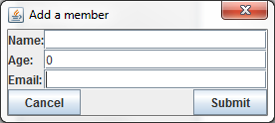

A1 b)

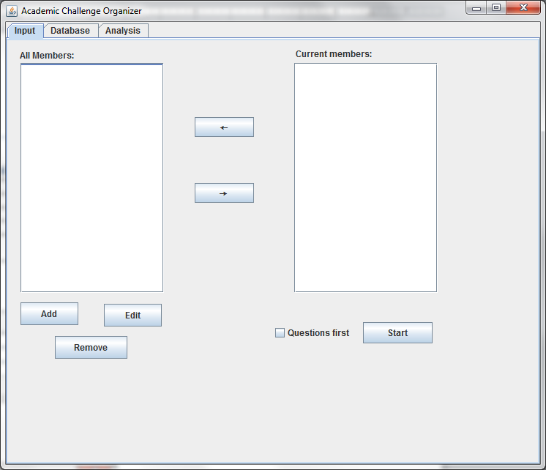

A2 a)

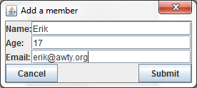

A2 b)

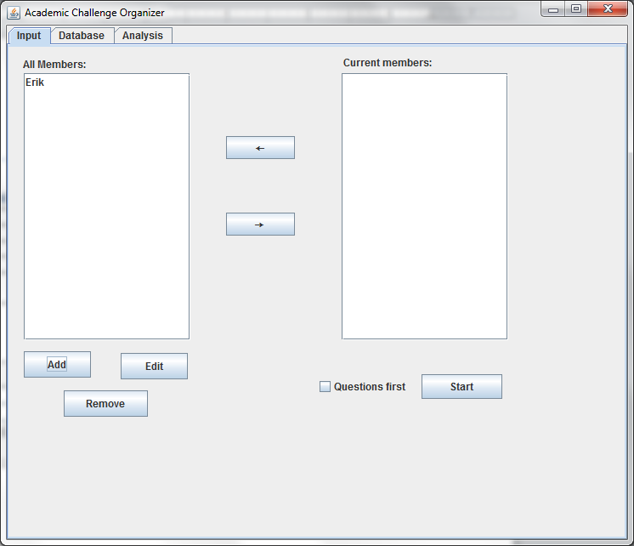

A3 a)

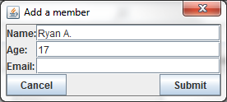

A3 b)

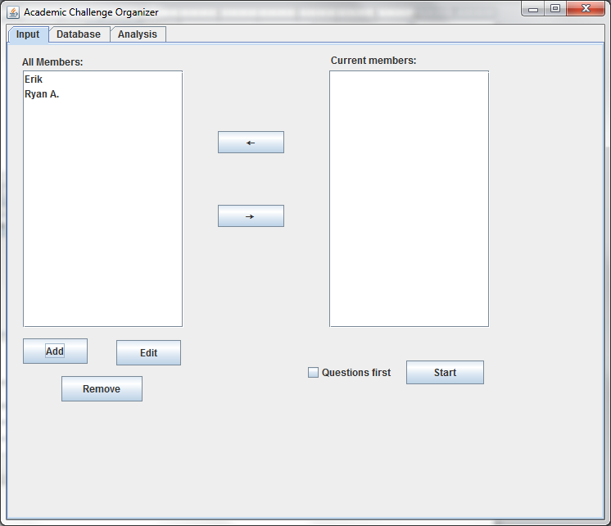

# Selection entry method

|  |  |  |
| --- | --- | --- |
|  | B1 | B2 |
| Action | Click start | Click start |
| Data | Questions first selected | Questions first not selected |
| Expected Result | Questions panel appears | Questions and answers panel appears |
| Actual Result | Questions panel appears | Questions and answers panel appears |

B1 a)

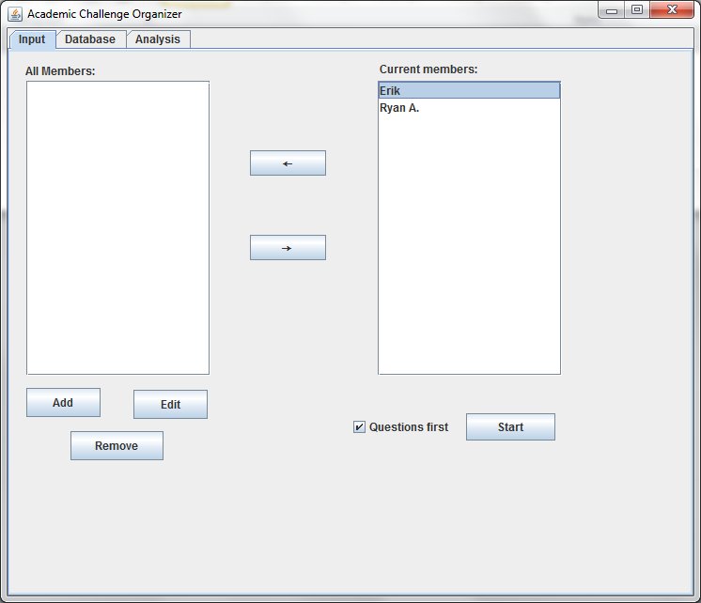

B1 b)

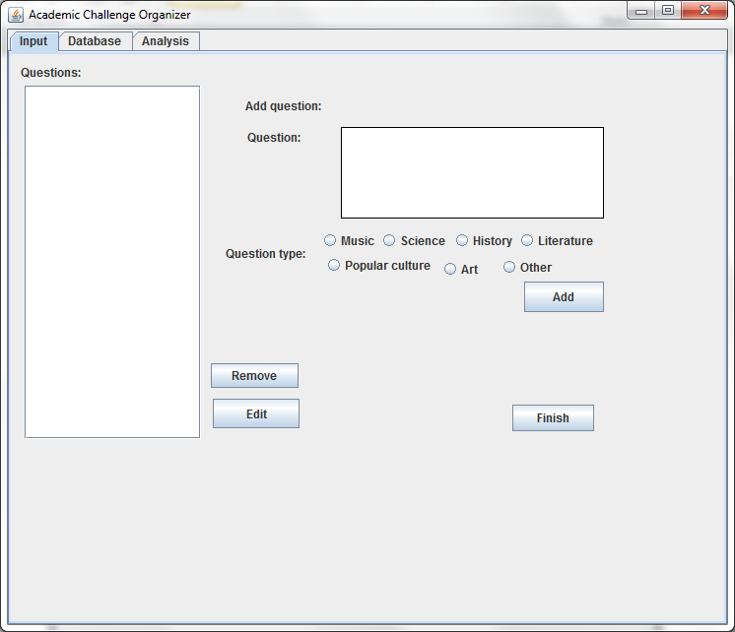

B2 a)

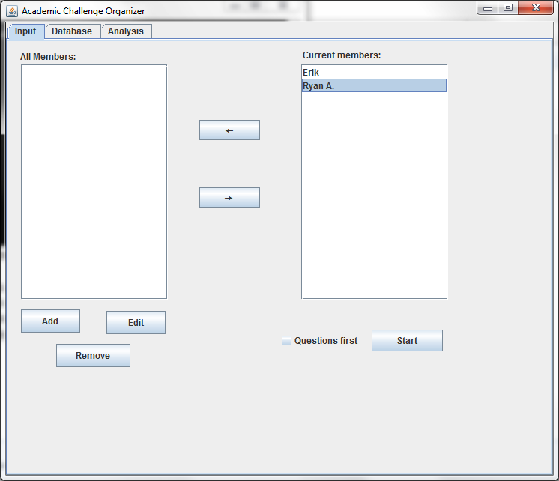

B2 b)

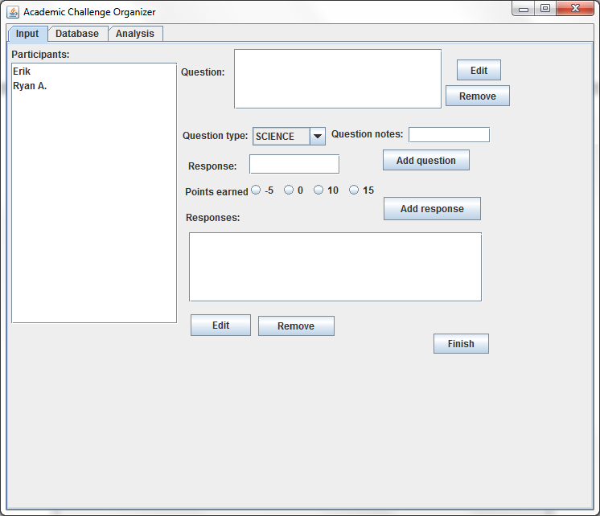

# Adding a question from the QuestionEntry panel

|  |  |  |
| --- | --- | --- |
|  | C1 | C2 |
| Action | Click add | Click add |
| Data | Question filled in, arbitrary question type | Question not filled in, arbitrary question type |
| Expected Result | Question appears | Blank question appears with some indicator that it is there |
| Actual Result | Question appears, date in parentheses | Question appears as solely a date in parentheses |

C1 a)

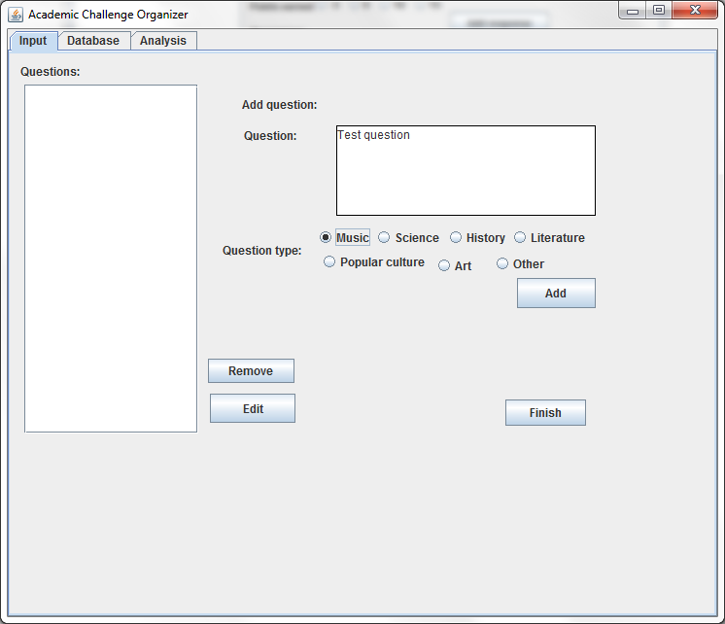

C1 b)

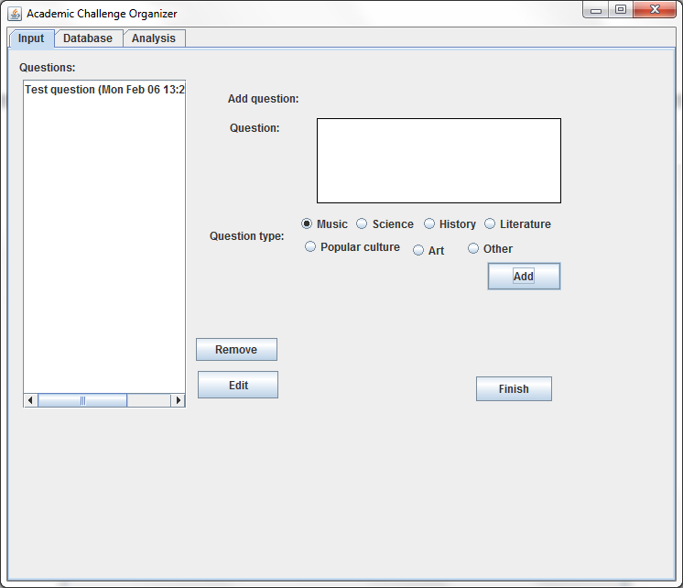

C2 a)

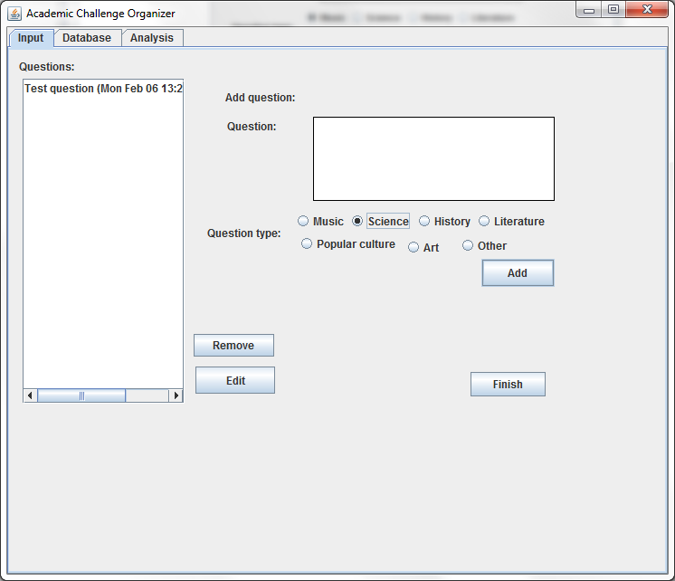

C2 b)

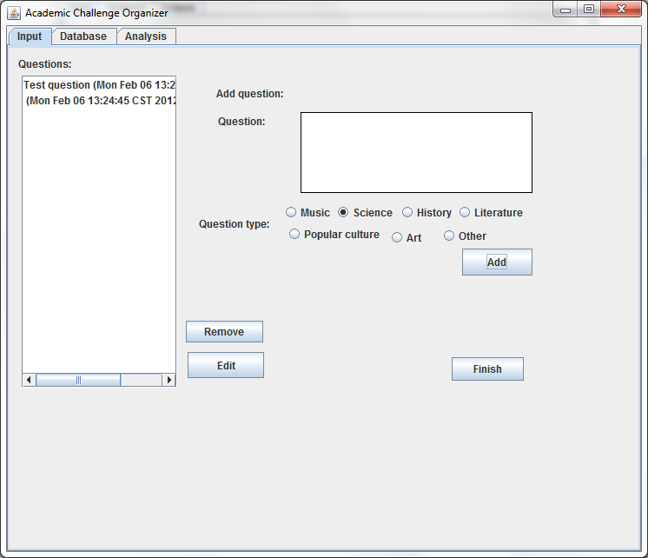

# Removing and Editing a Question

|  |  |  |  |  |
| --- | --- | --- | --- | --- |
|  | C4 | C5 | C6 | C7 |
| Action | Click edit | Click edit | Click remove | Click remove |
| Data | Question not selected | Question selected | Question not selected | Question selected |
| Expected Result | Warning | Opens edit dialog for selected question | Warning | Removes selected question |
| Actual Result | Warning appears. | Question edit dialog appears. | Nothing happens. | Question removed. |

C4 a)

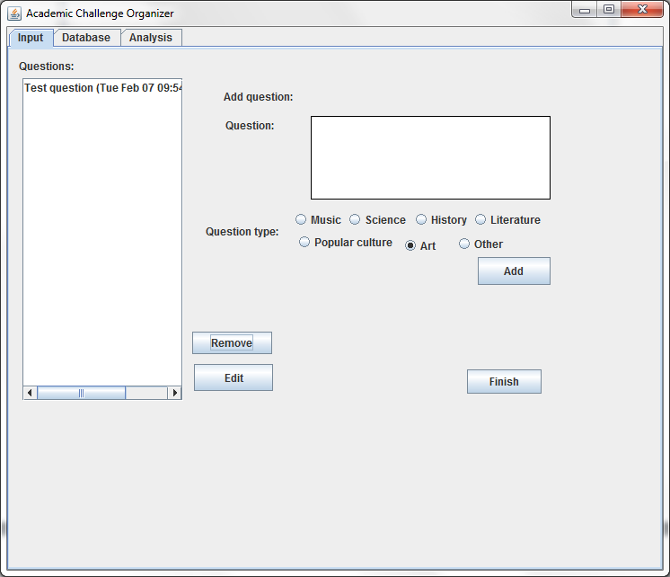

C4 b)

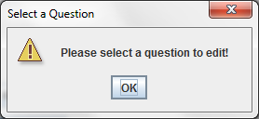

C5 a)

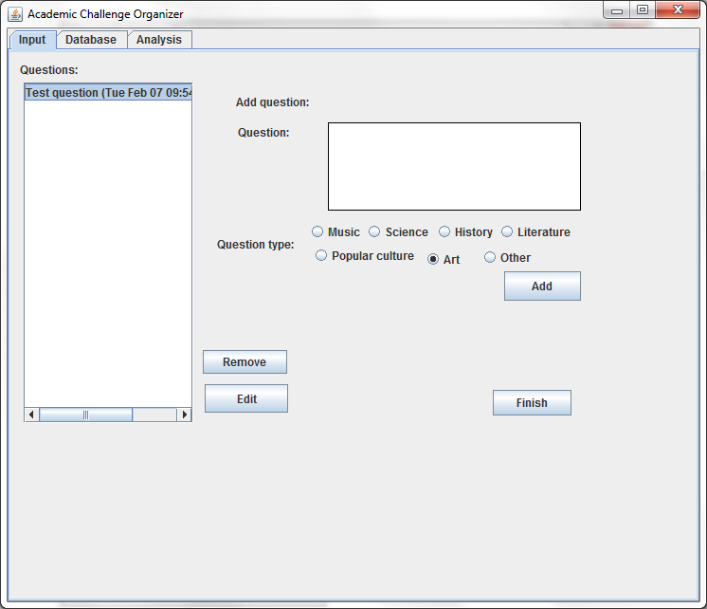

C5 b)

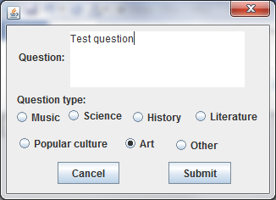

C6 a)

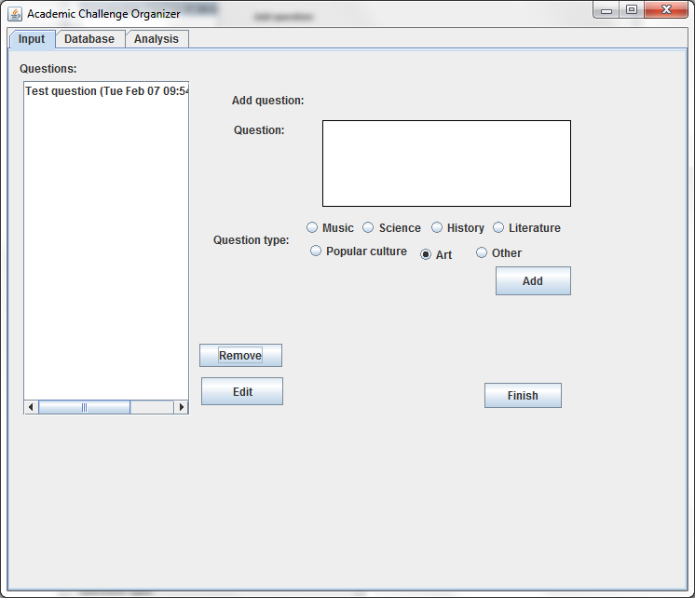

C6 b)

No change.

C7 a)

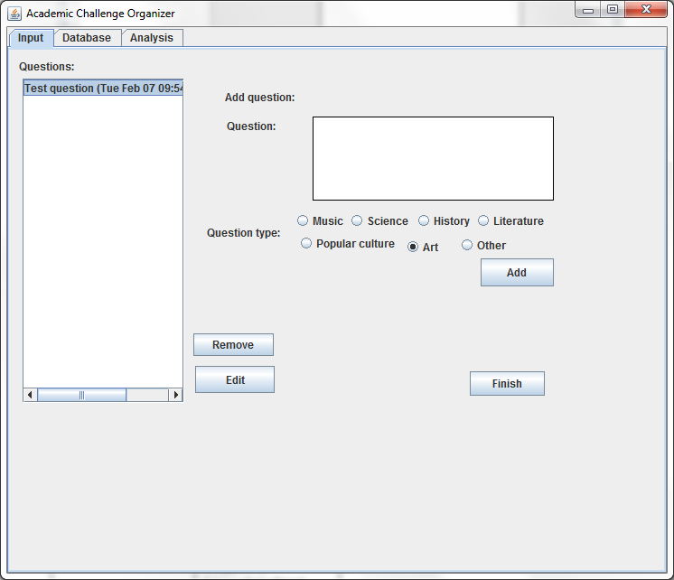

C7 b)

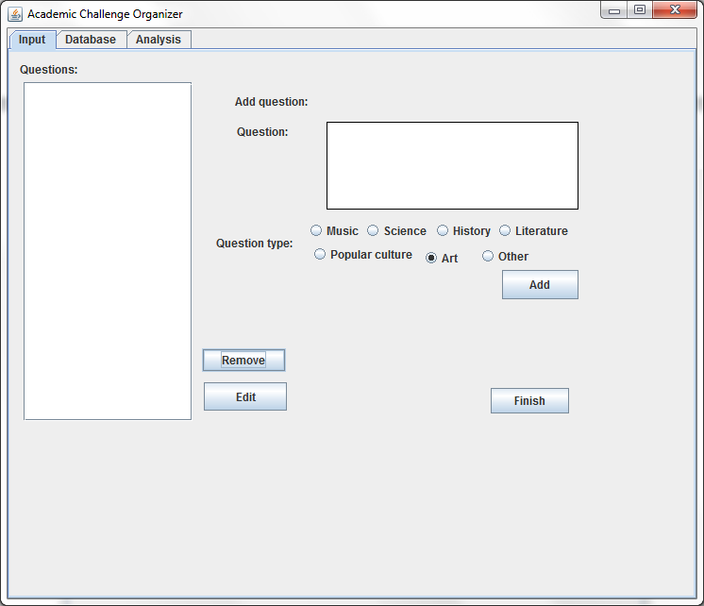

# Advancing to the AnswerEntryPanel

|  |  |
| --- | --- |
|  | C8 |
| Action | Click Finish |
| Expected Result | QuestionEntryPanel disappears, AnswerEntryPanel appears |
| Actual Result | Question appears, date in parentheses |

C8 a)

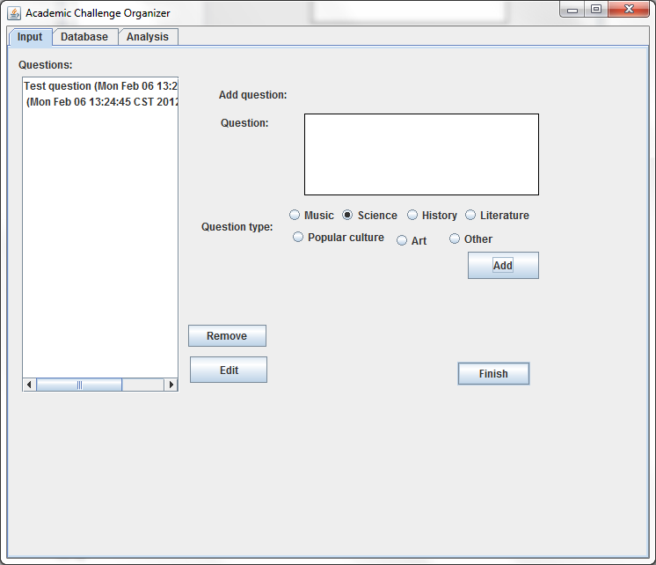

C8 b)

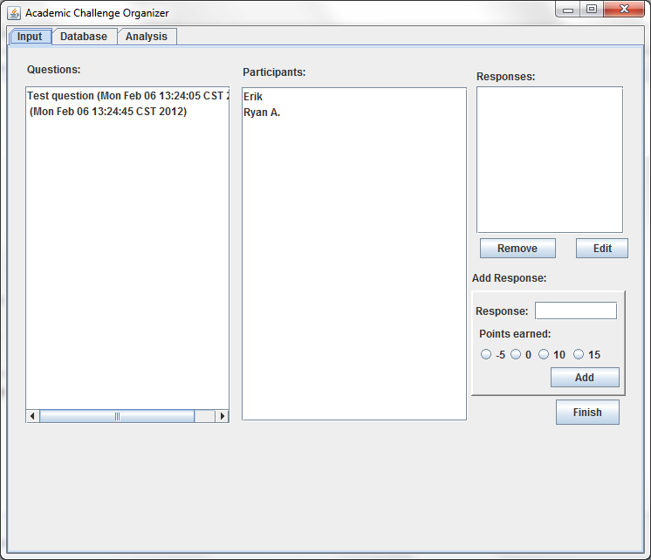

# Adding a Response to the AnswerEntryPanel

|  |  |  |  |
| --- | --- | --- | --- |
|  | D1 | D2 | D3 |
| Action | Click add | Click add | Click add |
| Data | Question not selected | Everything filled in | No response value filled in |
| Expected Result | Warning | Adds a response | Adds a response with no value |
| Actual Result | Error; more severe than expected | Response added | “-1” appears. Data files corrupted. |

D1 a) 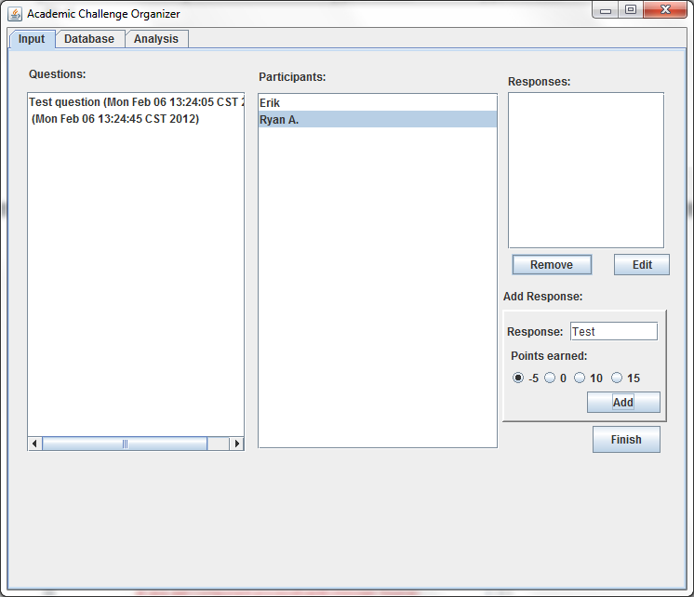

D1 b)

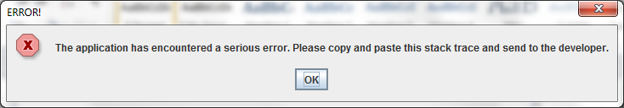

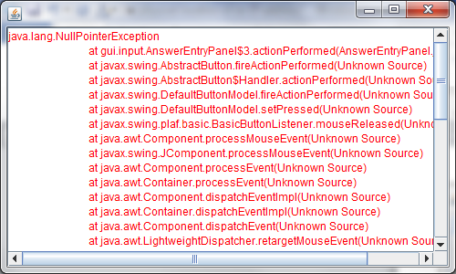

D2 a)

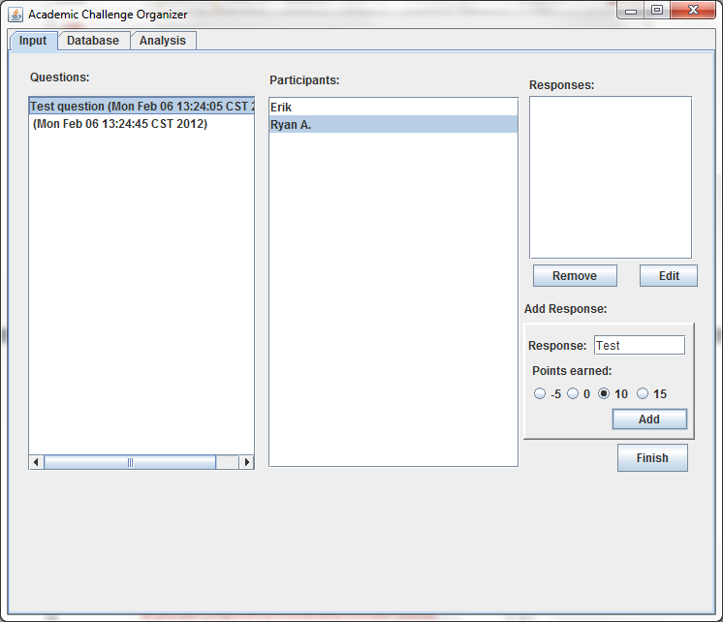



D2 b)

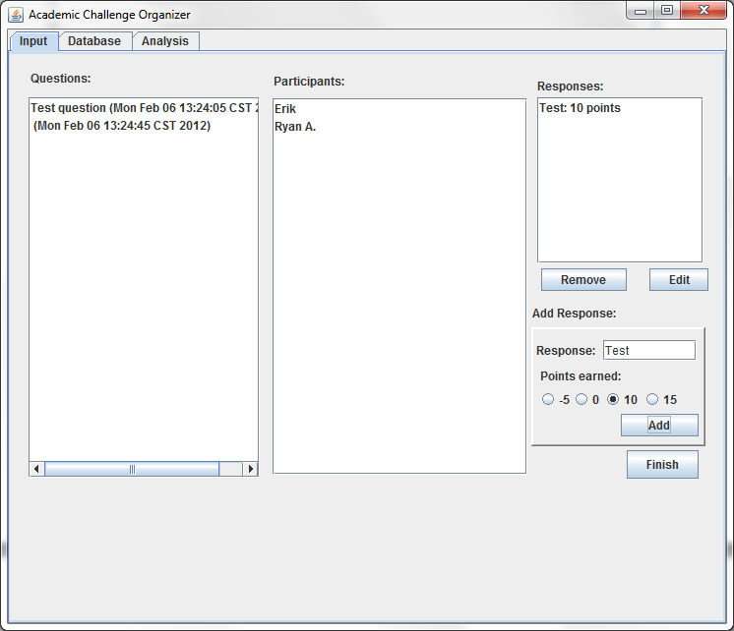

D3 a)

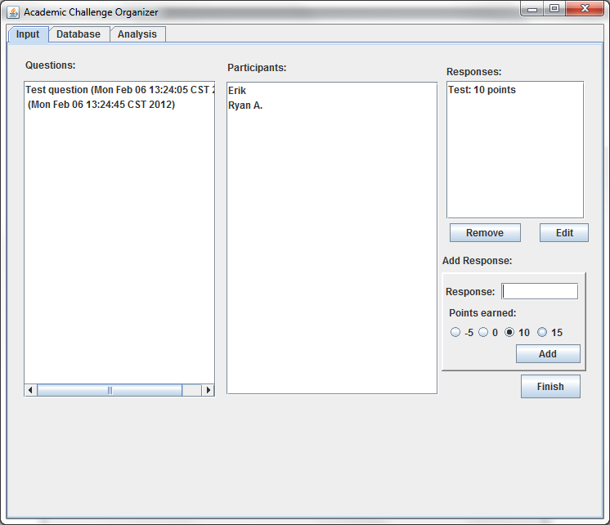

D3 b)

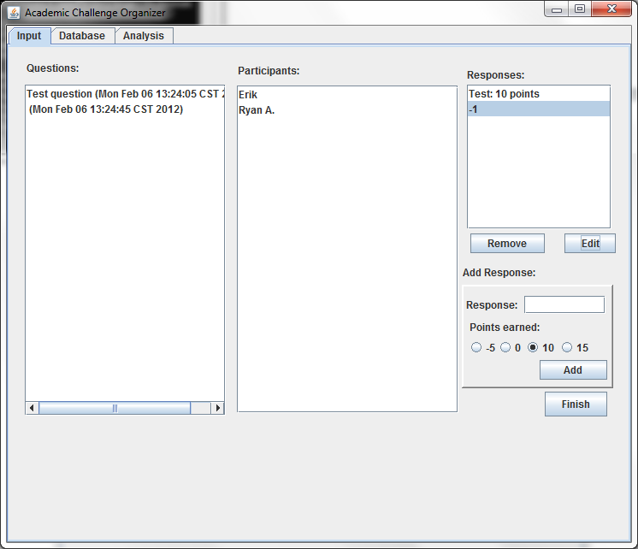

# Removing and Editing a Response

|  |  |  |  |  |
| --- | --- | --- | --- | --- |
|  | D4 | D5 | D6 | D7 |
| Action | Click edit | Click edit | Click remove | Click remove |
| Data | Response not selected | Response selected | Response not selected | Response selected |
| Expected Result | Warning | Opens edit dialog for selected response | Warning | Removes selected response |
| Actual Result | Warning appears. Wrong warning. | Response edit dialog appears. | Warning appears. Wrong warning. | Response removed. |

D4 a)

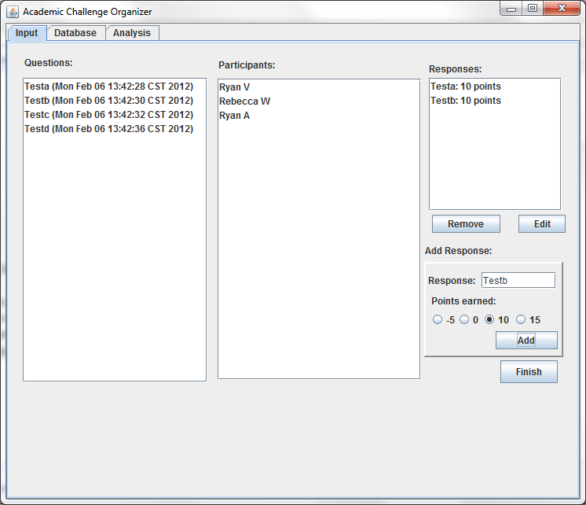

D4 b)

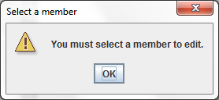

D5 a)

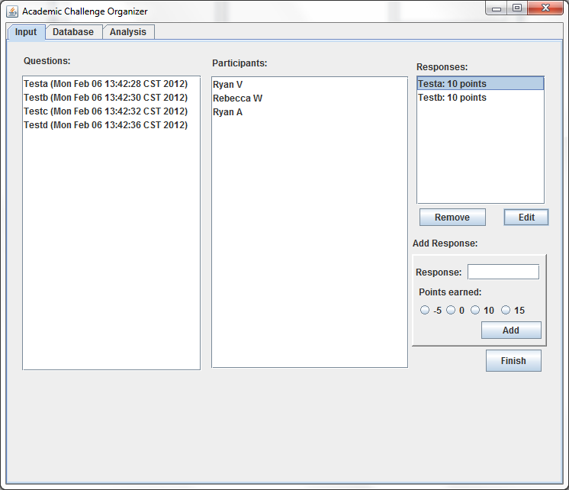

D5 b)

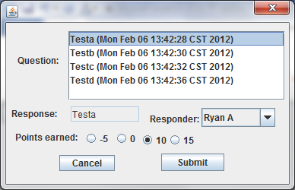

D6 a)

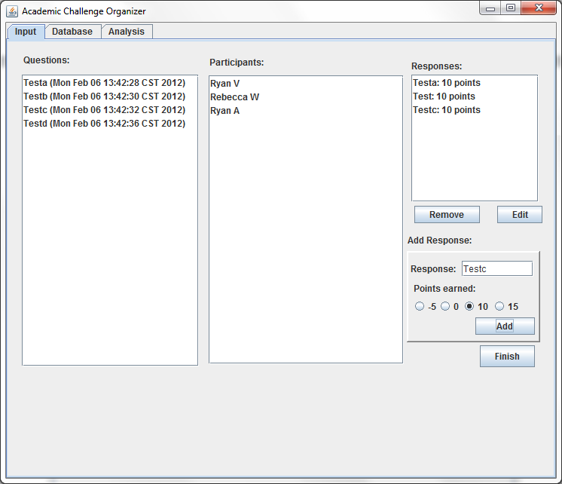

D6 b)

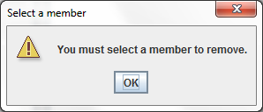

D7 a)

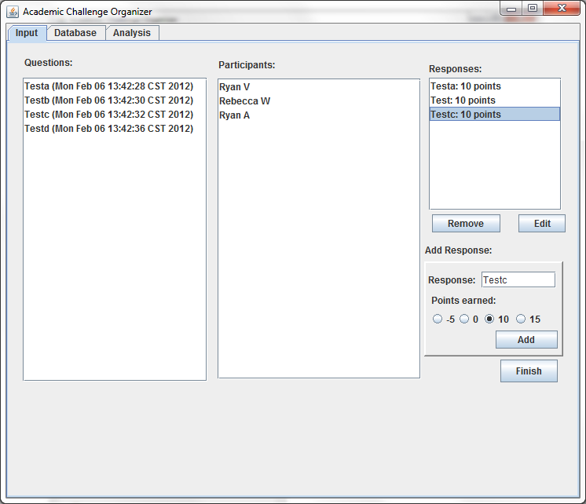

D7 b)

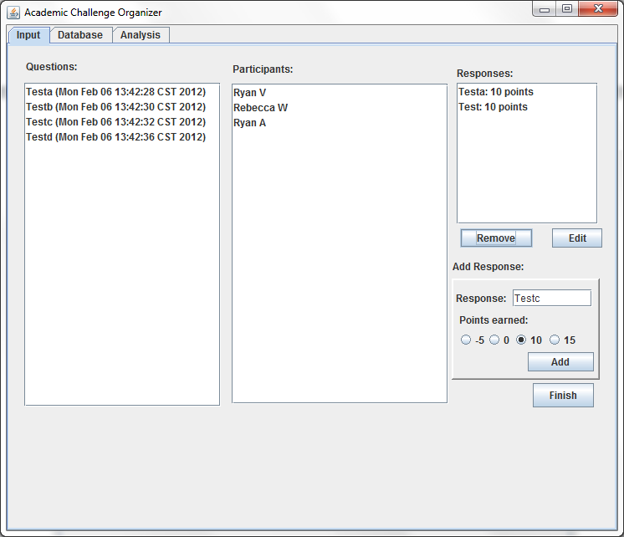

# Finishing the Session

|  |  |
| --- | --- |
|  | D8 |
| Action | Click Finish |
| Data | Responses added |
| Expected Result | Cycles to member selection panel, data added to data files. |
| Actual Result | Cycles to member selection panel, data added to data files. Responses: Only 2 responses added; responses that were removed were in fact removed. Questions: All 4 questions added were added. |

D8 a)

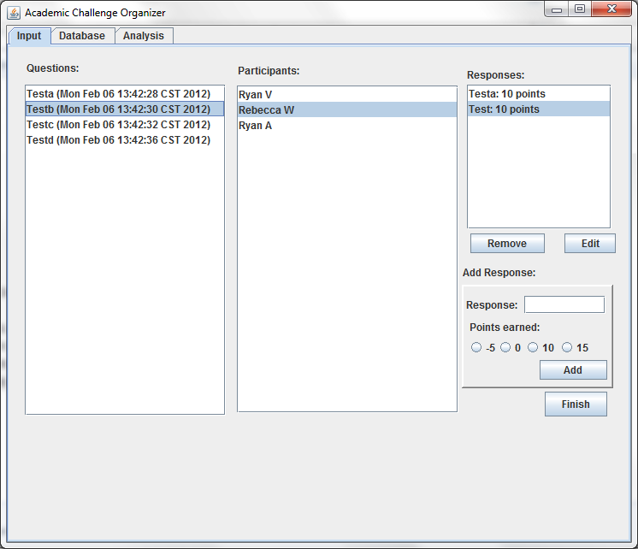

D8 b)

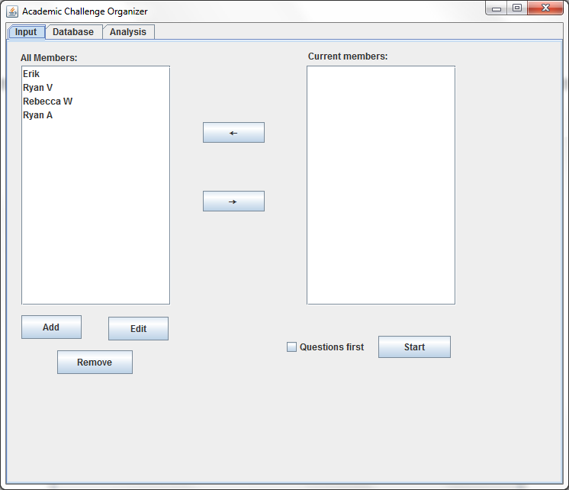

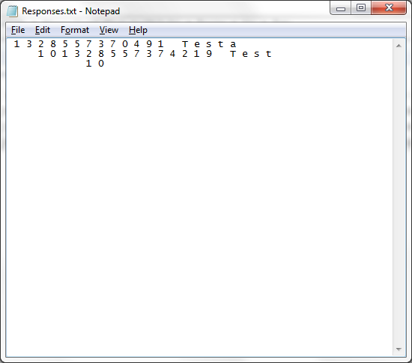

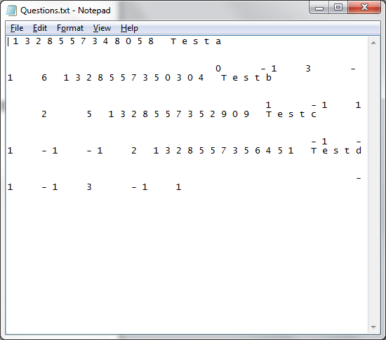

# Changing to QuestionAnswerPanel

|  |  |
| --- | --- |
|  | E1 |
| Action | Click Start |
| Data | Questions first not selected |
| Expected Result | Cycle to QuestionAnswerPanel |
| Actual Result | Cycles to QuestionAnswerPanel |

E1 a)

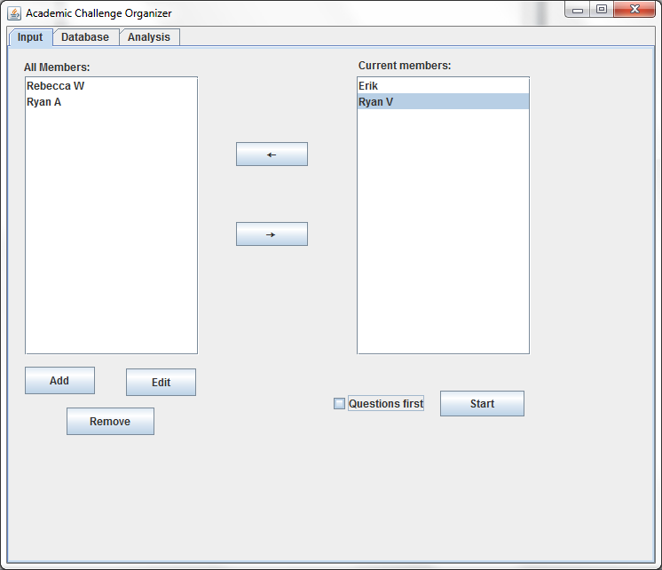

E1 b)

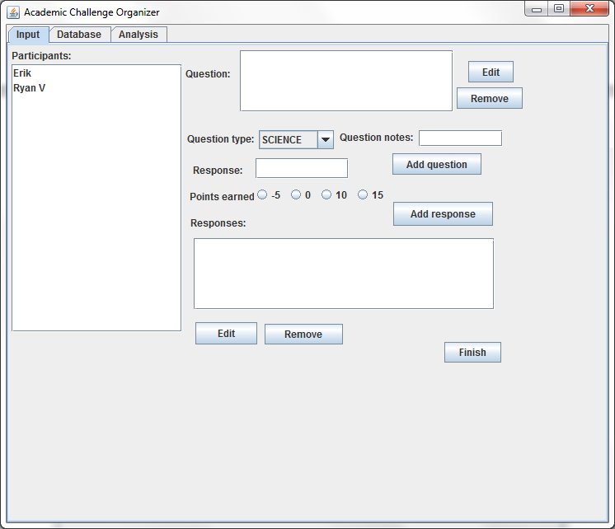

# Adding a question

|  |  |  |
| --- | --- | --- |
|  | E2 | E3 |
| Action | Click add | Click add |
| Data | No question notes | Everything filled in |
| Expected Result | Warning | Adds the question |
| Actual Result | Response edit dialog appears. | Warning appears. Wrong warning. |

E2 a)

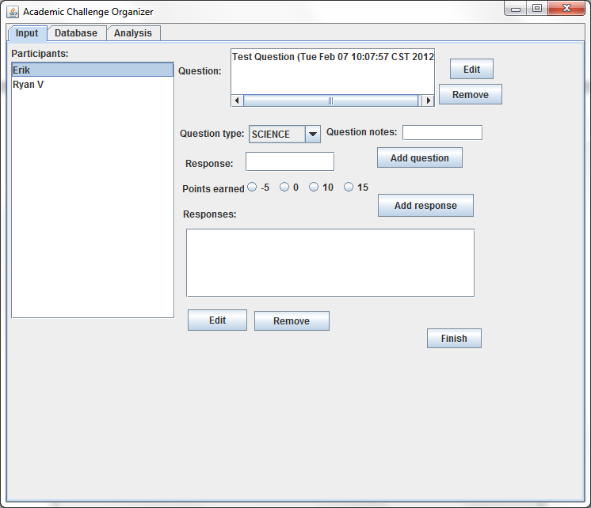

E2 b)

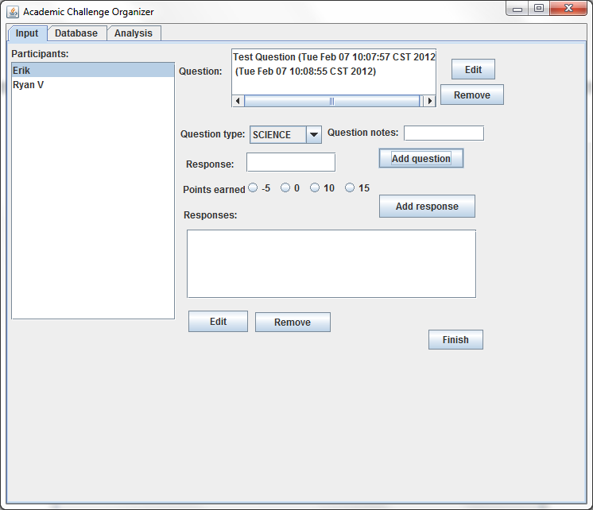

E3 a)

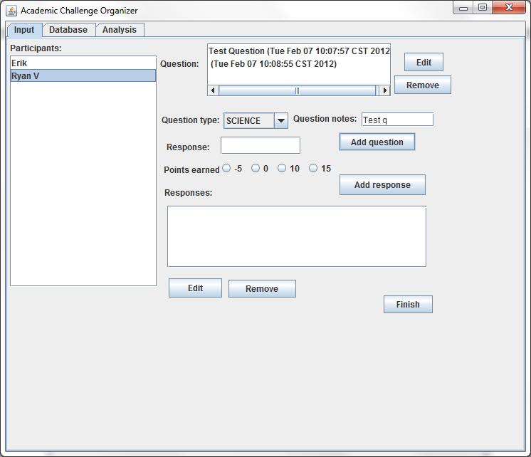

E3 b)

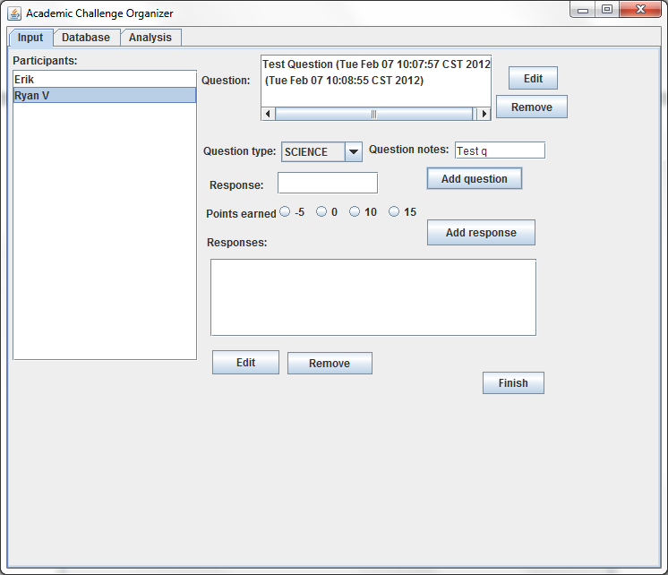

# Removing and Editing a Question

|  |  |  |  |  |
| --- | --- | --- | --- | --- |
|  | E4 | E5 | D6 | D7 |
| Action | Click edit | Click edit | Click remove | Click remove |
| Data | Question not selected | Question selected | Question not selected | Question selected |
| Expected Result | Warning | Opens edit dialog for selected question | Warning | Removes selected question |
| Actual Result | Warning appears. | Question edit dialog appears. | Warning appears. | Question removed. |

E4 a)

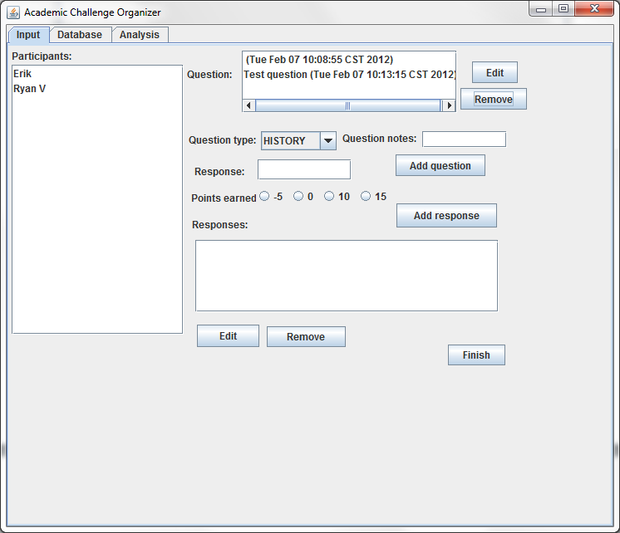

E4 b)

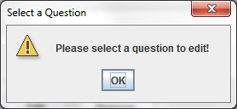

E5 a)

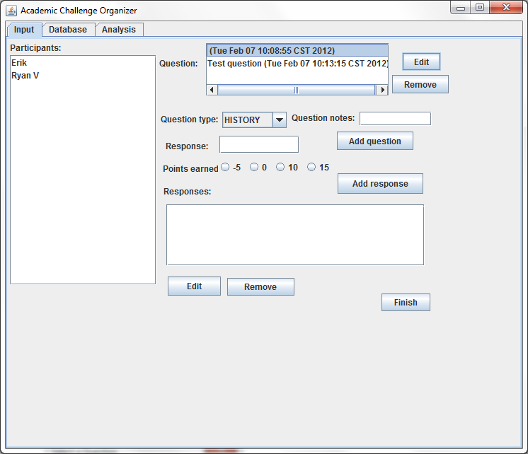

E5 b)

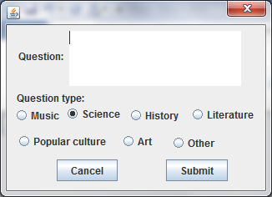

E6 a)

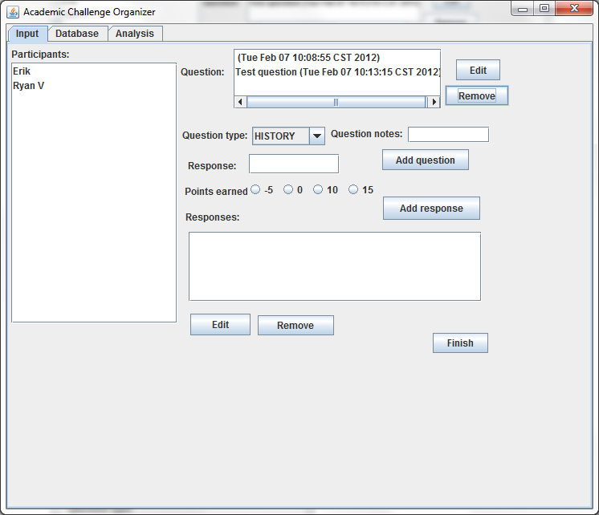

E6 b)

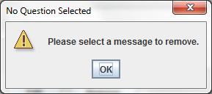

E7 a)

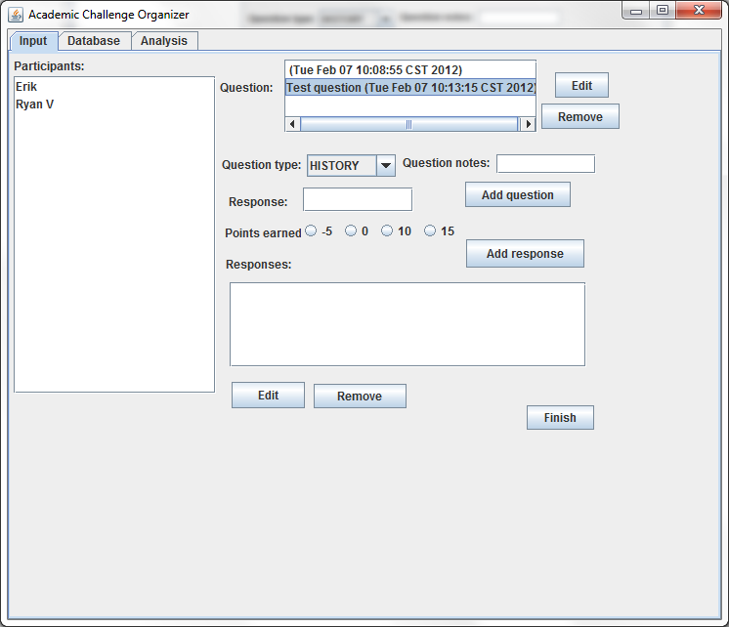

E7 b)

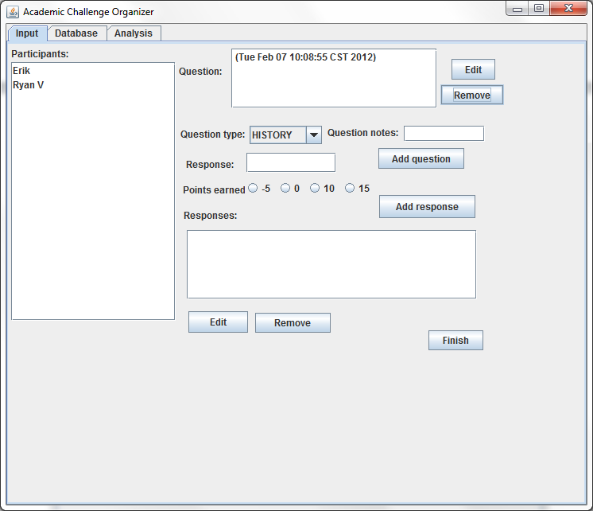

# Adding a response

|  |  |  |  |  |
| --- | --- | --- | --- | --- |
|  | E8 | E9 | E10 | E11 |
| Action | Click edit | Click edit | Click remove | Click remove |
| Data | Participant not selected | Response field empty | Question not selected | Everything filled in |
| Expected Result | Warning | Adds response with no value | Warning | Warning |
| Actual Result | Warning appears. | Response added with no value. Because the response has no value, the toString returns the ID. | Warning appears. | Response added |

E8 a)

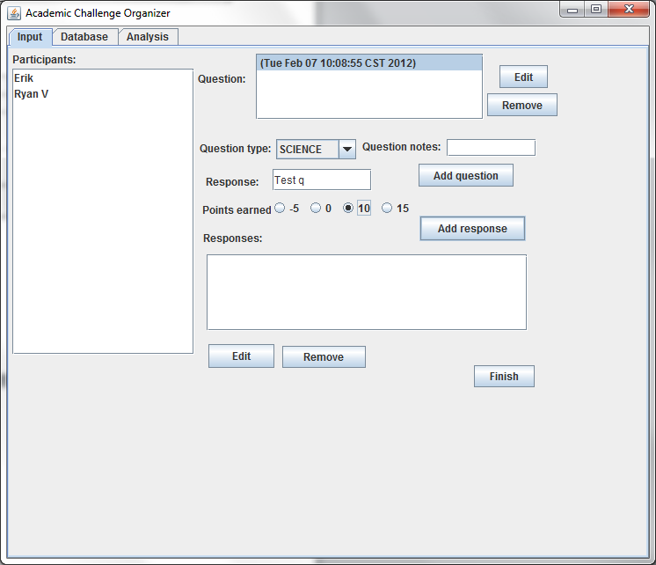

E8 b)

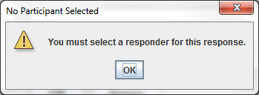

E9 a)

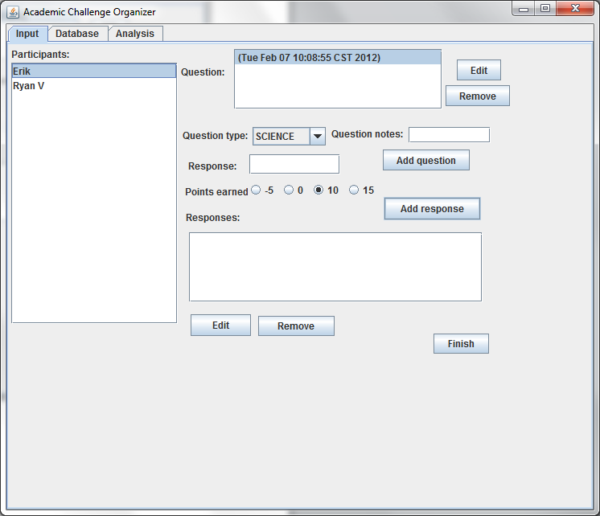

E9 b)

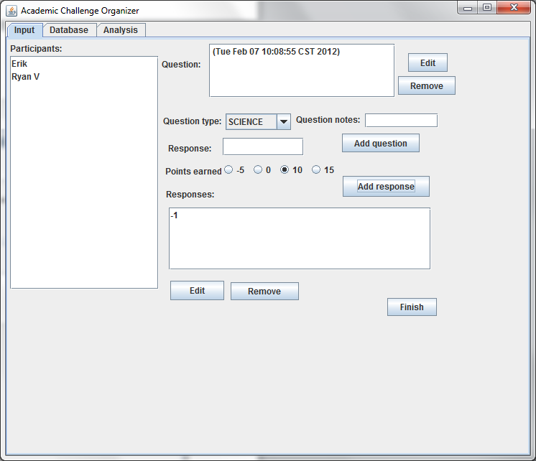

E10 a)

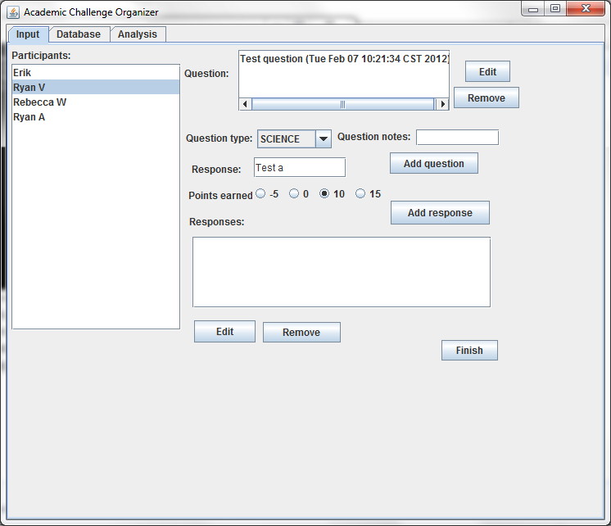

E10 b)

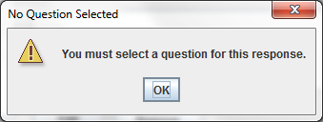

E11 a)

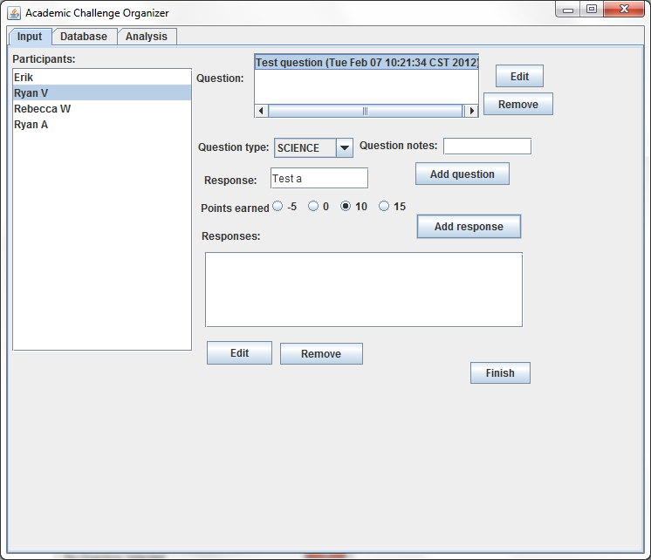

E11 b)

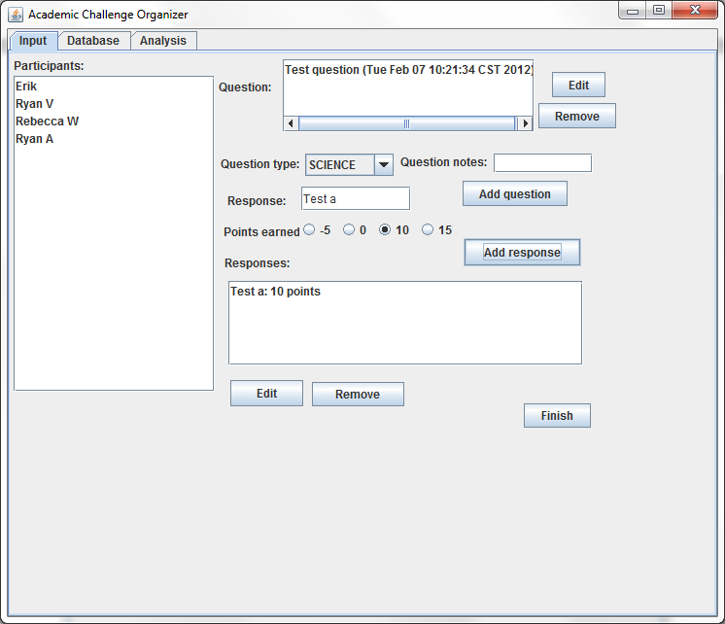

# Removing and Editing a Response

|  |  |  |  |  |
| --- | --- | --- | --- | --- |
|  | E12 | E13 | E14 | E15 |
| Action | Click edit | Click edit | Click remove | Click remove |
| Data | Response not selected | Response selected | Response not selected | Response selected |
| Expected Result | Warning | Opens edit dialog for selected response | Warning | Removes selected response |
| Actual Result | Warning appears. Wrong warning. | Response edit dialog appears. | Warning appears. Wrong warning. | Response removed. |

E12 a)

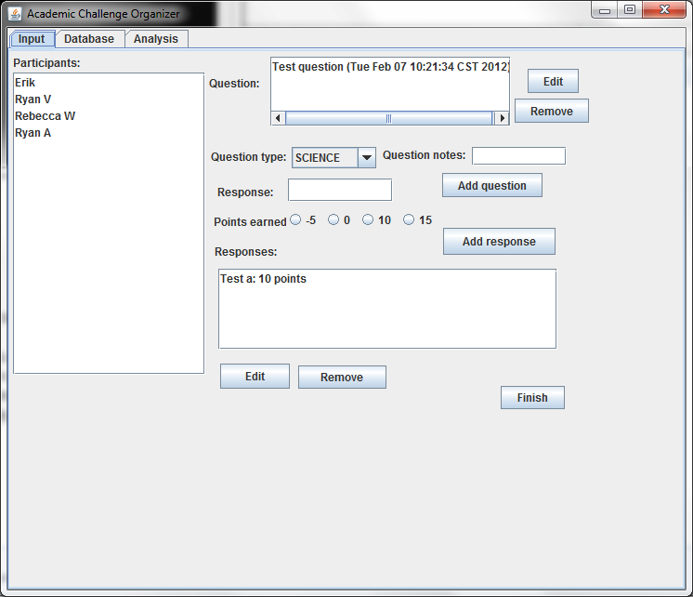

E12 b)

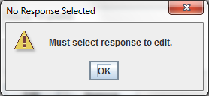

E13 a)

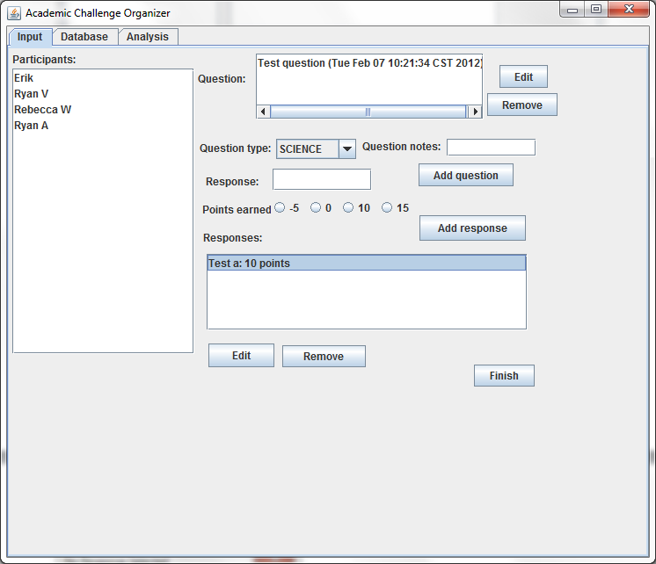

E13 b)

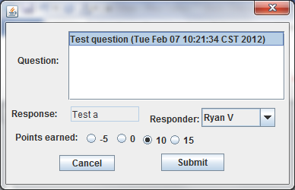

E14 a)

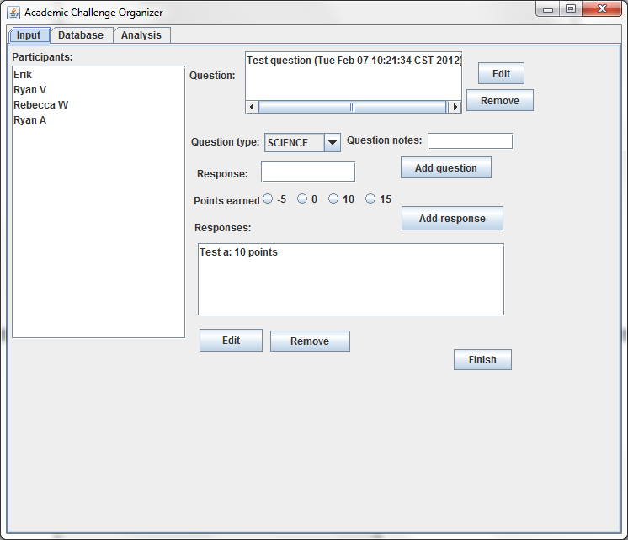

E14 b)

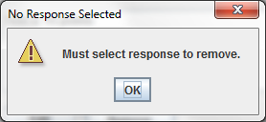

E15 a)

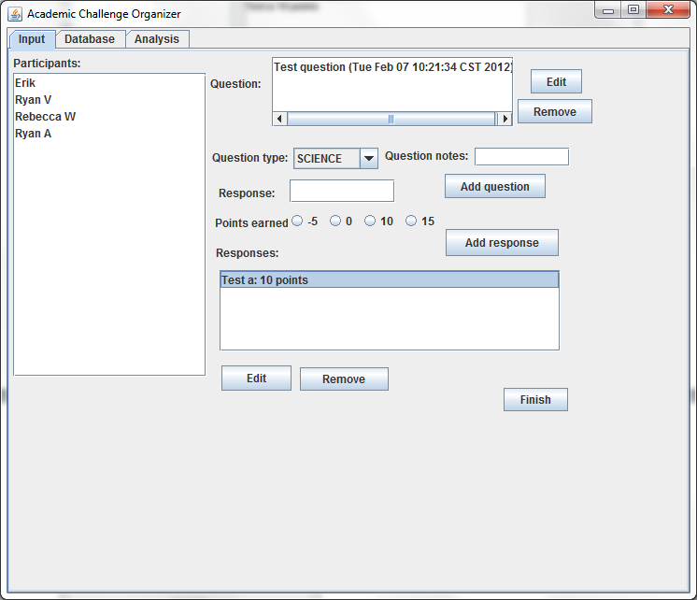

E16 b)

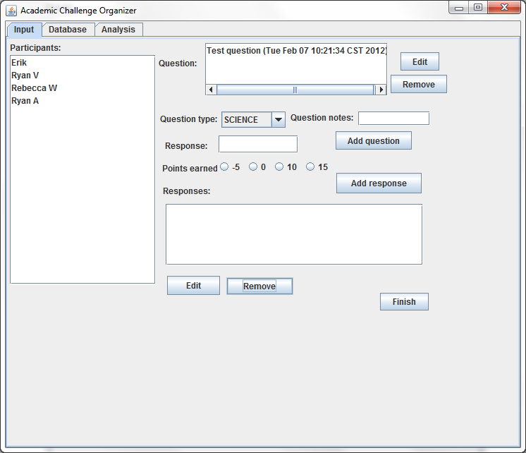

# Finishing the Session

|  |  |
| --- | --- |
|  | E17 |
| Action | Click finish |
| Data | Responses and questions added |
| Expected Result | Saves data, cycles to MemberSelectionPanel. |
| Actual Result | Saves data, cycles to MemberSelectionPanel. |

E17 a)

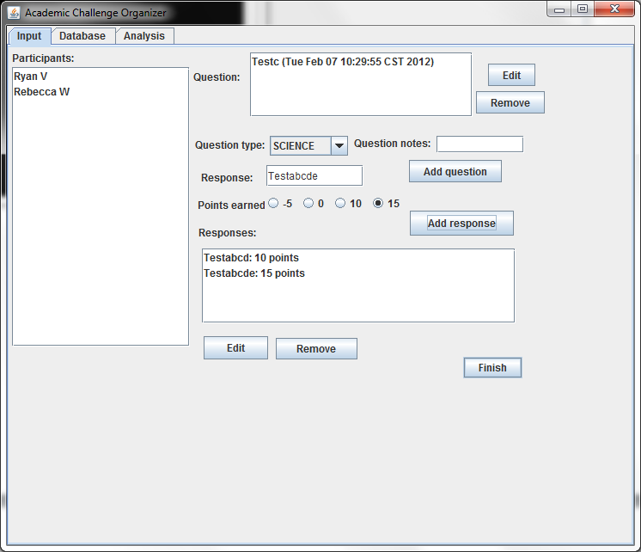

E17 b)

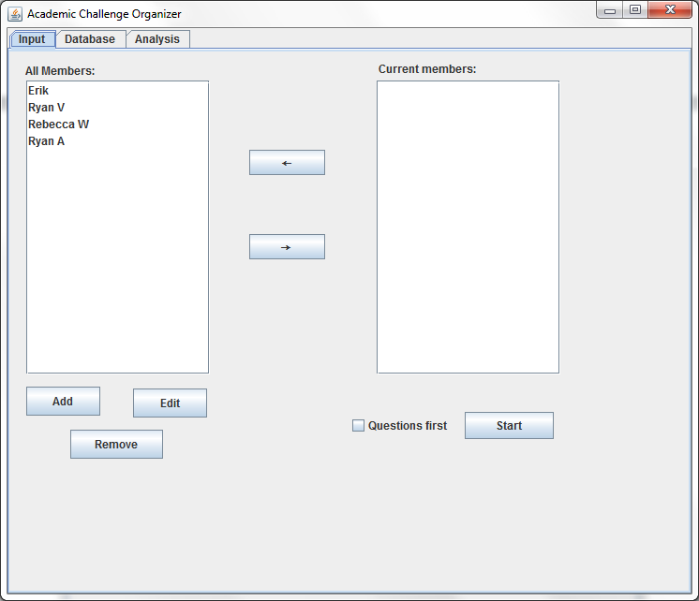

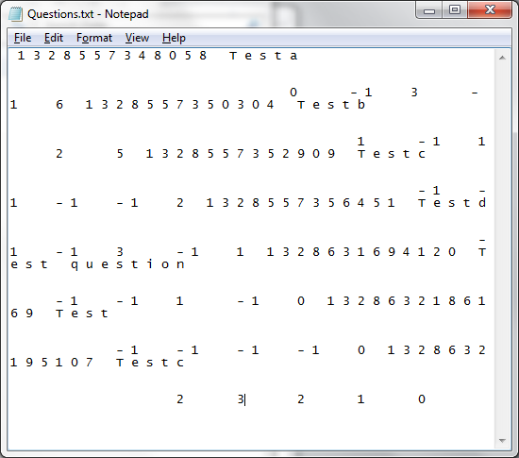

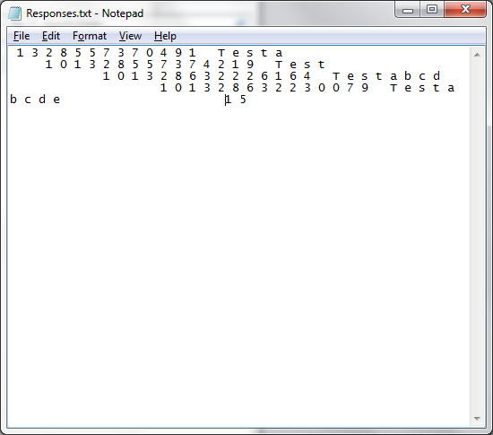

# Viewing the Database Listing and Selecting Responses

|  |  |  |  |  |
| --- | --- | --- | --- | --- |
|  | F1 | F2 | F3 | F4 |
| Action | Click “Database” tab | Select a member | Select a question | Select a response |
| Expected Result | Changes tabs to the database viewer | Questions for that member appear. Other selections cleared. | Responses for that question appear. Other selections cleared. | Other selections cleared. |
| Actual Result | Changes tabs to the database viewer | Questions for that member appear. Other selections cleared. | Responses for that question appear. Other selections cleared. | Other selections cleared. |

F1 a)

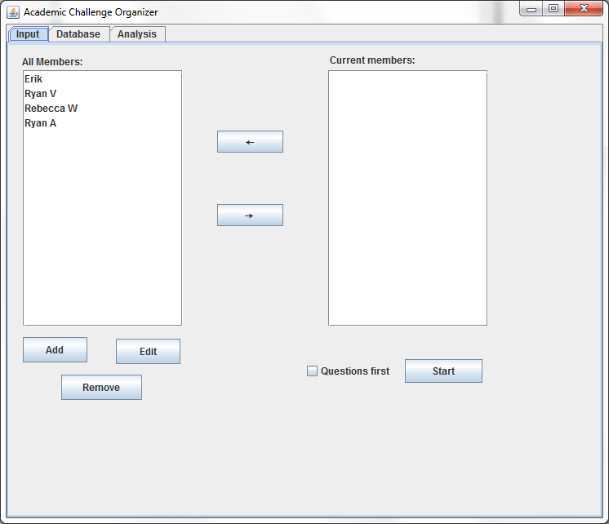

F1 b)

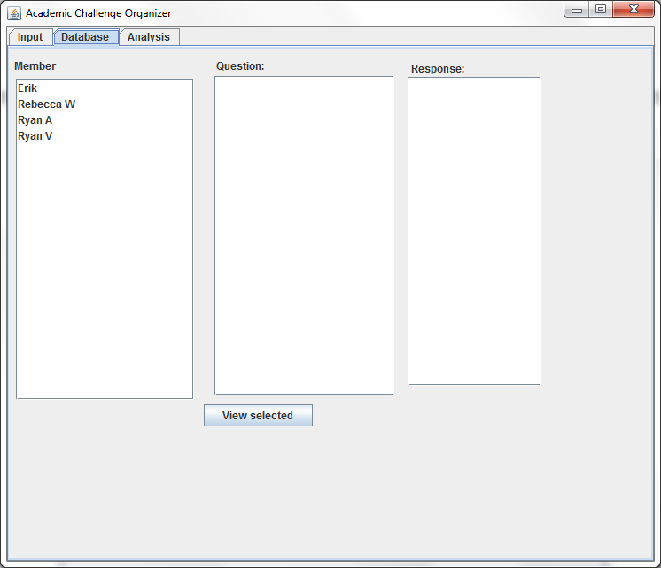

F2 a)

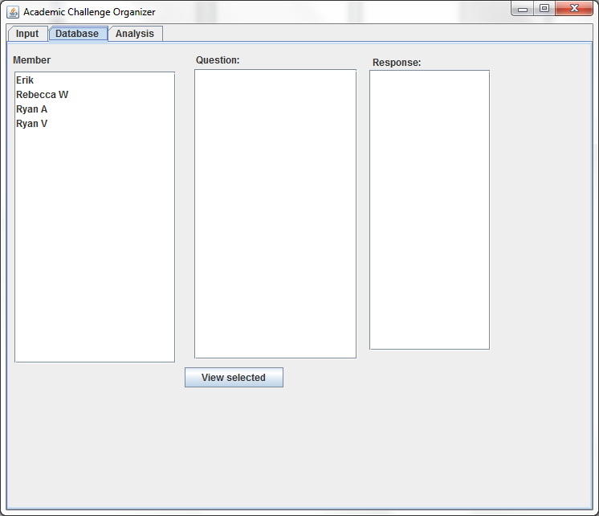

F2 b)

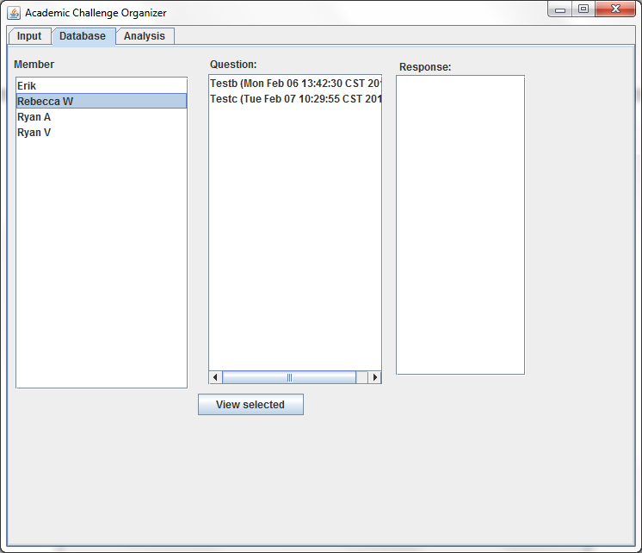

F3 a)

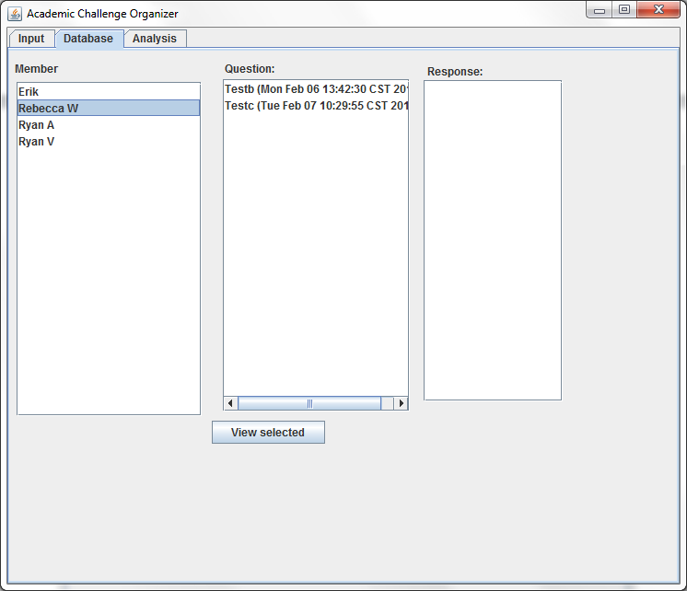

F3 b)

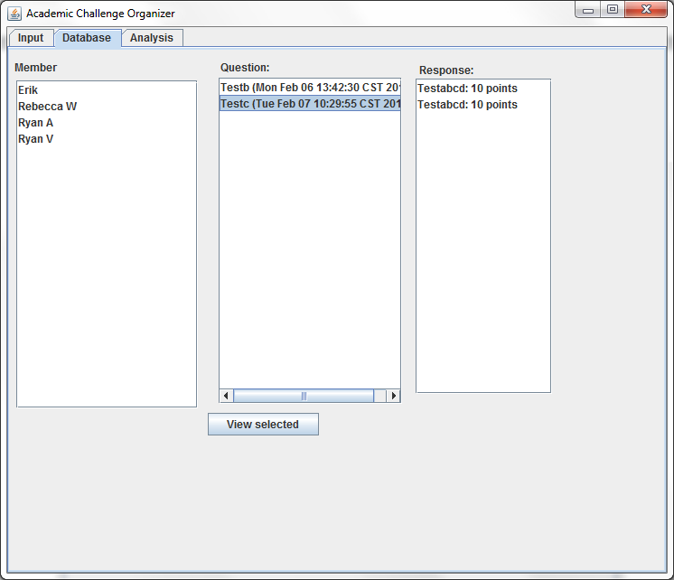

F4 a)

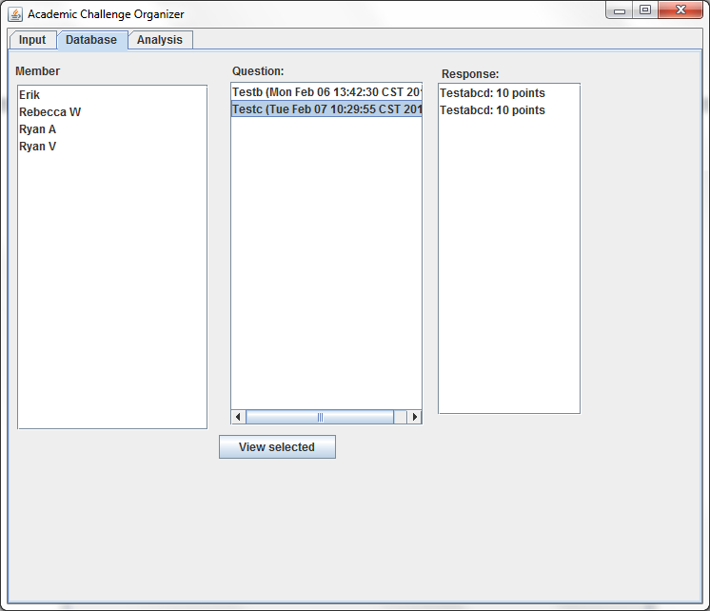

F4 b)

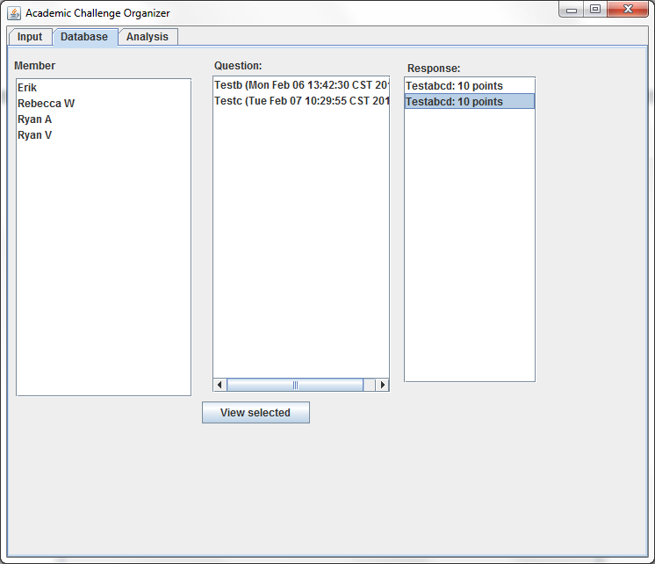

# Viewing Database Items

|  |  |  |  |  |
| --- | --- | --- | --- | --- |
|  | F5 | F6 | F7 | F8 |
| Action | Select a response | Click “View Selected” | Click “View Selected” | Click “View Selected” |
| Data | Nothing selected | Member selected | Question selected | Response Selected |
| Expected Result | Warning | Member data popup appears | Question data popup appears | Response data popup appears |
| Actual Result | Nothing | Member data popup appears | Question data popup appears | Response data popup appears |

F5 a)

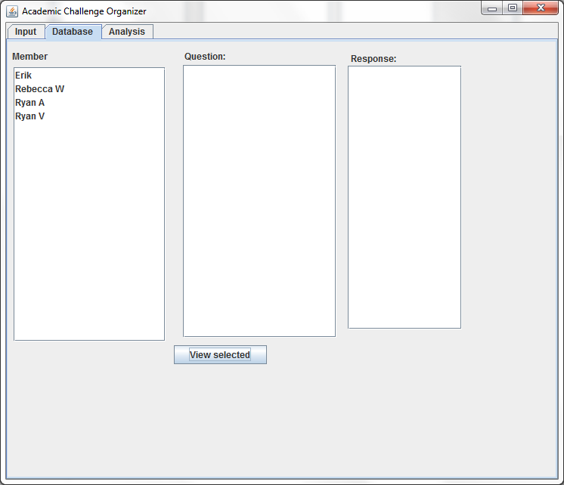

F5 b)

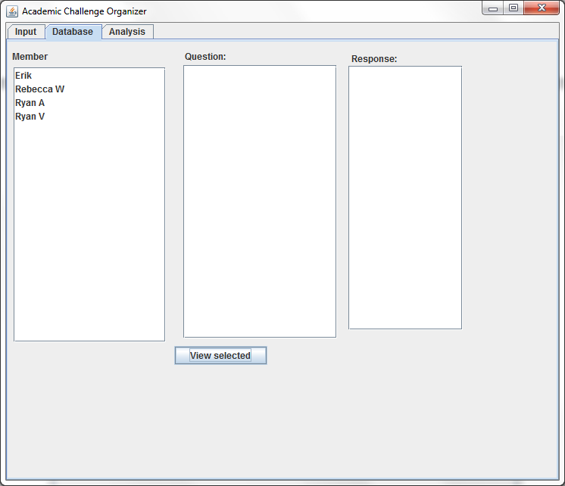

F6 a)

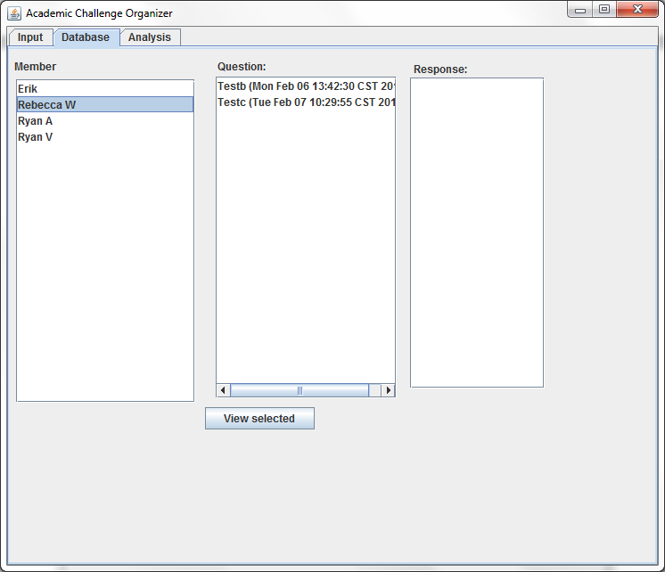

F6 b)

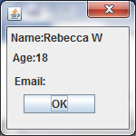

F7 a)

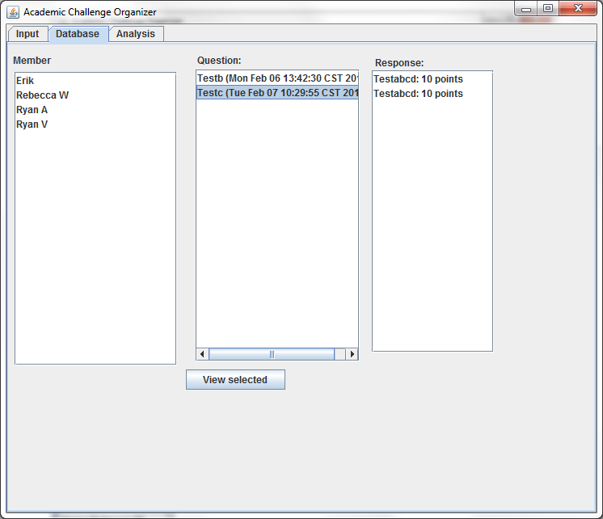

F7 b)

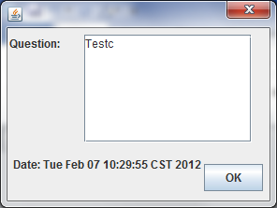

F8 a)

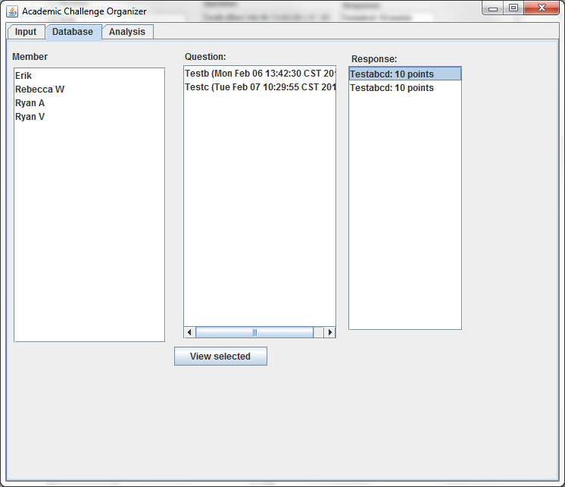

F8 b)

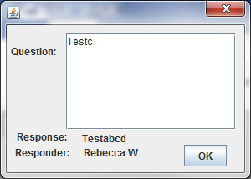

# Analysis panel

|  |  |
| --- | --- |
|  | G1 |
| Action | Analysis type selected |
| Data | Ranking in subject selected |
| Expected Result | Displays RankingInSubject’s options panel |
| Actual Result | Displays RankingInSubject’s options panel |

G1 a)

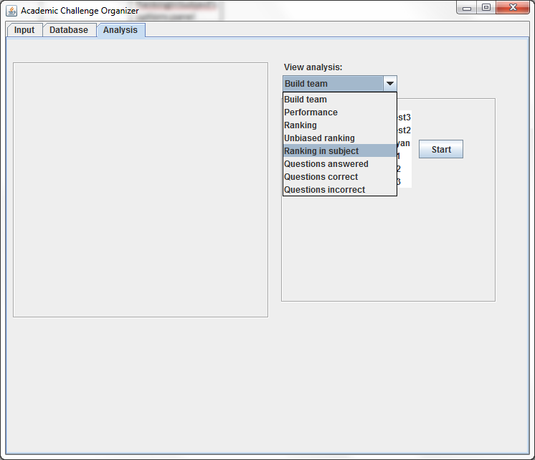

G1 b)

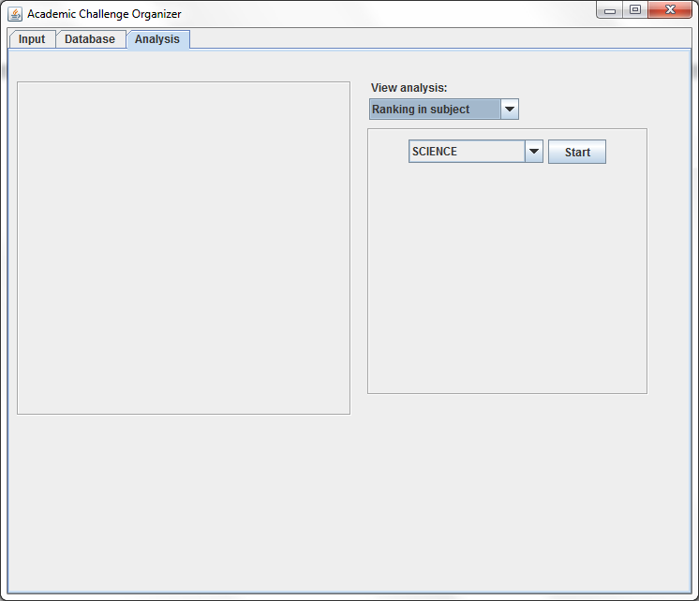

# Build team

|  |  |  |  |
| --- | --- | --- | --- |
|  | G2 | G3 | G4 |
| Action | Click “Start” | Click “Start” | Click “Start” |
| Data | Not enough members selected | 4 members selected | All members selected |
| Expected Result | Warning | Shows the only possible team’s score | Shows the scores of all combinations (not permutations) of teams. |
| Actual Result | Warning, displays number of members to select. | Shows the only possible team’s score | Shows the scores of all combinations (not permutations) of teams. |

G2 a)

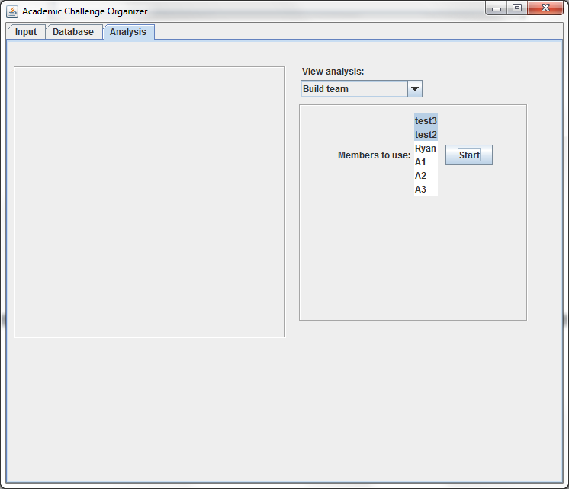

G2 b)

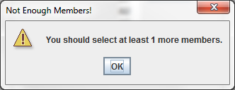

G3 a)

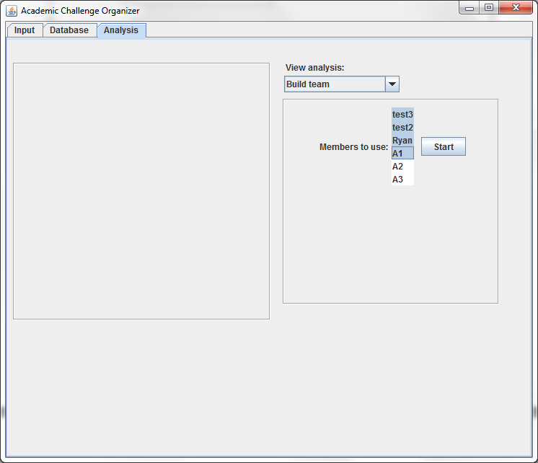

G3 b)

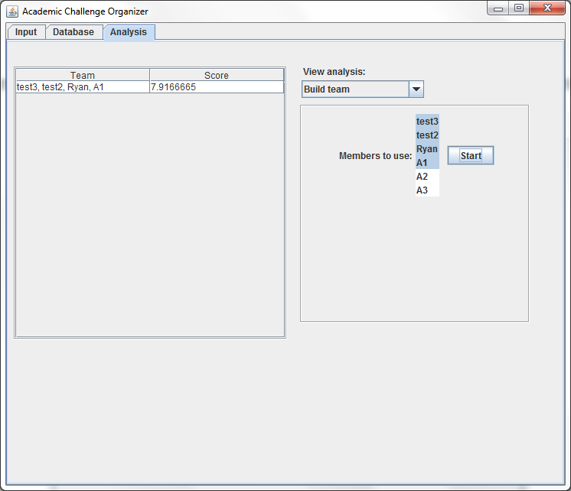

G4 a)

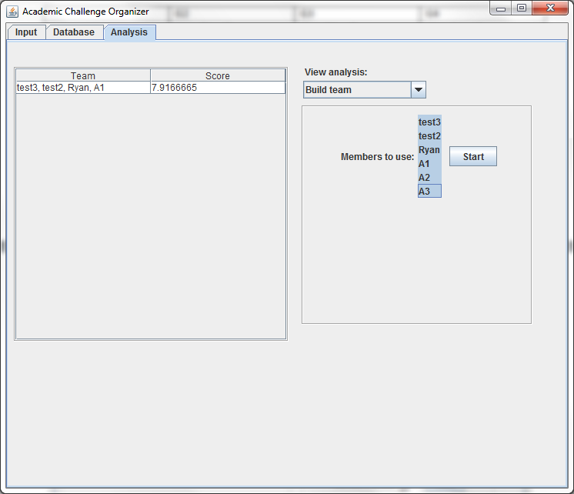

G4 b)

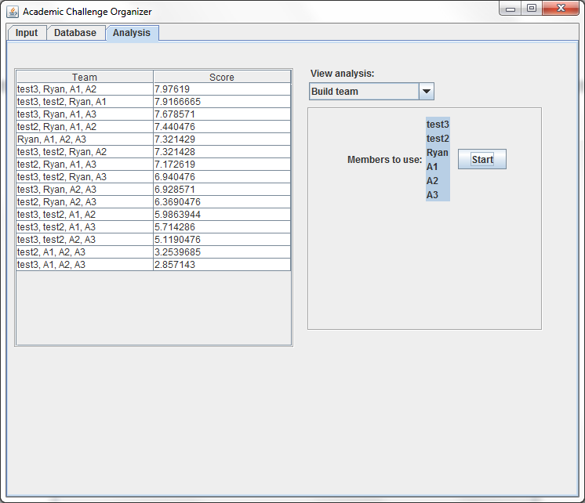

# Performance graph

|  |  |  |  |  |  |
| --- | --- | --- | --- | --- | --- |
|  | G5 | G6 | G7 | G8 | G9 |
| Action | Click “Start” | Click “Start” | Click “Start” | Click “Start” | Click “Start” |
| Data | Member without enough data selected | Graph: “Correct” | Graph: “Percent correct” | Graph: “Points” | Graph: “Average Points” |
| Expected Result | Warning | Graph of cumulative questions correct over time appears | Graph of percent questions correct over time appears | Graph of cumulative points over time appears | Graph of average points over time appears |
| Actual Result | Warning | Graph of cumulative questions correct over time appears | Graph of percent questions correct over time appears | Graph of cumulative points over time appears | Graph of average points over time appears |

G5 a)

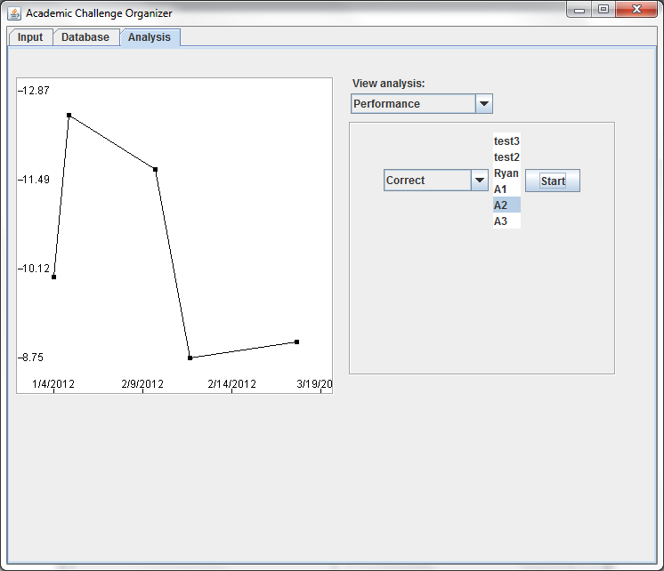

G5 b)

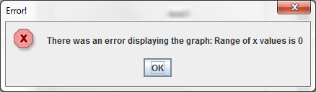

G6 a)

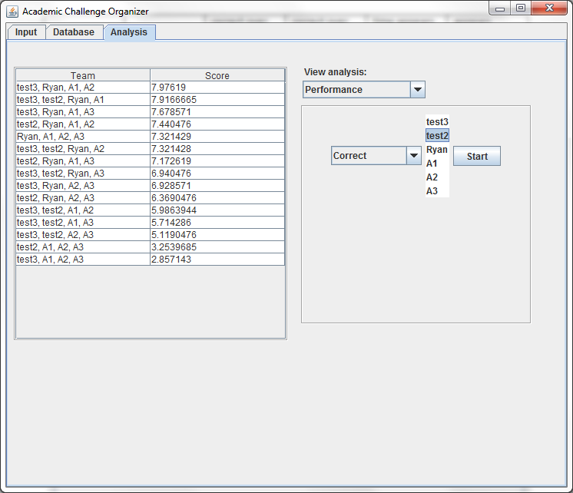

G6 b)

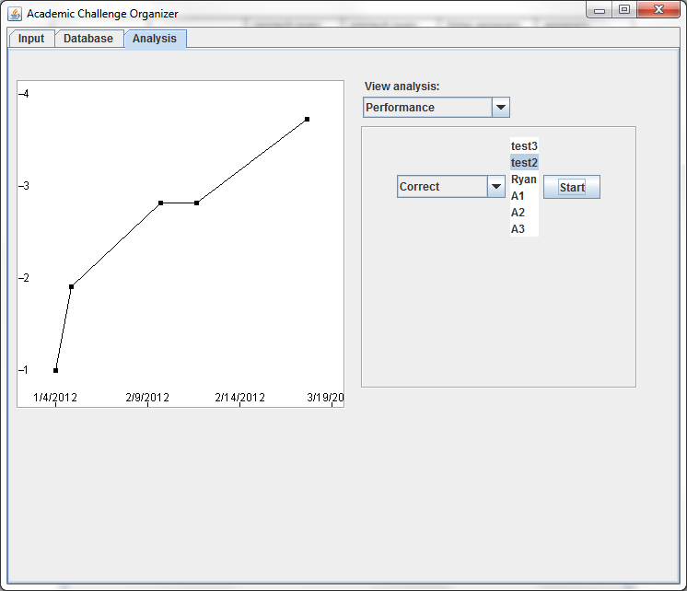

G7 a)

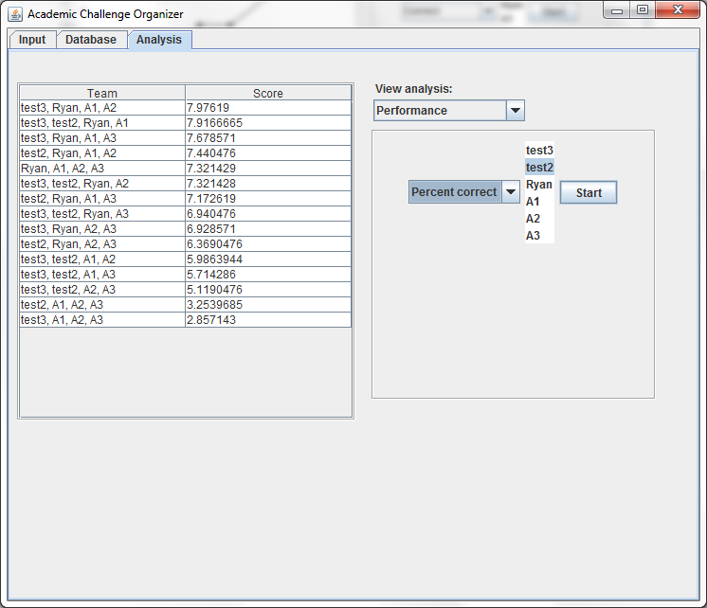

G7 b)

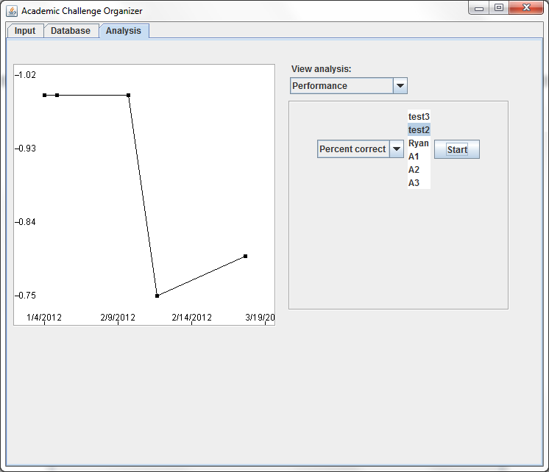

G8 a)

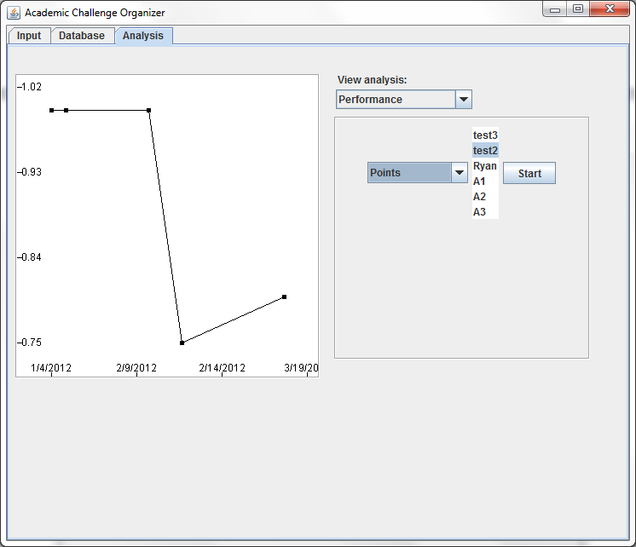

G8 b)

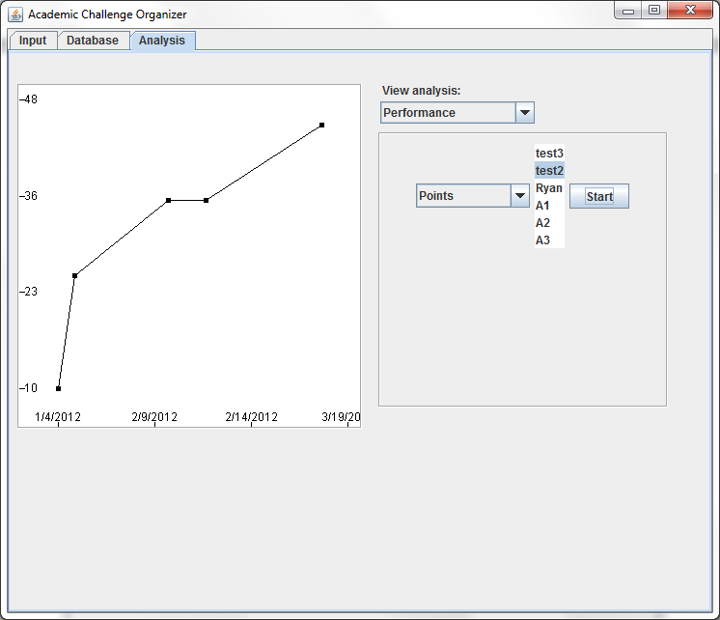

G9 a)

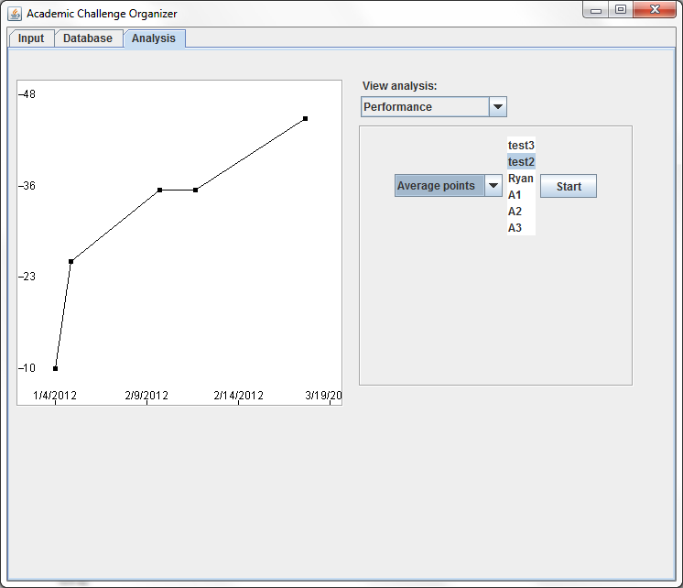

G9 b)

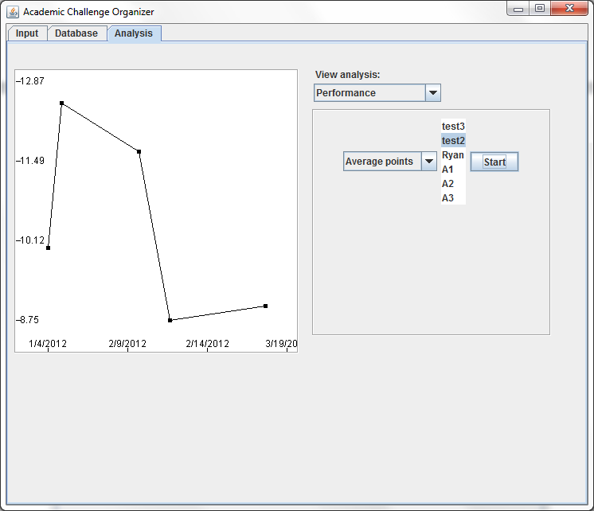

# Ranking charts

|  |  |  |  |
| --- | --- | --- | --- |
|  | G10 | G11 | G12 |
| Action | Select “Ranking” | Select “Unbiased Ranking” | Select “Ranking in Subject”, select a subject (“Science” here), click start |
| Expected Result | Ranking shown, biased by ability in subject | Ranking shown, unbiased | Ranking shown within selected subject |
| Actual Result | Ranking shown, biased by ability in subject | Ranking shown, unbiased | Ranking shown within selected subject |

G10 a)

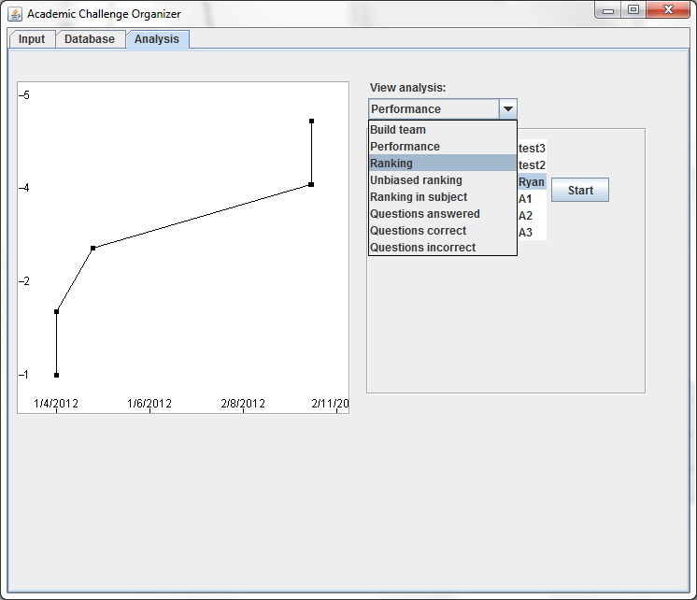

G10 b)

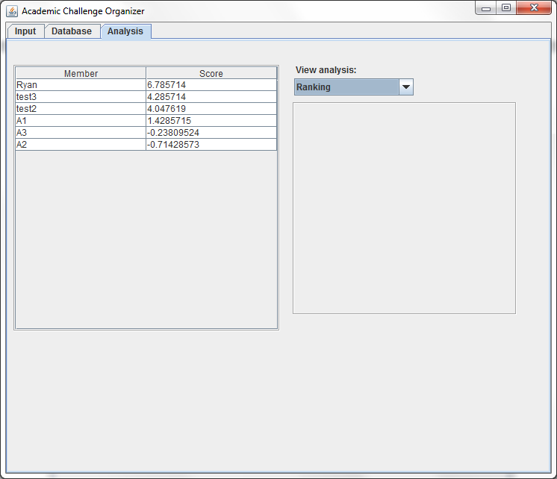

G11 a)

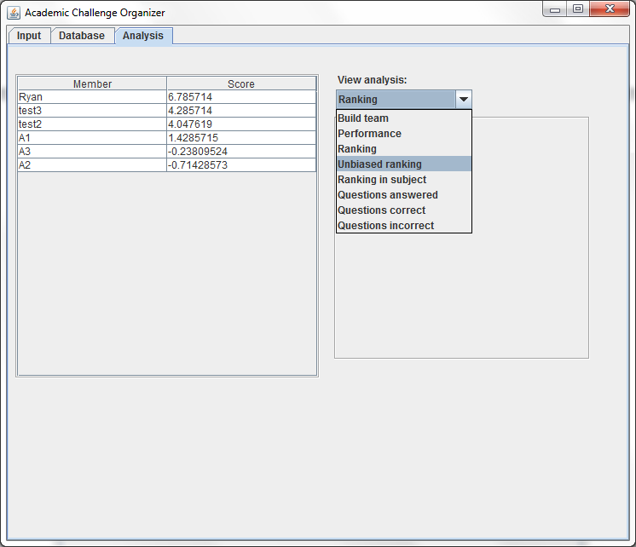

G11 b)

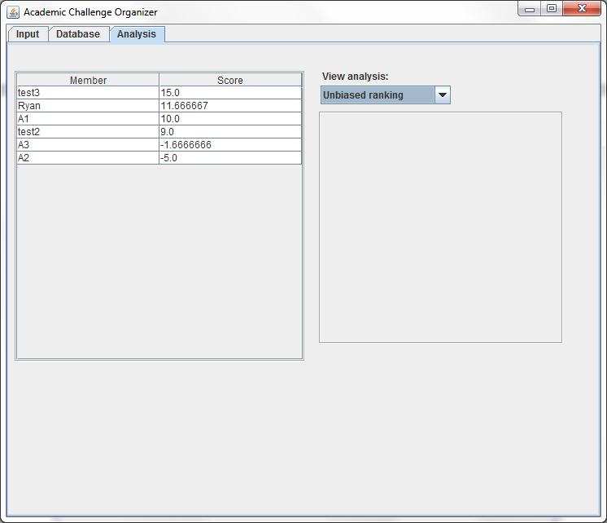

G12 a)

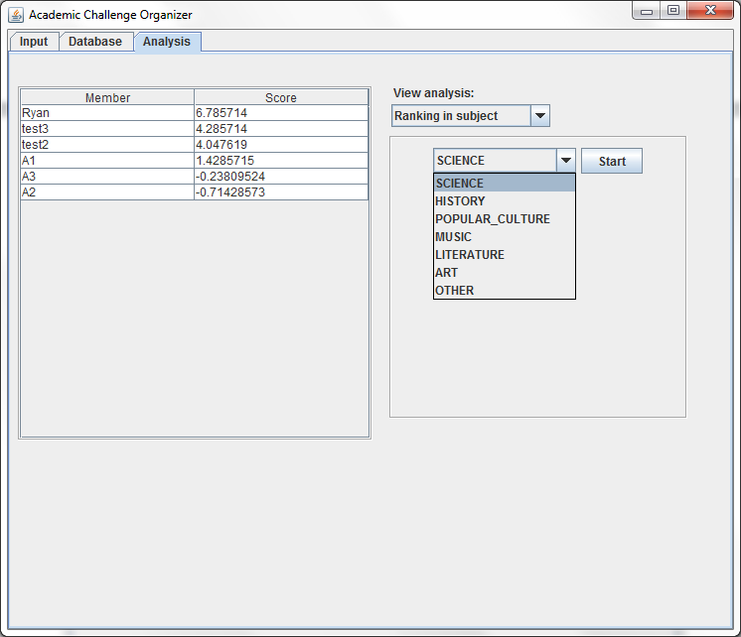

G12 b)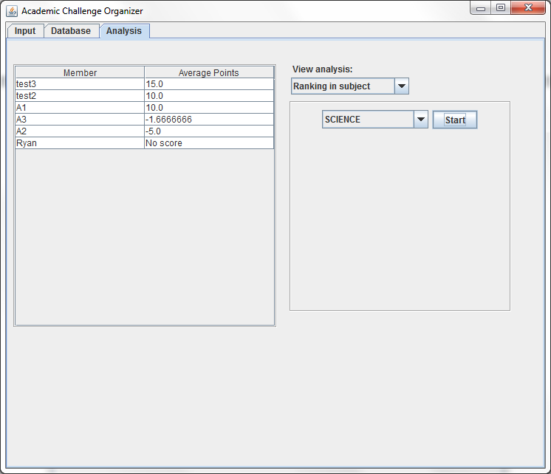

# Question statistics

|  |  |  |  |
| --- | --- | --- | --- |
|  | G13 | G14 | G15 |
| Action | Select “Questions Answered” | Select “Question Correct” | Select “Questions Incorrect” |
| Expected Result | Members sorted by number of questions answered | Members sorted by number of questions answered correctly | Members sorted by number of questions answered incorrectly |
| Actual Result | Members sorted by number of questions answered | Members sorted by number of questions answered correctly | Members sorted by number of questions answered incorrectly |

G13 a)

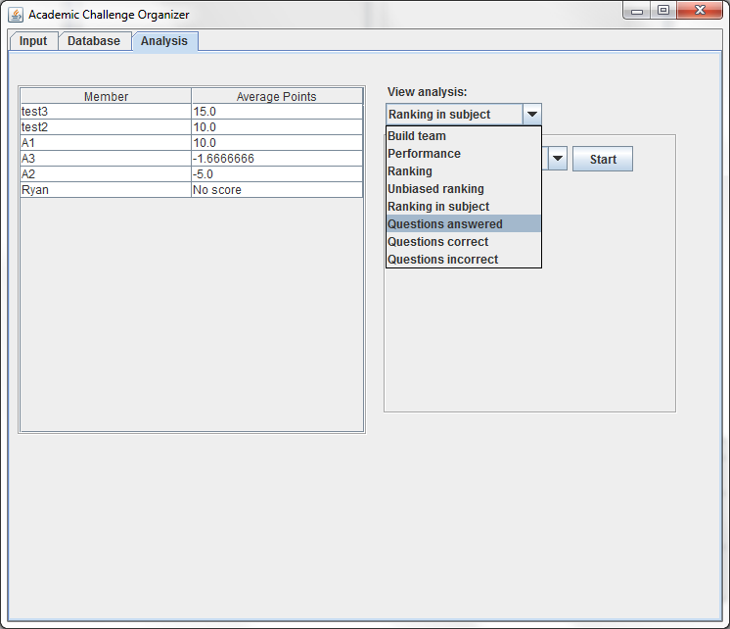

G13 b)

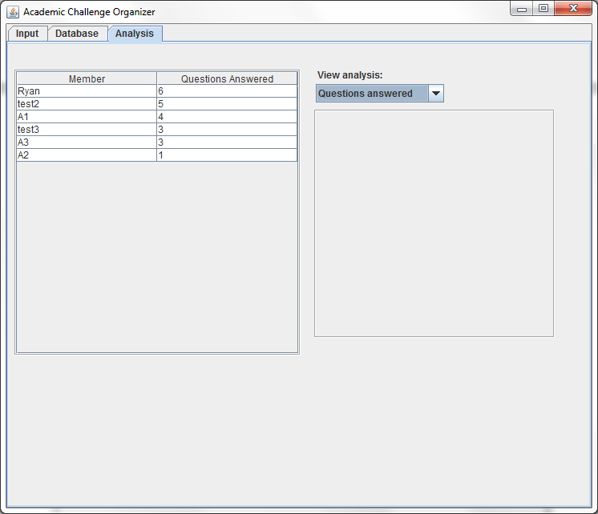

G14 a)

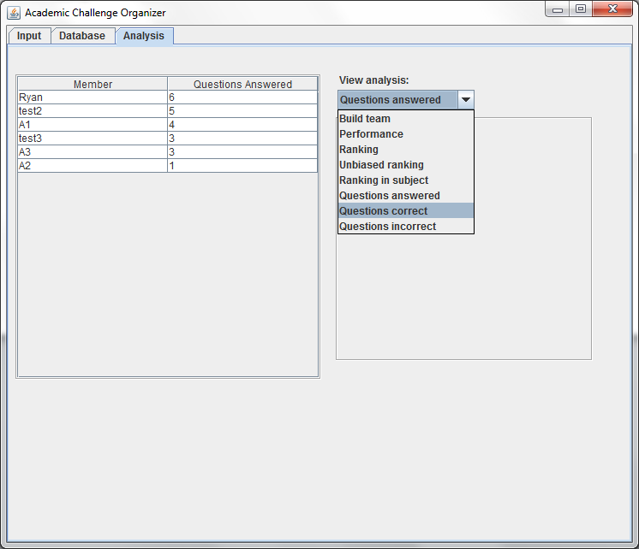

G14 b)

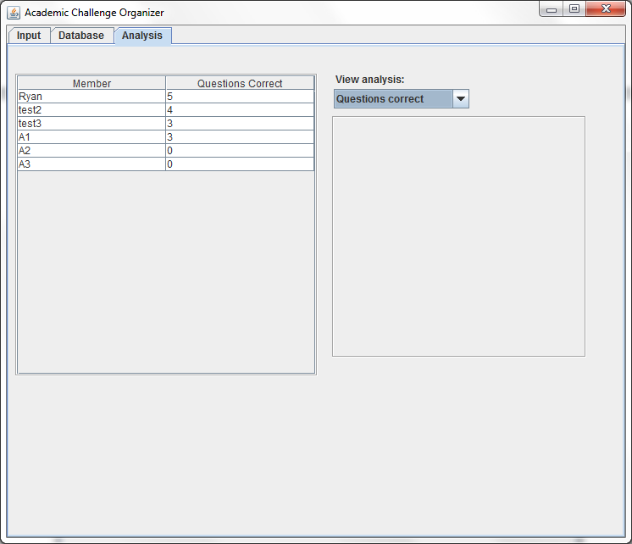

G15 a) 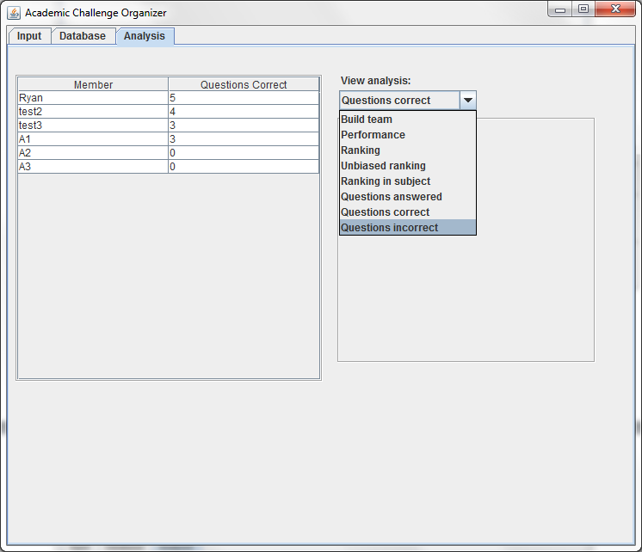

G15 b)

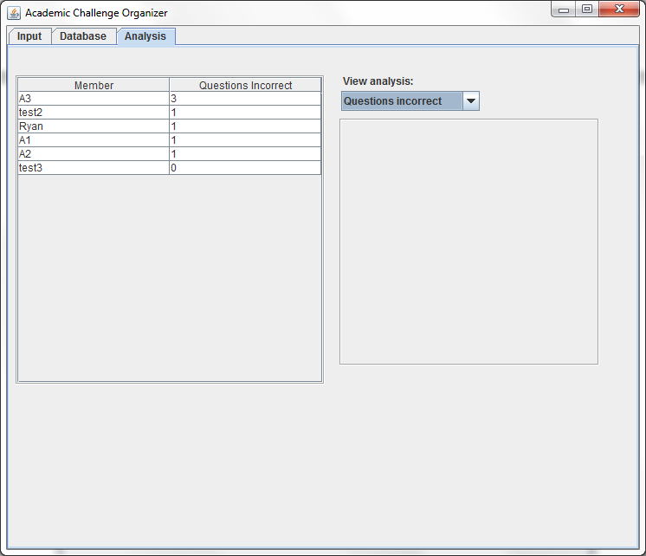

Evaluating Solutions

# Did it work?

My application worked, as was showing in the hardcopy (D1). Although it has some weird responses to anomaly entries, as long as all fields have something, even a letter, there are little to no known bugs.

# Did is address the criteria for success? (A2)

The application mostly addressed the criteria for success. Because more was addressed than not addressed, I will discuss what was not addressed and what was changed.

## Data viewing

I chose not to implement various sorting mechanisms due to time constraints. Each sorting mechanism would require its own method, unless the java.lang.reflect library is used to dynamically access properties. Even then, I would have to implement some method of selecting sorting mechanism, which would take much time. Instead, I defaulted sorting to alphabetical for Members and reverse-chronological (most recent first) for Responses and Questions.

## Analysis

Because I chose not to implement recording matches attended and questions heard (but not answered), it was impossible to analyze by percent correct per match (this likely would have been trivial, in any case) and percent correct per question heard. I chose not to implement recording matches because I felt that it was unnecessary and that my time could be better invested in improving other areas of the application, such as faster file handling and powerful graphs.

## Team Analyzer

I modified my equations for the team analyzer. They now look like this:

$$\frac{\sum_{i=1}^{t}{\frac{\sum_{j=1}^{R_{i}}{R_{ij}}}{R_{i}}}}{t}$$

Where $t$ is the number of subject types, $R$ is the matrix of responses, $R_{i}$ is the length of the set of responses for type $i$, and $R_{ij}$ is the points value of the response of type $i$ and offset $j$. I modified this equation to better suit my analyzer. It takes the average of the response set for each type, then averages all those averages.

## Analysis Caching

I chose not to implement analysis caching because it was entirely unnecessary. Retrieving a file containing analyses would barely, if even, reduce time, as opposed to simply re-computing the analysis. This will also not impact maximum memory usage.

# Data sets

As explained in the criteria for success, larger data sets are suggested, but not required. Some graphs require larger data sets simply to set axes, but the team generator will always work. The only situation in which the team generator will not work is when there are fewer than 3 members (i.e. 0, 1, or 2). This is not a flaw in the application, but done by design. There is simply no use in running calculations for under 3 members, seeing as this is the minimum legal team size.

# Limitations & Additional Features

As with any data-based analysis, larger data sets are always better. The application works in all aspects, although there are a few bugs if the user makes mistakes. As well, it is not possible to undo an error once it has been submitted, except in the case of members.

Once a response or question has been removed, there is no way to edit or remove it. If the user makes an error and realizes after finishing the session or continuing to the next panel, the user cannot undo this mistake. The ability to edit and remove responses and questions that have already been submitted would fix this. This would be done through the database panel.

If a user starts a session but does not include all the desired members, users cannot be added. An option to edit the session’s members should be made available.

In addition to this, a user cannot remove questions once the user has progressed to the AnswerEntryPanel. This could be changed in a similar manage to the above: by offering the option to edit questions at any point.

If the user decides to throw out a series of questions after the session has started, it is impossible to do so without sufficient knowledge of technology. The only way to end the session is to close the application, delete the session file, then reload the application, OR load the application, end the task (either force-quit on Unix-based machines or end-task on Windows machines), and reload the application.

# Was the initial design appropriate?

The initial design was not appropriate. My initial design was a wizard-like setup, which would be very inconvenient. Even though hotkeys would make things faster, few people know how to use hotkeys, and the user cannot be expected to understand how to use them. My second design was much more appropriate. It resembles the current design and is far friendlier than the initial design.

# The client’s thoughts

Overall, the client was satisfied with the application. The client stated that the input was a little bit difficult to use, and would like it to be faster to enter data; perhaps the initial design would have been more appropriate. He was impressed with the ability to generate teams and stated that the algorithm seemed to work from the data he had tested.

Documentation of Mastery Aspects

# Aspect 1

Aspect #1: Adding data to an instance of the RandomAccessFile class by direct manipulation of the file pointer using the seek method

1. Definition: AbstractFileHandler.writeBlock(Block) (p. 76)
2. Usage: DataHandler.write() at line 79 (p. 112), Session.dumpSession() at line 132 (p. 217), called by InputPanel.<init> at line 54 (p. 116)

### Definition:

AbstractFileHandler.java:

/**

* Writes a block to the file.

*

* **@param** block

* The block to write to the file. If the block ID is -1, an ID

* is assigned. This is used for adding blocks. If the ID is not

* -1, then the writer writes at the relevant position.

* **@throws** IOException

* When the write failed. See the exception for details.

*/

**public** **void** writeBlock(Block block) **throws** IOException

{

**int** id;

**long** pos;

// check if "add" or "edit" is requested.

**if** (block.getID() == -1)

// assign an ID

block.setID(**this**.findNextAvailableID(block.getBlockSize()));

// get the ID so the writer knows where to write

id = block.getID();

// find the position to write to

pos = (**long**) id * block.getBlockSize();

// call the write() function to initialize writing

**this**.writeString(block.getContents(), pos);

}

/**

* Writes a string to the given position

*

* **@param** str

* The string to be written, intended to be

* {@code block.getContents()}

* **@param** pos

* The position to write to

* **@throws** IOException

* When raf encouters a problem

*/

**protected** **void** writeString(String str, **long** pos) **throws** IOException

{

// Move the pointer to the desired location

**this**.raf.seek(pos);

// iterate through the string

**for** (**char** c : str.toCharArray())

**this**.raf.writeChar(c); // write each character

}

### Usage:

InputPanel.java:

**else** **if** (obj **instanceof** QuestionAnswerEntryPanel

|| obj **instanceof** AnswerEntryPanel)

{

Logger.*getLogger*(**this**.getClass().getName()).log(Level.*ALL*,

"Session finished");

Session.*dumpSession*();

panel = **new** MemberSelectionPanel();

}

#### Calls:

Session.java:

**try**

{

DataHandler dh = MainFrame.*getInstance*().getDataHandler();

**for** (Response r : *session*.responses)

dh.write(r);

**for** (Question q : *session*.questions)

dh.write(q);

*session* = **null**;

// remove session backup file

**new** File(Constants.*FILE_SESSION*).delete();

**return** **true**;

}

#### Calls:

DataHandler.java:

/**

* Writes a block and assigns an ID.

*

* **@param** block

* The block to write

* **@throws** IOException

* When a write error occurs.

* **@see** #delete(Block)

*/

**public** **void** write(Block block) **throws** IOException

{

**boolean** flag = **false**;

// if there's a failure in writing, we shouldn't add the member

**if** (block **instanceof** Member && block.getID() == -1)

flag = **true**;

AbstractFileHandler afh = **this**.getFileHandler(block);

afh.writeBlock(block);

// now that the writing has succeeded, we write the member

**if** (flag)

**this**.memberCache.append((Member) block);

}

# Aspect 2

Aspect #2: Deleting data from an instance of the RandomAccessFile class by direct manipulation of the file pointer using the seek method. (Data primitives or objects may be shuffled or marked as deleted by use of a flag field. Therefore files may be ordered or unordered).

1. Definition: AbstractFileHandler.delete(Block) (p. 77-78)
2. Usage: DataHandler.delete(Block) at line 149 (p. 112-113), MemberSelectionPanel.getRemoveButton() at line 275 (p. 145-146).

## Definition:

AbstractFileHandler.java:

/**

* Deletes a given block.

*

* **@param** block

* The block to be deleted

* **@throws** IOException

* When the file handler encounters a problem. See the exception

* for details.

*/

**public** **void** delete(Block block) **throws** IOException

{

**long** pos;

// Calculate the start position of the block

pos = block.getID() * block.getBlockSize();

// Seek to the block

**this**.raf.seek(pos);

// Mark the block for deletion by writing a

// deletion marker to the first slot

**this**.raf.writeChar(*DELETION_MARKER*);

}

## Usage:

MemberSelectionPanel.java:

**try**

{

MainFrame.*getInstance*().getDataHandler()

.delete(m);

MemberSelectionPanel.**this**.updateLists();

}

#### Calls:

DataHandler.java:

/**

* Delete a block. Manages deleting all traces.

*

* **@param** block

* The block to delete

* **@throws** IOException

* When a write error occurs.

* **@see** #write(Block)

*/

**public** **void** delete(Block block) **throws** IOException

{

**if** (block == **null**)

**return**;

...

**this**.getFileHandler(block).delete(block);

}

# Aspect 3

Aspect #3: Searching for specified data in a file.

1. Definition: AbstractFileHandler.find(int, int) (p. 78)
2. Usage: MemberFileHandler.loadAllMembers() at line 48 (p. 138), DataHandler.<init> at line 42 (p. 111).

## Definition:

AbstractFileHandler.java:

/**

* Finds the unique block corresponding to the unique ID given.

*

* **@param** id

* The ID of the block

* **@param** blockSize

* The size of each block in the file. Should be a constant.

* **@return** The block with the unique ID given.

* **@throws** IOException

* When file reading fails. See exception for details.

*/

**public** Block find(**int** id, **int** blockSize) **throws** IOException

{

**long** pos;

String value;

// Calculate the position of the desired block

pos = (**long**) id * blockSize;

**if** (pos > **this**.raf.length())

**return** **null**;

// Read the value of the block at the location

value = **this**.read(pos, blockSize / 2);

// verify that the block exists and is not deleted

**if** (value.length() == 0 || value.charAt(0) == *DELETION_MARKER*)

**return** **null**;

// Convert the String to a Block and return it

**return** **this**.stringToBlock(id, value);

}

## Usage:

DataHandler.java:

// load member cache

**try**

{

**this**.memberCache = **this**.mfh.loadAllMembers();

}

**catch** (Exception ex)

{

ex.printStackTrace();

// error, initialize memberCache as empty list to avoid NPE

**this**.memberCache = **new** LinkedList<Member>();

}

#### Calls:

MemberFileHandler.java:

/**

* Loads all members in the file

*

* **@return** A {@link LinkedList} of generic type {@link Member} containing

* all {@link Member}s in this file.

* **@throws** IOException

* If reading has an error.

*/

**public** LinkedList<Member> loadAllMembers() **throws** IOException

{

LinkedList<Member> members = **new** LinkedList<Member>();

**int** id = 0;

Block block;

**while** ((block = **this**.find(id, *MEMBER_BLOCK_SIZE* * *CHAR_SIZE*)) != **null**)

{

members.append((Member) block);

id++;

}

**return** members;

}

# Aspect 4

Aspect #4: Recursion

1. Definition: DataHandler.delete(Block) at line 127 (p. 112-113).
2. MemberSelectionPanel.getRemoveButton() at line 275 (p. 145-146).

Note: Recursion is used to remove referenced objects, extending block but of a different type.

## Definition:

DataHandler.java:

/**

* Delete a block. Manages deleting all traces.

*

* **@param** block

* The block to delete

* **@throws** IOException

* When a write error occurs.

* **@see** #write(Block)

*/

**public** **void** delete(Block block) **throws** IOException

{

...

**else** **if** (block **instanceof** Question)

{

**this**.delete(((Question) block).answer1);

**if** (((Question) block).answer2 != **null**)

**this**.delete(((Question) block).answer2);

}

...

}

## Usage:

MemberSelectionPanel.java:

**try**

{

MainFrame.*getInstance*().getDataHandler()

.delete(m);

MemberSelectionPanel.**this**.updateLists();

}

# Aspect 5

Aspect #6: Polymorphism

1. Definition: AbstractFileHandler.stringToBlock(int, String) at line 35 (p. 75)
2. Override at: MemberFileHandler.stringToBlock(int, String) at line 130 (p. 140), QuestionFileHandler.stringToBlock(int, String) at line 37 (p. 188-189), ResponseFileHandler.stringToBlock(int, String) at line 32 (p. 213).
3. Usage: AbstractFileHandler.find(int, int) at line 195 (p. 78).

## Definition:

AbstractFileHandler.java:

**protected** **abstract** Block stringToBlock(**int** id, String s);

## Overrides:

MemberFileHandler.java:

@Override

**protected** Block stringToBlock(**int** id, String s)

{

**if** (s.equals(""))

**return** **null**;

Member member = **new** Member();

member.setID(id);

member.age = Byte.*parseByte*(s.substring(*MEMBER_BLOCK_AGE_OFF*,

*MEMBER_BLOCK_AGE_OFF* + *MEMBER_BLOCK_AGE_SIZE*).trim());

member.name = s.substring(*MEMBER_BLOCK_NAME_OFF*,

*MEMBER_BLOCK_NAME_OFF* + *MEMBER_BLOCK_NAME_SIZE*).trim();

member.email = s.substring(*MEMBER_BLOCK_EMAIL_OFF*,

*MEMBER_BLOCK_EMAIL_OFF* + *MEMBER_BLOCK_EMAIL_SIZE*).trim();

**return** member;

}

QuestionFileHandler.java:

@Override

**protected** Block stringToBlock(**int** id, String s)

{

**if** (s.length() == 0)

**return** **null**;

Question q = **new** Question();

... //modify q for about 50-60 lines, so I won’t show it

**return** q;

}

ResponseFileHandler.java:

@Override

**protected** Block stringToBlock(**int** id, String s)

{

**if** (s.length() == 0)

**return** **null**;

Response r = **new** Response();

r.setID(id);

r.date = Long.*parseLong*(s.substring(*RESPONSE_BLOCK_DATE_OFF*,

*RESPONSE_BLOCK_DATE_OFF* + *RESPONSE_BLOCK_DATE_SIZE*).trim());

r.value = s.substring(*RESPONSE_BLOCK_VALUE_OFF*,

*RESPONSE_BLOCK_VALUE_OFF* + *RESPONSE_BLOCK_VALUE_SIZE*).trim();

r.pointsEarned = Byte.*parseByte*(s.substring(*RESPONSE_BLOCK_EARNED_OFF*,

*RESPONSE_BLOCK_EARNED_OFF* + *RESPONSE_BLOCK_EARNED_SIZE*).trim());

**return** r;

}

## Usage

AbstractFileHandler.java:

/**

* Finds the unique block corresponding to the unique ID given.

*

* **@param** id

* The ID of the block

* **@param** blockSize

* The size of each block in the file. Should be a constant.

* **@return** The block with the unique ID given.

* **@throws** IOException

* When file reading fails. See exception for details.

*/

**public** Block find(**int** id, **int** blockSize) **throws** IOException

{

**long** pos;

String value;

// Calculate the position of the desired block

pos = (**long**) id * blockSize;

**if** (pos > **this**.raf.length())

**return** **null**;

// Read the value of the block at the location

value = **this**.read(pos, blockSize / 2);

// verify that the block exists and is not deleted

**if** (value.length() == 0 || value.charAt(0) == *DELETION_MARKER*)

**return** **null**;

// Convert the String to a Block and return it

**return** **this**.stringToBlock(id, value);

}

# Aspect 6

Aspect #7: Inheritance

* + - 1. Definition: AbstractFileHandler
      2. Usage: MemberFileHandler, QuestionFileHandler, ResponseFileHandler

## Definition:

AbstractFileHandler.java:

/**

* Superclass of all file handlers in this application, aside from

* {@link Session}, which is handled differently.

*

* This superclass handles writing, deleting, reading, finding, and ID

* assigning. The method {@link #init()} <b>must</b> be called. Failure to do so

* will result in a NullPointerException.

*

* **@author** Ryan Amos

*

* **@see** DataHandler

* **@see** Session

*/

**public** **abstract** **class** AbstractFileHandler **implements** Constants

## Extended by:

MemberFileHandler.java:

/**

* {@link Member} specific {@link AbstractFileHandler}. Provides 3 unique

* methods:

*

* **@see** #loadAllMembers()

* **@see** #findQuestions(Member)

* **@see** #findResponses(Member)

*

* **@author** Ryan Amos

*

* **@see** AbstractFileHandler

* **@see** Member

*/

**public** **class** MemberFileHandler **extends** AbstractFileHandler

QuestionFileHandler.java:

/**

* {@link Question} specific {@link AbstractFileHandler}.

*

* **@author** Ryan Amos

*

* **@see** AbstractFileHandler

* **@see** Question

*/

**public** **class** QuestionFileHandler **extends** AbstractFileHandler

ResponseFileHandler.java:

/**

* {@link Response} specific {@link AbstractFileHandler}.

*

* **@author** Ryan Amos

*

* **@see** AbstractFileHandler

* **@see** Response

*/

**public** **class** ResponseFileHandler **extends** AbstractFileHandler

# Aspect 7

Aspect #8: Encapsulation.

Method encapsulation:

1. Definition: AbstractFileHandler.writeBlock(Block) at line 71 (p. 76)
2. Usage: DataHandler.write(Block) at line 79 (p. 112), MemberAddAndEditDialog.getButtonPanel() at line 166-167 (p. 133-134)

## Definition:

AbstractFileHandler.java:

/**

* Writes a block to the file.

*

* **@param** block

* The block to write to the file. If the block ID is -1, an ID

* is assigned. This is used for adding blocks. If the ID is not

* -1, then the writer writes at the relevant position.

* **@throws** IOException

* When the write failed. See the exception for details.

*/

**public** **void** writeBlock(Block block) **throws** IOException

{

**...**

}

Usage:

MemberAddAndEditDialog.java:

**this**.submit.addActionListener(**new** ActionListener()

{

**public** **void** actionPerformed(ActionEvent e)

{

...

**try**

{

MainFrame.*getInstance*().getDataHandler()

.write(MemberAddAndEditDialog.**this**.member);

...

}

**catch** (IOException ex)

{

ex.printStackTrace();

}

MemberAddAndEditDialog.**this**.dispose();

}

});

#### Calls

DataHandler.java:

/**

* Writes a block and assigns an ID.

*

* **@param** block

* The block to write

* **@throws** IOException

* When a write error occurs.

* **@see** #delete(Block)

*/

**public** **void** write(Block block) **throws** IOException

{

**boolean** flag = **false**;

// if there's a failure in writing, we shouldn't add the member

**if** (block **instanceof** Member && block.getID() == -1)

flag = **true**;

AbstractFileHandler afh = **this**.getFileHandler(block);

afh.writeBlock(block);

// now that the writing has succeeded, we write the member

**if** (flag)

**this**.memberCache.append((Member) block);

}

Private member encapsulation:

1. Definition: LinkedList.headNode at line 55 (p. 120)
2. Usage: LinkedList.findByID(int) at line 215 (p. ), DataHandler.findMemberByID(int) at line 60 (p. ), QuestionFileHandler.stringToBlock(String) at line 87 (p. )

# Definition:

LinkedList.java:

**private** Node<T> headNode;

# Usage:

QuestionFileHandler.java:

@Override

**protected** Block stringToBlock(**int** id, String s)

{

...

**if** (responder1id != -1)

q.responder1 = dh.findMemberByID(responder1id);

...

}

#### Calls

DataHandler.java:

**public** Member findMemberByID(**int** id)

{

**return** **this**.memberCache.findByID(id);

}

#### Calls

LinkedList.java:

/**

* Finds the element with the given id.

*

* **@param** id

* The ID to search for

* **@return** The element if it exists, {@code null} otherwise.

*/

**public** T findByID(**int** id)

{

Node<T> n = **this**.headNode;

**while** (n != **null**)

{

**if** (n.getValue().getID() == id)

**return** n.getValue();

n = n.next;

}

**return** **null**;

}

# Aspect 8

Aspect #9: Parsing a text file or other data stream

1. Definition: AbstractFileHandler.read(long, int) at line 223-224 (p. 78)
2. Usage: AbstractFileHandler.find(int, int) at line 118 (p. 78-79), QuestionFileHandler.stringToBlock(int, String) at line 57-58 (p. 188-189),

## Definition:

/**

* Reads from the file for a given length. Usually, the provided length is

* the length of the block to be read.

*

* **@param** pos

* The offset from the start of the file

* **@param** length

* The length to read in

* **@return** The String of the desired length at the desired offset. Usually a

* block.

* **@throws** IOException

* When raf has a problem

*/

**protected** String read(**long** pos, **int** length) **throws** IOException

{

StringBuffer buf;

buf = **new** StringBuffer();

// Seek to the desired position.

**this**.raf.seek(pos);

// Read in the block. Stop when the block is of the desired length

**try**

{

**while** (buf.append(**this**.raf.readChar()).length() < length)

;

}

...

}

## Usage

@Override

**protected** Block stringToBlock(**int** id, String s)

{

...

**if** (response2id != -1)

**try**

{

q.answer2 = (Response) rfh.find(response1id,

*RESPONSE_BLOCK_SIZE* * 2);

q.answer2.question = q;

}

**catch** (IOException e)

{

e.printStackTrace();

}

...

**return** q;

}

#### Calls

AbstractFileHandler.java:

/**

* Finds the unique block corresponding to the unique ID given.

*

* **@param** id

* The ID of the block

* **@param** blockSize

* The size of each block in the file. Should be a constant.

* **@return** The block with the unique ID given.

* **@throws** IOException

* When file reading fails. See exception for details.

*/

**public** Block find(**int** id, **int** blockSize) **throws** IOException

{

**long** pos;

String value;

// Calculate the position of the desired block

pos = (**long**) id * blockSize;

**if** (pos > **this**.raf.length())

**return** **null**;

// Read the value of the block at the location

value = **this**.read(pos, blockSize / 2);

// verify that the block exists and is not deleted

**if** (value.length() == 0 || value.charAt(0) == *DELETION_MARKER*)

**return** **null**;

// Convert the String to a Block and return it

**return** **this**.stringToBlock(id, value);

}

# Aspects 9-12

Aspect #12-15: Up to four aspects can be awarded for the implementation of abstract data types (ADTs) according to the table entitled “Implementation of ADTs”.

ADT: LinkedList<T>; Definition at LinkedList.java (p. 119-124).

## Implementation #1

LinkedList.clone() at line 245 (p. 123):

@Override

**public** LinkedList<T> clone()

{

LinkedList<T> clone = **new** LinkedList<T>();

**if** (**this**.headNode == **null**)

{

clone.headNode = **null**;

clone.tailNode = **null**;

clone.length = 0;

**return** clone;

}

clone.headNode = **new** Node<T>(**this**.headNode.getValue());

Node<T> n1 = **this**.headNode;

Node<T> n2 = clone.headNode;

**while** (n1.next != **null**)

{

n1 = n1.next;

Node<T> newNode = **new** Node<T>(n1.getValue());

newNode.prev = n2;

n2.next = newNode;

n2 = newNode;

}

clone.tailNode = n2;

clone.length = **this**.length;

**return** clone;

}

Implemented at DataHandler.getMembers() at line 53 (p. 111-112) (in order to allow mutation of the list without affecting the cache):

**public** LinkedList<Member> getMembers()

{

**return** **this**.memberCache.clone();

}

## Implementation #2

LinkedList.append(T) at line 70 (p. 120):

/**

* Appends an item to the end of the {@code LinkedList}

*

* **@param** item

* The item to append

*/

**public** **void** append(T item)

{

// create the node to add

Node<T> newNode = **new** Node<T>(item);

**this**.length++;

// empty list

**if** (**this**.headNode == **null**)

{

**this**.headNode = newNode;

**this**.tailNode = newNode;

**return**;

}

newNode.prev = **this**.tailNode;

// give the current end/tail node a "next" value

**this**.tailNode.next = newNode;

// update the tail node to point to the new tail node

**this**.tailNode = newNode;

}

Implemented at: QuestionEditDialog.getSubmitButton() at line 197-198 (p. 174-175):

**private** JButton getSubmitButton()

{

**if** (**this**.submitButton == **null**)

{

...

**this**.submitButton.addActionListener(**new** ActionListener()

{

**public** **void** actionPerformed(ActionEvent e)

{

...

**try**

{

Session.*getInstance*().getQuestions()

.append(QuestionEditDialog.**this**.q);

...

}

...

}

});

}

**return** **this**.submitButton;

}

## Implementation #3

LinkedList.iterator() at line 100 (p. 120-121):

**public** Iterator<T> iterator()

{

**return** **new** Iterator<T>()

{

// set the first node in the list to the head node

Node<T> n = LinkedList.**this**.headNode;

**public** **boolean** hasNext()

{

// only has a next if n can be read

**return** **this**.n != **null**;

}

**public** T next()

{

// retrieve the value for return later

T value = **this**.n.getValue();

// travel along the LinkedList

**this**.n = **this**.n.next;

**return** value;

}

**public** **void** remove()

{

**throw** **new** UnsupportedOperationException();

}

};

}

Implemented at: MemberSelectionPanel.updateLists() at line 413 (p. 148) (using a for-each loop requires the iterator() method. As such, LinkedList.iterator() is implicitly called):

**public** **void** updateLists()

{

LinkedList<Member> left = MainFrame.*getInstance*().getDataHandler()

.getMembers();

LinkedList<Member> right = Session.*getInstance*().getParticipants();

**for** (Member m : right)

left.remove(m);

**this**.allMembersList.setListData(left.toArray(**new** Member[0]));

**this**.currentMembersList.setListData(right.toArray(**new** Member[0]));

}

## Implementation #4

LinkedList.findByID(int) at line 213 (p. ):

/**

* Finds the element with the given id.

*

* **@param** id

* The ID to search for

* **@return** The element if it exists, {@code null} otherwise.

*/

**public** T findByID(**int** id)

{

Node<T> n = **this**.headNode;

**while** (n != **null**)

{

**if** (n.getValue().getID() == id)

**return** n.getValue();

n = n.next;

}

**return** **null**;

}

Implemented at: DataHandler.findMemberByID(int) at line 60 (p. 112), called by QuestionFileHandler.stringToBlock(String) at line 87 (p. 188-189)

QuestionFileHandler.java:

@Override

**protected** Block stringToBlock(**int** id, String s)

{

...

**if** (responder1id != -1)

q.responder1 = dh.findMemberByID(responder1id);

...

}

#### Calls

DataHandler.java:

**public** Member findMemberByID(**int** id)

{

**return** **this**.memberCache.findByID(id);

}

# Aspect 13

Aspect #16: External libraries:

## Definition:

MainFrame.java, using javax.swing (p. 125-128):

/**

* The main {@link JFrame} of the application, which acts as a central hub

* for all activity. It provides access to the main {@link DataHandler} and

* manages all graphical interfaces.

*

* **@author** Ryan Amos

*

* **@see** Main

*/

**public** **class** MainFrame **extends** JFrame

{

...

**public** MainFrame()

{

**super**();

**if** (*frame* != **null**)

**throw** **new** RuntimeException("Instance already exists.");

*frame* = **this**;

**this**.initialize();

**this**.setVisible(**true**);

}

...

}

## **Usage:**

Application Entry point Main.main(String[]), Main.java at line (p. 229)

**public** **static** **void** main(String[] args)

{

...

/* Initialize the MainFrame */

MainFrame.*getInstance*();

}

# Aspect 14

Aspect #19: Arrays of two or more dimensions

1. Definition: TeamAnalyzer.getOptionsPanel(ResultFoundListener) at line 99 (p. 220-221)
2. Usage: TeamAnalyzer.getOptionsPanel(ResultFoundListener) at line 128 (p. 221). This will then call back to AnalysisPanel (p. 80-82) to update the plot.

## Definition:

System.*out*.println("Generating teams...");

**int**[][] combinations = Combinations.*getCombinations*(

(TeamAnalyzer.**this**.members.getSelectedValues().length == 3) ? 3

: 4, TeamAnalyzer.**this**.members

.getSelectedValues().length);

System.*out*.println("Computing scores...");

Member[][] teams = **new** Member[combinations.length][];

**float**[] scores = **new** **float**[combinations.length];

**for** (**int** i = 0; i < combinations.length; i++)

{

Member[] team = **new** Member[combinations[i].length];

**for** (**int** j = 0; j < team.length; j++)

team[j] = (Member) TeamAnalyzer.**this**.members

.getSelectedValues()[combinations[i][j]];

combinations[i] = **null**; // dump from memory to save space

teams[i] = team; // save team

scores[i] = TeamAnalyzer.**this**.getScore(team);

System.*out*.println(TeamAnalyzer.**this**

.arrayToString(teams[i])

+ " recieved score "

+ scores[i]);

}

## Usage:

System.*out*.println("Sorting data...");

/* bubble sort */

Utility.*bubbleSort*(teams, scores);

System.*out*.println("Preparing table...");

/* prepare table */

Object[][] data = **new** Object[teams.length][2];

**for** (**int** i = 0; i < data.length; i++)

{

data[i][0] = TeamAnalyzer.**this**.arrayToString(teams[i]);

teams[i] = **null**;

data[i][1] = scores[i];

}

rfl.resultFound(**new** JScrollPane(**new** JTable(data, **new** String[]

{ "Team", "Score" })));

# Aspect 15

Aspect #11: The use of any five standard level mastery factors.

## 1. SL Aspect #15: The use of sentinels or flags.

1. Definition: Utility.bubbleSort(Object[], float[]) at line 26 (p. 228).
2. Usage: TeamAnalyzer.getOptionsPanel(ResultFoundListener) at line 120 (p. 221), Utility.bubbleSort(Object[], float[]) at line 27, 29, and 46 (p. 228).

### Defintion:

/**

* Sorts in descending order by score. Assumes each Object is mapped to each

* float. m[i] is swapped with scores[i]

*

* **@param** m

* The array of data. Can be arrays of arrays, objects, etc

* **@param** scores

* The scores for each object in that data array. Must have the

* same length as the data array

*/

**public** **static** **void** bubbleSort(Object[] m, **float**[] scores)

{

**if** (m.length != scores.length)

**throw** **new** IllegalArgumentException("m and scores do not map!");

/* bubble sort */

**boolean** b = **true**;

**while** (b)

{

b = **false**;

**for** (**int** i = 1; i < scores.length; i++)

**if** (scores[i] > scores[i - 1]

|| (!Float.*isNaN*(scores[i]) && Float

.*isNaN*(scores[i - 1])))

{

// swap

// swap score

**float** temp1 = scores[i];

scores[i] = scores[i - 1];

scores[i - 1] = temp1;

// swap team

Object temp2 = m[i];

m[i] = m[i - 1];

m[i - 1] = temp2;

b = **true**;

}

}

}

### Usage:

/* bubble sort */

Utility.*bubbleSort*(teams, scores);

#### Calls:

**public** **static** **void** bubbleSort(Object[] m, **float**[] scores)

{

**if** (m.length != scores.length)

**throw** **new** IllegalArgumentException("m and scores do not map!");

/* bubble sort */

**boolean** b = **true**;

**while** (b)

{

b = **false**;

**for** (**int** i = 1; i < scores.length; i++)

**if** (scores[i] > scores[i - 1]

|| (!Float.*isNaN*(scores[i]) && Float

.*isNaN*(scores[i - 1])))

{

// swap

// swap score

**float** temp1 = scores[i];

scores[i] = scores[i - 1];

scores[i - 1] = temp1;

// swap team

Object temp2 = m[i];

m[i] = m[i - 1];

m[i - 1] = temp2;

b = **true**;

}

}

}

## 2. SL Aspect #1: Arrays

Defintion & usage: see aspect 14 (p. 353-354)

### Defintion:

System.*out*.println("Computing scores...");

Member[][] teams = **new** Member[combinations.length][];

**float**[] scores = **new** **float**[combinations.length];

### Usage:

**for** (**int** i = 0; i < combinations.length; i++)

{

Member[] team = **new** Member[combinations[i].length];

**for** (**int** j = 0; j < team.length; j++)

team[j] = (Member) TeamAnalyzer.**this**.members

.getSelectedValues()[combinations[i][j]];

combinations[i] = **null**; // dump from memory to save space

teams[i] = team; // save team

scores[i] = TeamAnalyzer.**this**.getScore(team);

System.*out*.println(TeamAnalyzer.**this**

.arrayToString(teams[i])

+ " recieved score "

+ scores[i]);

}

...

/* prepare table */

Object[][] data = **new** Object[teams.length][2];

**for** (**int** i = 0; i < data.length; i++)

{

data[i][0] = TeamAnalyzer.**this**.arrayToString(teams[i]);

teams[i] = **null**;

data[i][1] = scores[i];

}

rfl.resultFound(**new** JScrollPane(**new** JTable(data, **new** String[]

{ "Team", "Score" })));

## 3. SL Aspect #2: User-defined objects

### Defintion:

MemberFileHandler.java: (p. 138)

**public** **class** MemberFileHandler **extends** AbstractFileHandler

{

**public** MemberFileHandler() **throws** IOException

{

**this**.init();

}

...

}

### Usage:

DataHandler.java: (p. 111-114)

**public** **class** DataHandler

{

...

**private** MemberFileHandler mfh;

...

**public** **void** write(Block block) **throws** IOException

{

**boolean** flag = **false**;

// if there's a failure in writing, we shouldn't add the member

**if** (block **instanceof** Member && block.getID() == -1)

flag = **true**;

AbstractFileHandler afh = **this**.getFileHandler(block);

afh.writeBlock(block);

// now that the writing has succeeded, we write the member

**if** (flag)

**this**.memberCache.append((Member) block);

}

...

**private** AbstractFileHandler getFileHandler(Block block)

{

**if** (block **instanceof** Member)

**return** **this**.mfh;

**if** (block **instanceof** Question)

**return** **this**.qfh;

**if** (block **instanceof** Response)

**return** **this**.rfh;

**throw** **new** UnsupportedOperationException(

"Block is not of type data.type.Member, data.type.Question" + "or data.type.Response");

}

...

}

## 4. SL Aspect #3: Objects as data records

Member.java: (p. 129-130)

**package** data.type;

**import** java.io.Serializable;

/**

* Represents a member/participant in Academic Challenge. This member answers

* {@link Question}s with {@link Response}s

*

* **@author** Ryan Amos

*

* **@see** Question

* **@see** Response

*/

**public** **class** Member **implements** Block, Serializable

{

**private** **static** **final** **long** *serialVersionUID* = 1L;

/**

* The member's name

*/

**public** String name;

/**

* The age of the member. A byte because I don't expect anyone will be

* older than 127 years

*/

**public** **byte** age;

/**

* The member's email

*/

**public** String email;

/**

* The id of the member. Correlates to the location in the question file.

*/

**public** **int** id;

**public** **int** getBlockSize()

{

**return** *MEMBER_BLOCK_SIZE* * *CHAR_SIZE*;

}

**public** String getContents()

{

**char**[] ret = **new** **char**[*MEMBER_BLOCK_SIZE*];

*arraycopy*(**this**.name.toCharArray(), 0, ret, *MEMBER_BLOCK_NAME_OFF*,

*MEMBER_BLOCK_NAME_SIZE*);

*arraycopy*(String.*valueOf*(**this**.age).toCharArray(), 0, ret,

*MEMBER_BLOCK_AGE_OFF*, *MEMBER_BLOCK_AGE_SIZE*);

*arraycopy*(**this**.email.toCharArray(), 0, ret, *MEMBER_BLOCK_EMAIL_OFF*,

*MEMBER_BLOCK_EMAIL_SIZE*);

**return** **new** String(ret);

}

/**

* Copies an array, but trims it as necessary. Arrays must be characters.

*

* **@see** System#arraycopy(Object, int, Object, int, int)

*/

**private** **static** **void** arraycopy(**char**[] src, **int** srcPos, **char**[] dest,

**int** destPos, **int** length)

{

**if** (src.length < length)

{

**char**[] newSrc = **new** **char**[length];

System.*arraycopy*(src, 0, newSrc, 0, src.length);

**for** (**int** i = src.length; i < length; i++)

newSrc[i] = ' ';

src = newSrc;

}

System.*arraycopy*(src, srcPos, dest, destPos, length);

}

**public** **int** getID()

{

**return** **this**.id;

}

**public** **void** setID(**int** id)

{

**this**.id = id;

}

@Override

**public** String toString()

{

**return** **this**.name;

}

@Override

**public** **boolean** equals(Object o)

{

Member m = (Member) o;

**return** (m.age == **this**.age && m.email.equals(**this**.email)

&& m.id == **this**.id && m.name.equals(**this**.name));

}

}

### Usage:

Member is one of my primary record types. Examples are plentiful of the usage.

MemberAddAndEditDialog.java: (p. 133-134)

**this**.submit.addActionListener(**new** ActionListener()

{

**public** **void** actionPerformed(ActionEvent e)

{

MemberAddAndEditDialog.**this**.member.name =

MemberAddAndEditDialog.**this**.nameField

.getText();

MemberAddAndEditDialog.**this**.member.email =

MemberAddAndEditDialog.**this**.emailField

.getText();

**try**

{

MemberAddAndEditDialog.**this**.member.age = Byte

.*valueOf*(MemberAddAndEditDialog.**this**.ageField.getText());

}

**catch** (Exception ex)

{

MemberAddAndEditDialog.**this**.member.age = 0;

}

**try**

{

MainFrame.*getInstance*().getDataHandler() .write(MemberAddAndEditDialog.**this**.member);

MemberAddAndEditDialog.**this**.owner.updateLists();

}

**catch** (IOException ex)

{

ex.printStackTrace();

}

MemberAddAndEditDialog.**this**.dispose();

}

});

## 5. SL Aspect #4: Simple selection

### Defintion

QuestionFileHandler.java: (p. 188-189)

**if** (responder1id != -1)

q.responder1 = dh.findMemberByID(responder1id);

### Usage:

See aspect 5. (p. 341-343)